## WeRateDogs Twitter Users Activity Data Analysis and Visualizations

#### By Itaman Favour Ofure

## WeRateDogs is a Twitter account that rates people's dogs with a humorous comment about the dogs. The dogs most always have a denominator of 10 but the numerators almost always have a greater value than 10 which is what makes it unique. WeRateDogs has over 4 million followers on twitter and has received international coverage.

## Going through the twitter page and the data I have gathered, assessed and cleaned, I wonder what exactly the user’s activities on this page like.

## My focus went to the dog stages, firstly, there are four dog stages; doggo, floofer, pupper, and puppo. I will briefly explain the different dog stages below.

## Doggo - This stage of dog is explained as a bigger pupper, in short, an adult dog.

## Pupper - A small doggo, it is usually younger.

## Puppo - This stage is the stage between pupper and doggo. It is the equivalent of a teenager.

## Floofer - This is a dog with fur.

## Which dog stages are most liked by the audience? Although a lot of dog stages data could not be retrieved during the wrangling process, I worked with the ones available. From my analysis, using the histogram below comparing dog stages and the like counts accumulated by each stage against each other.

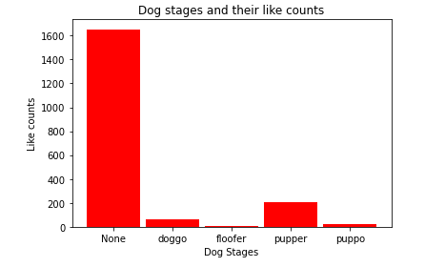

I was able to draw three (3) insights from my analysis and visualization, they are:

* The dog stage with the highest like/the most liked dog stage is the dog stage pupper. Apparently the audience like small dogs a lot.
* The least liked dog stage is the dog stage floofer. Seems the audience do not like furry dogs much.
* And lastly, I observed that the pupper dog stage has over twice the like count of the puppo and floofer dog stages.