Exercícios – Banco de Dados.

Itanú Romero - BP3007863
1 -
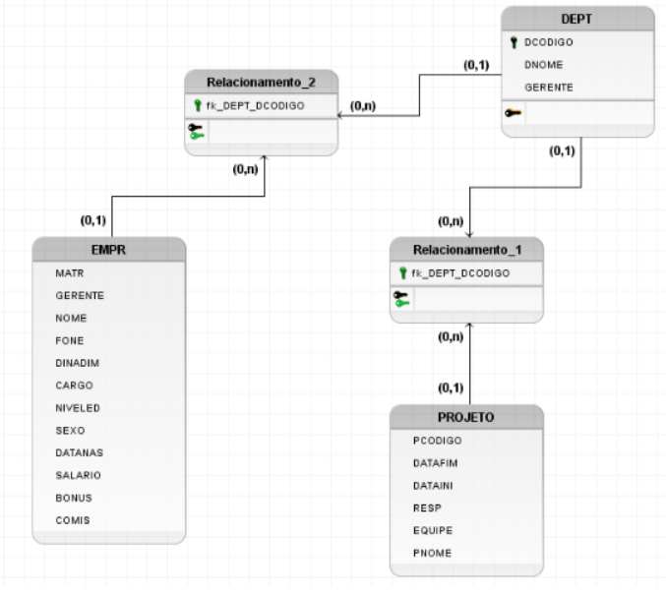
2 -

CREATE DATABASE Atv1-BDII;
CREATE TABLE IF NOT EXISTS `empr` (
`MATR` char(6) NOT NULL,
`NOME` varchar(12) NOT NULL,
`SOBRENOME` varchar(15) NOT NULL,
`DEPT` char(3) DEFAULT NULL,
`FONE` char(14) DEFAULT NULL,
`DINADIM` date DEFAULT NULL,
`CARGO` char(10) DEFAULT NULL,
`NIVELED` int(11) DEFAULT NULL,
`SEXO` char(1) DEFAULT NULL,
`DATANAS` date DEFAULT NULL,
`SALARIO` decimal(9,2) DEFAULT NULL,
`BONUS` decimal(9,2) DEFAULT NULL,
`COMIS` decimal(9,2) DEFAULT NULL
);
CREATE TABLE IF NOT EXISTS `dept` (
`DCODIGO` char(3) NOT NULL,
`DNOME` varchar(36) NOT NULL,
`GERENTE` char(6) DEFAULT NULL
);
CREATE TABLE IF NOT EXISTS `projeto` (
`PCODIGO` char(6) DEFAULT NULL,
`PNOME` varchar(24) DEFAULT NULL,
`DCODIGO` char(3) DEFAULT NULL,
`RESP` char(6) DEFAULT NULL,
`EQUIPE` int(5) NOT NULL,
`DATAINI` date NOT NULL,
`DATAFIM` date NOT NULL
);

3 -
INSERT INTO `dept`(`DCODIGO`, `DNOME`, `GERENTE`) VALUES ("A1", "DIV. SERVIÇOS DE COMPUTADOR", 10), ("B1", "PLANEJAMENTO", 20), ("C1", "CENTRO DE INFORMAÇÕES", 30), ("D1", "CENTRO DE DESENVOLVIMENTO", 40), ("E1", "SERVIÇOS DE SUPORTE", null), ("A1", "SERVIÇOS COMUNITÁRIOS", null);
INSERT INTO `projeto`(`PCODIGO`, `PNOME`, `DCODIGO`, `RESP`, `EQUIPE`, `DATAINI`, `DATAFIM`) VALUES ("P200", "Outubro rosa", "D1", 100, 7, "2020-09-21", "2020-10-19"), ("A100", "Novembro azul", "D1", 100, 7, "2020-10-01", "2020-10-31"), ("D200", "Suporte na Praça", "E1", 200, 8, "2020-10-25", "2020-10-28"), ("F200", "Brainstorm", "B1", 300, 9, "202010-21", "2020-10-21"), ("G200", "Brechó", "A1", 400, 10, "2020-10-31", "2020-11-10"), ("Y200", "Live de Esclarecimento", "C1", 500, 2, "2020-11-01", "2020-11-01"), ("X200", "Semana da Diversidade", "C1", 500, 2, "2020-10-26", "2020-10-31"), ("W200", "Apresentação de Projetos", "C1", 500, 2, "2020-12-21", "2020-12-21"), ("M200", "Show da Anitta", "D1", 100, 7, "2021-01-01", "2020-01-01"), ("N200", "Natal", "D1", 100, 7, "2020-12-23", "2020-12-25");

INSERT INTO `empr`(`MATR`, `NOME`, `SOBRENOME`, `DEPT`, `FONE`, `DINADIM`, `CARGO`, `NIVELED`, `SEXO`, `DATANAS`, `SALARIO`, `BONUS`, `COMIS`) VALUES (100, "Fernando", "Nogueira", "D1", "40331212", "2000-09-21", "Gerente", 15, "M", "1994-01-18", 7550.00, 500.00, 1000.00), (100, "Jéssica", "Fernandes", "D1", "40393939", "2020-01-21", "Estágiario", 2, "F", "2000-02-28", 900.00, 0, 0), (100, "Gabriel", "Telles", "D1", "40029414", "2018-10-21", "Júnior 3", 7, "M", "1996-06-21", 1700.00, 300.00, 0), (400, "Fernando", "Alvarenga", "A1", "40000123", "2010-01-21", "Senior", 17, "M", "1989-02-25", 9550.00, 1500.00, 0), (400, "Martin", "Nópolis", "A1", "44484848", "2009-05-21", "Pleno", 21, "M", "1975-01-20", 10750.00, 2500.00, 0), (500, "Matheus", "Fagundes", "C1", "40335155", "1994-01-05", "Estoquista", 2, "M", "1999-01-01", 600.00, 0, 0), (500, "Alexandra", "Belgir", "C1", "40002121", "2020-09-21", "", 7, "F", "1994-03-28", 7485.00, 1200.00, 500.00), (200, "Wesley", "Camargo", "E1", "454545454", "1974-11-11", "", 4, "M", "1994-05-05", 754.00, 300.00, 250.00), (200, "Hanah", "Martega", "E1", "40123232", "2018-10-11", "Suporte", 2, "F", "200104-20", 1152.00, 0, 0), (200, "Victoria", "Grande", "E1", "45420123", "2017-09-21", "", 15, "F", "2000-01-18", 3500.00, 500.00, 1000.00), (300, "Jiovane", "Martins", "B1", "40133232", "200104-26", "Limpeza", 9, "M", "1945-01-22", 1700.00, 100.00, 0), (300, "Vinicius", "Diesel", "B1", "45656453", "2007-03-21", "Professor", 15, "M", "1972-01-28", 500.00, 500.00, 10000.00), (300, "Bob", "Bota", "B1", "45153256", "2020-09-21", "Camareiro", 4, "M", "2000-05-31", 700.00, 500.00, 0), (100, "Debora", "Pereira", "A1", "47897878", "2001-01-02", "", 15, "F", "2000-04-05", 470.00, 500.00, 1000.00), (500, "Beatriz", "Valera", "C1", "40010112", "2020-1001", "Front-end", 29, "F", "2000-03-28", 1000.00, 200.00, 300.00), (200, "Adriana", "Martins", "E1", "41231231", "1984-11-11", "Artista", 4, "F", "1984-05-05", 450.00, 300.00, 250.00), (200, "Carolina", "Ribeiro", "E1", "41567894", "2015-11-11", "Médico", 50, "F", "1990-04-20", 15152.00, 0, 0), (200, "Amanda", "Magalhães", "E1", "41323647", "2018-06-11", "Chef", 25, "F", "1955-05-18", 450.00, 0, 3000.00), (300, "Ricardo", "Souza", "B1", "41236547", "2001-0420", "Repórter", 7, "M", "1985-02-22", 1700.00, 100.00, 0), (300, "Marcia", "Silveira", "B1", "48784894", "2005-03-21", "Dentista", 45, "F", "1990-04-08", 7500.00, 1500.00, 1000.00);

4 -

a-)
SELECT SOBRENOME, NOME, DEPT, DATANAS, DINADIM, SALARIO FROM `empr` WHERE (SALARIO * 12) > 30000
b-)
SELECT * FROM `dept` WHERE GERENTE is null;
c-)
SELECT SOBRENOME, NOME, DEPT, DATANAS, DINADIM, SALARIO FROM `empr` WHERE (SALARIO * 12) < 20000 ORDER BY SOBRENOME, NOME;
d-)
SELECT * FROM `dept` WHERE DCODIGO = "A1";
e-)
SELECT DCODIGO, DNOME FROM `dept` WHERE DNOME LIKE "%Serviço%";
f-)
SELECT MATR, SOBRENOME, DEPT, FONE FROM `empr` WHERE DEPT BETWEEN "B1" AND "D1";
g-)
SELECT SOBRENOME, DEPT, (SALARIO * COMIS) AS "Rendimento" FROM `empr` WHERE DEPT = "B1" OR DEPT = "C1" ORDER BY DEPT, (SALARIO * COMIS) DESC;
h-)
SELECT SOBRENOME, SALARIO, DEPT FROM `empr` WHERE SALARIO > 3000 ORDER BY SOBRENOME;

