Python Developer Internship Assignment
Submitted by: Tanmay Itape
Date: June 12, 2026
Submitted to: khushi@tradexa.co.in

1. Project Overview
A Django 6.x web application built with two apps — users and products — each connected to its own SQLite database via a custom database router. The project demonstrates custom user authentication, post creation with @login_required, a ForeignKey without database constraint, admin customization, and public product listing.

2. Tech Stack
- Backend: Python 3, Django 6.x
- Frontend: Bootstrap 5 (CDN)
- Database: SQLite (two separate files)
- Configuration: python-decouple (environment variables)
- Version Control: Git & GitHub

3. Folder Structure
tradexa_assignment/
├── config/
│ ├── settings.py
│ ├── urls.py
│ ├── routers.py
│ └── ...
├── users/
│ ├── models.py
│ ├── views.py
│ ├── forms.py
│ ├── admin.py
│ └── templates/users/...
├── products/
│ ├── models.py
│ ├── views.py
│ ├── admin.py
│ └── templates/products/...
├── users_db.sqlite3
├── products_db.sqlite3
├── manage.py
├── requirements.txt
├── .env.example
└── README.md

4. Models

User (users.models.User)
- Inherits from AbstractUser
- Provides username, first_name, last_name, email, password

Post (users.models.Post)
- user: ForeignKey to User with db_constraint=False, on_delete=CASCADE
- text: TextField
- created_at, updated_at: auto-managed DateTime fields

Product (products.models.Product)
- name: CharField
- weight: DecimalField (kg)
- price: DecimalField
- created_at, updated_at — both displayed on the public Products page to show when a product was last modified

5. Database Router Explanation
- Router file: config/routers.py
- Routes users app to default database (users_db.sqlite3)
- Routes products app to products_db database (products_db.sqlite3)
- Prevents cross-database relations via allow_relation()
- Ensures migrations run only on the correct database via allow_migrate()
- Every read/write operation is directed based on app_label

6. Authentication Flow
- Custom user model set via AUTH_USER_MODEL = 'users.User'
- Django's built-in LoginView and LogoutView used
- Post creation view decorated with @login_required — unauthenticated users are redirected to login with ?next=/create/
- Session-based authentication handled by Django middleware
- Navbar shows dynamic links based on user.is_authenticated
- Edit post view (@login_required) allows only the post owner to edit their own posts — accessible via /edit/<id>/

7. Admin Customization
- All models registered with custom ModelAdmin classes
- UserAdmin inherited for user management
- PostAdmin and ProductAdmin include list_display, list_filter, search_fields
- Admin accessible only to staff users

8. Screenshots
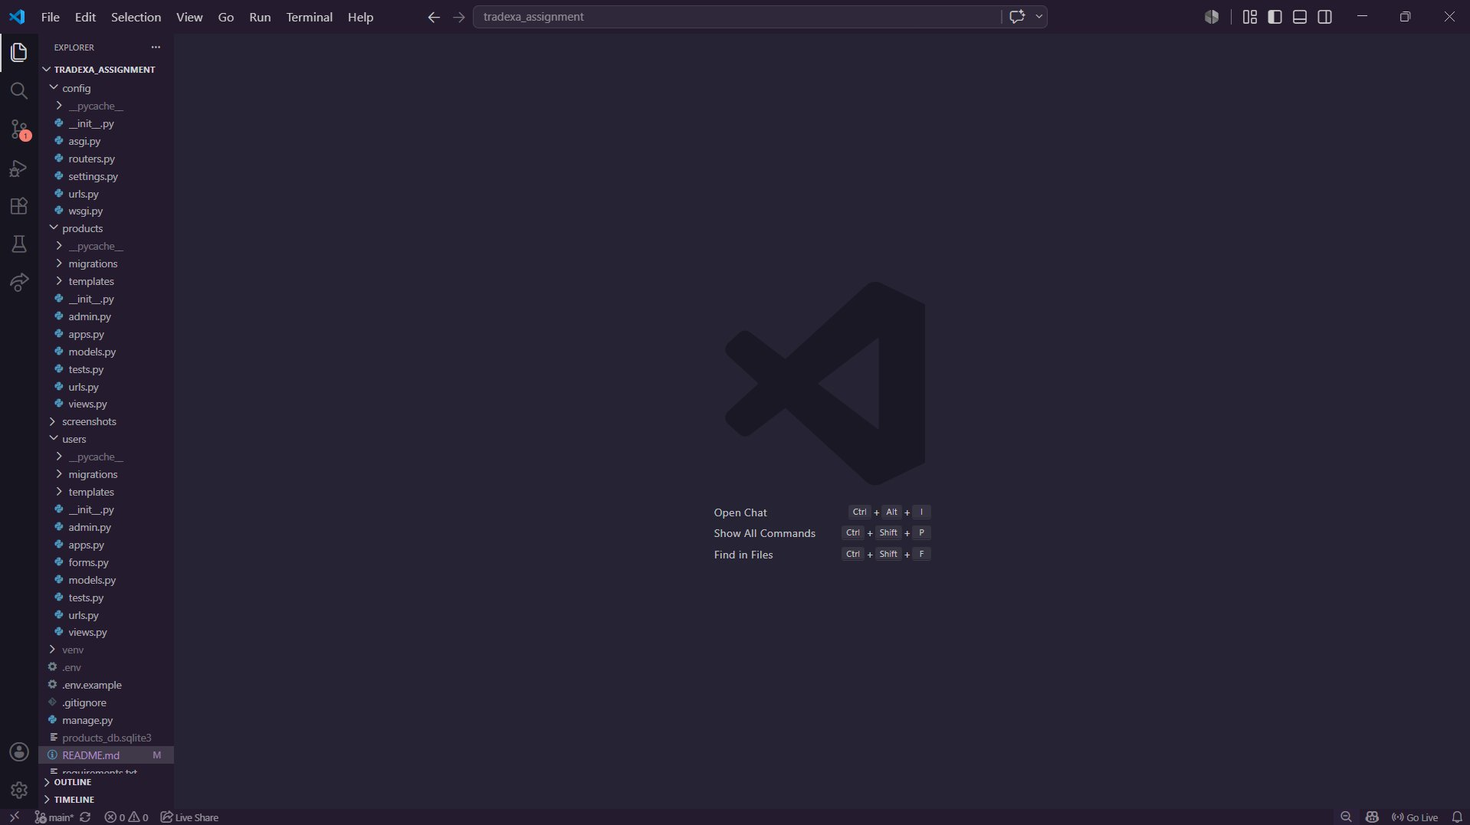
Figure 1: Project Folder Structure
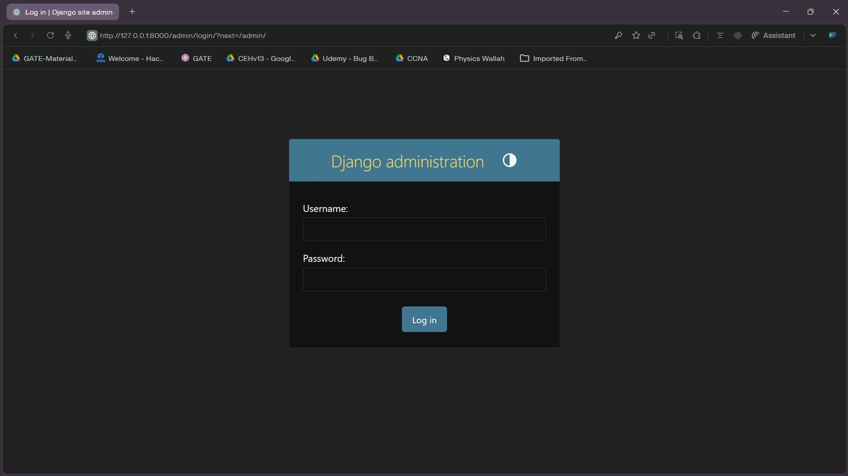
Figure 2: Admin Login Page
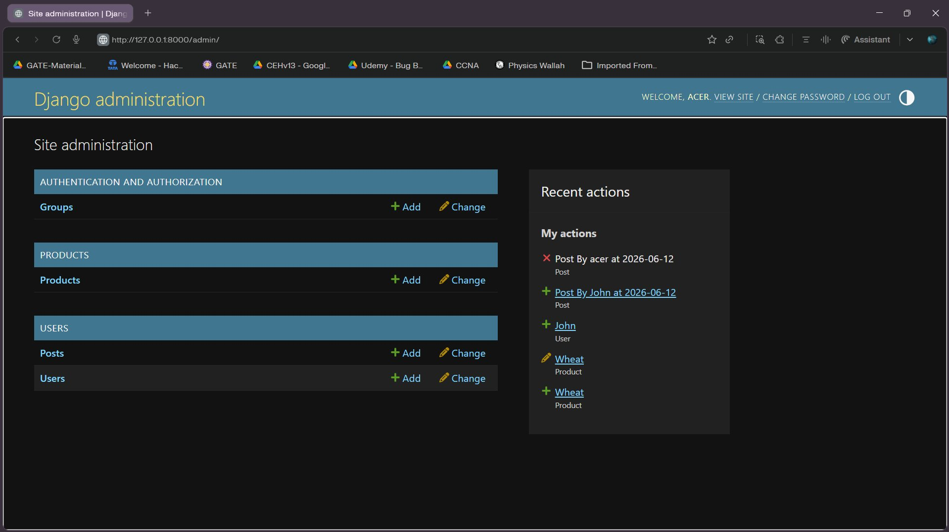
Figure 3: Admin Dashboard
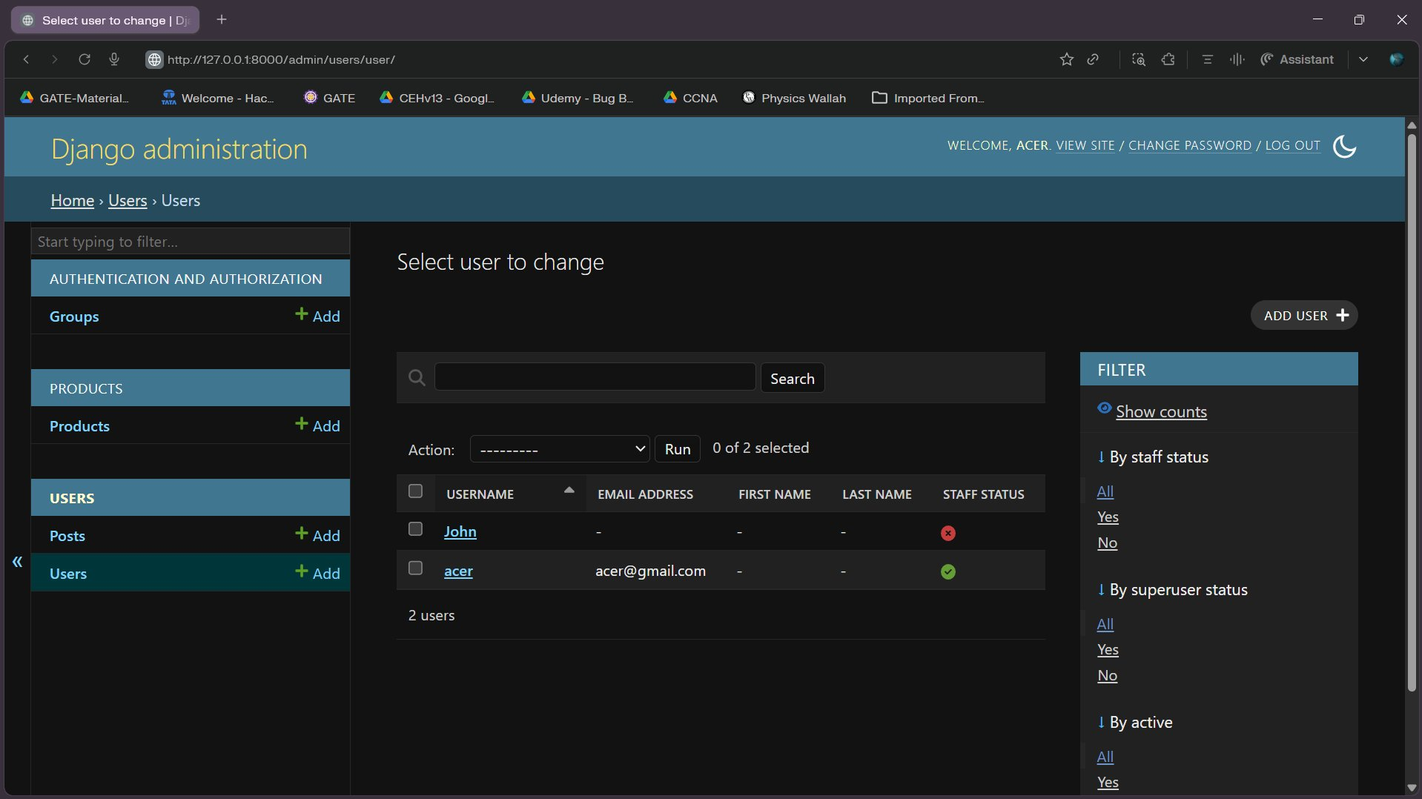
Figure 4: Users List (Admin)
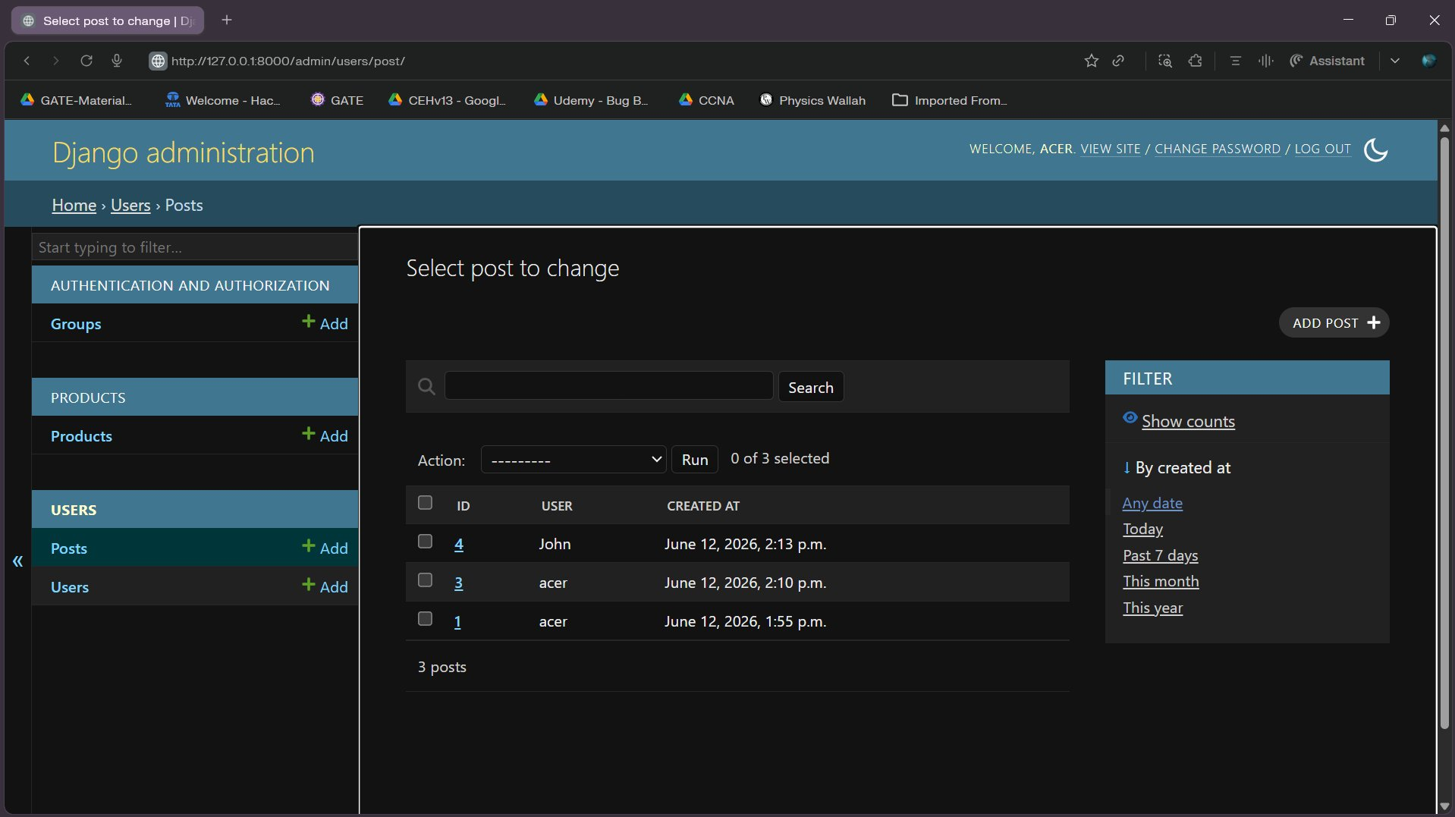
Figure 5: Posts List (Admin)
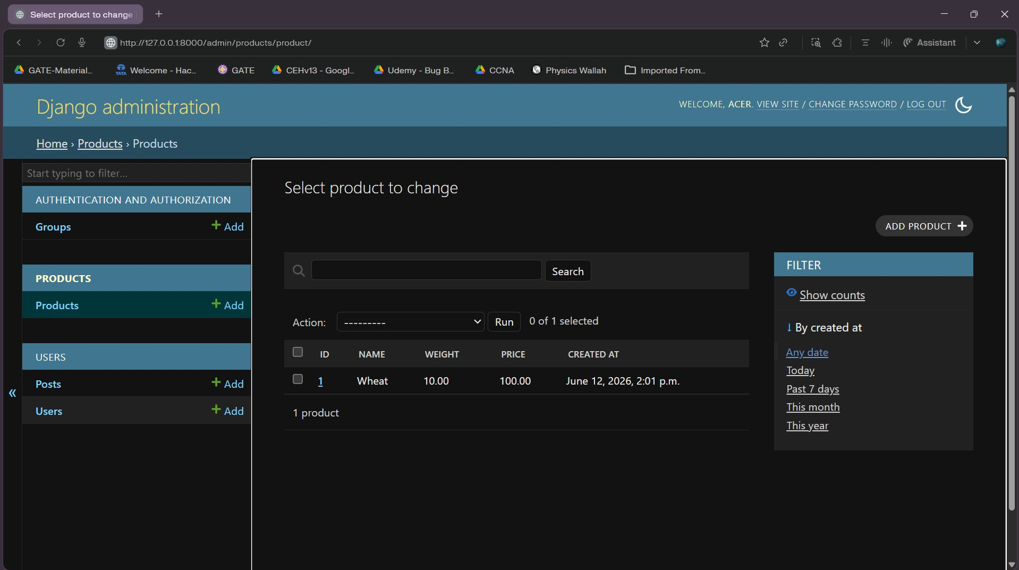
Figure 6: Products List (Admin)
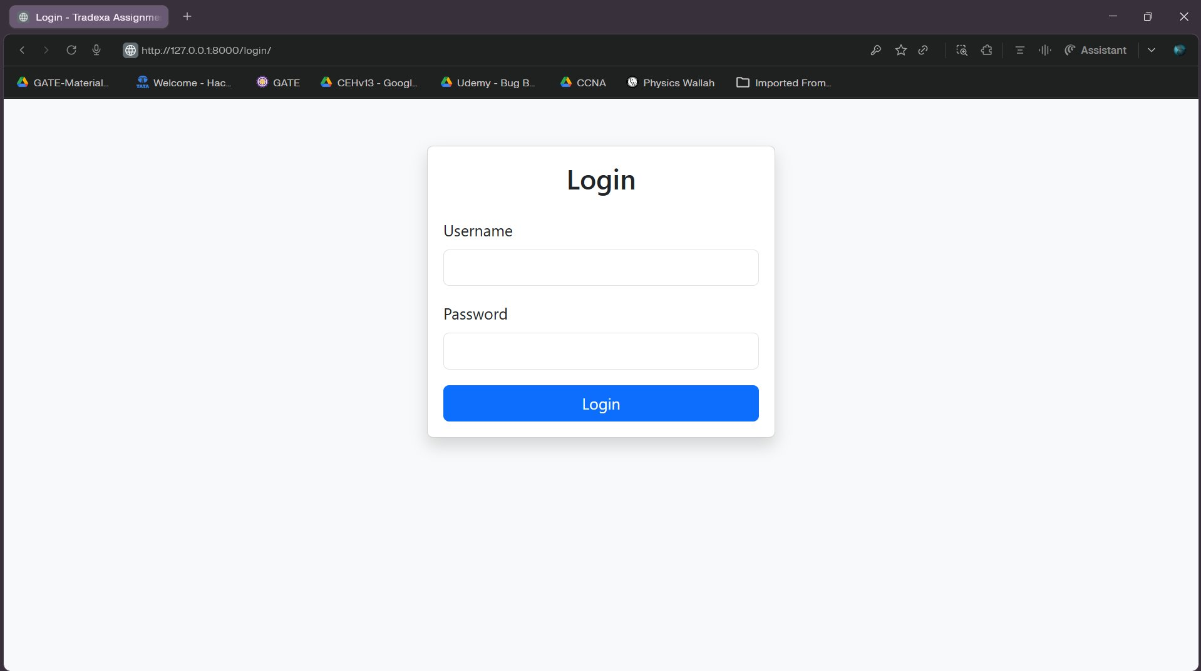
Figure 7: User Login Page
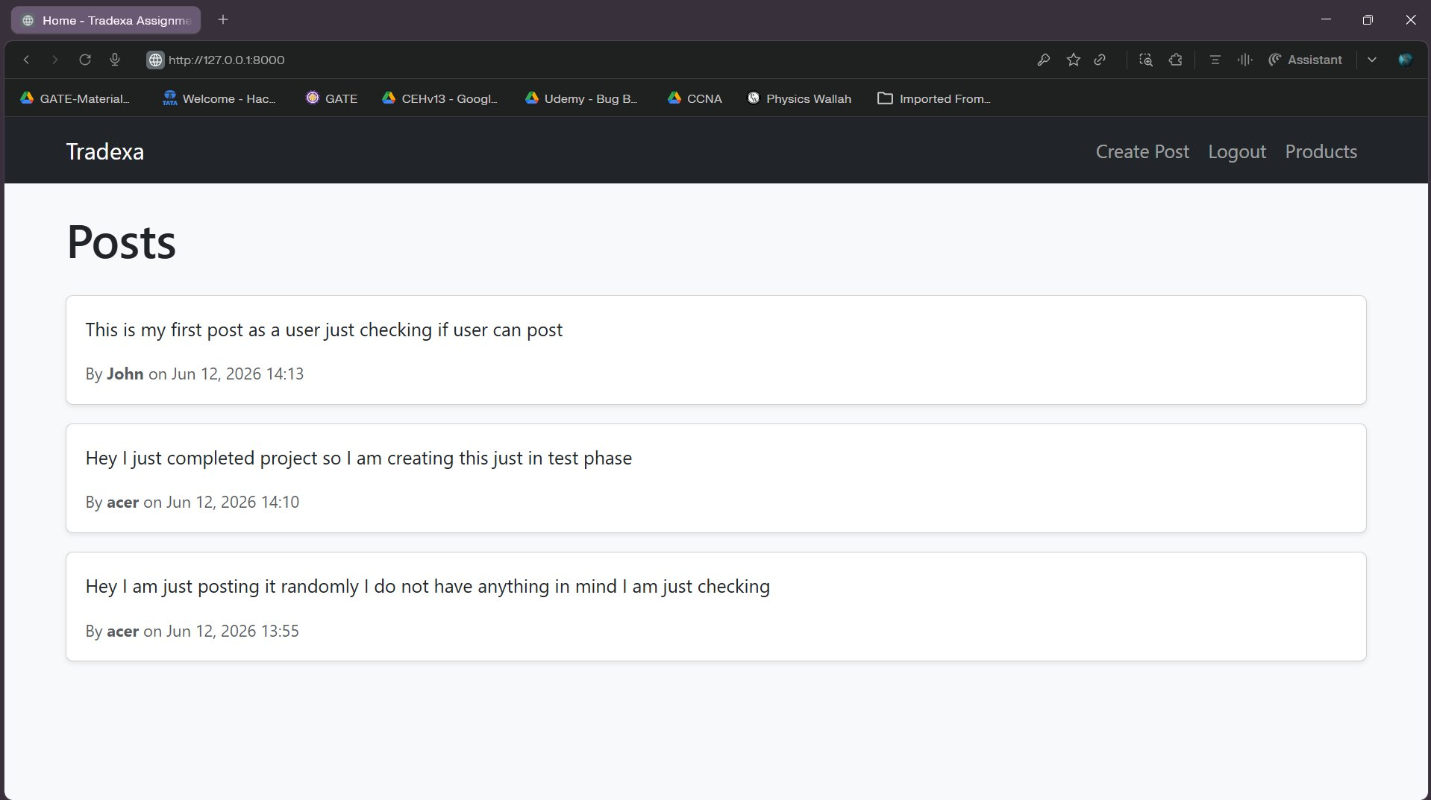
Figure 8: Home Page (Posts Feed)
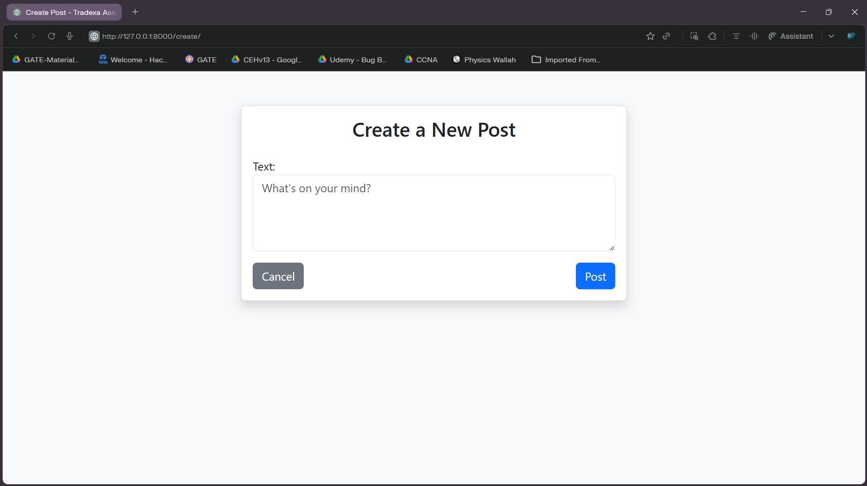
Figure 9: Create Post Page
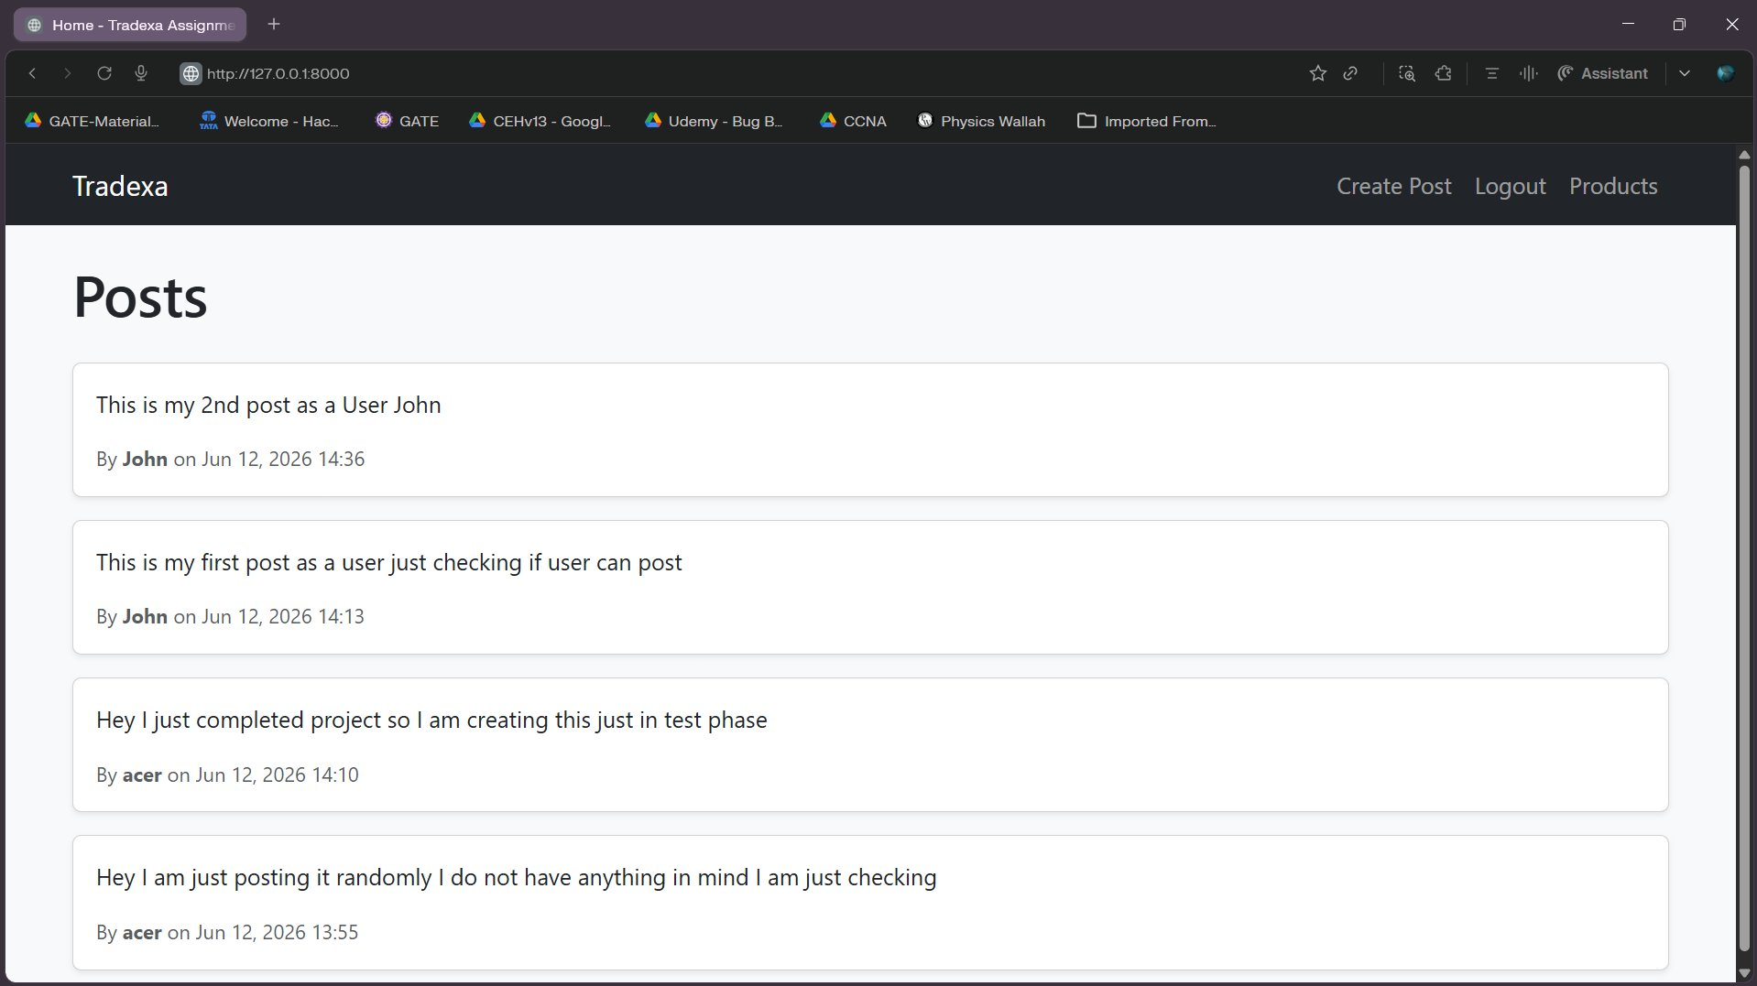
Figure 10: Successful Post Created
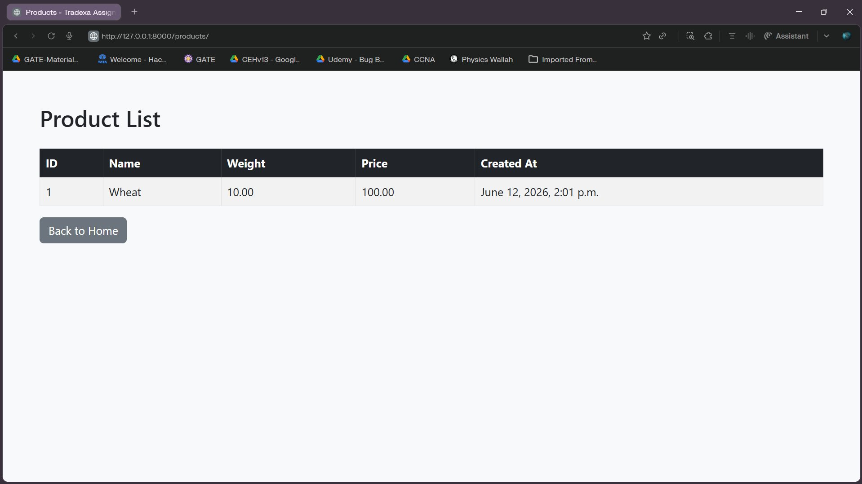
Figure 11: Public Products Page
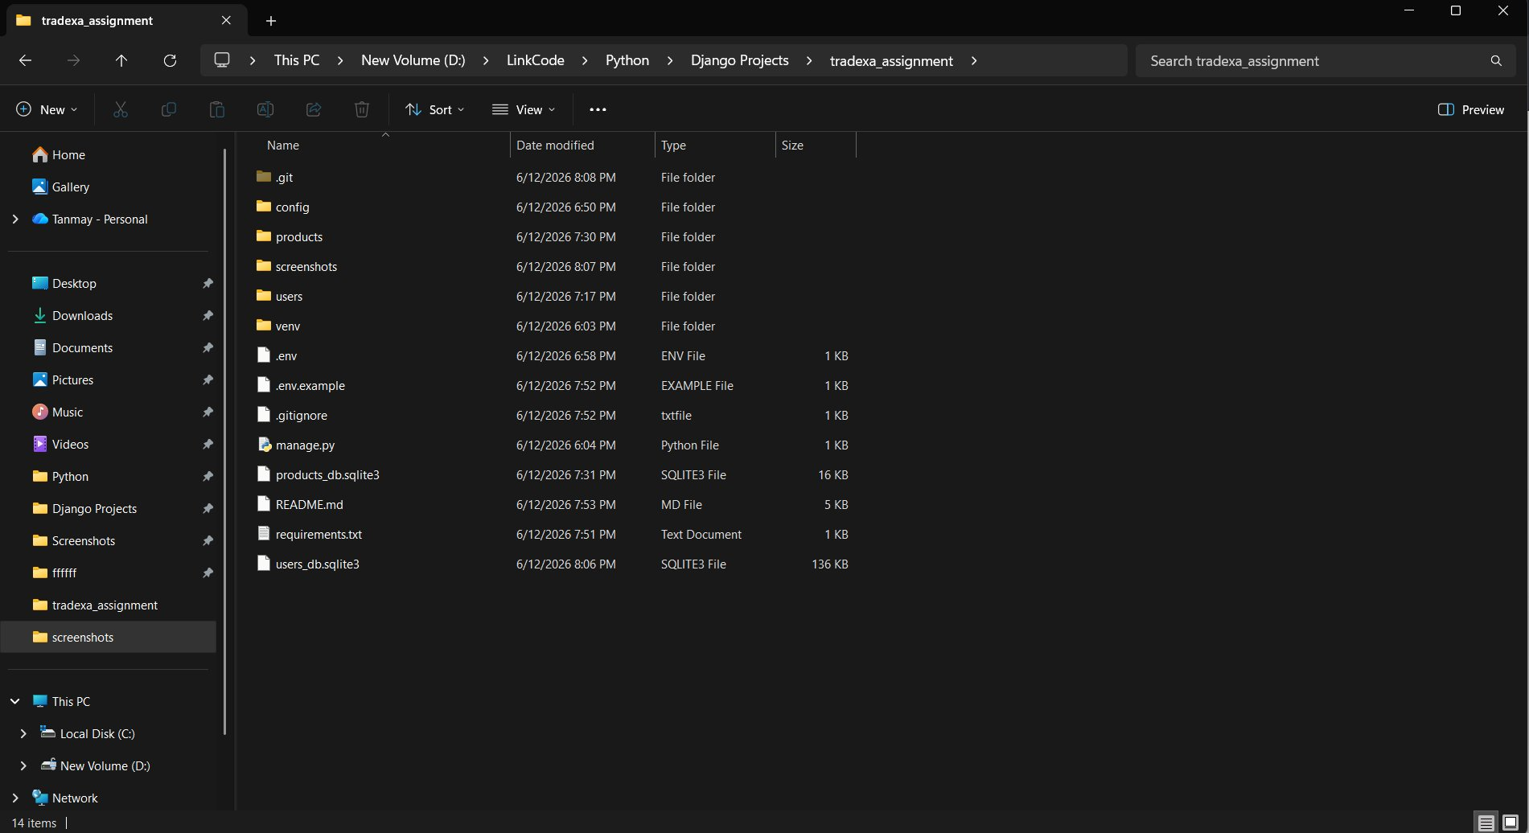
Figure 12: Database Files
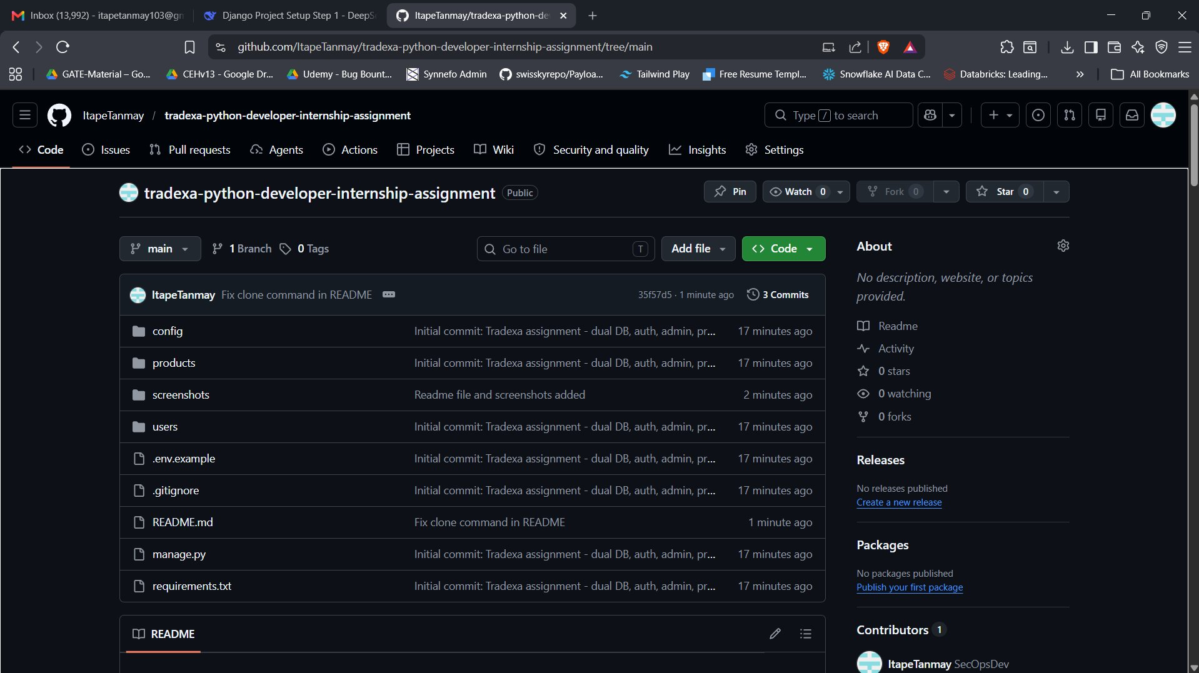
Figure 13: GitHub Repository
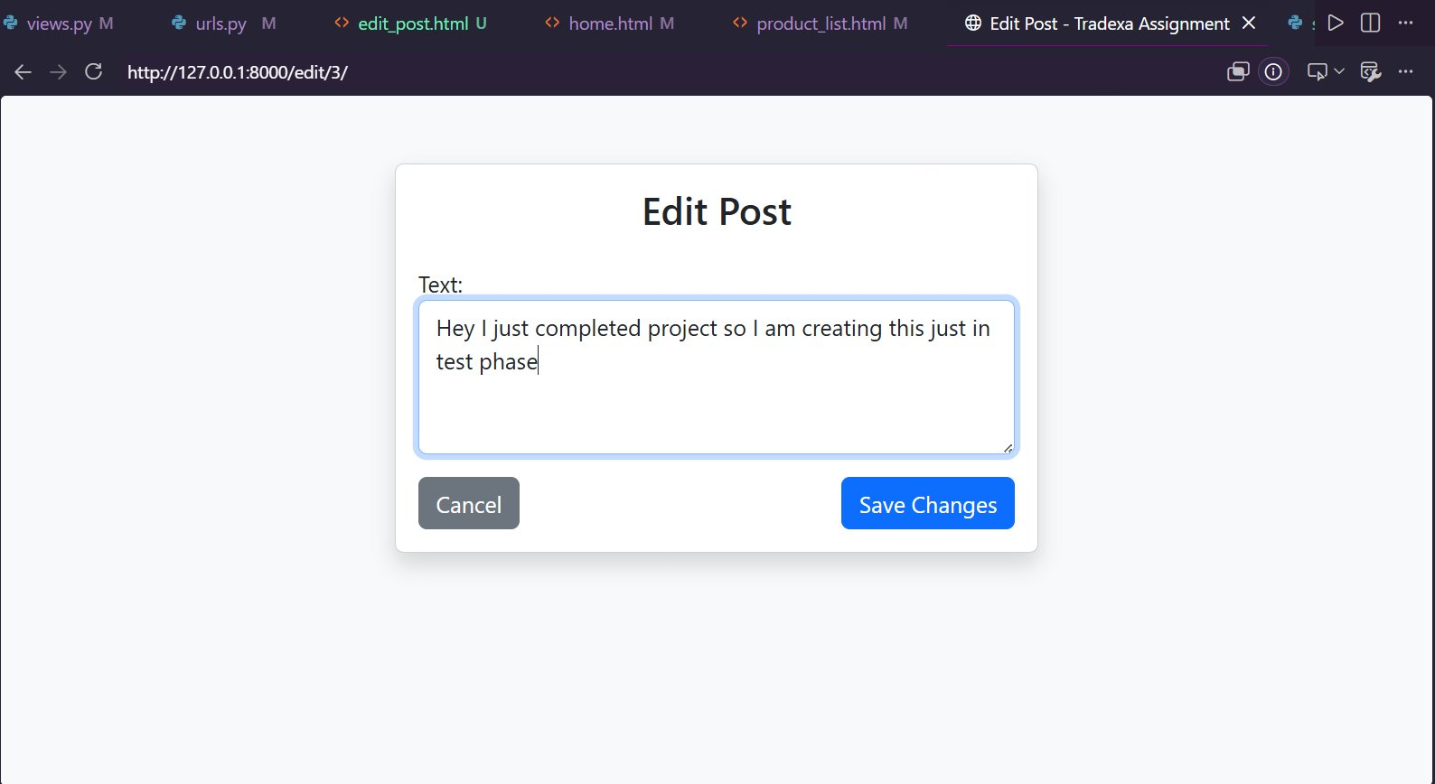
Figure 14: Edit Post Page
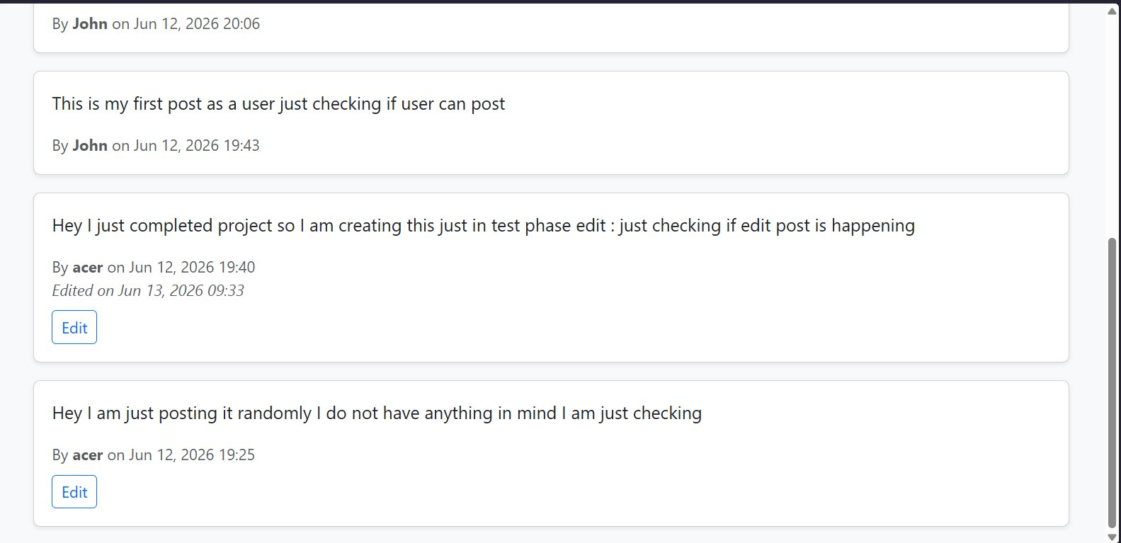
Figure 15: Edit Post – Success (Updated Feed)
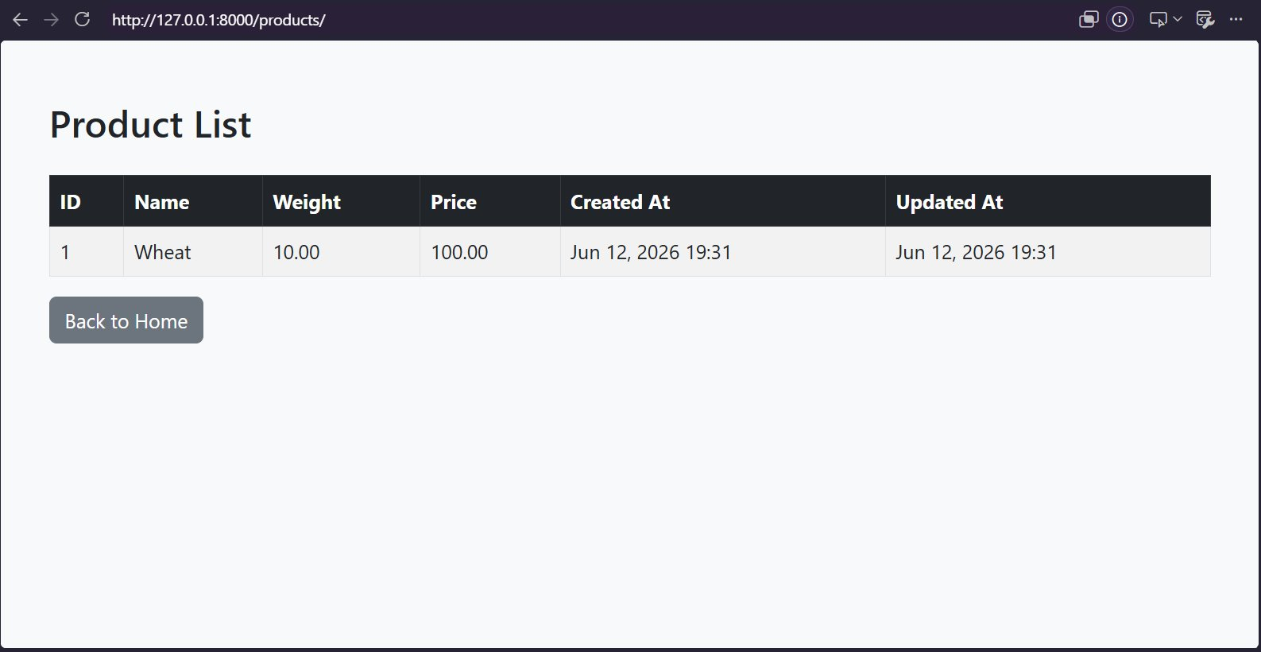
Figure 16: Products Page with Updated At Column

9. GitHub Link
https://github.com/ItapeTanmay/tradexa-python-developer-internship-assignment

10. Conclusion
This project demonstrates the ability to build a multi-app Django application with advanced configurations like dual databases, database routing, custom authentication, and admin customization. All assignment requirements have been fulfilled, and the code follows industry best practices (PEP 8, separation of concerns, secure config via environment variables).

