**SONARQUBE**

* [SonarQube](https://www.sonarqube.org/) is an open source platform developed by SonarSource for continuous inspection of Code Quality

* SonarQube offers reports on duplicated code, coding standards, unit tests, bugs and security vulnerabilities

* SonarQube provides fully automated analysis and integration with Maven and Continuous Integration tools like Jenkins

* SonarQube is a Java application that requires a Java Runtime Environment and a Database.

**Setting Up SonarQube**

> Install Java

> sudo yum -y install java-1.8.0* wget unzip

* **Download SonarQube**
  + cd ~
  + wget  https://binaries.sonarsource.com/Distribution/sonarqube/sonarqube-6.7.7.zip
  + unzip ~/sonarqube-6.7.7.zip

**Start the Sonar**

> ~/sonarqube-6.7.7/bin/linux-x86-64/sonar.sh status

> ~/sonarqube-6.7.7/bin/linux-x86-64/sonar.sh start

> ~/sonarqube-6.7.7/bin/linux-x86-64/sonar.sh status

* Default Credentials for login
  + Username : admin
  + Password : admin

**Perform Sonar Analysis**

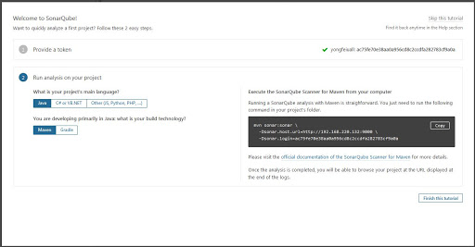

* Provide Token -> **Generate Token**
* What is your **project main language** - **java**
* **Build Technology - Maven**
* **Copy the command you get in - Execute SonarQube For maven**
* Change the directory to Application i.e JavaApp you created using maven
* cd ~/JavaApp
* mvn sonar:sonar…………………………...
* http://server-ipaddress:9000

Now you can see the project displayed under the projects section with analysis report.

