Manhattan Distance + Enhancement

My heuristic estimation function is inspired by the famous

`Manhattan Distance` heuristics, which evaluates a given node

With respect to a given goal node, by the number of

"Gridded" distance from a misplaced marble to its goal position.

My enhancement to the heuristic function is adding to

the calculated `Manhattan Distance` of a given marble

At index (i, j), the movement cost of that marble (to indicate total distance in weight) and count the misplaced marbles. $D$ represents the sum of Manhattan distances of all misplaced marbles.

My heuristic evaluation function, $h\left(n\right)$, is defined:

$$h\left(n\right)=D+\#misplaced_{n}(+punishments)$$

I've enhanced my heuristic by adding a "punishment"

value to states which have misplaced marbles that are blocked from all 4 moving directions.

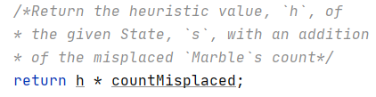

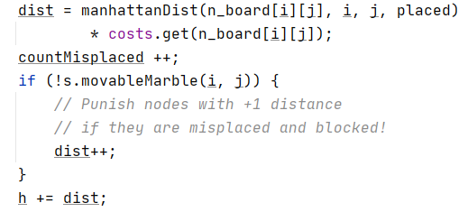

Claim:

My heuristic function $h$ is $consistent$ and $admissible.$

*Note:* My heuristic function, $h$, avoids grading nodes by the `cost` function $of the misplaced marbles!$

It is easy to see that if $g$ is a goal state – then $h\left(g\right)=0$.

Because all marbles are placed in their goal position.

*Admissibility:*

My heuristic function never overestimates a node target.   
The general idea is that each State is evaluated with a strong relation

to the goal State.

I've had trouble proving my enhanced function, but it is clear that a board with a `G` marble with distance 2 and `R` with distance 1 –

should be prioritized over `G` with distance 1 and `B` with distance 1, no matter the given states.

*Note*: If for example `G` with distance 1 to travel, was blocked from all sides, then this state gets punished by 1 point to let the marble out of the way.

This is not a proof of the properties of my heuristic function, but a general explanation of the main idea behind the heuristic evaluation.

Hope the code makes a lot more sense!