■

FLOWER Under Measurement Noise Scale Mismatch
A paired robustness study across five linear inverse problems and two image domains
Project report
Itay Shorian
14 October 2026
20 CelebA images | 20 AFHQ-Cat images | 1,000 reconstructions | PSNR SSIM LPIPS

Abstract
FLOWER uses a pretrained flow-matching prior and a measurement-aware Gaussian refinement to solve linear inverse problems. The refinement requires a measurement-noise standard deviation, but real applications may not know it accurately. This study changes only the standard deviation supplied to FLOWER while holding each measurement, degradation operator, mask or kernel, model, and random trajectory fixed. The benchmark evaluates five ratios from 0.5 to 1.5 on 20 fixed images from each of the paper's CelebA and AFHQ-Cat 100-image test pools and covers denoising, deblurring, super-resolution, random inpainting, and box inpainting. No new learned model or noise-estimation update is introduced: the released Flower1-OT checkpoints and FLOWER update equations are retained. The largest mean absolute response of the paired PSNR curve occurs for CelebA denoising at 1.05 dB, while the smallest occurs for CelebA random inpainting at 0.02 dB. The results therefore quantify where FLOWER needs an accurate noise scale and where moderate misspecification has limited effect.

Research question and contribution
The research question is how reconstruction quality changes when the measurement was generated with the true noise scale but FLOWER receives a different scale. The project contributes a controlled paired benchmark, not a new generative model and not an additional noise estimator. Pairing removes measurement and solver randomness from comparisons between noise assumptions.
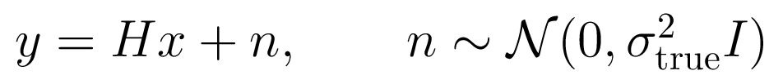
- The covariance shape is fixed and correct in every experiment.
- The assumed standard deviation ratios are 0.5, 0.75, 1.0, 1.25, and 1.5.
- The corresponding variance ratios are 0.25, 0.5625, 1.0, 1.5625, and 2.25.

FLOWER method
FLOWER starts from a source sample and advances along a straight-line flow. At each time it performs a prior prediction, a measurement refinement, and a progression step. The public experiments use the deterministic Flower1 setting with gamma equal to zero, so the refinement uses its conditional mean rather than drawing its covariance term [1].
Step | Operation | Dependence on assumed sigma
1 | Predict a flow-consistent destination from the velocity network | No explicit dependence
2 | Combine the destination with the measurement through a Gaussian refinement | Direct dependence through inverse variance
3 | Move to the next flow time and inject decreasing source noise | Indirect dependence through the refined destination

A smaller assumed sigma increases the coefficient of the data term and forces closer agreement with a noisy measurement. A larger assumed sigma weakens data consistency and gives the flow prior more influence. Ill-posed operators can amplify this tradeoff because the measurement does not constrain every image direction equally.

Mathematical justification

Optimal velocity gives the conditional destination
For conditional flow matching with a straight path, the squared-error optimum is the conditional mean of the target velocity. Because X1 equals Xt plus one minus t times X1 minus X0, taking the conditional expectation yields Proposition 1 of the paper.
This short proof explains why the first step acts as a denoiser: an optimally trained velocity network predicts the conditional mean destination associated with the current noisy flow state.

Gaussian multiplication gives the refinement
FLOWER approximates the destination distribution by a Gaussian centered at the prior prediction and combines it with the Gaussian linear likelihood. Multiplying the two densities adds their quadratic exponents. Collecting the terms in x gives posterior precision nu to the power minus two times the identity plus sigma to the power minus two times H transpose H. Completing the square gives the mean and covariance displayed above, which is Proposition 2 in the paper.
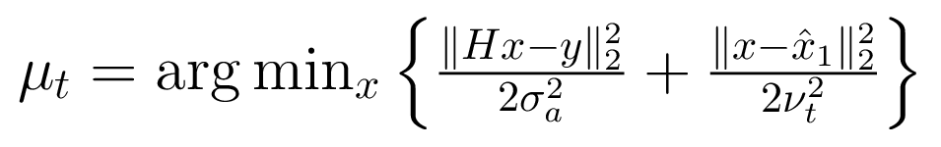
Differentiating this objective and setting the gradient to zero produces the same normal equation as the Gaussian mean. This proves the equivalence between the Bayesian conditional mean and FLOWER's proximal measurement step. It also identifies the exact location of the noise mismatch: the data-fidelity weight is the reciprocal of the assumed variance.

Progression preserves the conditional path
Under the paper's independence and Gaussian approximations, the weighted sum of a refined Gaussian destination and independent standard Gaussian source noise is Gaussian with the mean and covariance stated in Proposition 3. Theorem 1 then follows from the law of total probability: if the current state has the correct conditional distribution and the transition is correct, integrating the transition over the current conditional state yields the next conditional distribution.
Repeating this argument gives an inductive ancestral-sampling interpretation. The paper notes that gamma equal to one is required for the full covariance sampling argument, while gamma equal to zero gives better reconstruction metrics in practice. This project follows the reported Flower1-OT reconstruction setting with gamma equal to zero.

Experimental design
Component | Protocol
Images | 20 fixed random images from each paper-ordered 100-image test pool, seed 2026
Pairing | One measurement per image and task; identical measurement and source-noise trajectory across ratios
Control | Assumed sigma divided by true sigma equals 1.0
Model | Official pretrained optimal-transport flow model for each dataset
Metrics | PSNR and SSIM are higher-is-better; LPIPS is lower-is-better
Uncertainty | 95 percent confidence interval across 20 paired image-level differences

Task | True sigma | CelebA operator | AFHQ-Cat operator
Denoising | 0.20 | Identity | Identity
Deblurring | 0.05 | 61 x 61 Gaussian, blur sigma 1 | 61 x 61 Gaussian, blur sigma 3
Super-resolution | 0.05 | 2x decimation | 4x decimation
Random inpainting | 0.01 | 70 percent missing | 70 percent missing
Box inpainting | 0.05 | Centered 40 x 40 box | Centered 80 x 80 box

CelebA uses 100 FLOWER steps for every task. AFHQ-Cat uses 100 steps for denoising and box inpainting, 200 for random inpainting, and 500 for deblurring and super-resolution, matching the public Flower1-OT scripts. The selected images remain fixed across all tasks.
Implementation fidelity. The released optimal-transport checkpoints, preprocessing, task parameters, FLOWER-1 update, and metric conventions are retained. For the five structured linear operators in this benchmark, the Gaussian refinement is evaluated with operator-specific closed forms. Each closed form solves the same normal equation as the paper's proximal Gaussian mean; it changes the numerical linear-algebra implementation, not the reconstruction objective. Consequently, the paper's 100-image means are used only as a contextual scale check, while all mismatch claims use paired comparisons inside this experiment.

Results
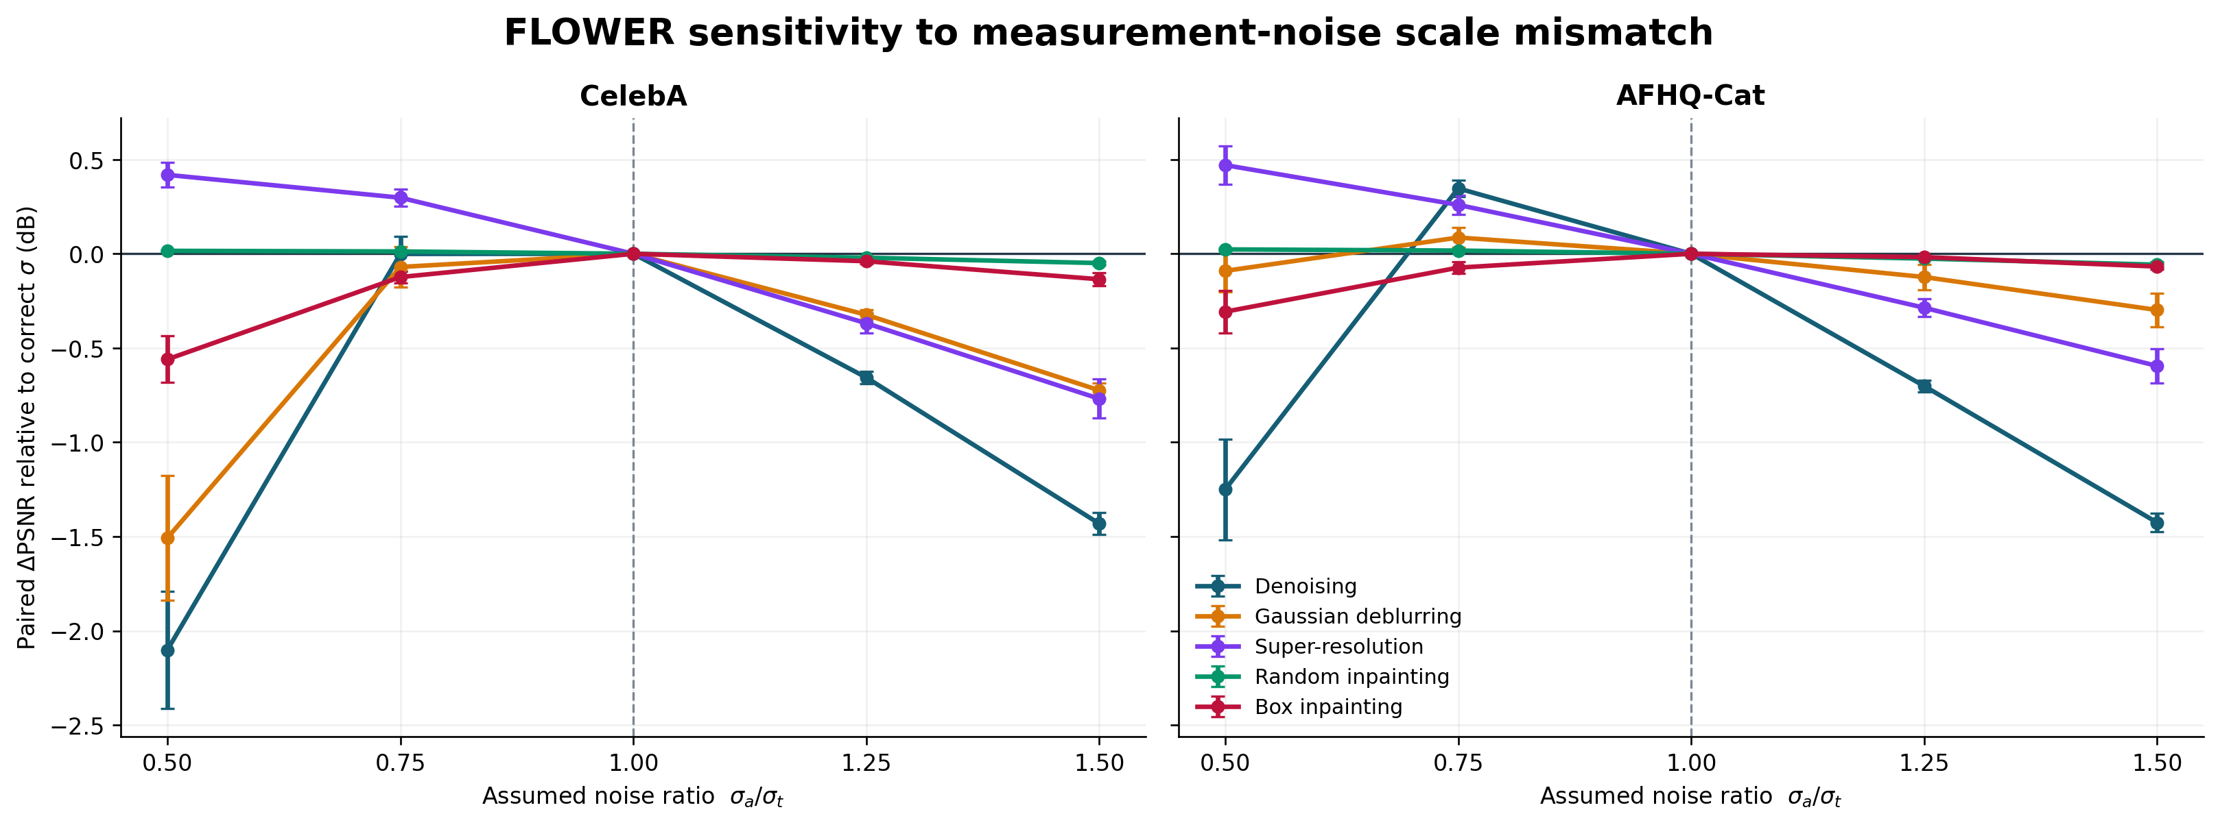
Figure 1 Mean paired PSNR change relative to the correct noise scale. Error bars show 95 percent confidence intervals across 20 images.
The strongest average response is CelebA denoising with mean absolute paired change 1.05 dB across the four mismatched ratios. Its largest tested deviation occurs at ratio 0.5, where the mean paired change is -2.10 dB and 100% of the images have lower PSNR than their own control reconstruction. The least responsive setting is CelebA random inpainting at 0.02 dB.
Dataset | Task | Control PSNR | Largest response ratio | Paired delta dB | Paper PSNR
CelebA | Denoising | 32.22 | 0.5 | -2.10 | 32.28
CelebA | Gaussian deblurring | 34.74 | 0.5 | -1.51 | 34.98
CelebA | Super-resolution | 32.14 | 1.5 | -0.77 | 32.36
CelebA | Random inpainting | 32.65 | 1.5 | -0.05 | 33.08
CelebA | Box inpainting | 30.54 | 0.5 | -0.56 | 31.19
AFHQ-Cat | Denoising | 31.31 | 1.5 | -1.43 | 31.69
AFHQ-Cat | Gaussian deblurring | 27.45 | 1.5 | -0.30 | 28.64
AFHQ-Cat | Super-resolution | 26.15 | 1.5 | -0.60 | 26.23
AFHQ-Cat | Random inpainting | 32.15 | 1.5 | -0.06 | 32.97
AFHQ-Cat | Box inpainting | 26.70 | 0.5 | -0.31 | 26.19

Table 1 Condensed results. The paper values use 100 images, while this project uses a fixed 20-image subset from the same benchmark pool. The paper column is therefore contextual and not an exact sample-matched replication target.
Dataset | Task | Best sigma ratio | Delta PSNR | Delta SSIM | Delta LPIPS
CelebA | Denoising | 1 | +0.00 | +0.000 | +0.000
CelebA | Gaussian deblurring | 1 | +0.00 | +0.000 | +0.000
CelebA | Super-resolution | 0.5 | +0.42 | +0.003 | -0.012
CelebA | Random inpainting | 0.5 | +0.02 | -0.000 | -0.001
CelebA | Box inpainting | 1 | +0.00 | +0.000 | +0.000
AFHQ-Cat | Denoising | 0.75 | +0.35 | +0.011 | -0.050
AFHQ-Cat | Gaussian deblurring | 0.75 | +0.09 | +0.007 | -0.016
AFHQ-Cat | Super-resolution | 0.5 | +0.47 | +0.024 | -0.062
AFHQ-Cat | Random inpainting | 0.5 | +0.02 | +0.000 | -0.004
AFHQ-Cat | Box inpainting | 1 | +0.00 | +0.000 | +0.000

Table 2 Empirically best tested ratio for each dataset-task pair. Deltas are paired against ratio 1.0; positive PSNR and SSIM and negative LPIPS indicate improvement. A best ratio different from 1.0 does not estimate the true noise; it shows that finite-model and discretization error can make deliberate likelihood reweighting score better on this sample.

Final reconstruction evidence
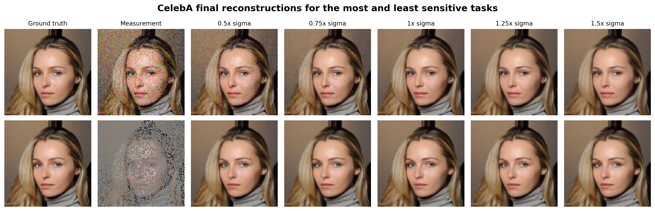
Figure 2 CelebA final reconstructions under the five assumed noise scales. Top row: denoising; bottom row: random inpainting.
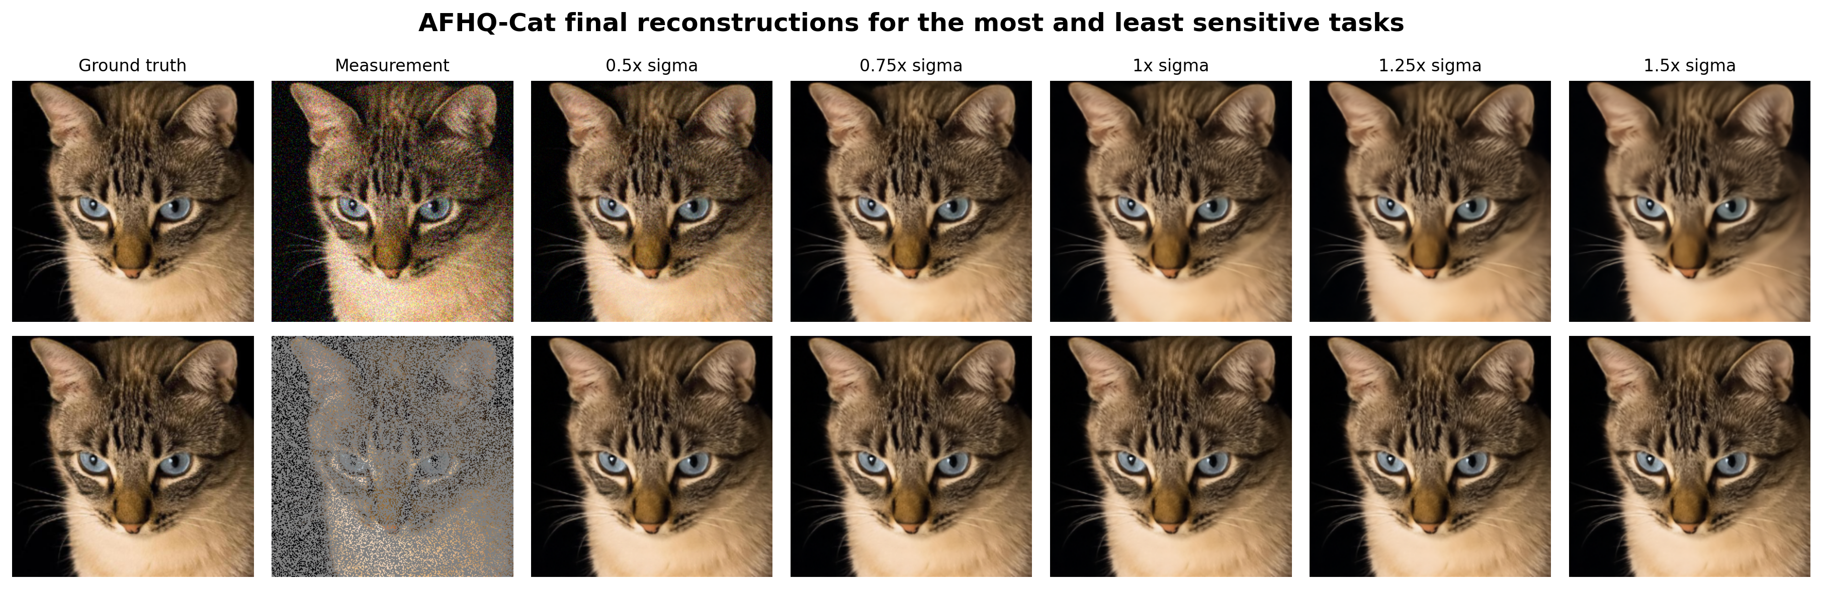
Figure 3 AFHQ-Cat final reconstructions using the same predeclared selection rule. Top row: denoising; bottom row: random inpainting.
The qualitative rows use one image chosen before results were examined. Within each dataset, the plotted tasks are selected by the highest and lowest mean absolute paired PSNR sensitivity. This avoids choosing examples only because their failures look dramatic. The images show whether numerical changes correspond to visible residual noise, excessive smoothing, missing detail, or structural artifacts.

Trajectory evidence
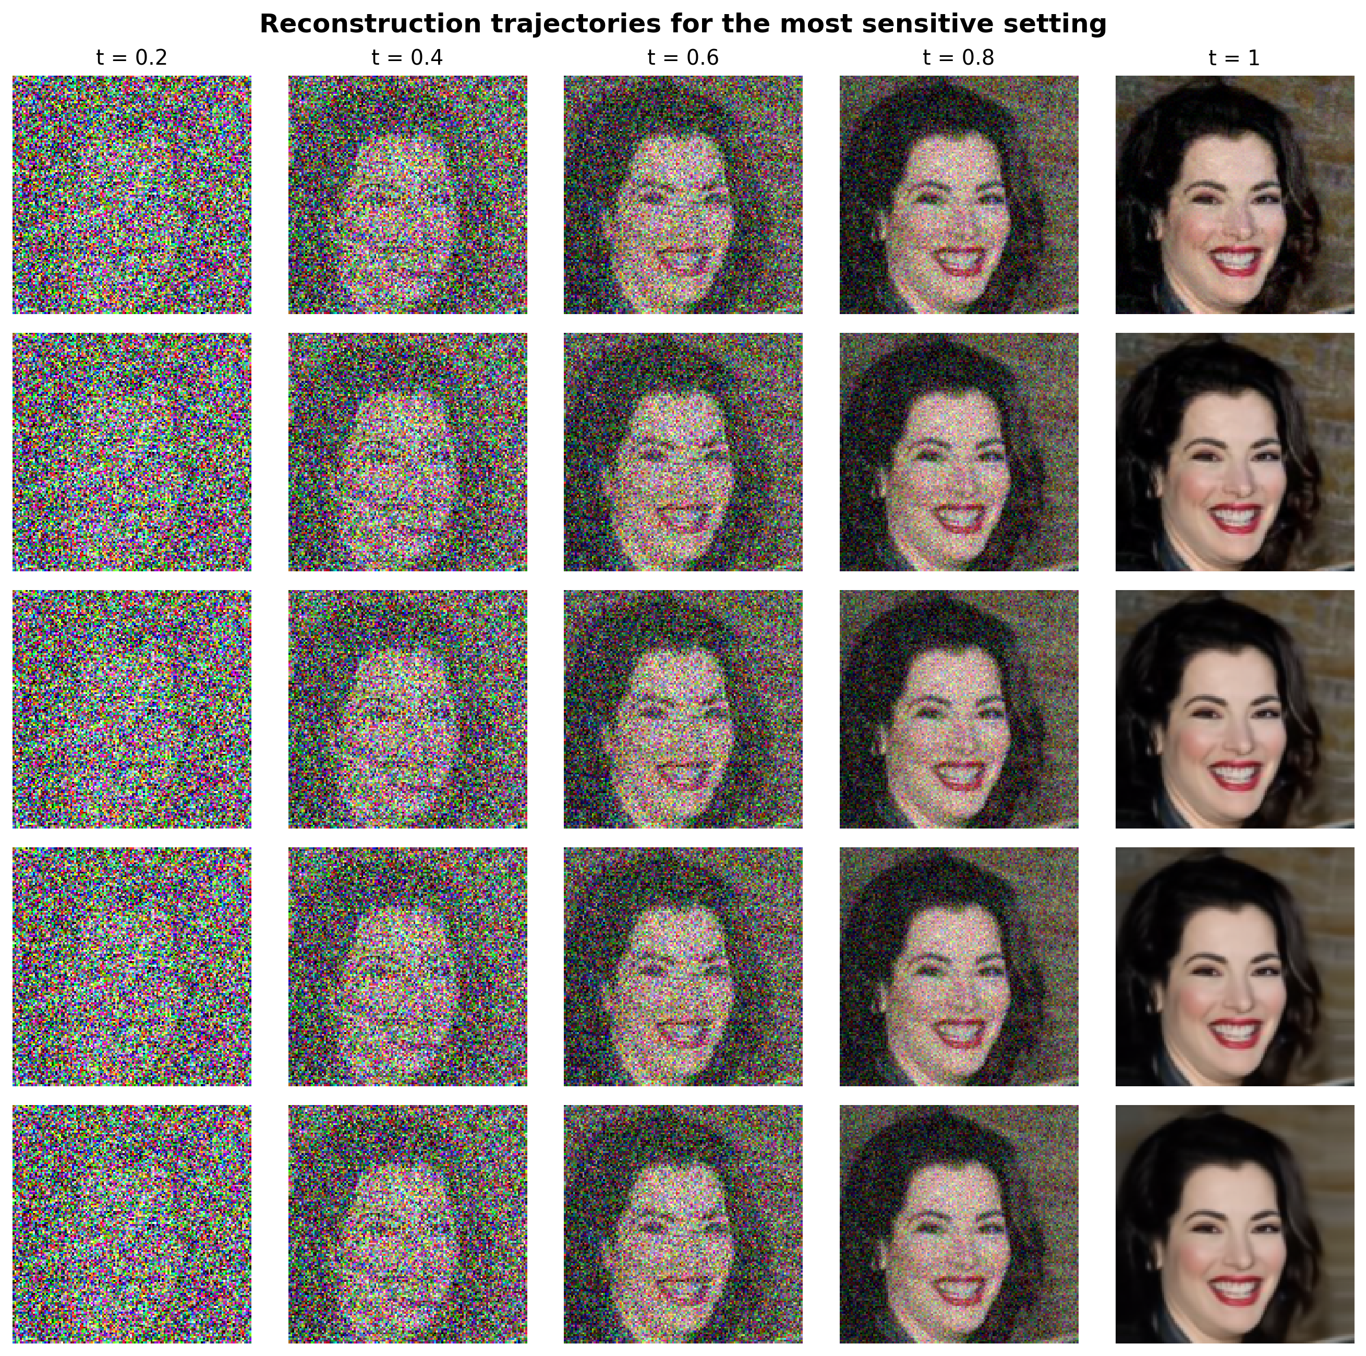
Figure 4 FLOWER states at five flow times for the most sensitive dataset-task setting and an image closest to median sensitivity.
Early columns show whether the trajectories begin to separate immediately after measurement refinement. Later columns show whether the prior compensates for an initial mismatch or whether the discrepancy accumulates. Because the source-noise sequence is shared, visible separation can be attributed to the assumed likelihood scale and its downstream effect on the state.

Mechanistic evidence
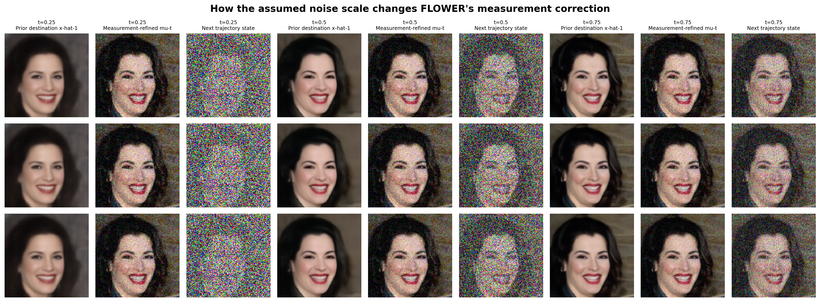
Figure 5 Prior destination, measurement-refined destination, and next trajectory state for three ratios and three flow times.
Sigma does not appear explicitly in the velocity-network destination formula, but previous refinements change the state presented to the network. The direct effect appears in the gap between the prior destination and the refined destination. Underestimation generally produces a stronger measurement correction, while overestimation preserves more of the prior prediction. The next state carries that difference into later iterations.

Conclusions
- Sensitivity rank 1: CelebA denoising has mean absolute paired PSNR response 1.05 dB.
- Sensitivity rank 2: AFHQ-Cat denoising has mean absolute paired PSNR response 0.93 dB.
- Sensitivity rank 3: CelebA gaussian deblurring has mean absolute paired PSNR response 0.66 dB.
Across all dataset-task settings, the mean PSNR change over the two underestimated ratios is -0.21 dB, compared with -0.41 dB over the two overestimated ratios. This aggregate describes directionality but does not replace the task-level curves, because inverse operators constrain different image subspaces.
- Moderate underestimation is not uniformly harmful: at ratio 0.5, super-resolution improves by +0.42 dB on CelebA and +0.47 dB on AFHQ-Cat, with SSIM moving upward and LPIPS downward in both cases.
- AFHQ-Cat denoising peaks at ratio 0.75 (+0.35 dB PSNR, +0.011 SSIM, and -0.050 LPIPS), but stronger underestimation at ratio 0.5 reverses the result to -1.25 dB. The response is therefore nonlinear as well as asymmetric.
- Random inpainting is almost invariant over the tested range: its mean absolute paired PSNR response is 0.02 dB on CelebA and 0.03 dB on AFHQ-Cat.
The project supports a practical conclusion: correct noise calibration matters most for the settings with the steepest paired curves. A flat curve indicates tolerance within the tested range, while an asymmetric curve identifies whether conservative or aggressive noise assumptions are more damaging. These claims apply to the released Flower1-OT models, the tested noise levels, and the fixed 20-image samples.

Limitations
- Twenty images reduce compute cost but give wider confidence intervals than the paper's 100-image tables.
- The project tests isotropic Gaussian noise-scale mismatch and does not test an incorrect covariance shape.
- The five ratios describe a response curve over a limited range and do not identify behavior under extreme misspecification.
- The control uses the correct supplied sigma, but finite model and discretization error can still make another ratio score better on a small sample.
- The paper's theoretical posterior argument uses approximations and gamma equal to one, whereas the reconstruction benchmark uses gamma equal to zero for image quality.

Reproducibility
The repository records the random image selection, measurements, solver seeds, masks, task parameters, paper step counts, raw metrics, paired deltas, confidence intervals, selection rules for qualitative figures, and all five figure builders. The completed run was executed as a Kaggle background version on Tesla T4 GPUs; its packaged output was imported without modifying the numeric results.
Artifact | Location
Protocol | config/robustness.json
Selected images | data_splits/*random20_seed2026*
Raw results | artifacts/experiments/main/metrics.csv
Paired results | artifacts/experiments/main/metrics_with_deltas.csv
Aggregate results | artifacts/experiments/main/summary.csv
Figures | artifacts/figures/figure1 through figure5
GPU workflow | notebooks/run_full_benchmark_kaggle.ipynb

Appendix full results table
Dataset | Task | Sigma ratio | Variance ratio | PSNR | SSIM | LPIPS
CelebA | Denoising | 0.5 | 0.25 | 30.12 +/- 0.25 | 0.803 +/- 0.013 | 0.072 +/- 0.017
CelebA | Denoising | 0.75 | 0.5625 | 32.22 +/- 0.48 | 0.906 +/- 0.009 | 0.024 +/- 0.005
CelebA | Denoising | 1 | 1 | 32.22 +/- 0.52 | 0.917 +/- 0.009 | 0.031 +/- 0.005
CelebA | Denoising | 1.25 | 1.5625 | 31.57 +/- 0.53 | 0.906 +/- 0.011 | 0.045 +/- 0.008
CelebA | Denoising | 1.5 | 2.25 | 30.79 +/- 0.53 | 0.893 +/- 0.013 | 0.058 +/- 0.010
CelebA | Gaussian deblurring | 0.5 | 0.25 | 33.24 +/- 0.62 | 0.898 +/- 0.008 | 0.047 +/- 0.013
CelebA | Gaussian deblurring | 0.75 | 0.5625 | 34.67 +/- 0.81 | 0.941 +/- 0.005 | 0.020 +/- 0.003
CelebA | Gaussian deblurring | 1 | 1 | 34.74 +/- 0.89 | 0.947 +/- 0.006 | 0.025 +/- 0.005
CelebA | Gaussian deblurring | 1.25 | 1.5625 | 34.42 +/- 0.90 | 0.944 +/- 0.007 | 0.032 +/- 0.006
CelebA | Gaussian deblurring | 1.5 | 2.25 | 34.02 +/- 0.90 | 0.939 +/- 0.007 | 0.039 +/- 0.007
CelebA | Super-resolution | 0.5 | 0.25 | 32.55 +/- 0.97 | 0.926 +/- 0.009 | 0.021 +/- 0.005
CelebA | Super-resolution | 0.75 | 0.5625 | 32.43 +/- 0.96 | 0.928 +/- 0.010 | 0.027 +/- 0.005
CelebA | Super-resolution | 1 | 1 | 32.14 +/- 0.92 | 0.923 +/- 0.011 | 0.033 +/- 0.006
CelebA | Super-resolution | 1.25 | 1.5625 | 31.77 +/- 0.87 | 0.917 +/- 0.012 | 0.039 +/- 0.006
CelebA | Super-resolution | 1.5 | 2.25 | 31.37 +/- 0.82 | 0.909 +/- 0.013 | 0.046 +/- 0.007
CelebA | Random inpainting | 0.5 | 0.25 | 32.66 +/- 1.16 | 0.943 +/- 0.009 | 0.016 +/- 0.003
CelebA | Random inpainting | 0.75 | 0.5625 | 32.66 +/- 1.16 | 0.943 +/- 0.009 | 0.016 +/- 0.003
CelebA | Random inpainting | 1 | 1 | 32.65 +/- 1.16 | 0.943 +/- 0.009 | 0.017 +/- 0.003
CelebA | Random inpainting | 1.25 | 1.5625 | 32.63 +/- 1.15 | 0.943 +/- 0.009 | 0.018 +/- 0.003
CelebA | Random inpainting | 1.5 | 2.25 | 32.60 +/- 1.15 | 0.942 +/- 0.009 | 0.018 +/- 0.003
CelebA | Box inpainting | 0.5 | 0.25 | 29.98 +/- 0.98 | 0.897 +/- 0.008 | 0.033 +/- 0.009
CelebA | Box inpainting | 0.75 | 0.5625 | 30.41 +/- 1.07 | 0.932 +/- 0.006 | 0.024 +/- 0.007
CelebA | Box inpainting | 1 | 1 | 30.54 +/- 1.09 | 0.946 +/- 0.006 | 0.021 +/- 0.006
CelebA | Box inpainting | 1.25 | 1.5625 | 30.50 +/- 1.08 | 0.947 +/- 0.006 | 0.023 +/- 0.007
CelebA | Box inpainting | 1.5 | 2.25 | 30.40 +/- 1.07 | 0.945 +/- 0.006 | 0.026 +/- 0.007
AFHQ-Cat | Denoising | 0.5 | 0.25 | 30.06 +/- 0.38 | 0.805 +/- 0.011 | 0.068 +/- 0.010
AFHQ-Cat | Denoising | 0.75 | 0.5625 | 31.65 +/- 0.62 | 0.886 +/- 0.009 | 0.059 +/- 0.006
AFHQ-Cat | Denoising | 1 | 1 | 31.31 +/- 0.63 | 0.875 +/- 0.010 | 0.109 +/- 0.010
AFHQ-Cat | Denoising | 1.25 | 1.5625 | 30.61 +/- 0.64 | 0.854 +/- 0.013 | 0.157 +/- 0.013
AFHQ-Cat | Denoising | 1.5 | 2.25 | 29.88 +/- 0.65 | 0.830 +/- 0.016 | 0.195 +/- 0.016
AFHQ-Cat | Gaussian deblurring | 0.5 | 0.25 | 27.36 +/- 0.84 | 0.756 +/- 0.024 | 0.260 +/- 0.021
AFHQ-Cat | Gaussian deblurring | 0.75 | 0.5625 | 27.54 +/- 0.82 | 0.759 +/- 0.023 | 0.280 +/- 0.021
AFHQ-Cat | Gaussian deblurring | 1 | 1 | 27.45 +/- 0.82 | 0.751 +/- 0.024 | 0.297 +/- 0.021
AFHQ-Cat | Gaussian deblurring | 1.25 | 1.5625 | 27.33 +/- 0.82 | 0.743 +/- 0.025 | 0.310 +/- 0.023
AFHQ-Cat | Gaussian deblurring | 1.5 | 2.25 | 27.15 +/- 0.82 | 0.735 +/- 0.026 | 0.321 +/- 0.023
AFHQ-Cat | Super-resolution | 0.5 | 0.25 | 26.62 +/- 0.89 | 0.756 +/- 0.027 | 0.225 +/- 0.017
AFHQ-Cat | Super-resolution | 0.75 | 0.5625 | 26.41 +/- 0.85 | 0.745 +/- 0.027 | 0.259 +/- 0.019
AFHQ-Cat | Super-resolution | 1 | 1 | 26.15 +/- 0.80 | 0.732 +/- 0.027 | 0.287 +/- 0.022
AFHQ-Cat | Super-resolution | 1.25 | 1.5625 | 25.86 +/- 0.76 | 0.719 +/- 0.028 | 0.310 +/- 0.025
AFHQ-Cat | Super-resolution | 1.5 | 2.25 | 25.56 +/- 0.73 | 0.706 +/- 0.029 | 0.331 +/- 0.027
AFHQ-Cat | Random inpainting | 0.5 | 0.25 | 32.17 +/- 1.19 | 0.912 +/- 0.012 | 0.042 +/- 0.005
AFHQ-Cat | Random inpainting | 0.75 | 0.5625 | 32.17 +/- 1.19 | 0.912 +/- 0.012 | 0.043 +/- 0.005
AFHQ-Cat | Random inpainting | 1 | 1 | 32.15 +/- 1.18 | 0.912 +/- 0.012 | 0.046 +/- 0.005
AFHQ-Cat | Random inpainting | 1.25 | 1.5625 | 32.12 +/- 1.18 | 0.911 +/- 0.012 | 0.048 +/- 0.005
AFHQ-Cat | Random inpainting | 1.5 | 2.25 | 32.09 +/- 1.17 | 0.910 +/- 0.012 | 0.051 +/- 0.005
AFHQ-Cat | Box inpainting | 0.5 | 0.25 | 26.39 +/- 1.27 | 0.871 +/- 0.006 | 0.084 +/- 0.007
AFHQ-Cat | Box inpainting | 0.75 | 0.5625 | 26.62 +/- 1.34 | 0.905 +/- 0.005 | 0.066 +/- 0.006
AFHQ-Cat | Box inpainting | 1 | 1 | 26.70 +/- 1.37 | 0.917 +/- 0.006 | 0.061 +/- 0.006
AFHQ-Cat | Box inpainting | 1.25 | 1.5625 | 26.68 +/- 1.37 | 0.917 +/- 0.006 | 0.068 +/- 0.005
AFHQ-Cat | Box inpainting | 1.5 | 2.25 | 26.63 +/- 1.36 | 0.913 +/- 0.006 | 0.077 +/- 0.006

Table A1 Mean +/- 95 percent confidence interval across 20 images for every dataset, task, and assumed noise ratio.

References
[1] M. Pourya, B. El Rawas, and M. Unser, FLOWER A Flow Matching Solver for Inverse Problems, ICLR 2026. https://openreview.net/forum?id=QGd34p02mI
[2] M. Pourya, B. El Rawas, and M. Unser, official FLOWER implementation. https://github.com/mehrsapo/Flower
[3] R. Zhang, P. Isola, A. A. Efros, E. Shechtman, and O. Wang, The Unreasonable Effectiveness of Deep Features as a Perceptual Metric, CVPR 2018.
[4] Z. Wang, A. C. Bovik, H. R. Sheikh, and E. P. Simoncelli, Image Quality Assessment From Error Visibility to Structural Similarity, IEEE Transactions on Image Processing, 2004.
[5] Z. Liu et al., Deep Learning Face Attributes in the Wild, ICCV 2015.
[6] Y. Choi et al., StarGAN v2 Diverse Image Synthesis for Multiple Domains, CVPR 2020.

