⚽
Football Stats
Project Documentation
A Real-Time Football Statistics Web Application
React 18 · Vite · Bootstrap 5 · API-Football · Recharts

1. Project Planning & Management

1.1 Project Proposal

Project Title
Football Stats – A Real-Time Football Statistics Web Application

Project Overview
Football Stats is a modern, responsive web application that provides comprehensive football (soccer) statistics, live scores, league standings, player profiles, and team analytics. The platform aggregates data from the API-Football service to deliver a premium sports data experience covering the Egyptian Premier League and Europe's top football leagues.

Objectives
- Build a fully functional football statistics web application using React.js that consumes real-time data from API-Football.
- Display live scores, match results, league standings, player statistics, and team profiles from 7 major football leagues.
- Create a premium, dark-themed, responsive UI that works seamlessly across desktop, tablet, and mobile devices.
- Enable users to compare teams/players, save favorites locally, and search across all football entities.
- Implement smart caching to optimize API usage within the free tier limit (100 requests/day).

Scope
In Scope:
- 8 web pages: Home, League, Match Details, Team Profile, Player Profile, Compare, Favorites, Search
- 7 leagues: Egyptian Premier League, Premier League, La Liga, Serie A, Bundesliga, Ligue 1, Champions League
- Real-time data from API-Football (via RapidAPI)
- Responsive design (Desktop + Tablet + Mobile)
- Local favorites system using localStorage
- Smart API caching layer with 15-minute TTL

Out of Scope:
- User authentication / registration
- Backend server / database
- Betting / odds features
- News articles / transfer rumors
- Push notifications · Multi-language support (English-only for MVP)

Target Audience
- Football fans in Egypt and the Middle East
- Users who follow European football leagues
- Sports data enthusiasts who want quick access to statistics

1.2 Project Plan – Gantt Chart
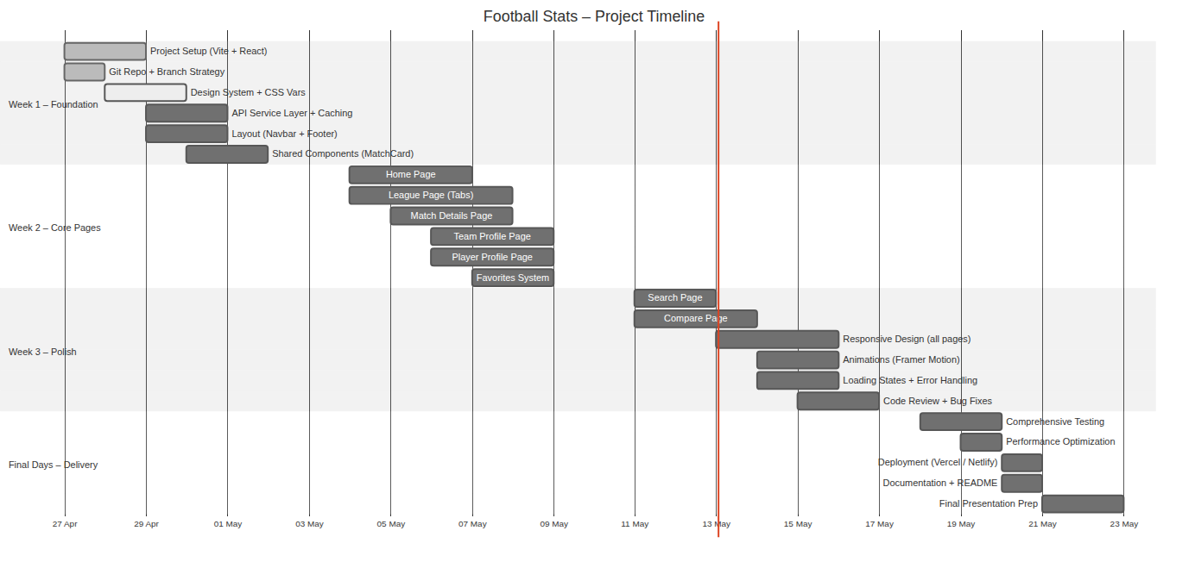
Figure 1 – Project Timeline (Gantt Chart)

Milestones
Milestone | Target Date | Deliverable
M1 – Foundation Complete | 3 May 2026 | Project setup, design system, API layer, shared components
M2 – Core Pages Complete | 10 May 2026 | All 8 pages functional with real API data
M3 – Polish Complete | 17 May 2026 | Responsive, animations, error handling, zero critical bugs
M4 – Final Delivery | 22 june 2026 | Deployed, documented, presentation ready

1.3 Task Assignment & Roles
Role | Member | Responsibilities
Project Lead + Home Page | Omar Lokma | Project setup, Git, Design System, API Service Layer, Navbar, Sidebar, Footer, Home Page, Code reviews
League & Matches | Basmala Shalaby | League Page (Standings, Fixtures, Top Scorers, Top Assists tabs), MatchCard, StandingsTable components
Team & Player | Yousef Amer | Team Profile Page, Player Profile Page, Radar & Bar charts (Recharts), TeamCard, PlayerCard components
Search, Compare & Favorites | Essam Hany | Search Page, Compare Page, Favorites Page, Match Details Page, Loader/Skeleton, Error handling, FavoritesContext

Collaboration Rules
- Every member works on their own feature/* branch
- Pull Requests to dev branch – reviewed by at least 1 other member
- Weekly merge from dev → main (every Sunday)
- Daily standup on WhatsApp/Discord (5-minute status update)
- Code must follow agreed naming conventions and folder structure

1.4 Risk Assessment & Mitigation Plan
# | Risk | Prob. | Impact | Mitigation Strategy
R1 | API daily limit exceeded (100 req/day) | High | High | localStorage caching (15-min TTL). Each member registers own API key (4×100 = 400/day).
R2 | API-Football service downtime | Low | High | Error boundaries with user-friendly messages. Cache last successful response.
R3 | Merge conflicts in Git | Med | Med | Each member works on separate pages. Daily sync. Small, frequent PRs.
R4 | Team member unavailable | Med | High | Cross-train on critical modules. Document all code. Redistribute tasks early.
R5 | Scope creep | Med | Med | Strict adherence to defined scope. Any new feature requires team agreement.
R6 | Performance issues (slow loading) | Med | Med | Lazy loading for routes. Skeleton loaders. Lighthouse audits weekly.
R7 | Responsive design inconsistencies | Med | Low | Bootstrap grid. Dedicated responsive review in Week 3. Test on real devices.
R8 | Missing data for Egyptian League | Med | Med | Conditional rendering – show stats only when API data is available.

1.5 KPIs (Key Performance Indicators)
KPI | Target | Measurement
Page Load Time | < 3 sec on 4G | Google Lighthouse
Lighthouse Performance | ≥ 80 / 100 | Chrome DevTools
Lighthouse Accessibility | ≥ 85 / 100 | Chrome DevTools
Mobile Responsiveness | 375 px – 1920 px | Manual + DevTools
API Cache Hit Rate | ≥ 60% | Console logging
Pages Completed | 8 / 8 pages | Feature checklist
Code Review Coverage | 100% of PRs reviewed | GitHub PR history
Zero Critical Bugs at Launch | 0 critical bugs | Manual QA
Deployment Uptime | 99%+ | Vercel dashboard
Cross-Browser Compatibility | Chrome, Firefox, Safari, Edge | Manual testing

2. Literature Review

2.1 Existing Platforms Analysis

FotMob
Strengths: Fast live scores, clean UI, excellent match details, offline support
Weaknesses: Heavy ads on free version, premium features behind paywall
Relevance: Inspiration for match card design and match details layout

SofaScore
Strengths: Detailed player ratings, extensive stats, heatmaps, shot maps
Weaknesses: Information overload for casual users, complex navigation
Relevance: Reference for statistics visualisation and player profile design

FlashScore
Strengths: Extremely fast score updates, covers many sports, clean standings layout
Weaknesses: Desktop-focused design, minimal visual appeal
Relevance: Reference for standings table and fixture list design

ESPN FC
Strengths: Rich content (news + stats), trusted brand, great mobile app
Weaknesses: Heavy page weight, many ads, slow initial load
Relevance: Reference for home page layout and league navigation

Comparative Analysis
Feature | FotMob | SofaScore | FlashScore | Football Stats
Live Scores | ✅ | ✅ | ✅ | ✅
League Standings | ✅ | ✅ | ✅ | ✅
Player Profiles | ✅ | ✅ | ❌ | ✅
Team Profiles | ✅ | ✅ | ✅ | ✅
Head to Head | ✅ | ✅ | ✅ | ✅
Player Comparison | ❌ | ✅ | ❌ | ✅
Team Comparison | ❌ | ❌ | ❌ | ✅
Favorites System | ✅ | ✅ | ✅ | ✅
Search | ✅ | ✅ | ✅ | ✅
Dark Mode Default | ✅ | ❌ | ❌ | ✅ (Default)
Free / No Ads | ❌ | ❌ | ❌ | ✅
Egyptian League | ✅ | ✅ | ✅ | ✅
No Login Required | ❌ | ❌ | ✅ | ✅
Radar Charts | ❌ | ✅ | ❌ | ✅

Key Differentiators of Football Stats
- Completely free with no ads – unlike all competitors
- Both Team AND Player comparison – most platforms offer only one
- Dark mode by default – premium look from launch
- No login required – zero friction to access all features
- Focused on Egyptian + European leagues – tailored for the target audience

2.2 Technology Review
Technology | Why Selected | Alternatives Considered
React 18 | Component-based, large ecosystem, team expertise | Vue.js, Angular, Svelte
Vite | Fastest build tool, HMR, modern defaults | Create React App (slower), Webpack
React Bootstrap | Bootstrap familiarity, React components, responsive grid | Tailwind CSS, Material UI, Chakra UI
Axios | Promise-based, interceptors for caching and error handling | Fetch API (no interceptors), Got
Recharts | React-native charts, easy radar/bar, responsive | Chart.js (not React-native), D3 (complex)
Framer Motion | Declarative animations, React integration, performant | CSS animations (limited), GSAP (heavy)
React Router v6 | Standard routing, nested routes, data loading | TanStack Router, Next.js Router
Context API | Built-in React, sufficient for favorites state | Redux (overkill), Zustand, Jotai

2.3 Suggested Improvements (Future Work)
- Progressive Web App (PWA) – offline support and installability
- Multi-language support – Arabic + English toggle
- Real-time WebSocket – live score updates without polling
- User accounts – cloud-synced favorites across devices
- Advanced analytics – xG timeline, passing networks, heatmaps
- Fantasy football integration – player recommendations
- Social features – match predictions, fan polls

2.4 Grading Criteria
Criterion | Weight | Description
Documentation Quality | 20% | Completeness of project planning, requirements, and design documents
Implementation Quality | 30% | Clean code, best practices, component reusability, naming conventions
Testing & QA | 15% | Test coverage, bug tracking, cross-browser testing
Presentation | 15% | Demo quality, team coordination, Q&A handling
UI/UX Design | 10% | Visual appeal, responsiveness, user experience
Innovation | 10% | Unique features, technical challenges solved, above-and-beyond efforts
3. Requirements Gathering

3.1 Stakeholder Analysis
Stakeholder | Type | Interest | Influence | Needs
Football Fans | Primary User | High | High | Quick access to stats, clean mobile-friendly experience
Project Supervisor | Evaluator | High | High | Well-documented code, proper architecture, working demo
Development Team (4) | Developer | High | High | Clear requirements, manageable scope, reusable components
API-Football Provider | External | Low | Med | Proper API usage within free tier, attribution in footer
Future Maintainers | Secondary | Low | Low | Clean code, documentation, modular architecture

3.2 User Stories
ID | As a... | I want to... | So that... | Priority
US-01 | Football Fan | View today's match scores on the home page | I can quickly see what's happening | Must Have
US-02 | Football Fan | Browse available leagues | I can pick the league I follow | Must Have
US-03 | Football Fan | View league standings with full statistics | I can see team rankings and form | Must Have
US-04 | Football Fan | View match details (events, stats, lineups) | I can analyse a specific match | Must Have
US-05 | Football Fan | View a team's profile, squad and recent results | I can follow my team's performance | Must Have
US-06 | Football Fan | View a player's profile and season statistics | I can see how a player is performing | Must Have
US-07 | Football Fan | Compare two teams side by side | I can analyse a matchup before a game | Should Have
US-08 | Football Fan | Compare two players side by side | I can debate who is the better player | Should Have
US-09 | Football Fan | Save my favourite teams and leagues | I can quickly access them later | Should Have
US-10 | Football Fan | See upcoming matches for my favourites | I don't miss important games | Should Have
US-11 | Football Fan | Search for any team, player, or league | I can find specific information quickly | Must Have
US-12 | Football Fan | Use the app on my mobile phone | I can check stats on the go | Must Have

3.3 Use Case Diagram
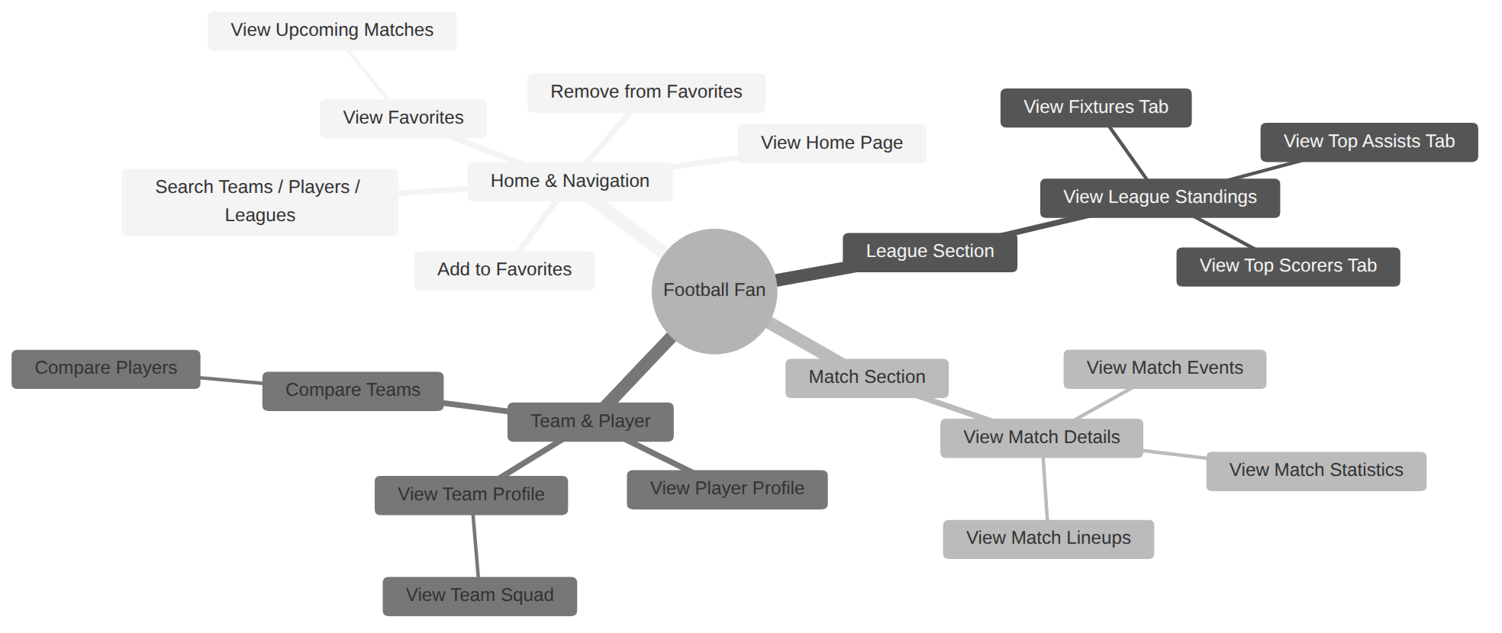
Figure 2 – Use Case Diagram

3.4 Functional Requirements

FR-01: Home Page
ID | Requirement | Priority
FR-01.1 | Display hero section with project branding and CTA buttons | Must
FR-01.2 | Show today's matches in horizontal scrollable cards | Must
FR-01.3 | Show available leagues as clickable cards | Must
FR-01.4 | Show latest match results from various leagues | Should
FR-01.5 | Show top 5 season scorers | Should

FR-02: League Page
ID | Requirement | Priority
FR-02.1 | Display league info (logo, name, country, season) | Must
FR-02.2 | Show standings table: Position, Team, MP, W, D, L, GF, GA, GD, PTS, Form | Must
FR-02.3 | Highlight Champions League qualification zone (top 4) | Must
FR-02.4 | Highlight relegation zone (bottom 3) | Must
FR-02.5 | Show fixtures list with round/status filtering | Must
FR-02.6 | Show top 20 scorers with goals count | Must
FR-02.7 | Show top 20 assist providers | Must

FR-03: Match Details Page
ID | Requirement | Priority
FR-03.1 | Display match score header with team logos and status | Must
FR-03.2 | Show match events timeline (goals, cards, substitutions) | Must
FR-03.3 | Show match statistics as comparison bars | Must
FR-03.4 | Show team lineups and formations | Should
FR-03.5 | Show head-to-head history (last 5 meetings) | Should

FR-04: Team Profile Page
ID | Requirement | Priority
FR-04.1 | Display team info (logo, name, stadium, coach, founded year) | Must
FR-04.2 | Show form guide (last 5 results as W/D/L coloured badges) | Must
FR-04.3 | Show season stats (matches, goals for/against, clean sheets) | Must
FR-04.4 | Show squad list grouped by position | Must
FR-04.5 | Show recent match results | Should

FR-05: Player Profile Page
ID | Requirement | Priority
FR-05.1 | Display player info (photo, name, age, nationality, position) | Must
FR-05.2 | Show current season statistics (goals, assists, appearances, rating) | Must
FR-05.3 | Show radar chart for multi-attribute comparison | Should
FR-05.4 | Display club name with clickable link to Team Profile | Should

FR-06: Compare Page
ID | Requirement | Priority
FR-06.1 | Allow mode toggle between "Teams" and "Players" | Must
FR-06.2 | Searchable dropdowns to select two entities | Must
FR-06.3 | Side-by-side comparison with visual percentage bars | Must
FR-06.4 | Comparison summary with key insights (winner per stat) | Should

FR-07: Favorites Page
ID | Requirement | Priority
FR-07.1 | Display all favorited teams and leagues in sections | Must
FR-07.2 | Show upcoming matches for favorited teams | Should
FR-07.3 | Allow removing favorites directly from the page | Must

FR-08: Search Page
ID | Requirement | Priority
FR-08.1 | Search input with 300 ms debounce | Must
FR-08.2 | Results grouped by category (Teams, Players, Leagues) | Must
FR-08.3 | Show trending/popular searches when query is empty | Should
FR-08.4 | Filter results by category (All, Teams, Players, Leagues) | Should

3.5 Non-Functional Requirements
Category | ID | Requirement | Target
Performance | NFR-01 | Page initial load time | < 3 sec on 4G
Performance | NFR-02 | Subsequent page navigation | < 1 sec (cached)
Performance | NFR-03 | API response caching TTL | 15 minutes in localStorage
Usability | NFR-04 | Mobile responsive design | 375 px – 1920 px
Usability | NFR-05 | Touch-friendly targets | Min 44 px × 44 px
Usability | NFR-06 | Consistent UI across all pages | Shared Design System
Reliability | NFR-07 | Graceful error handling | User-friendly messages, no blank screens
Reliability | NFR-08 | Fallback for missing API data | Conditional rendering
Security | NFR-09 | API keys not exposed | Environment variables (VITE_*)
Security | NFR-10 | No sensitive user data stored | Only favorites in localStorage
Compatibility | NFR-11 | Cross-browser support | Chrome, Firefox, Safari, Edge
Compatibility | NFR-12 | Cross-device support | Desktop, Tablet, Mobile
Maintainability | NFR-13 | Modular component architecture | Each page/component in its own folder
Scalability | NFR-14 | Easy to add new leagues | League config in constants.js

4. System Analysis & Design

4.1 Problem Statement
Football fans in Egypt face fragmented access to football statistics. Existing platforms like FotMob and SofaScore are either ad-heavy, require premium subscriptions for full features, or do not prioritise the Egyptian Premier League alongside European competitions.
Football Stats solves this by providing a free, ad-free, unified platform with real-time data covering both Egyptian and European leagues, featuring a modern dark-themed mobile-first design with zero login friction.

4.2 Class Diagram
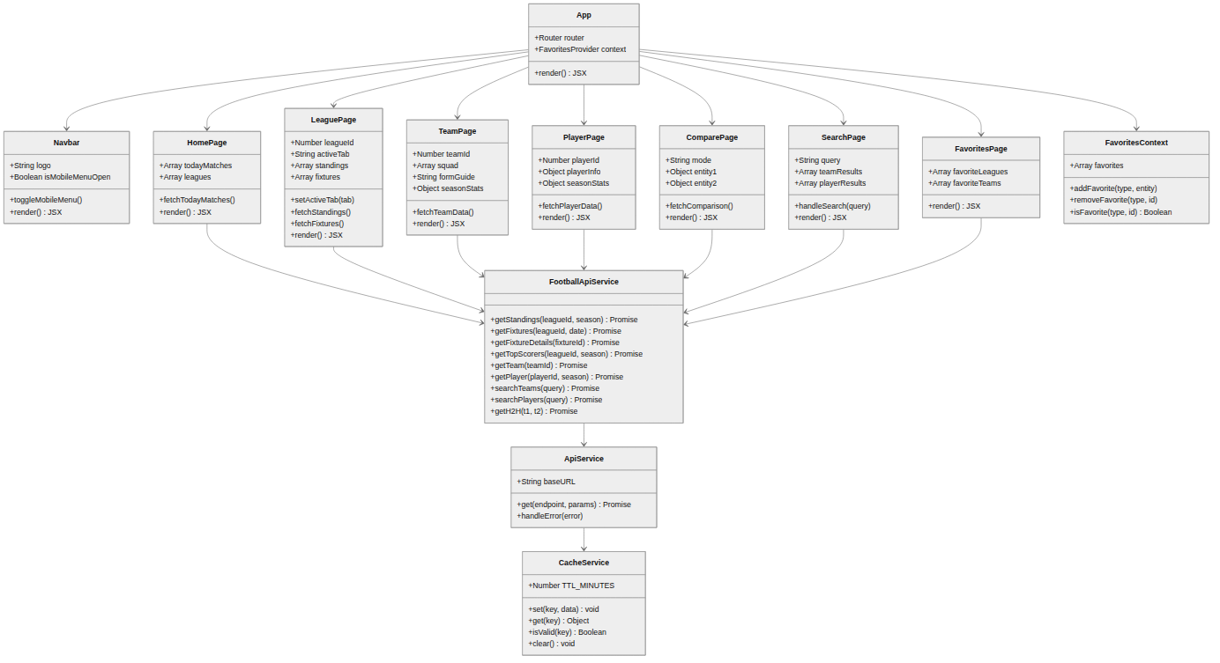
Figure 3 – Class Diagram

4.3 Data Flow Diagram – Level 0 (Context Diagram)
The context diagram shows the four key actors: the Football Fan, the Web Application, the API-Football external service, and the browser localStorage.
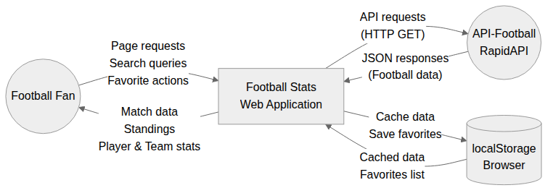
Figure 4 – DFD Level 0 (Context Diagram)

4.4 Data Flow Diagram – Level 1 (Detailed)
The Level 1 DFD decomposes the application into eight processes. The Cache Manager (8.0) acts as the central mediator between the API and all page processors, reading and writing to localStorage.
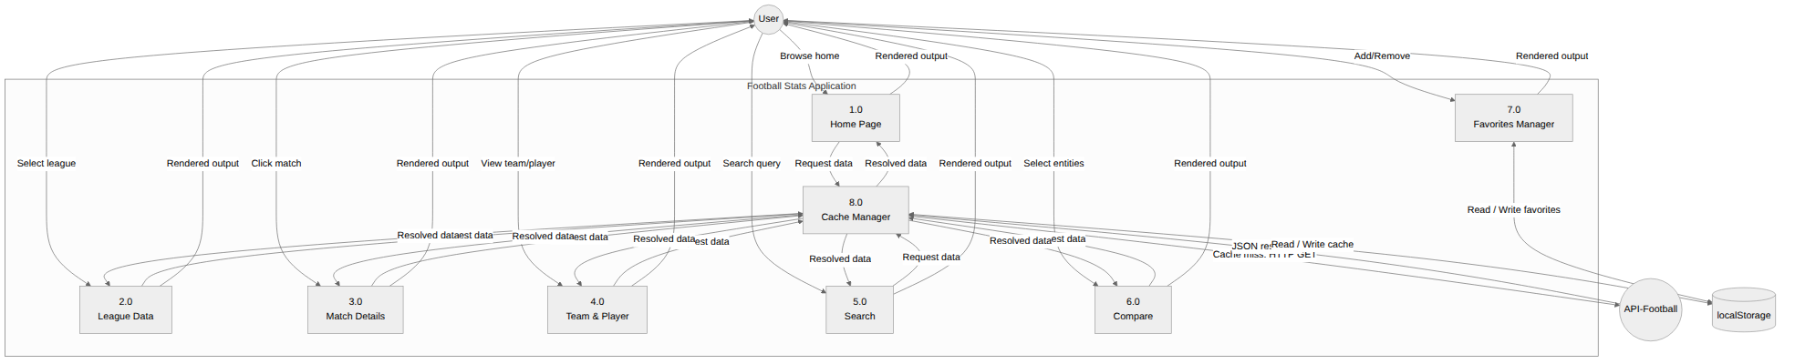
Figure 5 – DFD Level 1 (Detailed)

4.5 Sequence Diagrams

Sequence Diagram 1 – View League Standings
The League Page uses a cache-first strategy: it checks localStorage before calling API-Football. On a cache miss, it fetches, parses, and stores the response with a timestamp.
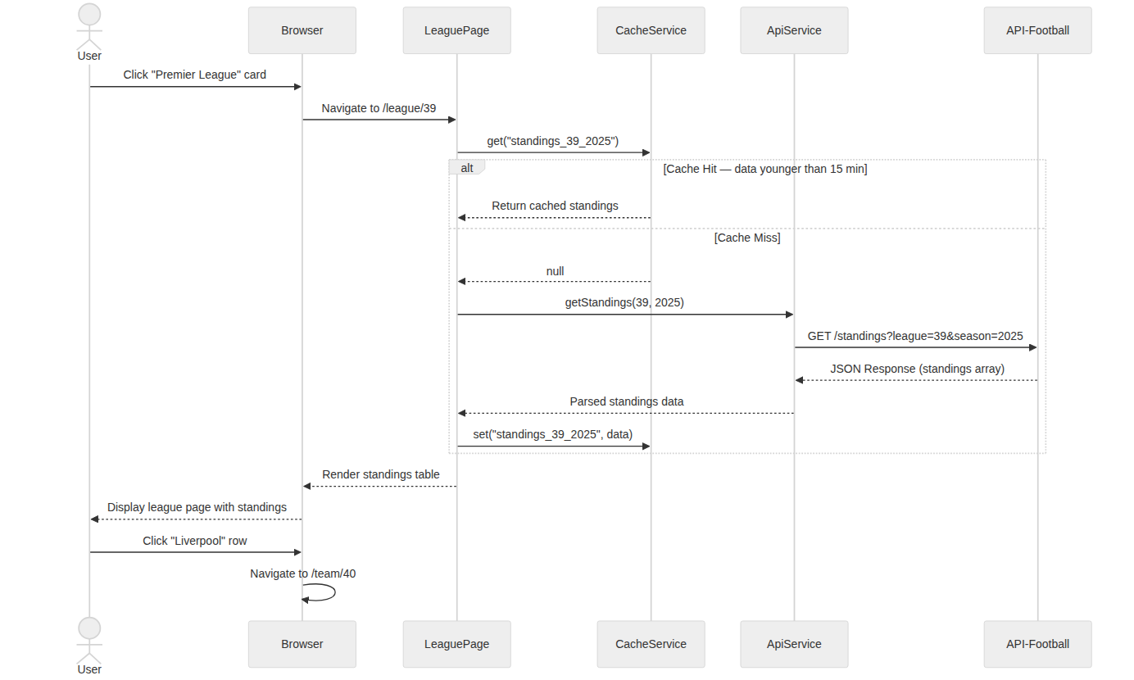
Figure 6 – Sequence: View League Standings

Sequence Diagram 2 – Search for a Player
The useDebounce hook batches rapid keystrokes and waits 300 ms of silence before firing parallel API calls for players and teams. Results are merged and displayed together.
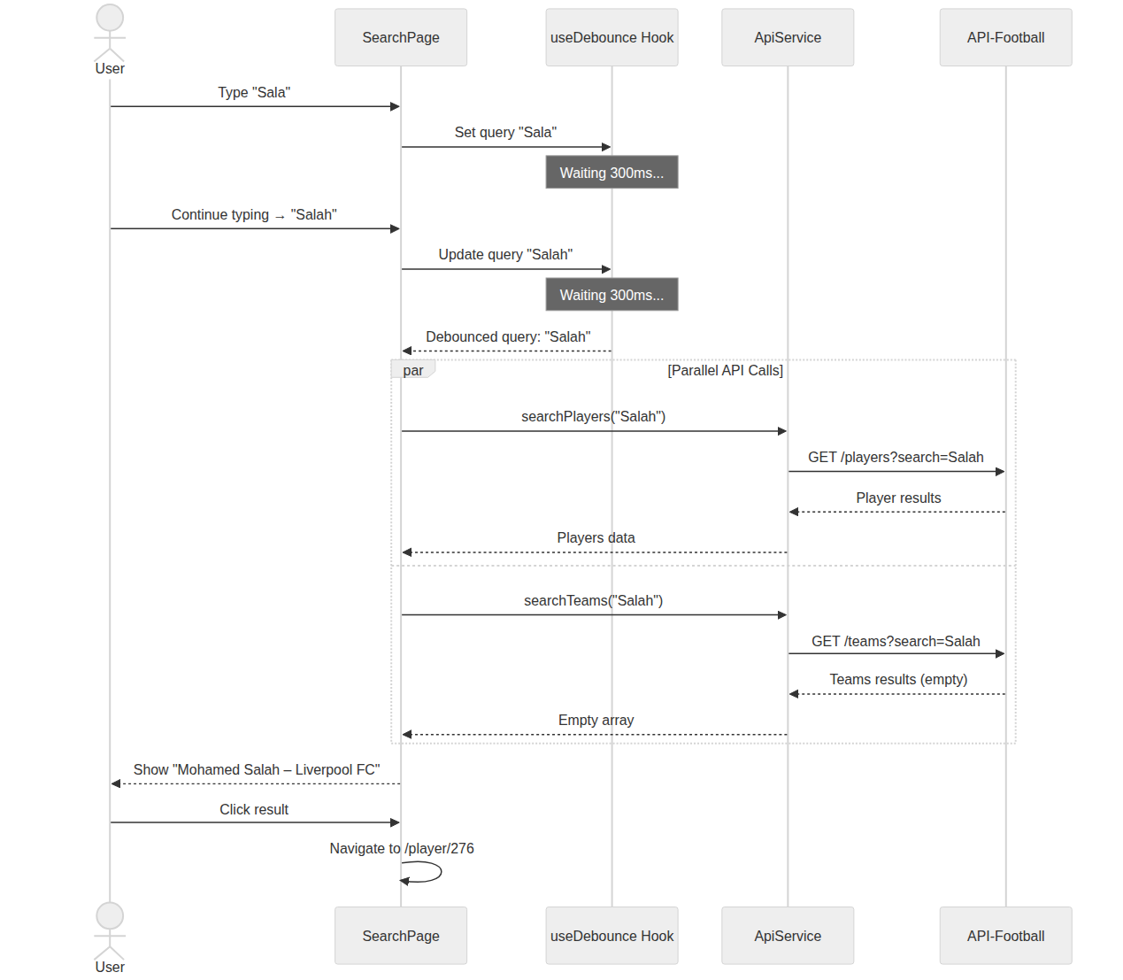
Figure 7 – Sequence: Search for a Player

Sequence Diagram 3 – Add Team to Favorites
Clicking the heart icon triggers FavoritesContext.addFavorite(), which updates in-memory state and persists the full favorites array to localStorage. On revisiting the Favorites page, the list is rehydrated from storage.
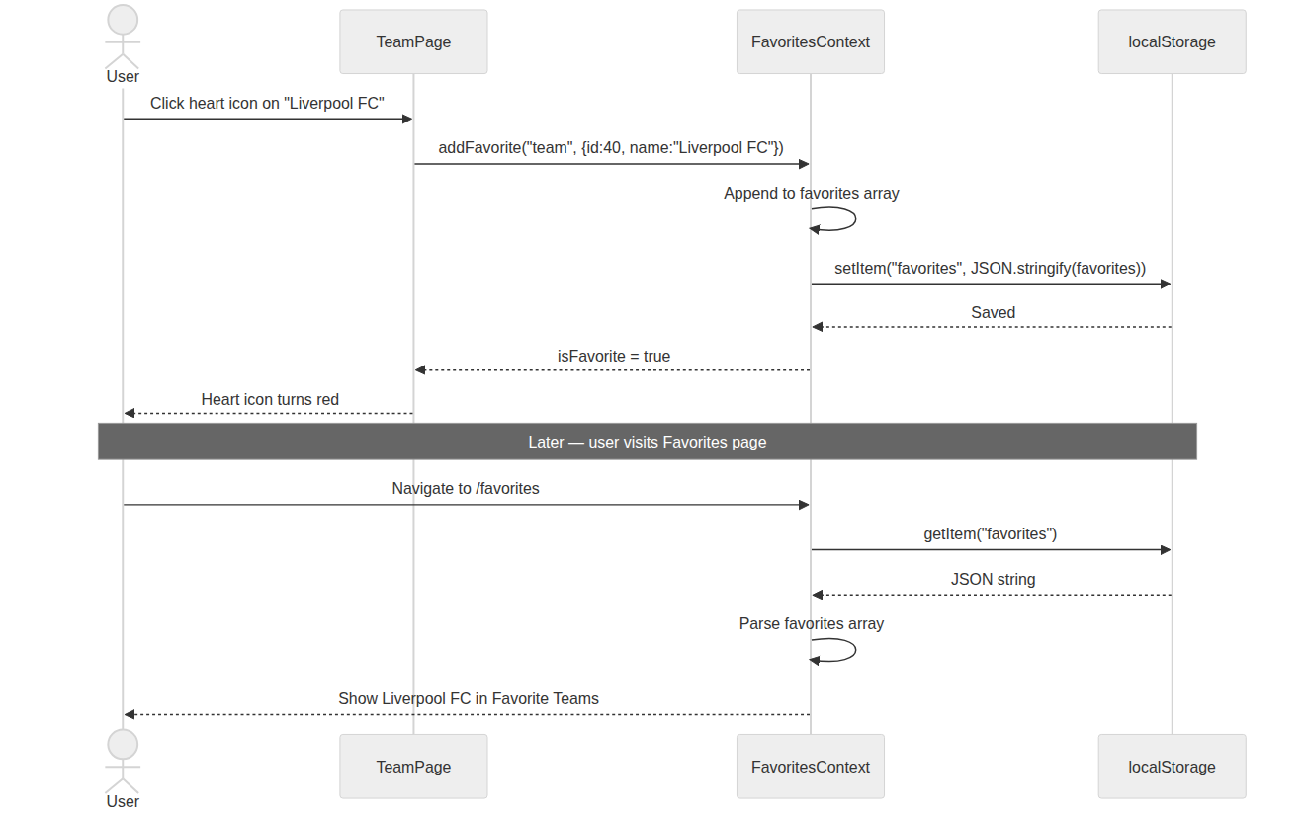
Figure 8 – Sequence: Add Team to Favorites

Sequence Diagram 4 – View Match Details
Two parallel cache checks run for fixture data and H2H history. Both paths include cache-hit and cache-miss branches. The user can then switch between Events, Statistics, and Lineups tabs without additional API calls.
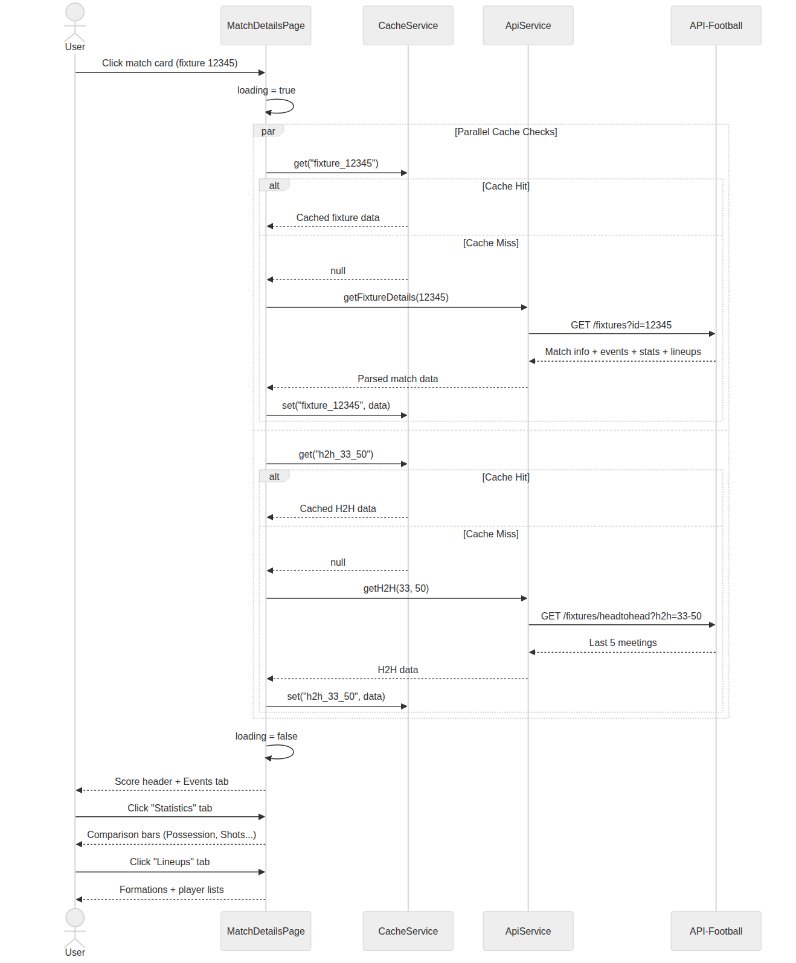
Figure 9 – Sequence: View Match Details

4.6 Activity Diagrams

Activity Diagram 1 – User Navigation Flow
Shows all navigation paths from the Home Page across all 8 pages, including cross-links between Team and Player Profile pages, and the Favorites shortcut paths.
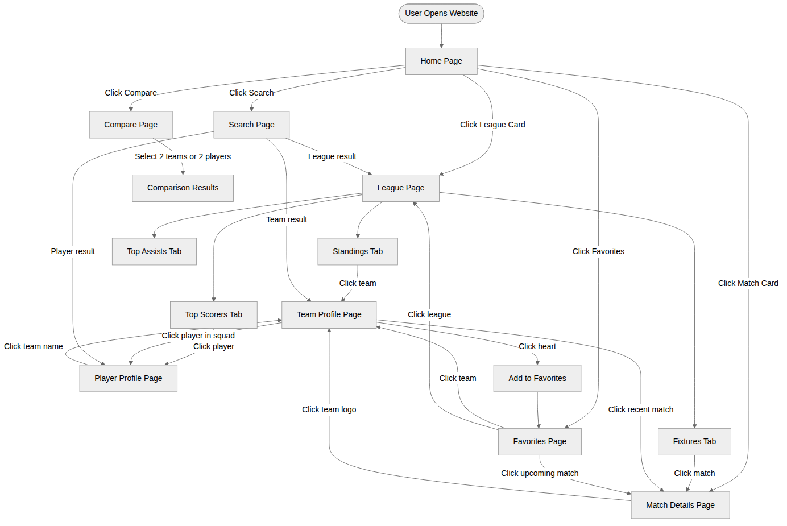
Figure 10 – Activity: User Navigation Flow

Activity Diagram 2 – API Caching Logic
Decision tree executed on every data request. Valid cache returns immediately; expired cache triggers an API call; on rate-limiting or error, the system falls back to stale cache data and displays a warning banner, or shows an error UI if no cache exists.
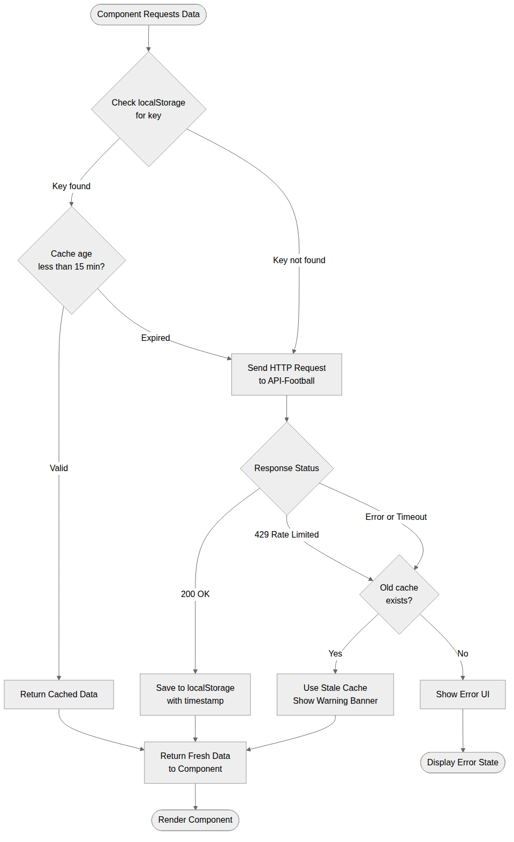
Figure 11 – Activity: API Caching Logic

4.7 State Diagrams

State Diagram 1 – Match Card Lifecycle
Covers the complete lifecycle: Scheduled → Live (with internal First Half / Half-Time / Second Half states) → Extra Time → Penalties → Full Time, plus the Postponed detour.
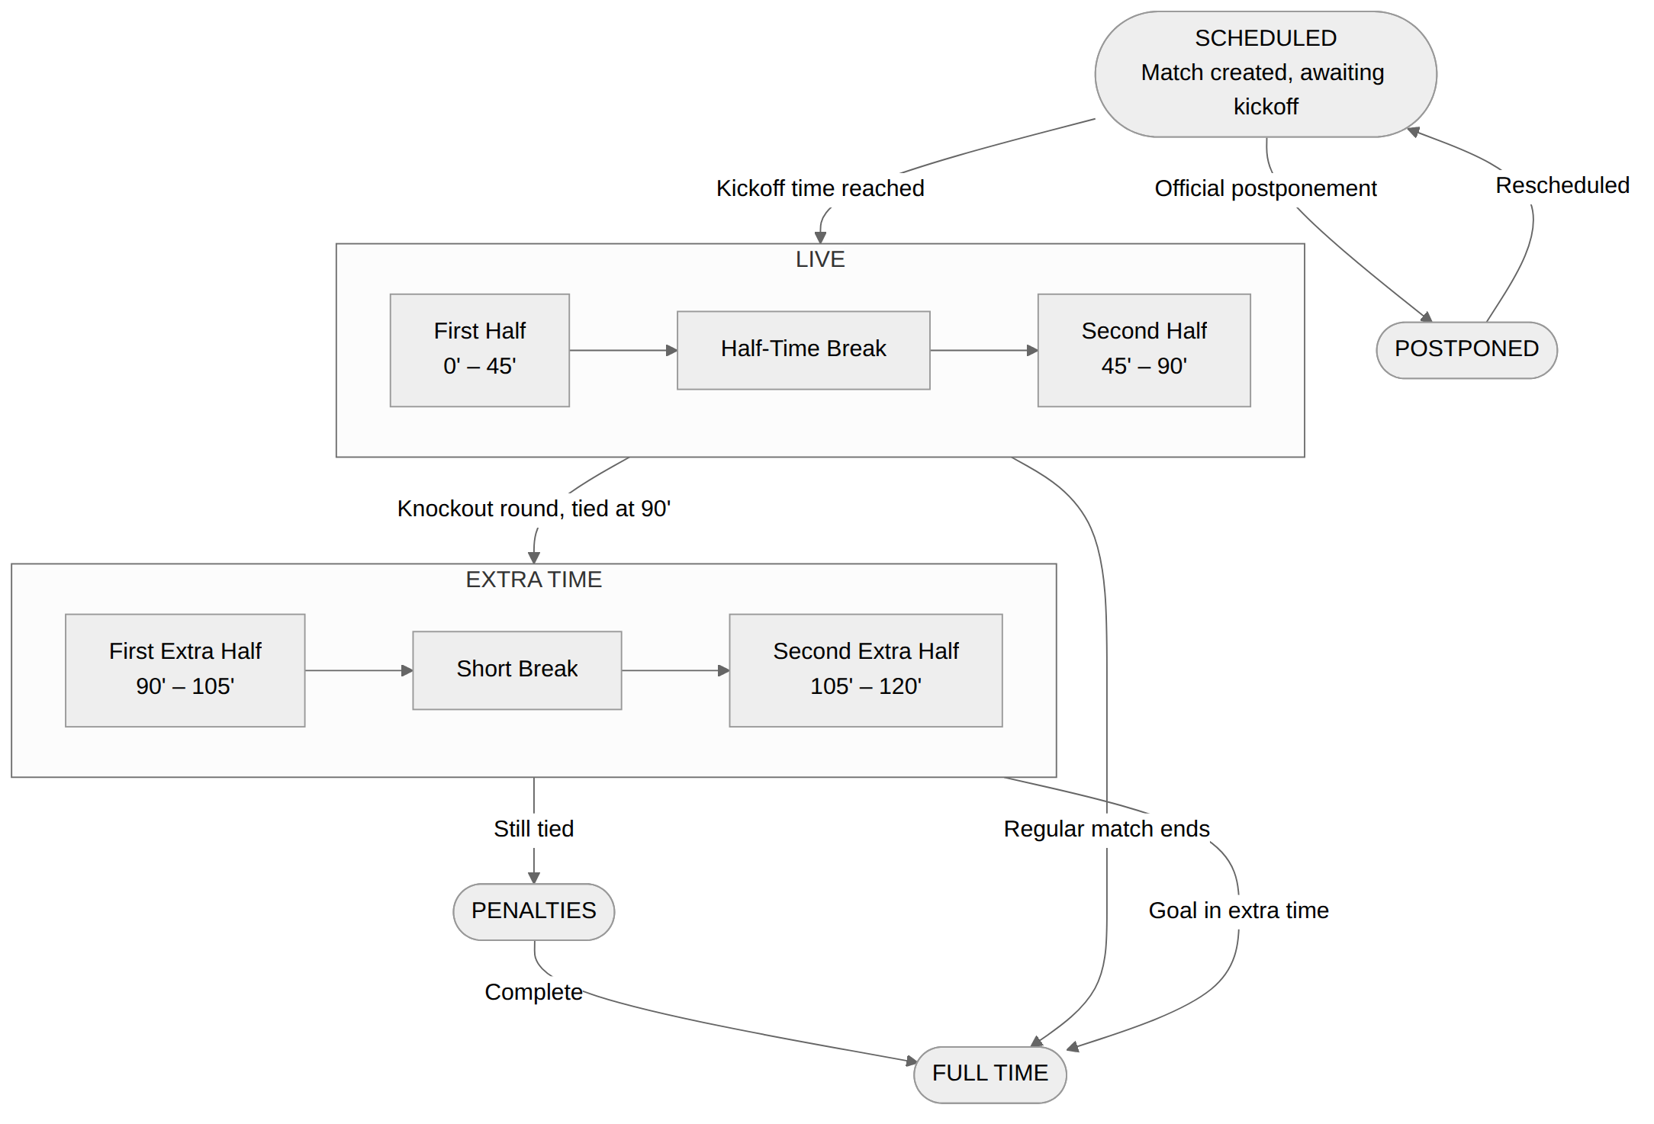
Figure 12 – State: Match Card Lifecycle

State Diagram 2 – Favorites Toggle
A two-state toggle with intermediate Saving and Removing transition states that confirm localStorage persistence before the heart icon changes colour.
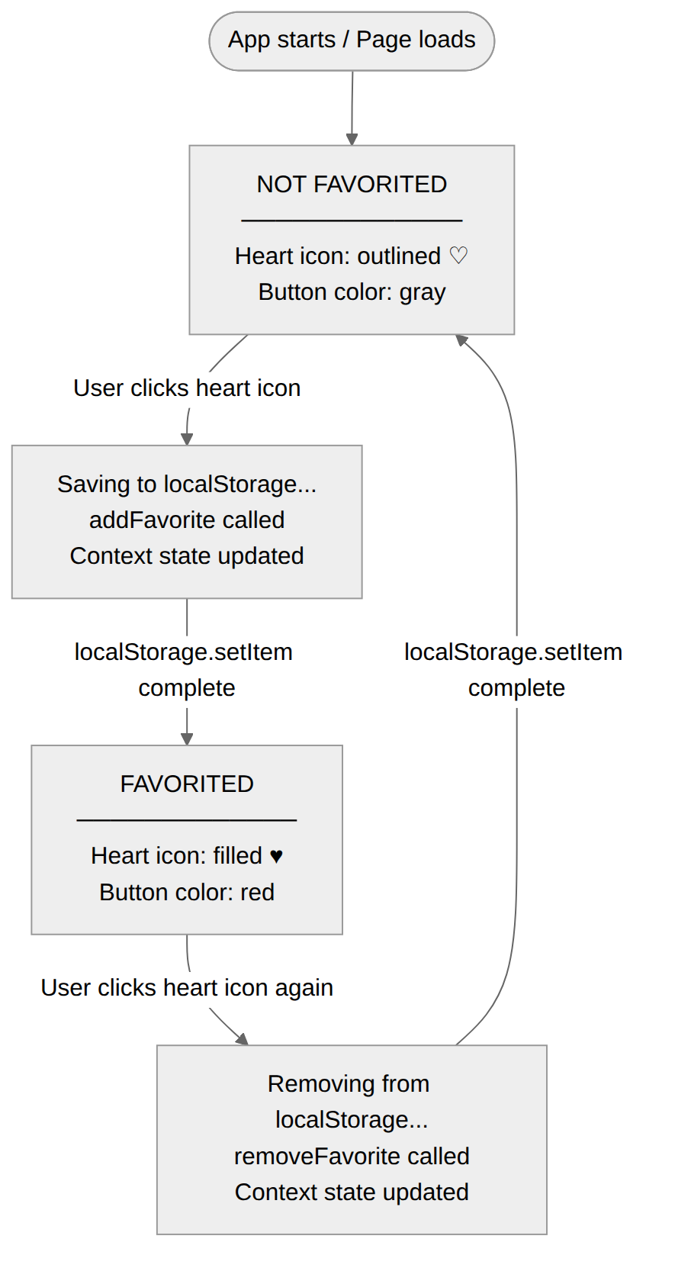
Figure 13 – State: Favorites Toggle

4.8 Component Diagram – Software Architecture
Four internal layers inside the browser (Presentation, State Management, Service, Data) connected to external services via RapidAPI.
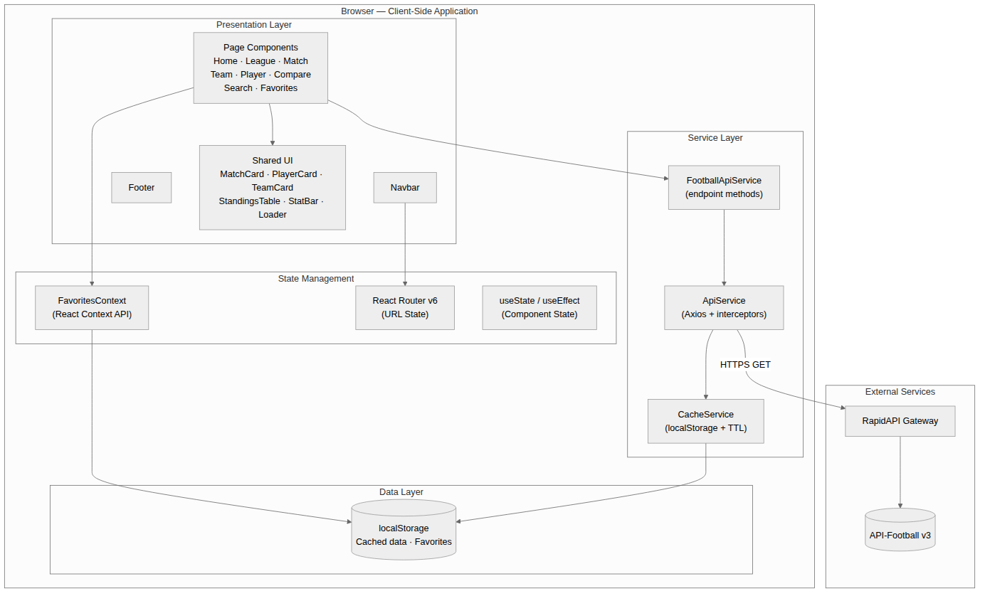
Figure 14 – Component Diagram

4.9 Deployment Diagram
User devices reach the Vercel Edge CDN for static assets and call RapidAPI directly for live data. Source code on GitHub triggers automated builds on every push to main.
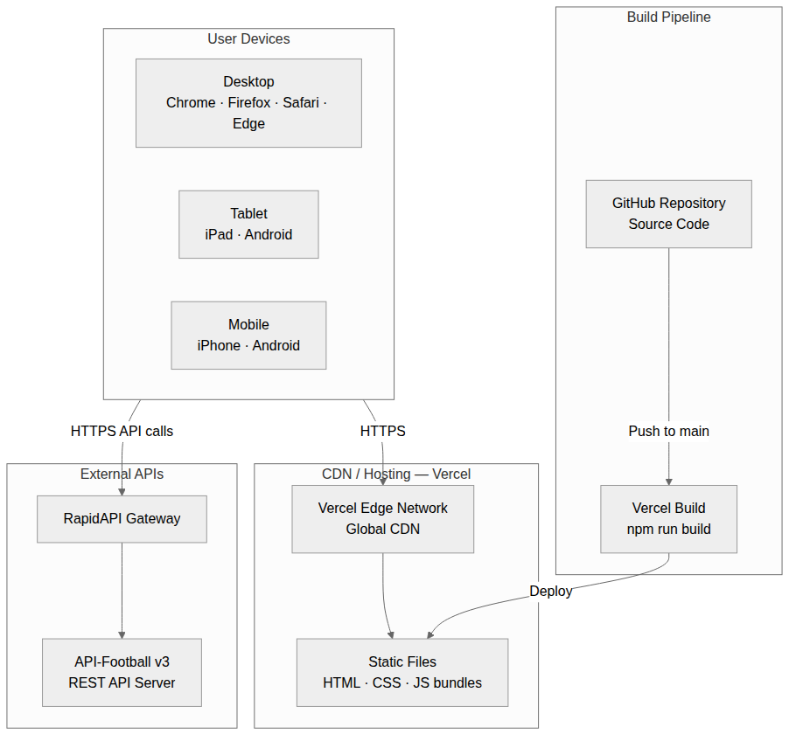
Figure 15 – Deployment Diagram

4.10 Technology Stack
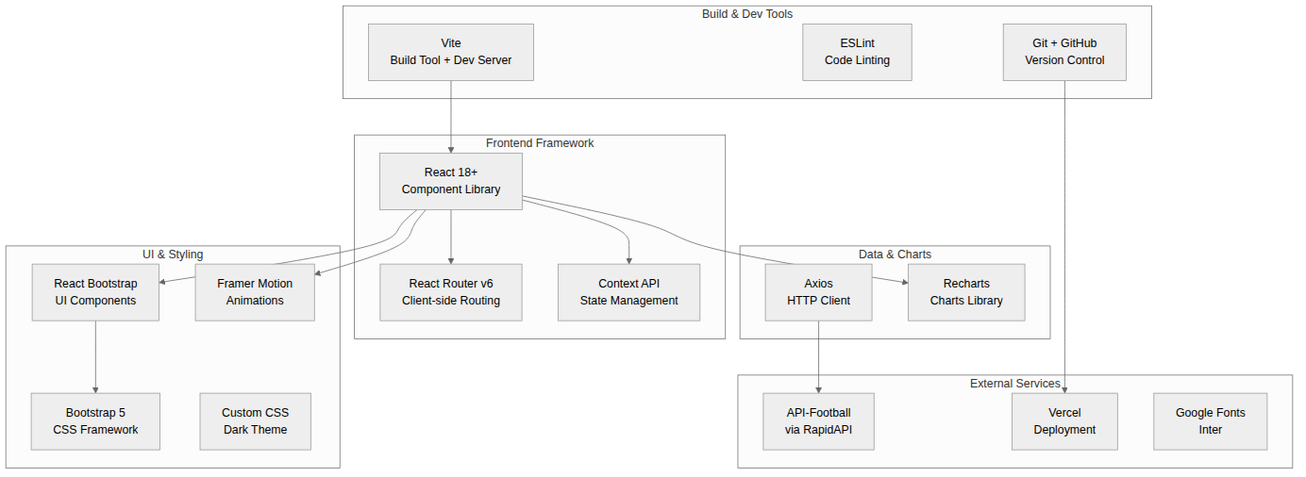
Figure 16 – Technology Stack

4.11 Data Models

Entity-Relationship Diagram – API Data (API-Football v3)
Entities consumed from API-Football: League, Fixture, Team, Player, PlayerStats, TopScorer, Event, Statistic, Lineup with full cardinality notation.
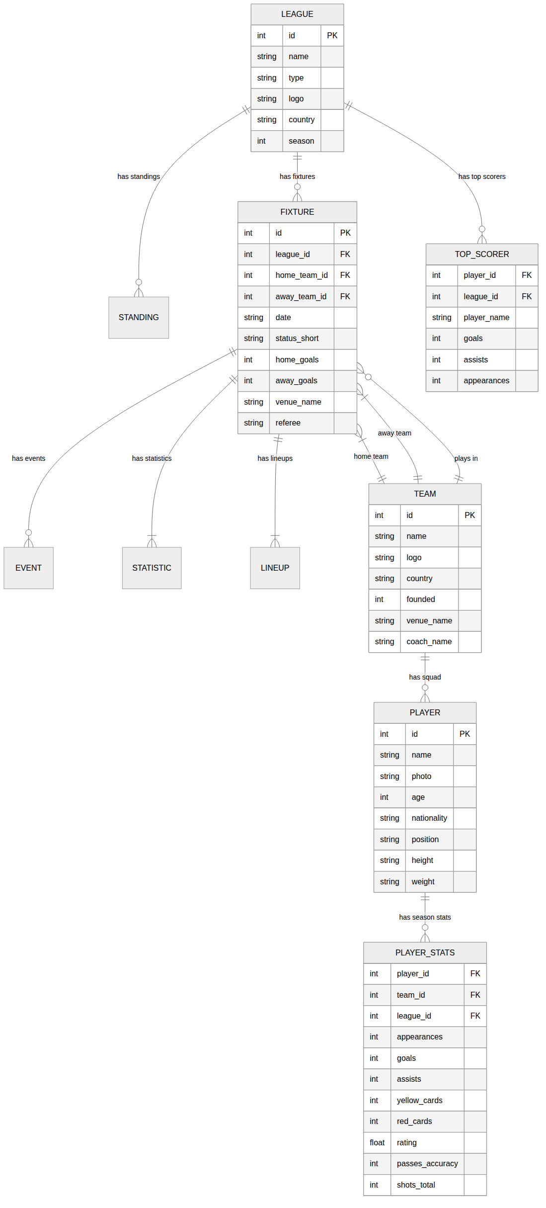
Figure 17 – ER Diagram: API Data

Entity-Relationship Diagram – localStorage Schema
Client-side persistence model: LOCAL_STORAGE contains FAVORITE_ITEM records (team or league) and CACHE_ENTRY records (API responses with TTL timestamps).
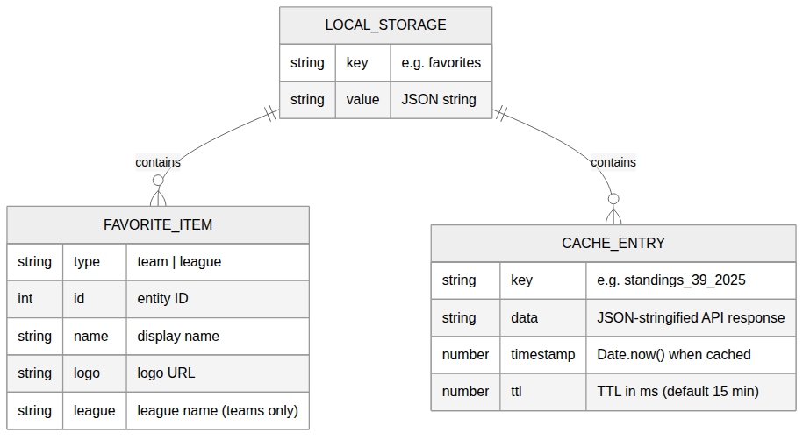
Figure 18 – ER Diagram: localStorage Schema

localStorage Key Naming Convention
favorites → Array of favorite items
cache_standings_39_2025 → Standings for league 39, season 2025
cache_fixtures_39_2026-05-14 → Fixtures for league 39 on specific date
cache_fixture_12345 → Match details for fixture 12345
cache_team_40 → Team info for team ID 40
cache_player_276_2025 → Player stats for player 276, season 2025
cache_search_salah → Search results for "salah"
cache_h2h_33_50 → H2H history for teams 33 vs 50

4.12 API Integration Configuration
Configuration | Value
Base URL | https://api-football-v1.p.rapidapi.com/v3
Auth Header | x-rapidapi-key: {API_KEY}
Host Header | x-rapidapi-host: api-football-v1.p.rapidapi.com
Response Format | JSON
Rate Limit | 100 requests / day (Free Plan)
Cache Strategy | localStorage with 15-minute TTL
Error Handling | Retry once, then show cached data or error banner

Environment Variables (.env)
VITE_API_FOOTBALL_KEY=your_rapidapi_key_here
VITE_API_FOOTBALL_HOST=api-football-v1.p.rapidapi.com
VITE_API_BASE_URL=https://api-football-v1.p.rapidapi.com/v3
VITE_CACHE_TTL_MINUTES=15

4.13 UI/UX Design System

Design Principles
- Dark Mode First – Reduces eye strain for extended sports viewing sessions
- Data Density Balance – Show enough data without overwhelming the user
- Football-Themed Aesthetics – Stadium-inspired colours, scoreboard layouts
- Mobile-First Responsive – Designed at 375 px and scaled up
- Consistent Component Library – Reusable cards, tables, and stat bars

Colour System
Token | Value | Usage
--bg-primary | #0d1117 | Page background
--bg-card | #161b22 | Card surfaces
--border | #30363d | Card borders
--accent-green | #00e676 | Primary CTA, active states
--accent-blue | #58a6ff | Links, secondary accent
--text-primary | #e6edf3 | Main text
--text-secondary | #8b949e | Subdued text
--win | #3fb950 | Win indicator (green)
--draw | #d29922 | Draw indicator (yellow)
--loss | #f85149 | Loss indicator (red)

Typography
Element | Font | Weight | Size
Page Headings | Inter | 700 Bold | 28–36 px
Section Titles | Inter | 600 Semibold | 20–24 px
Body Text | Inter | 400 Regular | 14–16 px
Data / Stats | Inter | 500 Medium | 14 px
Small Labels | Inter | 400 Regular | 12 px

Responsive Breakpoints
Breakpoint | Width | Layout
Mobile | < 576 px | Single column, bottom nav, hamburger menu
Tablet | 576 px – 991 px | Two-column grids, collapsible elements
Desktop | ≥ 992 px | Full layout, top navbar, multi-column

Build & Deployment Pipeline
Step | Tool | Description
1. Code | VS Code + Git | Developers write code locally on feature branches
2. Push | GitHub | Code pushed to feature/* branch
3. Review | GitHub PR | Team reviews and approves pull requests
4. Merge | GitHub | Approved PRs merged to dev, then main weekly
5. Build | Vercel | Auto-triggered build on push to main
6. Deploy | Vercel CDN | Static files distributed globally via edge network
7. Live | Custom Domain | Application accessible to end users

