SehhaTech System
System Design Document
Aligned with the final implemented .NET + React project
June 2026
Document purpose
This document presents the system design of SehhaTech as implemented in the final project. It describes the platform architecture, domain entities, data flows, use cases, activity workflows and sequence interactions for the clinic management system and patient portal.

1. Introduction
SehhaTech is a multi-tenant healthcare management platform delivered as two connected web systems. The first system is the clinic management system used by Super Admin, Clinic Admin, Doctor and Reception roles. The second system is the Patient Portal used by public visitors and patients to browse clinics, authenticate securely and book appointments online.
The implementation follows a layered .NET architecture: SehhaTech.Core contains domain models, DTOs and interfaces; SehhaTech.Infrastructure contains EF Core DbContext, migrations, background jobs and external integrations; SehhaTech.API exposes staff and clinic-management endpoints; SehhaTech.PatientPortal.API exposes patient-facing endpoints. Both APIs use SQL Server through EF Core and share the same domain database.
Area | Final implementation
Frontend apps | Two React + Vite applications: clinic/staff frontend and patient portal frontend.
Backend APIs | Two API boundaries: SehhaTech.API and SehhaTech.PatientPortal.API.
Architecture | Clean layered structure: API, Core, Infrastructure.
Database | SQL Server with Entity Framework Core Code-First migrations.
Staff authentication | JWT authentication with role-based authorization and TenantMiddleware.
Patient authentication | OTP verification, access tokens, refresh tokens and blocked-account handling.
Tenant isolation | TenantId is resolved from JWT and injected into HttpContext for every tenant-scoped request.
External integrations | Paymob for subscription/payment flow, Cloudinary for uploads, SMS service for OTP, Hangfire for jobs.

2. System Scope and Implementation Overview
The implemented platform is composed of staff-facing clinic management features and public patient-facing portal features. The design separates staff authentication from portal authentication while keeping all clinic-owned data isolated through TenantId.
Module | Implemented design
Staff roles | SuperAdmin, ClinicAdmin, Doctor and Reception access the clinic management frontend through JWT authentication and role-based authorization.
Doctor profile | Doctor is a clinical profile linked to a staff User by UserId and connected to appointments, schedules and slot templates.
Reception operations | Reception manages patients, appointments, check-in queue, appointment status and payment invoices.
Patient portal | PortalUser, OTPRecord and PortalRefreshToken support patient registration, login, phone verification and secure sessions.
Online booking | PatientBooking links portal booking requests to clinic Patient and Appointment records using an idempotent booking flow.
Subscriptions and reports | Subscription and PaymentInvoice support Paymob payment flows, while MonthlyReport and Hangfire support reporting jobs.

3. Class Diagram
The class diagram represents SehhaTech as two connected systems sharing the same backend domain. Tenant is the central clinic boundary. Staff users are represented by User, while Doctor is a profile linked to a User through UserId. Reception is not a separate inherited class; it is a User role. Patient is the clinic medical record entity, while PortalUser is the online user account used by the patient portal. Appointments connect Tenant, Patient and Doctor, and can be created from staff screens or from online portal bookings.
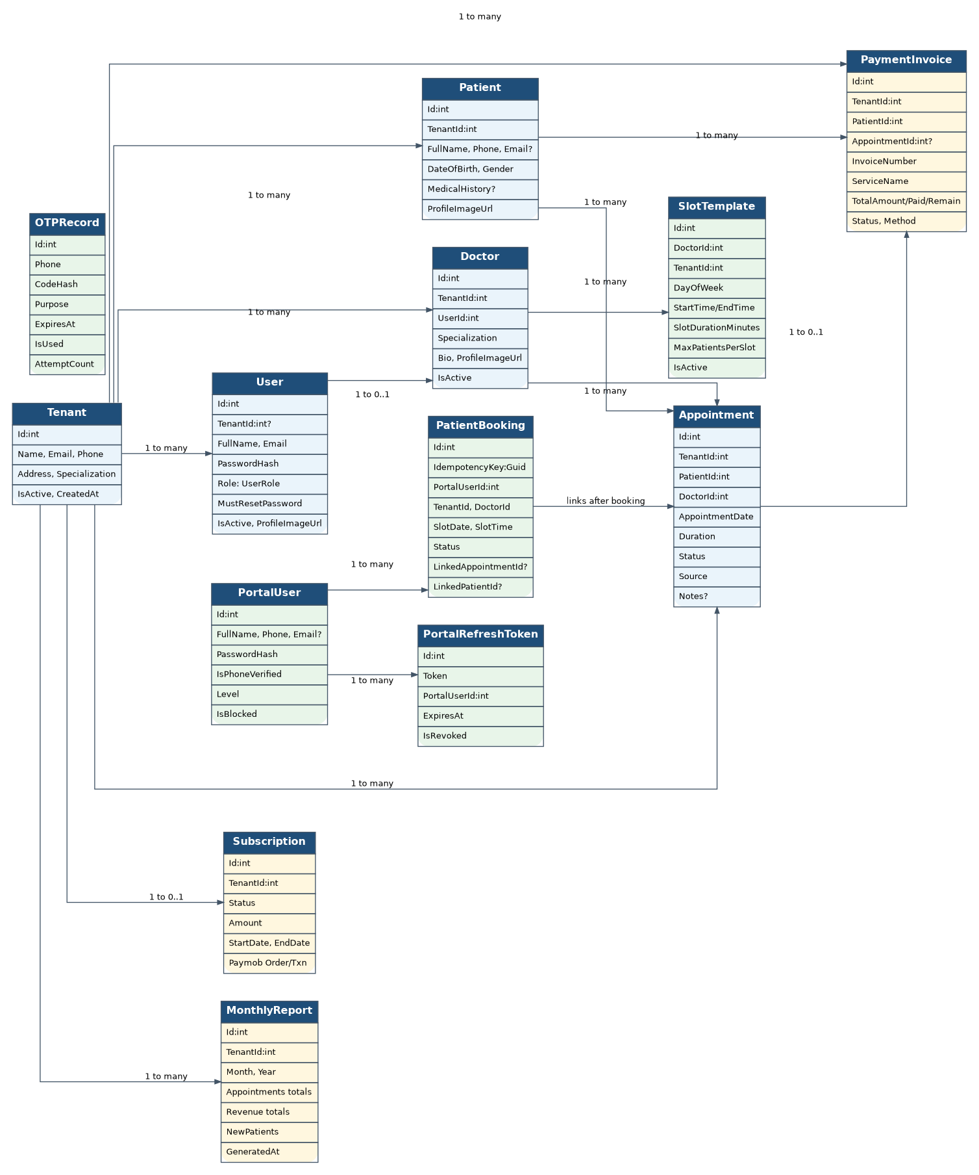
Figure 1 - Class Diagram

4. Entity-Relationship Diagram (ERD)
The ERD shows the final SQL Server schema created through EF Core. Every clinic-owned table carries TenantId to enforce tenant isolation. Roles are stored as enum values in Users, not as a separate Roles table. PatientBooking, PortalUser, OTPRecord and PortalRefreshToken represent the patient portal extension. PaymentInvoice and MonthlyReport represent the reception payment flow and the reporting module.
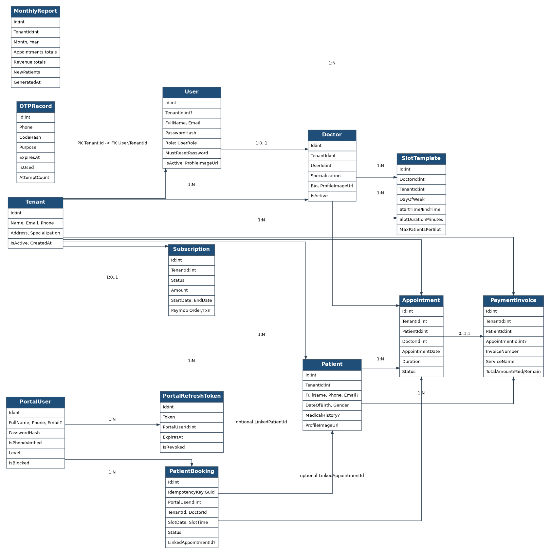
Figure 2 - Entity-Relationship Diagram

5. DFD Level 0 - Context Diagram
The Level 0 DFD shows SehhaTech as a platform boundary containing the two React frontends, the .NET APIs, SQL Server, background jobs and external integrations. Users interact with the system through role-specific flows, while Paymob, SMS/OTP and Cloudinary are external service providers.
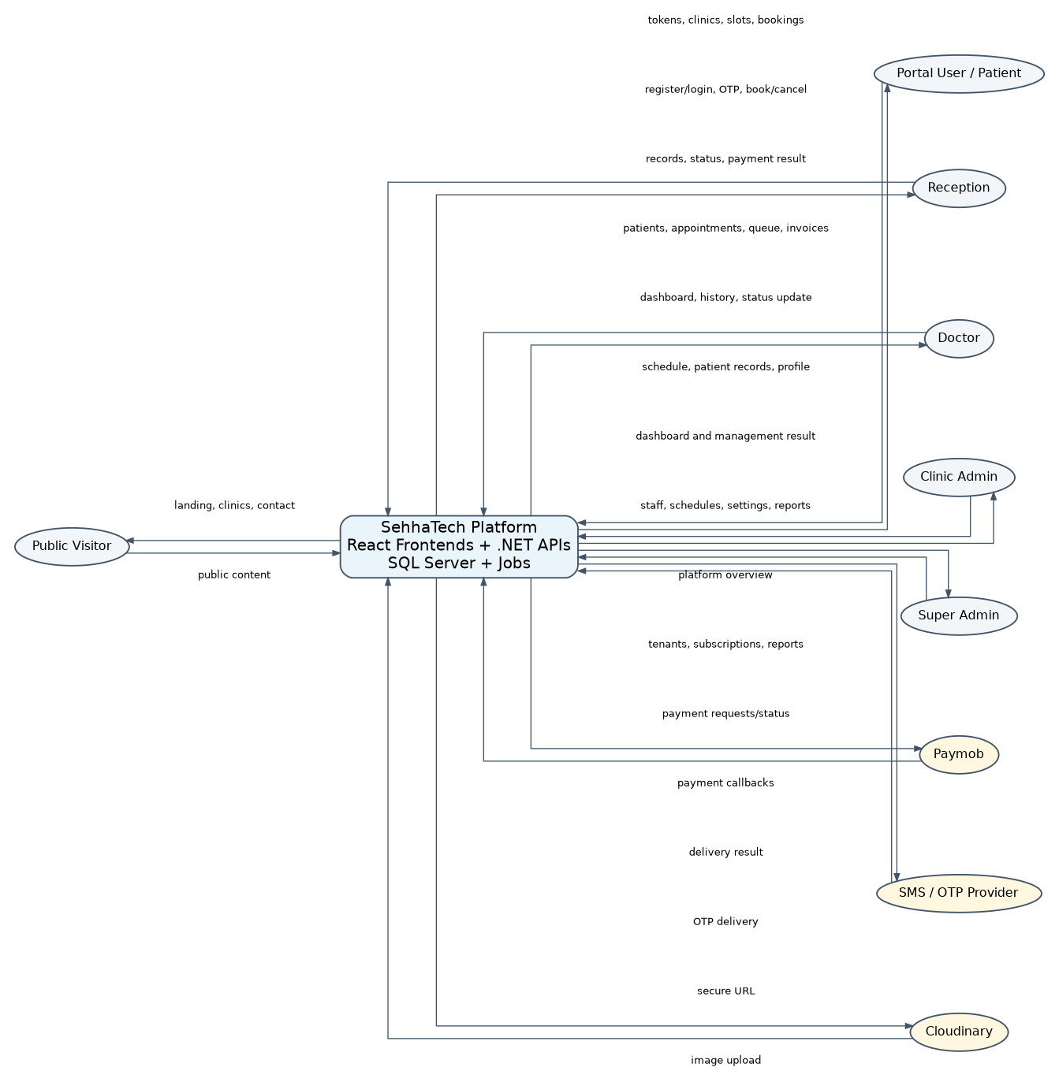
Figure 3 - DFD Level 0 Context Diagram

6. DFD Level 1 - Decomposed Processes
The Level 1 DFD decomposes the implementation into authentication, tenant validation, admin operations, reception operations, doctor operations, portal authentication, clinic search, online booking, subscription payments, reports/jobs and uploads/chatbot. The diagram also shows the main data stores used by each process.
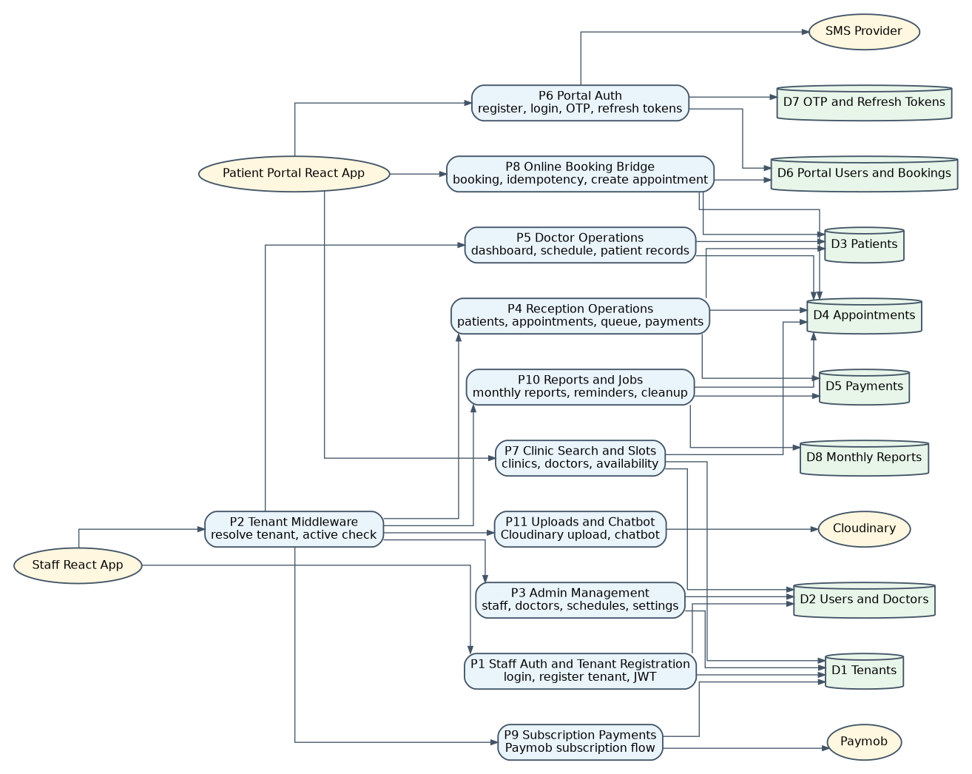
Figure 4 - DFD Level 1

7. Use Case Diagram
The use case diagram separates staff users from patient portal users. Staff use cases depend on staff JWT authentication and TenantMiddleware. Patient portal use cases depend on portal authentication, OTP verification and refresh tokens.
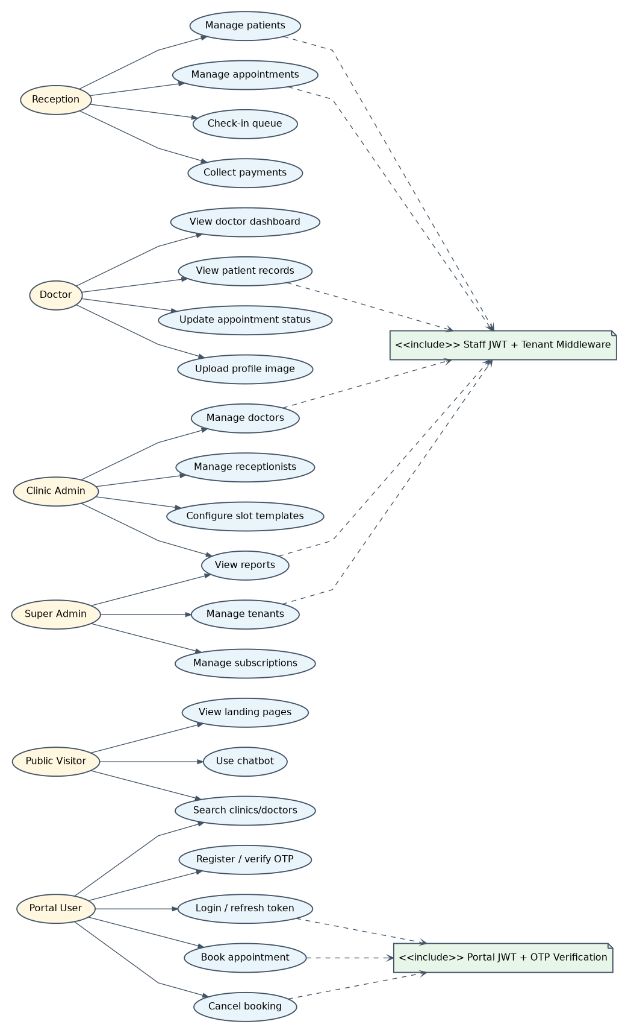
Figure 5 - Use Case Diagram

8. Activity Diagrams

8.1 Staff Login and Tenant Validation Flow
The user submits credentials from the staff frontend. AuthService validates the user and password hash, checks active status, resolves tenant requirements and returns a JWT with role, TenantId and MustResetPassword. TenantMiddleware then validates protected requests and injects TenantId into HttpContext.
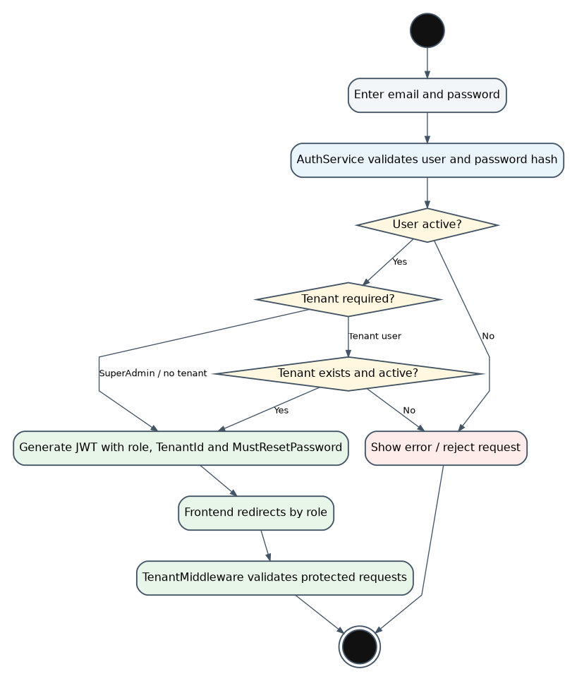
Figure 6 - Activity Diagram: Staff Login and Tenant Validation

8.2 Clinic Registration and Subscription Flow
Clinic registration creates an inactive tenant and a ClinicAdmin account. The subscription flow integrates with Paymob, receives callback data and activates the tenant after successful payment.
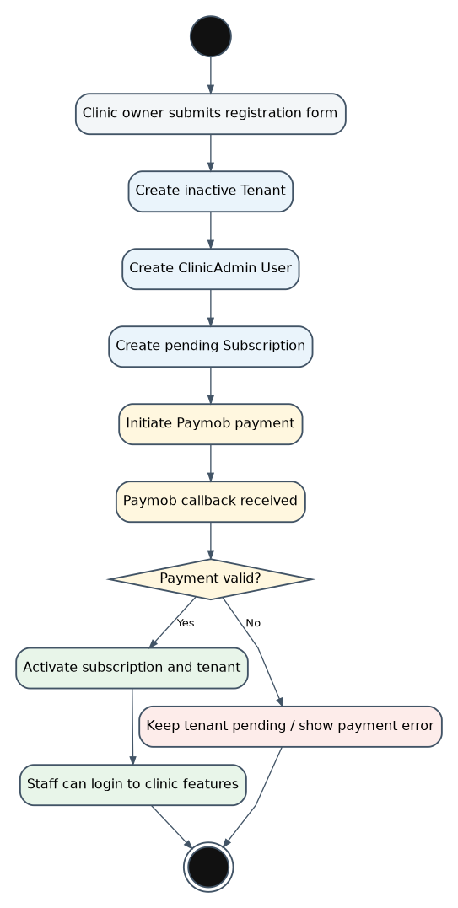
Figure 7 - Activity Diagram: Clinic Registration and Subscription

8.3 Clinic Admin Staff and Schedule Management Flow
Clinic Admin can manage doctors, receptionists, clinic settings and doctor SlotTemplates. When a doctor is added, the system creates both a User record and a Doctor profile linked by UserId.
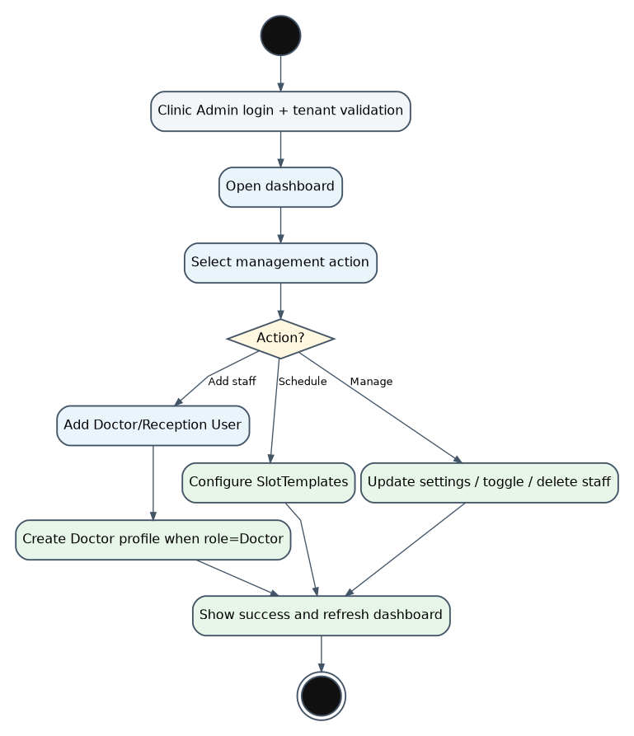
Figure 8 - Activity Diagram: Clinic Admin Staff and Schedule Management

8.4 Reception Patient, Appointment, Queue and Payment Flow
Reception manages patients, appointments, check-in queue and invoices. Appointment creation validates tenant scope, future date/time, duration, doctor availability through SlotTemplates and conflict overlap before saving. A PaymentInvoice is created for visit payment tracking.
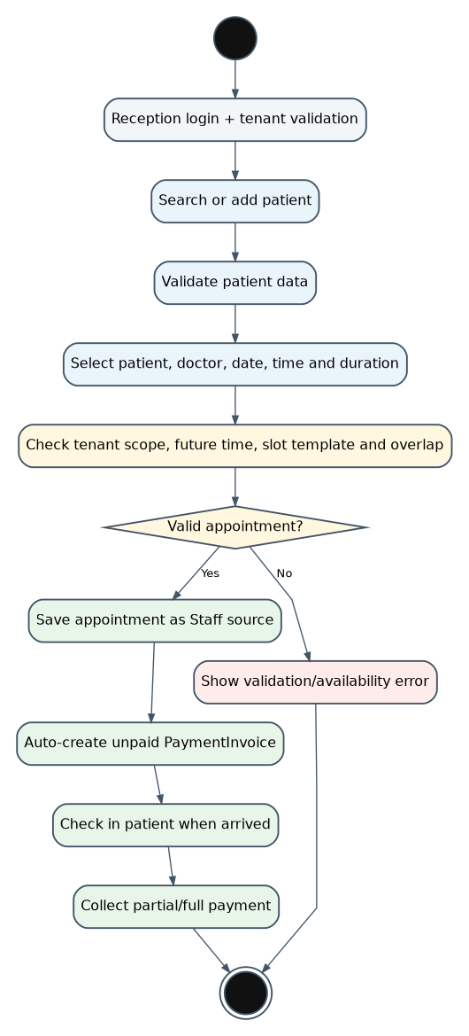
Figure 9 - Activity Diagram: Reception Operations

8.5 Doctor Workflow
Doctor views dashboard, schedule and patient records within the same tenant and doctor scope. Doctors can update appointment status to Completed or NoShow, while completed appointments are treated as locked.
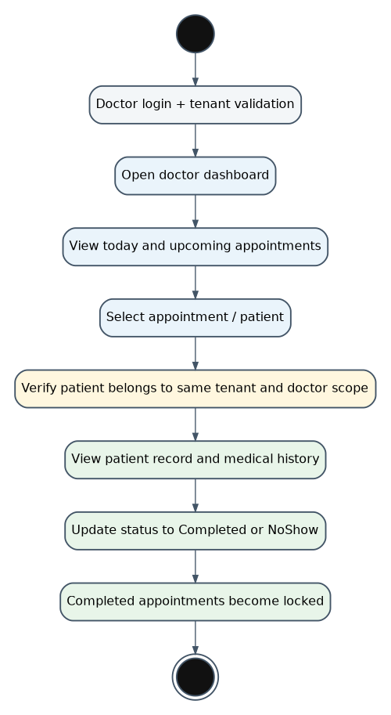
Figure 10 - Activity Diagram: Doctor Workflow

8.6 Patient Portal Registration, Login and Booking Flow
Patient portal users register or log in, verify OTP, search clinics and doctors, request available slots and submit bookings using an IdempotencyKey. BookingService protects the booking process with duplicate and slot-conflict checks and then creates/links Patient and Appointment records.
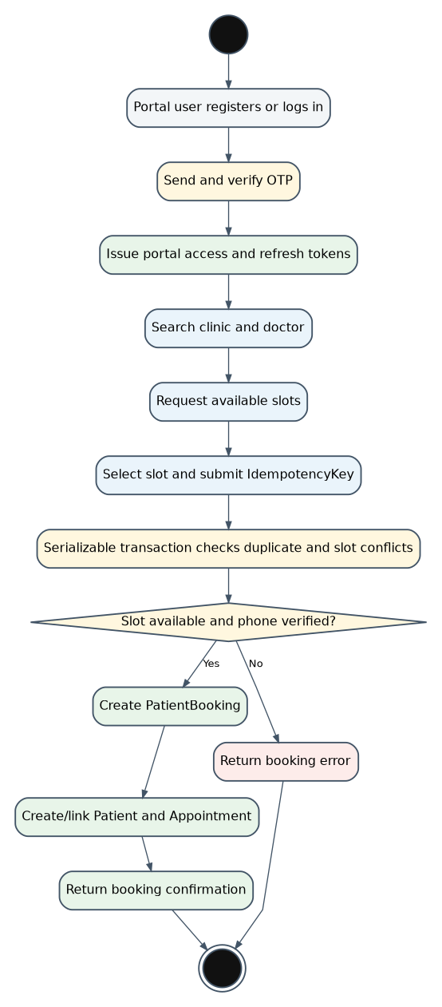
Figure 11 - Activity Diagram: Patient Portal Booking

9. Sequence Diagrams

9.1 Staff Login and Protected Request Sequence
This sequence shows the runtime path for staff authentication and protected tenant-scoped requests. The staff frontend posts credentials to AuthController, AuthService validates users and tenants through SQL Server, JwtService generates the token, and TenantMiddleware resolves TenantId before controllers query tenant-scoped data.
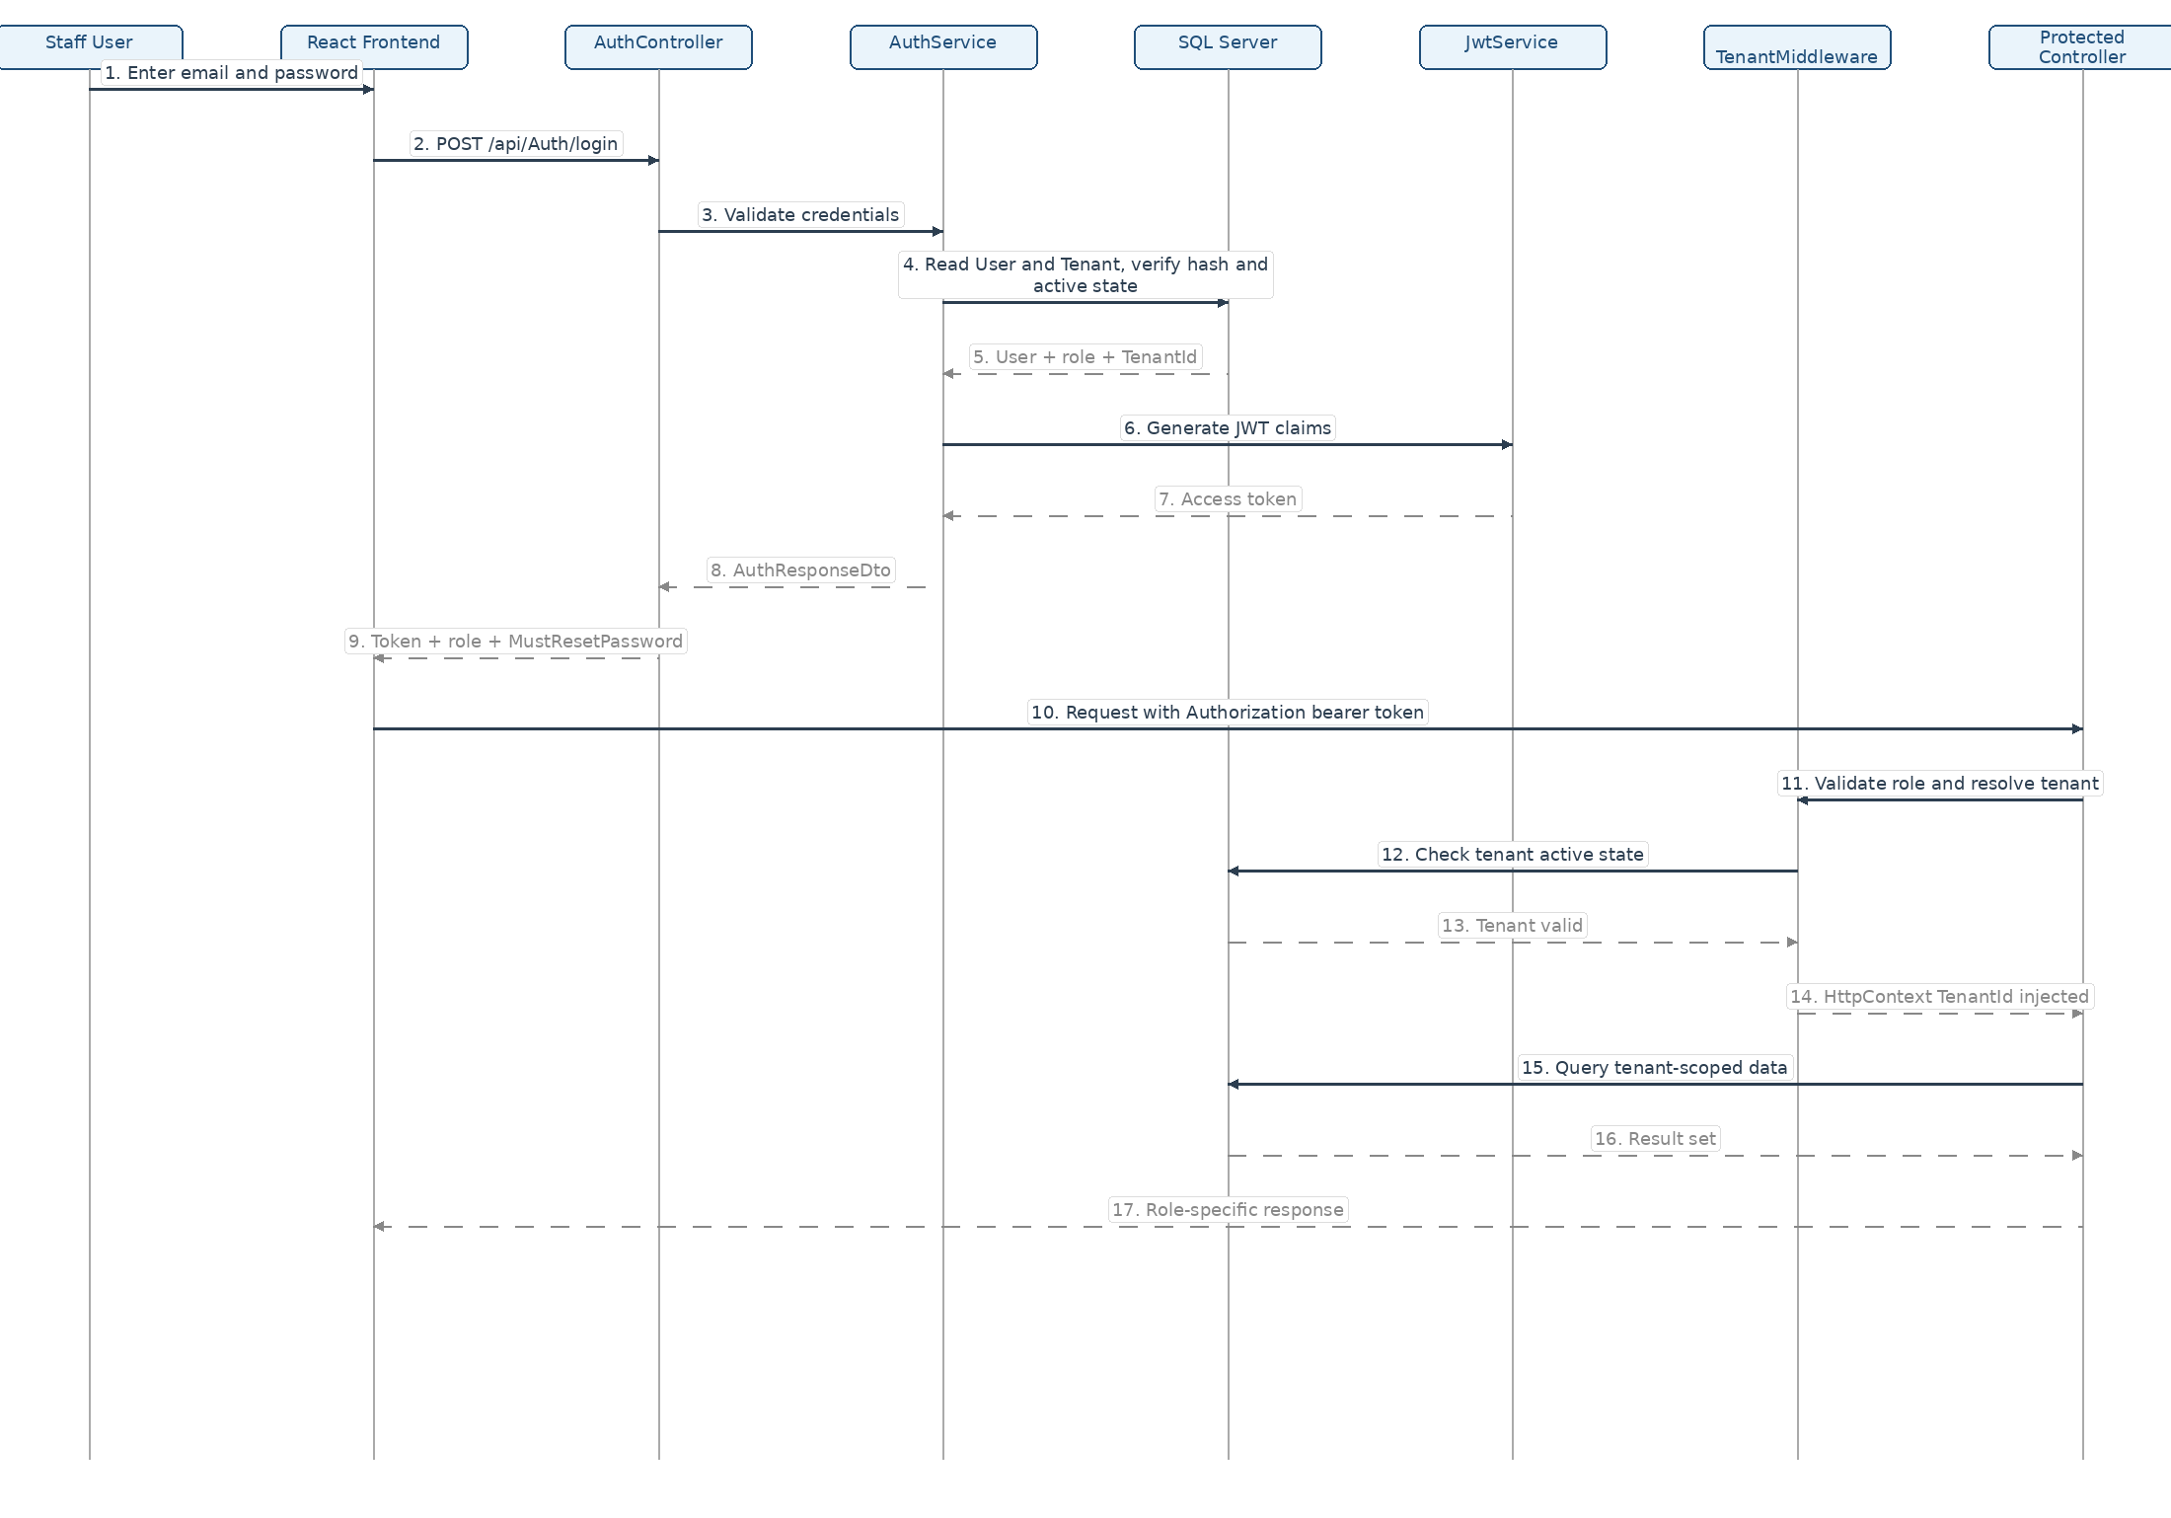
Figure 12 - Sequence Diagram: Staff Login and Protected Request

9.2 Patient Portal Booking Sequence
This sequence shows the online booking path. The patient authenticates through the portal, verifies OTP, chooses a clinic/doctor/slot and submits a booking request with an IdempotencyKey. BookingService performs transaction-safe checks, creates PatientBooking and links the booking to clinic Patient and Appointment records.
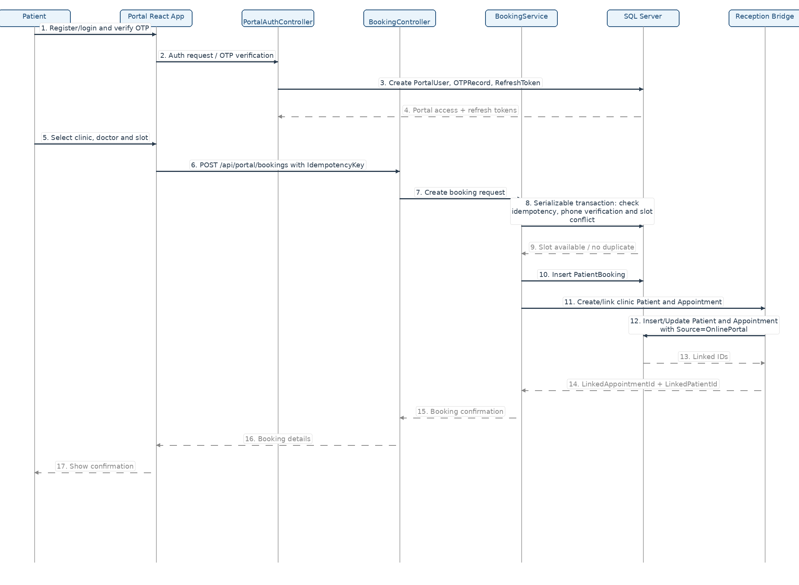
Figure 13 - Sequence Diagram: Patient Portal Booking and Integration Bridge

10. Summary
The SehhaTech implementation includes two complete web management systems, a separate patient portal, staff JWT authentication, patient OTP/JWT authentication, subscription activation, payment invoices, online booking integration, doctor slot templates, queue/check-in, report generation, image upload and chatbot support.
The diagrams focus on the real implementation structure: .NET API projects, TenantId-based isolation, SQL Server persistence through EF Core, React frontends, portal/staff authentication separation, and the actual domain entities implemented in the codebase.

Appendix A - Design Coverage Checklist
- Patient portal users are separated from staff roles in authentication and use case diagrams.
- Doctor is represented as a clinical profile linked to UserId.
- Reception is represented as a staff User role.
- PortalUser, OTPRecord, PortalRefreshToken and PatientBooking are included in the ERD.
- SlotTemplate and online availability flow are included in booking diagrams.
- PaymentInvoice is included in reception and payment flows.
- Subscription and Paymob callback flow are included in tenant activation diagrams.
- TenantMiddleware is shown explicitly in sequence and DFD diagrams.
- MonthlyReport and Hangfire monthly job are represented in reporting diagrams.
- Cloudinary upload and chatbot service are represented as supporting flows.

