Sauce Demo Playwright Framework Overview

1. Purpose
This document describes the Playwright framework created for the Sauce Demo website, including page object classes, test data files, and end-to-end workflow tests.

2. Page Classes

InventoryPageSauceDemo
Location: src/pages/inventory.page.ts
Handles inventory item selection and add-to-cart actions.
Key methods:
- goto()
- verifyInventoryPage()
- getProductCard(productName)
- getProductTitle(productName)
- getProductPrice(productName)
- getProductDescription(productName)
- getAddToCartButton(productName)
- getRemoveButton(productName)
- addToCart(productName)
- removeFromCart(productName)
- getCartCount()
- goToCart()

CartPageSauceDemo
Location: src/pages/cart.page.ts
Verifies cart contents and navigates to checkout.
Key methods:
- verifyCartPage()
- getCartItemNames()
- getCartItemPrices()
- getCartItemDescriptions()
- verifyCartItems(expectedNames)
- verifyCartItemPrices(expectedPrices)
- verifyCartItemDescriptions(expectedDescriptions)
- goToCheckout()

CheckoutPageSauceDemo
Location: src/pages/checkout.page.ts
Fills checkout step one customer information.
Key methods:
- verifyCheckoutStepOnePage()
- enterFirstName(value)
- enterLastName(value)
- enterPostalCode(value)
- clickContinue()

CheckoutStepTwoPageSauceDemo
Location: src/pages/checkout-step-two.page.ts
Verifies order overview details and finishes checkout.
Key methods:
- verifyCheckoutOverviewPage()
- getCheckoutItemNames()
- getCheckoutItemPrices()
- getCheckoutItemDescriptions()
- verifyCheckoutItemNames(expectedNames)
- verifyCheckoutItemPrices(expectedPrices)
- verifyCheckoutItemDescriptions(expectedDescriptions)
- clickFinish()

CheckoutCompletePageSauceDemo
Location: src/pages/checkout-complete.page.ts
Verifies checkout completion and navigates back home.
Key methods:
- verifyCheckoutCompletePage()
- clickBackHome()

3. Test Data Files
The framework uses CSV data files to drive product verification and checkout information:
- src/tests/test-data/inventoryData.csv
- Contains inventory test data with columns: productName, expectedDescription, expectedPrice.
- src/tests/test-data/userData.csv
- Contains checkout user data with columns: firstName, lastName, postalCode.

4. Test Specifications

inventory.add-all.spec.ts
End-to-end test that runs the full workflow in a single spec shown below:
- inventory add-to-cart
- cart verification
- checkout info
- overview verification
- finish and complete checkout

inventory.add-all-multipletest.spec.ts
Split workflow tests covering each stage separately:
- inventory add-to-cart
- cart verification
- checkout info
- overview verification
- finish and complete checkout

5. Framework Architecture
The framework follows a Page Object Model design. Each page class encapsulates locators and actions for a specific Sauce Demo page. Tests drive the workflow by combining these page objects and consuming test data from CSV files.
Architecture diagram:
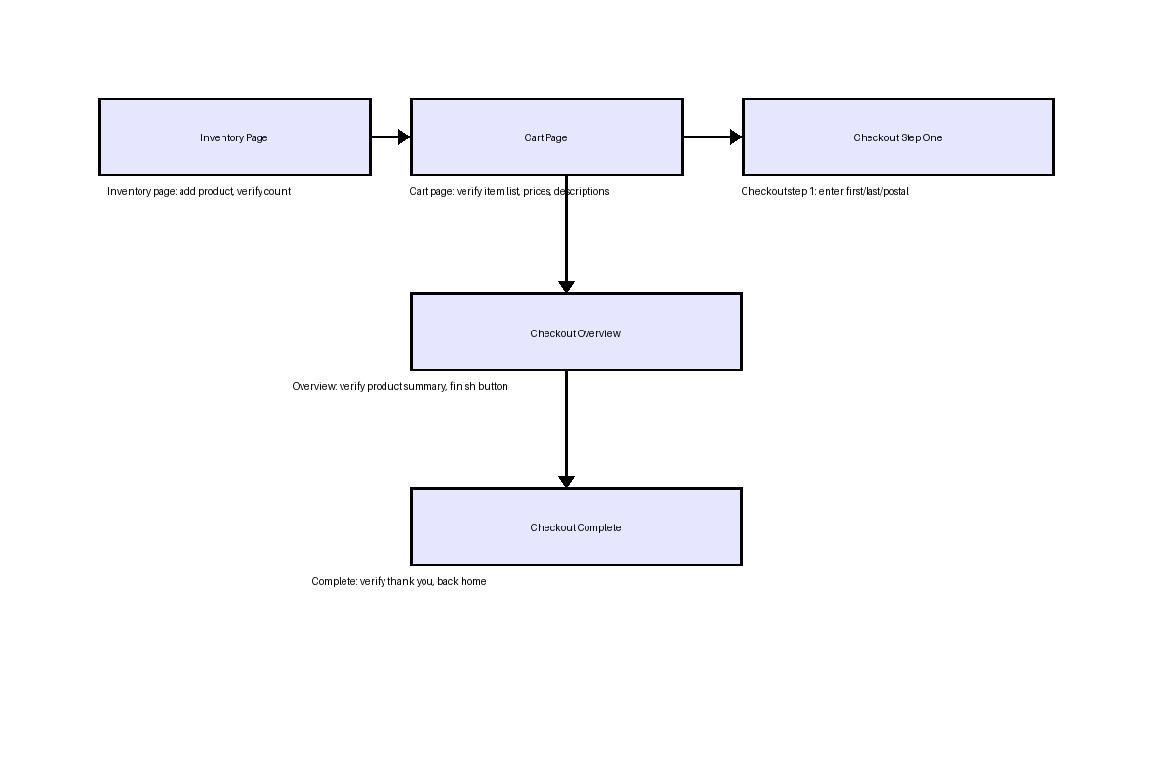

6. Notes
Fixture support:
- The project uses auth-page-fixture.ts to provide logged-in page setup and extend Playwright test fixtures.
Utility support:
- The dataReaderTyped.ts utility loads CSV/Excel/JSON data files and provides typed arrays to tests.
Generated files: sauce-demo-framework-overview.docx and sauce-demo-framework-architecture.png in the project root.

7. How to run tests
Use the following commands from the project root to run tests:
- 1. Run all Playwright tests:
- npx playwright test
- 2. Run the end-to-end single-spec flow:
- npx playwright test src/tests/inventory.add-all.spec.ts
- 3. Run the split-stage workflow spec:
- npx playwright test src/tests/inventory.add-all-multipletest.spec.ts
- 4. Run a specific test with headless or browser project settings:
- npx playwright test src/tests/inventory.add-all-multipletest.spec.ts --project=chromium --headed

8. npm test command examples
Use the following npm test commands with the Playwright test runner:
- Run all tests:
- npm test --
- Run the end-to-end single-spec flow:
- npm test -- src/tests/inventory.add-all.spec.ts --headed --workers=1 --project=chromium
- Run the split-stage workflow spec:
- npm test -- src/tests/inventory.add-all-multipletest.spec.ts --headed --workers=1 --project=chromium
- Run a single page object workflow spec (example):
- npm test -- src/tests/inventory.add-all.spec.ts --headed --workers=1 --project=chromium

9. Playwright advanced command options
You can add Playwright options to customize reporting and timeouts:
- Run with HTML reporter:
- npm test -- src/tests/inventory.add-all-multipletest.spec.ts --project=chromium --reporter=html
- Run with a custom test timeout of 60 seconds:
- npm test -- src/tests/inventory.add-all-multipletest.spec.ts --project=chromium --timeout=60000

10. Storage state and browser mode examples
The following examples show how to run Playwright tests with persistent storage or different browser modes:
- Use storage state to reuse authentication/session state across tests:
- npm test -- src/tests/inventory.add-all-multipletest.spec.ts --project=chromium --storage-state=storageState.json
- Run tests in headed mode to see the browser UI:
- npm test -- src/tests/inventory.add-all-multipletest.spec.ts --project=chromium --headed
- Run tests in headless mode explicitly:
- npm test -- src/tests/inventory.add-all-multipletest.spec.ts --project=chromium --headless

11. Default launch options from playwright.config.ts
The project config file provides default Playwright launch and test settings, so you rarely need to specify them on the command line.
Key settings in playwright.config.ts:
- • baseURL: https://www.saucedemo.com
- • storageState: .auth/user.json
- • viewport: { width: 1280, height: 720 }
- • ignoreHTTPSErrors: true
- • actionTimeout: 0
- • navigationTimeout: 30000
- • launchOptions.slowMo: 1000
Because these values are set in config, running tests such as `npm test -- src/tests/inventory.add-all-multipletest.spec.ts --project=chromium` will automatically use them unless overridden on the command line.
- Note: The config also sets the default reporter to HTML and enables trace collection on first retry.

