# API development: -

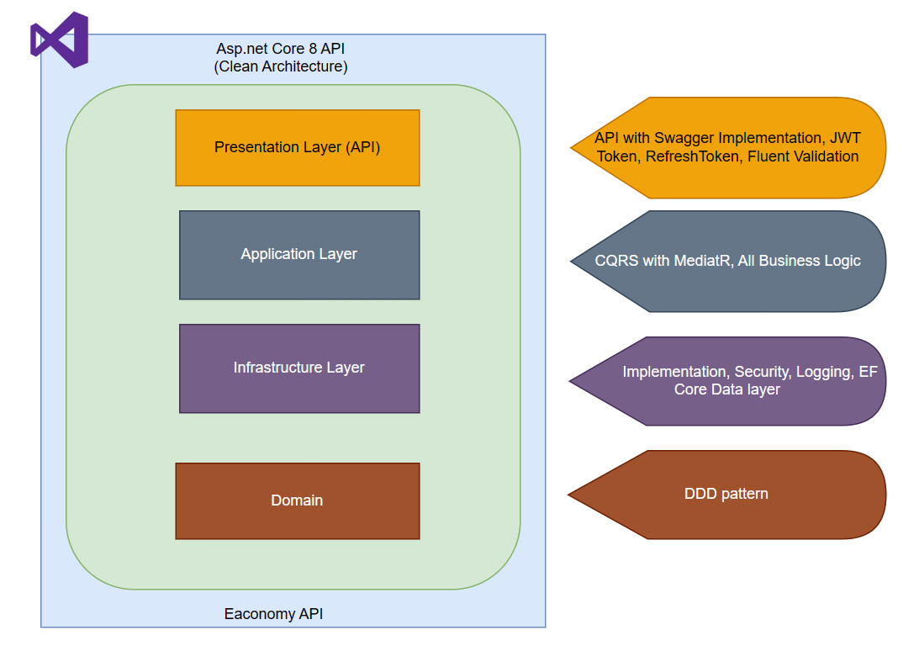

Cloud Service: -

Initially, during development phase, we can simply deploy API in Azure Web Service (Auto scaling) and Azure PaaS SQL DB. Also, we will setup, Azure DevOps for CI/CD.

As we progress, with more clarity, we can provision Azure Subscription with secure landing zone, Virtual network, security controls, centralized logging, monitoring tool, Azure AD for Identity and RBAC control. Also, we can consider, AKS (Kubernetes and Azure Cosmos DB with PostgreSQL for multi-tenant architecture).

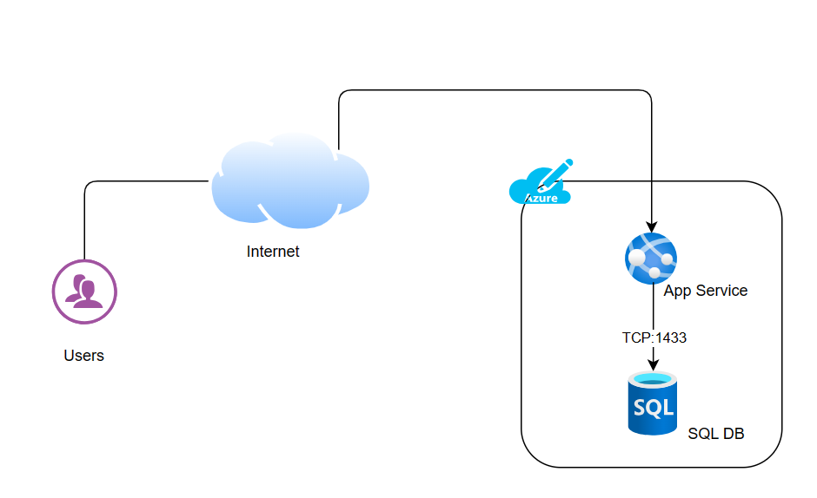

Azure Subscription with secured Landing Zone: -

Diagram will be attached shortly.