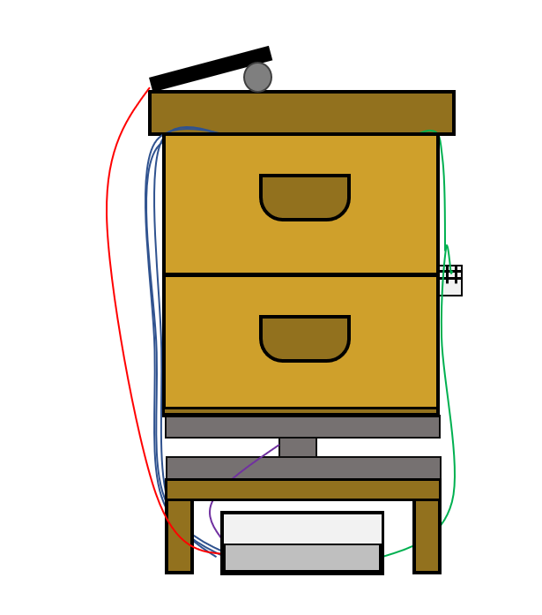

Tests results document

Connected beehive

DELAS Léo | DOS SANTOS Damien | DURAND DE GEVIGNEY Basile | TAN Caroline

EI2I 4 II – 19/01/2022

Summary

I – Temperature charts 2

II – Humidity charts 4

III – Weight chart 5

IV – System consumption 6

Conclusion 6

# I – Temperature charts

We have three temperature sensors, through our system installed on January 5th 2022 on a beehive.

All data collected from the temperature sensors are on this chart :

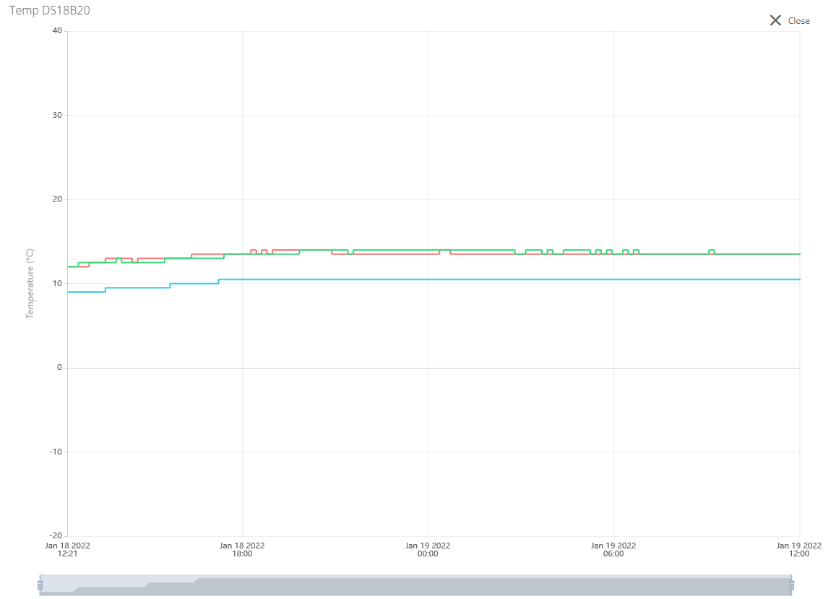

Figure 1 - Temperature charts

We can see that on the inside of the beehive, the temperature has been steady at around 10°C and 14°C.

And the results of the DHT are :

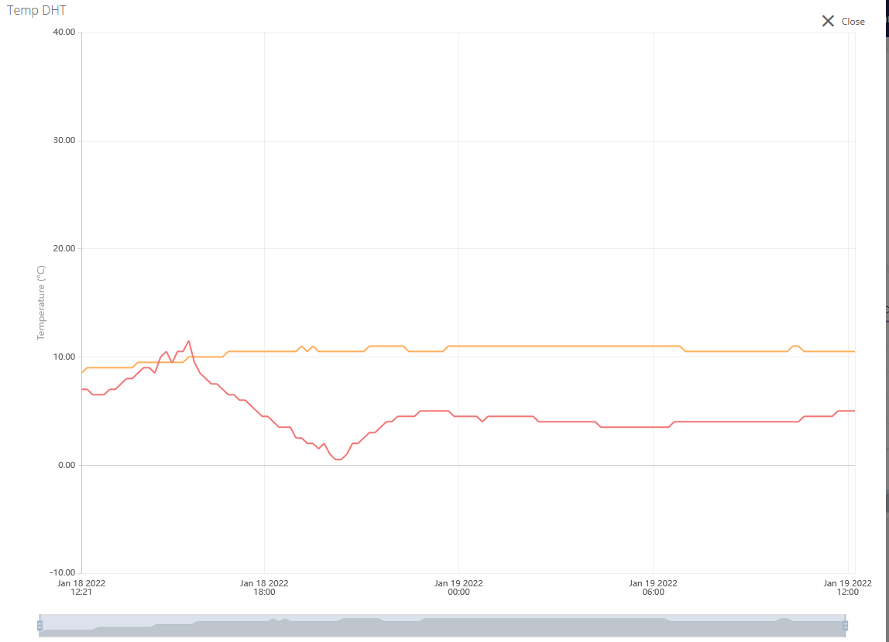

Figure 2 - Temperature from the DHT

We can see that the inside temperature is around 10°C and the outside temperature of the beehive is around 5° which matches with the temperature that we are feeling through the weeks.

We can conclude that the temperatures are steady and the beehive is in a good condition.

# II – Humidity charts

Since yesterday, the graph shows that the humidity is :

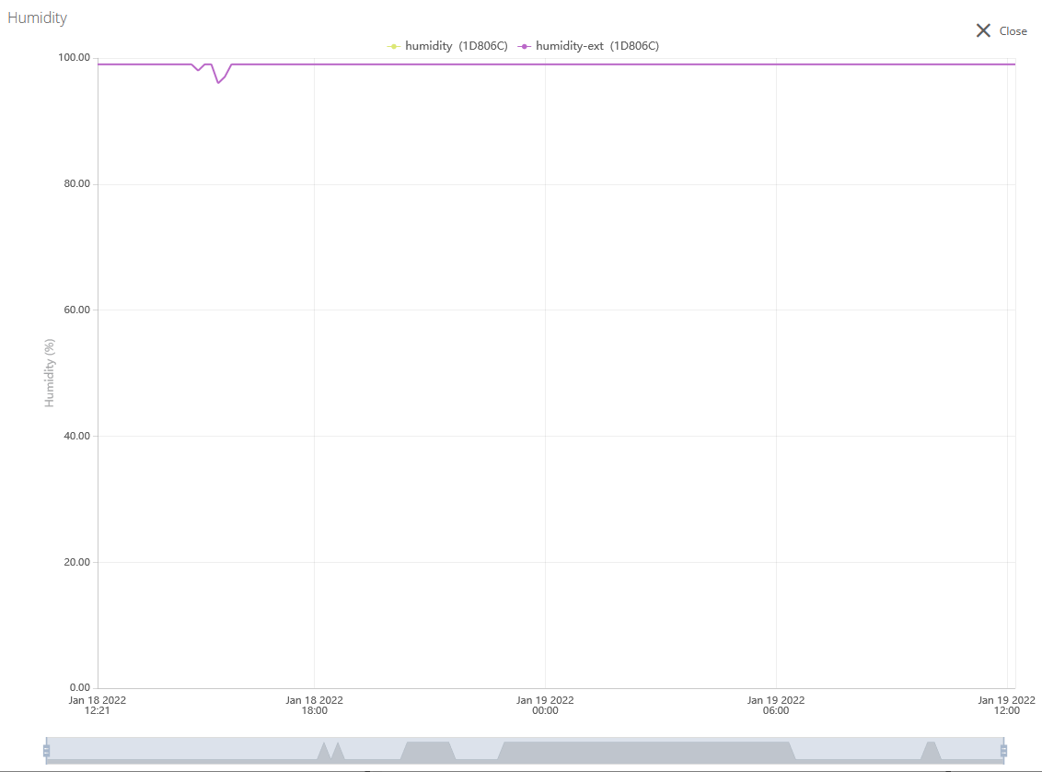

Figure 3 - Humidity chart

Since a few days ago, it has been raining and we can deduce that the reason why the humidity level is so high is because the sensor is in the water.

Before that, the chart was showing a normal level of humidity at around 50% on the outside.

# III – Weight chart

This is the weight chart :

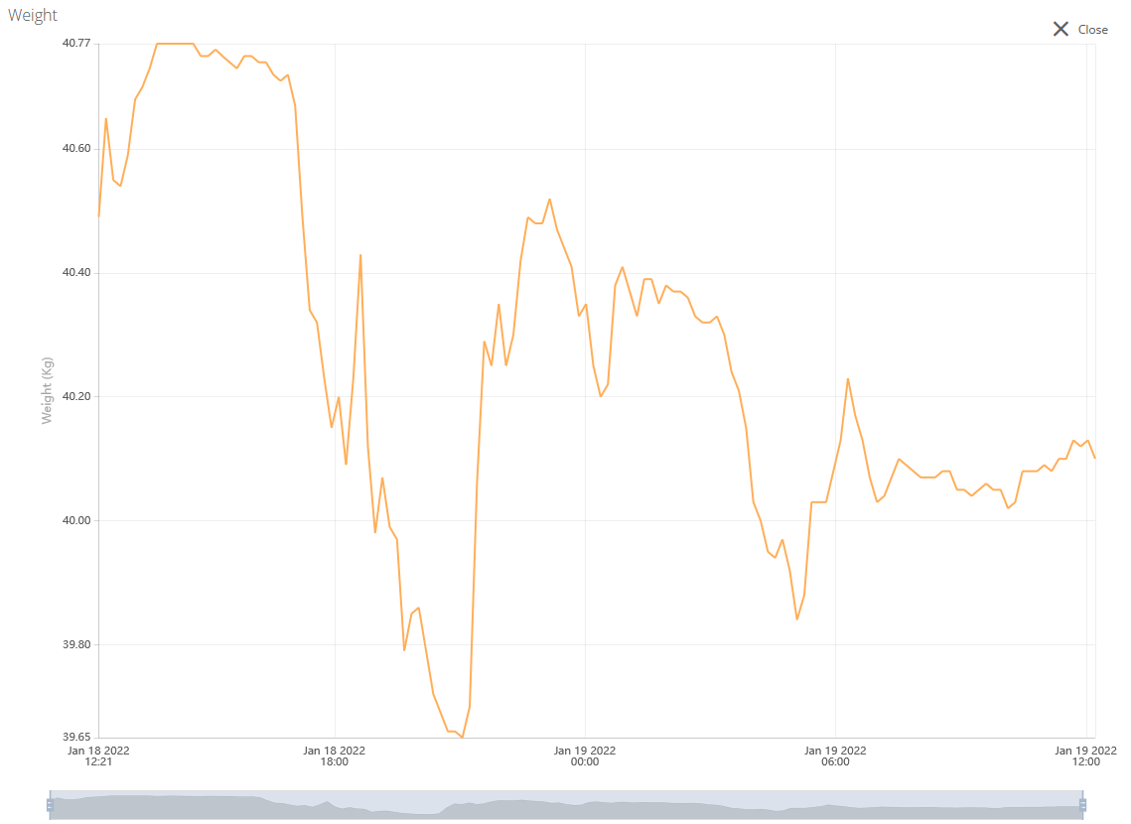

Figure 4 - Weight chart

We can see that the weight is moving slightly, it can be explained by the fact that the bees are moving from the inside to the outside and vice-versa and the production of honey also.

# IV – System consumption

Thanks to the OTII tool, we have measured the consumption of our system :

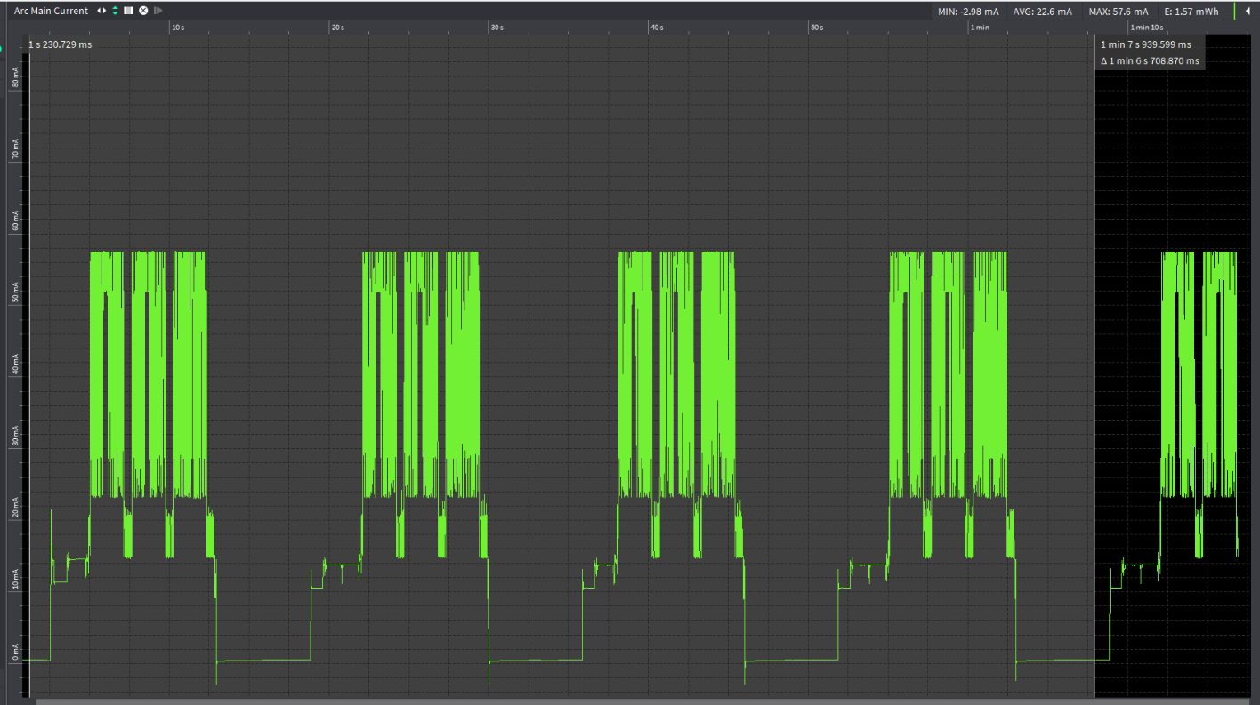

Figure 5 - System consumption

We know that the system consumes :

- 395 μWh / Message

- 138 messages per day

- 450 µA at rest

- 57.6 mA at max

And that the battery has a 4.41Wh capacity.

With all of this information, we can estimate an autonomy of 30 to 38 days and this is thanks to the solar cell.

# Conclusion

We can conclude that after two weeks, our system is still functioning properly because it is sturdy, the consumption has been optimized as much as possible.

Our project is a successful one and we are very proud and happy that our hard work has been paying off.