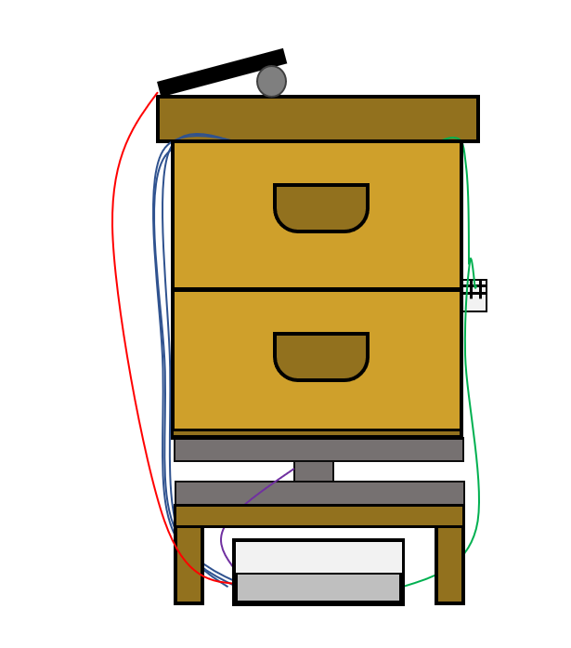

User guide

connected beehive

DELAS Léo | DOS SANTOS Damien | DURAND DE GEVIGNEY Basile | TAN Caroline

EI2I 4 II – 19/01/2022

Summary

I – Required components 2

II – PCB and connecting everything 3

III – Code 3

IV – Sigfox connection 4

V – Ubidots 5

VI – Installing the system on the beehive 6

Conclusion 8

# I – Required components

For this project, you need to have these components :

|  |  |
| --- | --- |
| Solar cell of 5,5 V/360 mA and dimensions of 180 x 80 m*m* |  |
| Power adapter card (LiPo Rider Pro) |  |
| Arduino MKR FOX 1200 board ABX00014 with SigFox interface |  |
| Li-Ion battery 3,7V 1050 mAh |  |
| Multiple temperature sensors |  |
| Weight sensor: strain gauge and HX711 |  |
| Temperature and humidity sensor DHT22 |  |

# II – PCB and connecting everything

For our project we have decided to design a PCB to connect together all of our components, for this we used the software EastEDA, which is a free software that allows you to do some PCB design and also some electrical schematics and others functions that we haven’t used in this project.

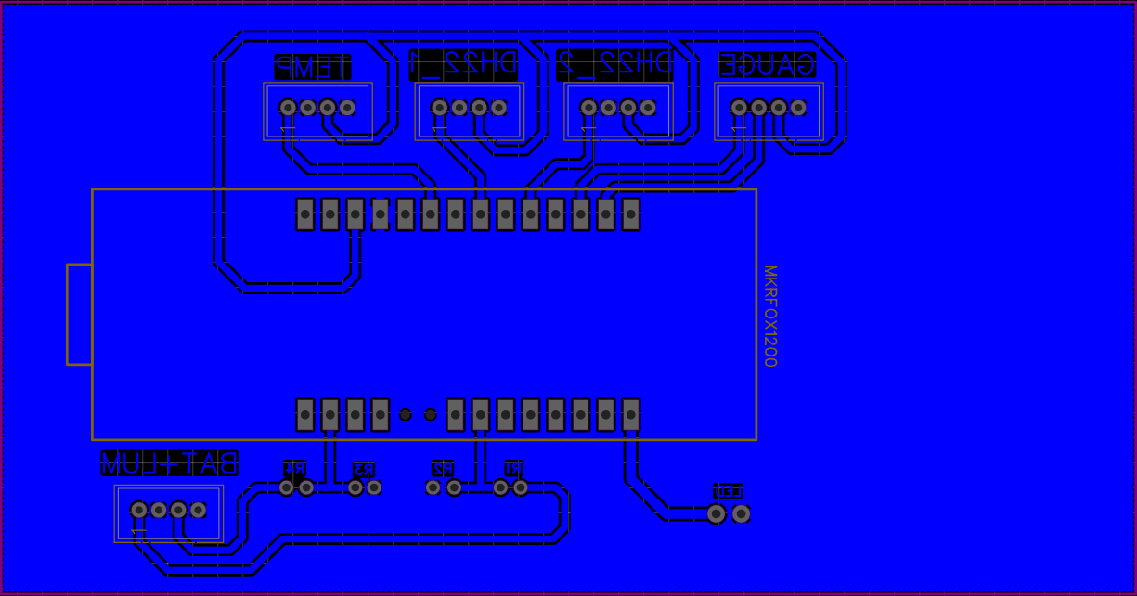

Figure 1 - PCB of the project

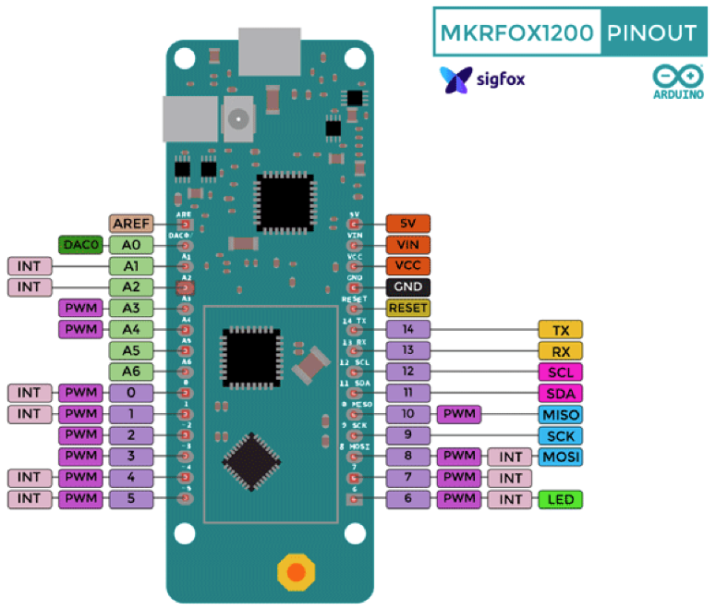Everything is written on the PCB on how to link everything. It is purposely reversed so the print is not reversed and can be easily read.  
The way the we put our Arduino board here, is by using some female pin header to easily swap out the board if needed while maintaining some robustness.  
The pinout of the maker fox is as follow :

# III – Code

For this project, you need to install the Arduino IDE and download the codes from our Github : <https://github.com/Ithoh/OpenRucheDLCB/tree/main/Codes>

It is divided between the main codes that are needed for the project :



And the test codes to check whether the sensors are working or not :

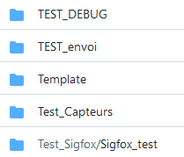

At first, you should test the sensors through compilation and then upload the code on the Arduino. Do not forget to select the right Arduino and the right port.

After checking that everything is working correctly, you can compile and upload the main code on the Arduino.

# IV – Sigfox connection

To access the data that is recovered, you need to log in your account Backend Sigfox with the login below :

|  |  |
| --- | --- |
| Mail | 001d806c@yopmail.com |
| Password | Sigfox21# |

On the website, you can check the messages that are sent every ten minutes by clicking on : Device, then Messages.

You should be able to see this after following these steps :

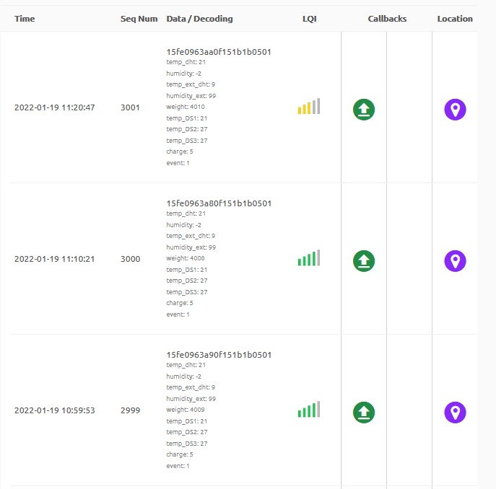

Figure 2 - Sigfox messages

If you want to know more about how Sigfox can read these messages, it is thanks to the parameters of the callback which you can access via Device Type, Callbacks and editing the only one that is actually there :

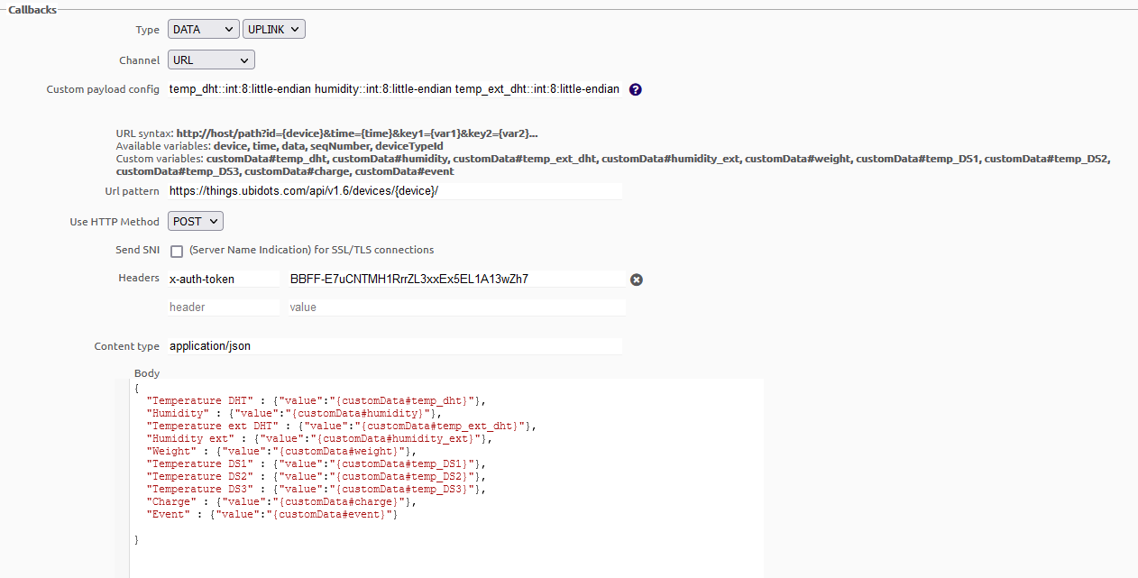

Figure 3 - Screenshot of the callbacks

# V – Ubidots

To connect to this website, the logins are :

|  |  |
| --- | --- |
| Login | 001d806c |
| Password | Sigfox21# |

On this website, you can see charts of the temperature and humidity, the battery level and the weight of the beehive :

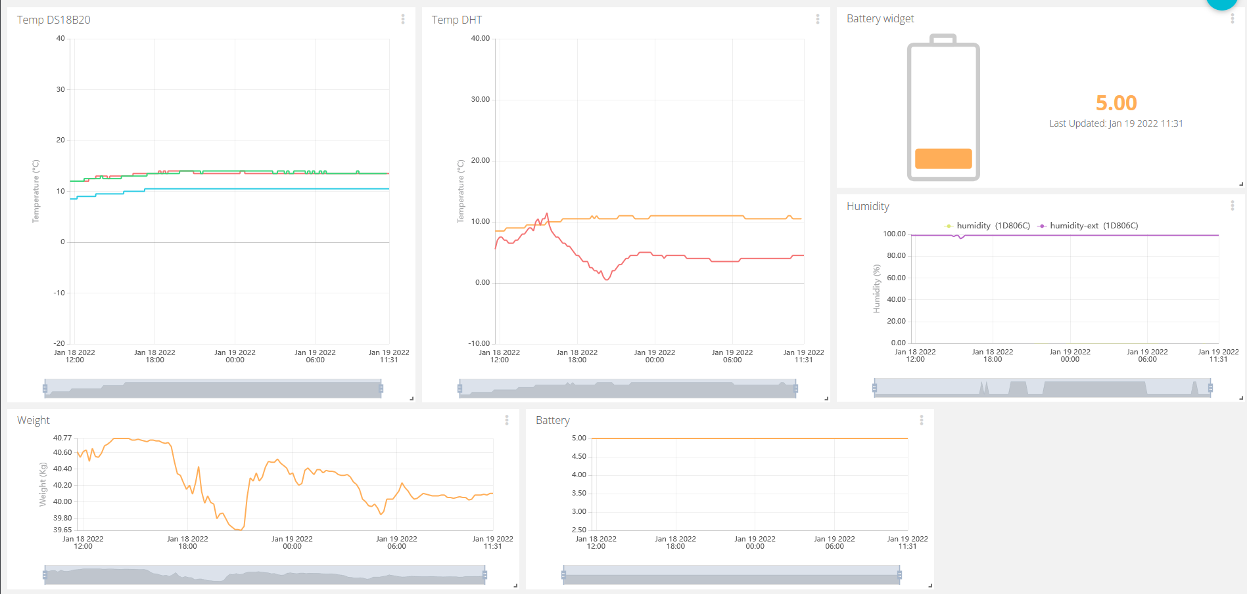

Figure 4 - Information of the beehive through Ubidots

With this website, it will send you alerts via mail and text message if your battery level is too low or if your beehive has been stolen.

Thanks to this interface, you can monitor the condition of your beehive and if everything is functioning properly.

# VI – Installing the system on the beehive

The system on the beehive is set up like this :

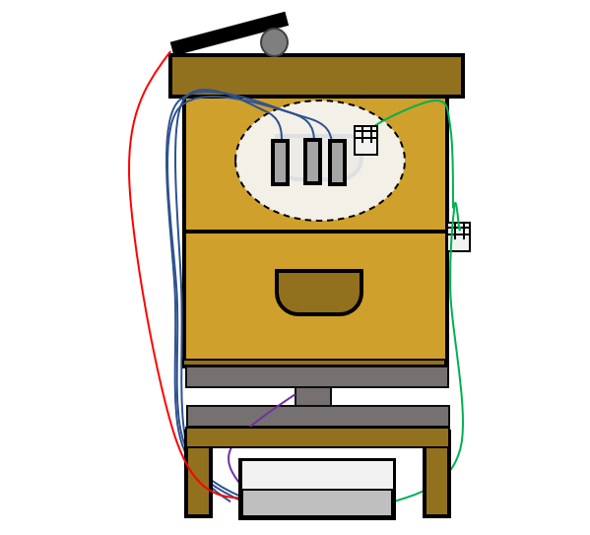

Figure 5 - Schematic of the beehive with the sensors

There are three temperature sensors and one DHT22 in the inside of the beehive and one DHT22 on the oustide. On the top of the beehive you have the solar cell. And it is on the weight gauge :

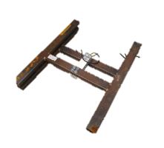

Figure 6 - Weight gauge

More precisely, the sensors are placed like this :

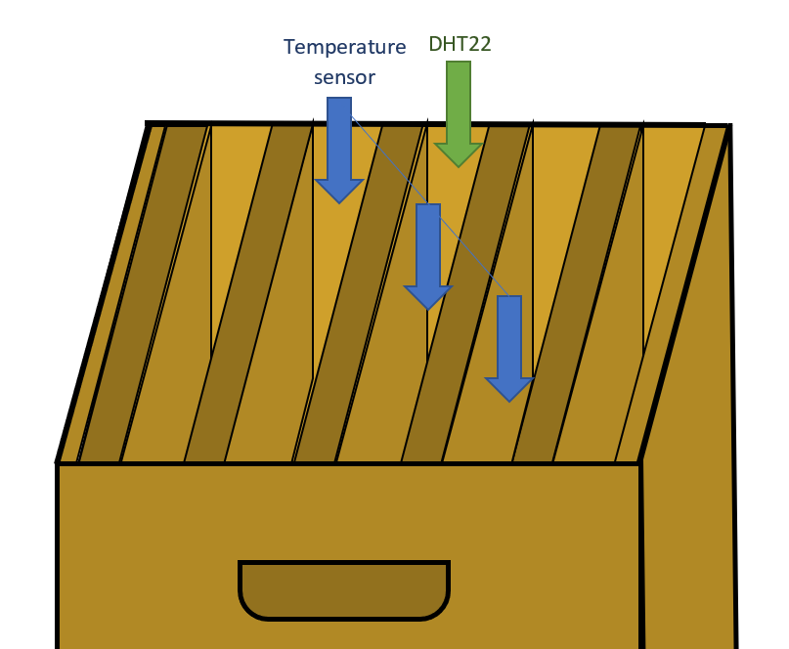

Figure 7 - Detailed position of the sensors

# Conclusion

With this project, you should be able to monitor the status of your beehive and take action if needed for the well-being of the bees !

Thank you for reading this user guide and hope that everything is clear !