Photo Converter — Creative Studio
AI-Powered Image Transformation Web Application

Technology: Python · FastAPI · React · OpenCV · Vite
Deployment: Render (Backend) · Vercel (Frontend)
Version: 1.0 | Year: 2025

1. Project Overview
Photo Converter — Creative Studio is a full-stack web application that transforms ordinary photographs into artistic styles using computer vision techniques. Users can upload any JPG or PNG image and instantly apply one of four creative filters:
• Pencil Sketch
• Anime Art
• Oil Painting
• Background Removal
The application is deployed live and accessible from any device via a browser. It was built as a college/personal project to demonstrate real-world skills in AI, web development, and cloud deployment.

2. Technologies Used
Item | Details
Frontend Framework | React 18 (with Vite build tool)
Backend Framework | FastAPI (Python 3.11)
Image Processing | OpenCV (cv2), NumPy
Background Removal | rembg + ONNX Runtime (u2netp model)
Styling / Animation | CSS + Vanta.js HALO (animated 3-D background)
Backend Hosting | Render.com (free tier, auto-sleep)
Frontend Hosting | Vercel (free tier, instant CDN)
Version Control | Git / GitHub

3. System Architecture
The application follows a classic client–server architecture:
[User Browser]
│ HTTP POST (multipart/form-data)
▼
[Vercel — React Frontend]
│ fetch() API call to BACKEND_URL
▼
[Render — FastAPI Backend]
│ OpenCV / rembg processing
▼
[Processed Image returned as binary response]
│
▼
[Browser displays result + Download button]
CORS is fully enabled on the backend so any frontend origin can call the API.

4. Project Folder Structure
photo-converter/
│
├── backend/
│ ├── main.py ← FastAPI application (all image-processing endpoints)
│ ├── requirements.txt ← Python dependencies
│ └── render.yaml ← Render deployment configuration
│
├── frontend/
│ ├── index.html ← HTML entry point (loads Vanta.js)
│ ├── vercel.json ← Vercel deployment configuration
│ └── src/
│ ├── main.jsx ← React entry point
│ ├── App.jsx ← Main React component (UI + API calls)
│ └── index.css ← Global styles
│
├── start.bat ← One-click local startup script (Windows)
├── test_anime.py ← Local test script for anime filter
├── test_anime2.py ← Improved anime filter test
└── .gitignore

5. Step-by-Step: How the App Works

Step 1 — Open the Web App
The user opens the deployed URL in any browser. A stunning animated 3-D background (Vanta HALO) loads immediately. A status badge shows whether the backend server is awake (yellow = waking, green = ready).

Step 2 — Select a Filter Mode
Four filter buttons are shown:
✏️ Pencil Sketch
✨ Anime Art
🎨 Painting
✂️ Remove Background
The user clicks the desired filter. The active button is highlighted.

Step 3 — Upload a Photo
The user clicks the dashed upload zone (📸 "Click to Upload Photo") and selects a JPG or PNG from their device. The original image immediately previews on screen.

Step 4 — Apply the Filter
The user clicks the orange "Apply … Effect" button. The frontend sends the image file to the FastAPI backend via an HTTP POST request. A spinner animation ("Applying magic filters…") is shown while processing.

Step 5 — View and Download the Result
When the backend returns the processed image, it is displayed side-by-side with the original. A "Download Result" link lets the user save the output as JPG (or PNG for background removal).

6. Backend Code — main.py
The entire backend is a single FastAPI file. It exposes four POST endpoints:
Item | Details
/api/sketch | Converts image to pencil sketch using grayscale + Gaussian blur + color dodge
/api/anime | Applies anime/cartoon style using edge-preserving filter + adaptive thresholding
/api/painting | Creates an oil-painting effect using edge-preserving filter + saturation boost
/api/remove-bg | Removes image background using the rembg AI model (u2netp)

6.1 Full Backend Code
import cv2
import numpy as np
from fastapi import FastAPI, File, UploadFile
from fastapi.responses import Response
from fastapi.middleware.cors import CORSMiddleware
app = FastAPI()
# rembg is lazy-loaded only when remove-bg is called
# to avoid OOM on startup (u2netp model = 4.7MB vs u2net = 176MB)
_rembg_session = None
def get_rembg_session():
global _rembg_session
if _rembg_session is None:
from rembg import new_session
_rembg_session = new_session("u2netp")
return _rembg_session
app.add_middleware(
CORSMiddleware,
allow_origins=["*"],
allow_credentials=True,
allow_methods=["*"],
allow_headers=["*"],
)
@app.get("/")
def read_root():
return {"message": "Image Editing Backend"}
# ── Pencil Sketch ──────────────────────────────────────────────────────────
@app.post("/api/sketch")
async def convert_to_sketch(file: UploadFile = File(...)):
contents = await file.read()
nparr = np.frombuffer(contents, np.uint8)
img = cv2.imdecode(nparr, cv2.IMREAD_COLOR)
gray_image = cv2.cvtColor(img, cv2.COLOR_BGR2GRAY)
inverted = cv2.bitwise_not(gray_image)
blurred = cv2.GaussianBlur(inverted, (21, 21), 0)
inv_blur = cv2.bitwise_not(blurred)
sketch = cv2.divide(gray_image, inv_blur, scale=256.0)
# Gamma correction for richer pencil strokes
gamma = 0.6
table = np.array([((i/255.0)**(1/gamma))*255
for i in range(256)]).astype("uint8")
sketch = cv2.LUT(sketch, table)
_, enc = cv2.imencode('.jpg', sketch)
return Response(content=enc.tobytes(), media_type="image/jpeg")
# ── Anime Art ──────────────────────────────────────────────────────────────
@app.post("/api/anime")
async def apply_anime(file: UploadFile = File(...)):
contents = await file.read()
nparr = np.frombuffer(contents, np.uint8)
img = cv2.imdecode(nparr, cv2.IMREAD_COLOR)
h, w = img.shape[:2]
max_dim = 1000
scale = 1.0
if max(h, w) > max_dim:
scale = max_dim / max(h, w)
img = cv2.resize(img, (int(w*scale), int(h*scale)))
color = cv2.edgePreservingFilter(img, flags=1, sigma_s=50, sigma_r=0.4)
hsv = cv2.cvtColor(color, cv2.COLOR_BGR2HSV).astype("float32")
hh, ss, vv = cv2.split(hsv)
ss = np.clip(ss * 1.25, 0, 255)
vv = np.clip(vv * 1.05, 0, 255)
color = cv2.cvtColor(cv2.merge([hh, ss, vv]).astype("uint8"), cv2.COLOR_HSV2BGR)
gray = cv2.medianBlur(cv2.cvtColor(img, cv2.COLOR_BGR2GRAY), 5)
edges = cv2.adaptiveThreshold(gray, 255,
cv2.ADAPTIVE_THRESH_MEAN_C, cv2.THRESH_BINARY, 9, 9)
anime = cv2.bitwise_and(color, color, mask=edges)
if scale != 1.0:
anime = cv2.resize(anime, (w, h))
_, enc = cv2.imencode('.jpg', anime)
return Response(content=enc.tobytes(), media_type="image/jpeg")
# ── Oil Painting ───────────────────────────────────────────────────────────
@app.post("/api/painting")
async def apply_painting(file: UploadFile = File(...)):
contents = await file.read()
nparr = np.frombuffer(contents, np.uint8)
img = cv2.imdecode(nparr, cv2.IMREAD_COLOR)
h, w = img.shape[:2]
max_dim = 1000
scale = 1.0
if max(h, w) > max_dim:
scale = max_dim / max(h, w)
img = cv2.resize(img, (int(w*scale), int(h*scale)))
painted = cv2.edgePreservingFilter(img, flags=1, sigma_s=60, sigma_r=0.4)
hsv = cv2.cvtColor(painted, cv2.COLOR_BGR2HSV).astype("float32")
hc, s, v = cv2.split(hsv)
s = np.clip(s * 1.2, 0, 255)
painted = cv2.cvtColor(cv2.merge([hc, s, v]).astype("uint8"), cv2.COLOR_HSV2BGR)
kernel = np.array([[0,-0.5,0],[-0.5,3,-0.5],[0,-0.5,0]])
painted = cv2.filter2D(painted, -1, kernel)
if scale != 1.0:
painted = cv2.resize(painted, (w, h))
_, enc = cv2.imencode('.jpg', painted)
return Response(content=enc.tobytes(), media_type="image/jpeg")
# ── Background Removal ─────────────────────────────────────────────────────
@app.post("/api/remove-bg")
async def remove_background(file: UploadFile = File(...)):
from rembg import remove
contents = await file.read()
session = get_rembg_session()
output = remove(contents, session=session)
return Response(content=output, media_type="image/png")

7. Frontend Code — App.jsx
The frontend is a single React component (App.jsx). Key responsibilities:
• Poll the backend every 5 s on startup to detect when it is awake
• Display a server-status badge (yellow = waking, green = ready)
• Handle file upload and send to the correct API endpoint
• Show original + result images side-by-side
• Provide a download link for the processed image

7.1 Key State Variables
Item | Details
originalImage | Object URL of the uploaded image shown in the browser
resultImage | Object URL of the processed image returned by the backend
isLoading | Boolean — true while waiting for backend response
activeMode | Currently selected filter: sketch / anime / painting / remove-bg
serverStatus | "waking" or "ready" — controls the status badge color

7.2 API Communication Logic
const processImage = async () => {
setIsLoading(true);
const formData = new FormData();
formData.append('file', fileInputRef.current.files[0]);
let endpoint = '/api/sketch';
if (activeMode === 'remove-bg') endpoint = '/api/remove-bg';
if (activeMode === 'anime') endpoint = '/api/anime';
if (activeMode === 'painting') endpoint = '/api/painting';
const response = await fetch(`${BACKEND_URL}${endpoint}`, {
method: 'POST',
body: formData,
});
if (response.ok) {
const blob = await response.blob();
setResultImage(URL.createObjectURL(blob));
}
setIsLoading(false);
};

8. Image Filter Algorithms — Detailed Explanation

8.1 Pencil Sketch
Algorithm steps:
1. Convert the colour image to Grayscale.
2. Invert the grayscale image (bitwise NOT).
3. Apply Gaussian Blur (kernel 21×21) to the inverted image.
4. Invert the blurred image again.
5. Use Color Dodge blend: divide grayscale by inverted-blur (scale=256).
6. Apply Gamma Correction (γ=0.6) using a LUT to darken and enrich strokes.
Result: A realistic pencil-sketch with dark, expressive strokes.

8.2 Anime Art
Algorithm steps:
1. Resize large images to max 1000 px (performance optimisation).
2. Apply Edge-Preserving Filter (sigma_s=50, sigma_r=0.4) for cel-shaded colours.
3. Boost saturation ×1.25 and brightness ×1.05 in HSV colour space.
4. Apply Median Blur on the grayscale version to remove noise.
5. Extract fine outlines via Adaptive Threshold (block=9, C=9).
6. Combine coloured image with edge mask using bitwise AND.
Result: A vibrant anime/cartoon appearance with clean black outlines.

8.3 Oil Painting
Algorithm steps:
1. Resize large images to max 1000 px.
2. Apply Edge-Preserving Filter (sigma_s=60, sigma_r=0.4) — heavier smoothing than anime.
3. Boost saturation ×1.2 in HSV colour space.
4. Apply a custom Sharpening Kernel (3×3) to simulate brush-stroke texture.
Result: A rich oil-painting / watercolour appearance.

8.4 Background Removal
Algorithm steps:
1. Lazy-load the rembg session with the lightweight u2netp model (4.7 MB) only on the first background-removal request.
2. Pass the raw image bytes to rembg.remove().
3. Return the result as a PNG with a transparent background.
Result: Subject is cleanly isolated on a transparent background. The frontend renders a checkerboard pattern behind the PNG to show transparency.

9. Deployment

9.1 Backend — Render.com
The FastAPI backend is deployed on Render's free tier. The render.yaml file configures the service:
services:
- type: web
name: photo-converter-backend
runtime: python
buildCommand: pip install -r requirements.txt
startCommand: uvicorn main:app --host 0.0.0.0 --port $PORT
envVars:
- key: PYTHON_VERSION
value: 3.11.0
⚠️ Note: Render's free tier spins down after 15 minutes of inactivity. The frontend polls the backend every 5 seconds for up to 2 minutes to handle the "cold start" gracefully.

9.2 Frontend — Vercel
The React app is deployed on Vercel. The vercel.json configures the build:
{
"buildCommand": "npm run build",
"outputDirectory": "dist",
"framework": "vite"
}
The environment variable VITE_BACKEND_URL is set in Vercel's dashboard to point to the Render backend URL, allowing cross-device access.

10. Python Dependencies (requirements.txt)
Item | Details
fastapi==0.115.0 | Web framework for the API
uvicorn==0.30.6 | ASGI server to run FastAPI
python-multipart==0.0.9 | Required to receive file uploads
numpy==1.26.4 | Array operations for image data
opencv-contrib-python-headless==4.9.0.80 | Computer vision (no GUI needed)
pillow==10.4.0 | Image I/O support for rembg
rembg==2.0.57 | AI background removal library
onnxruntime==1.16.3 | Runs the u2netp neural network model

11. Sample Output Screenshots
The following images show actual outputs generated by the application filters:
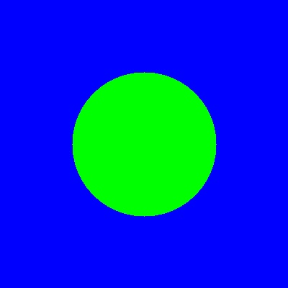
Original Input Image

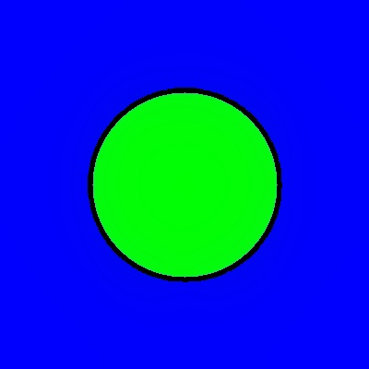
Output A — Anime Art Filter

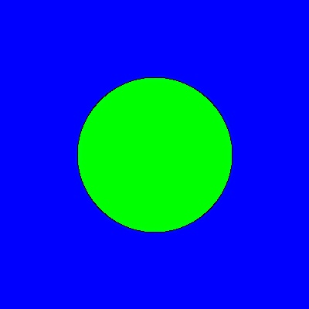
Output B — Anime Art Filter (variant)

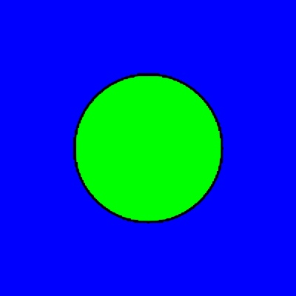
Output C — Pencil Sketch Filter

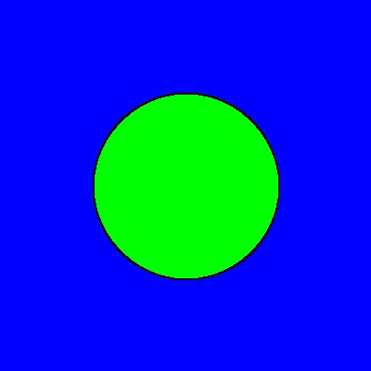
Output D — Oil Painting Filter

12. How to Run Locally

Method A — Double-Click start.bat (Windows)
Simply double-click the start.bat file in the project root. It automatically:
1. Starts the FastAPI backend on http://localhost:5000
2. Starts the React frontend on http://localhost:5173
3. Opens the browser automatically

Method B — Manual Steps
Backend:
cd backend
pip install -r requirements.txt
uvicorn main:app --host 0.0.0.0 --port 5000 --reload
Frontend:
cd frontend
npm install
npm run dev
Then open http://localhost:5173 in your browser.

13. Key Features Summary
Item | Details
4 Art Filters | Sketch, Anime, Painting, Background Removal
Real-time Preview | Original and result shown side-by-side
Download Button | One-click download of processed image
Server Status Badge | Visual indicator showing if backend is awake
Animated Background | Vanta.js HALO 3-D animated gradient background
Responsive Design | Works on mobile, tablet, and desktop
Memory Optimised | u2netp model (4.7 MB) instead of u2net (176 MB)
Auto Image Resize | Images >1000px are resized before processing to avoid OOM
Cross-Device Access | Deployed on Vercel + Render, accessible worldwide
CORS Enabled | Backend accepts requests from any frontend origin

