SOFTWARE REQUIREMENTS SPECIFICATION
IIPS Multimodal Student Assignment Analysis,
Evaluation & Learning Curve Analytics System
React + Vite + FastAPI + Docker Based AI-Assisted Academic Platform
Document Item | Details
Version | 1.1
Project Type | AI-assisted academic assessment and learning analytics platform
Target Institution | IIPS, DAVV
Users | Students, Faculty, Academic Administrators
Submission Modes | Text, PDF/Document, Image, Audio, Video
Frontend | React + Vite
Backend | FastAPI + Python
Database / Storage | Supabase PostgreSQL + Supabase Storage
Containerization | Docker + Docker Compose
Initial Implementation | 3-day MVP

Table of Contents
1. Introduction
2. Problem Statement
3. Proposed Solution
4. Objectives
5. Scope
6. Stakeholders and User Roles
7. System Overview
8. Functional Requirements
9. Multimodal Processing Requirements
10. AI-Assisted Evaluation
11. Learning Analytics
12. CO/PO Attainment
13. Dashboards
14. Database Requirements
15. API Requirements
16. Technology Stack
17. System Architecture
18. Docker Container Architecture
19. Data Flow Diagrams
20. Security Requirements
21. Non-Functional Requirements
22. Deployment Architecture
23. Docker Requirements
24. 3-Day MVP Development Plan
25. Testing Requirements
26. Future Enhancements
27. Conclusion

1. Introduction
The IIPS Multimodal Student Assignment Analysis, Evaluation & Learning Curve Analytics System is a web-based academic platform for assignment submission, AI-assisted evaluation, faculty review, competency mapping and longitudinal learning analytics. It supports text, documents, images, audio and video.
The platform combines conventional faculty/peer assessment with AI-assisted analysis. AI-generated results are recommendations and evidence for faculty review rather than an unconditional replacement for human academic judgment.

2. Problem Statement
Manual assignment evaluation becomes difficult when faculty handle 100+ students across multiple assignments. Conventional systems often store marks without maintaining structured evidence about concepts, competencies, skills, CO/PO attainment or learning progression.
- High faculty workload.
- Difficulty maintaining consistent rubric-based assessment.
- Limited semantic similarity analysis.
- Limited multimodal support.
- Difficulty identifying learning gaps.
- Manual CO/PO attainment and trend calculations.
- Limited personalized feedback.
- Limited batch-level visibility.

3. Proposed Solution
The system introduces multimodal processing and AI-assisted evaluation between student submissions and academic analytics. Submissions are processed by modality, converted into a common representation where practical, evaluated against rubrics and expected concepts, reviewed by faculty, and accumulated into learning analytics.
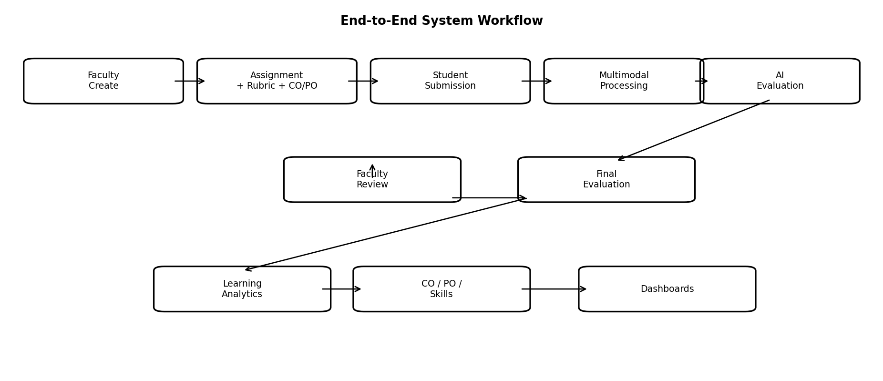

4. Objectives
- Centralized assignment submission.
- Support text/document/image/audio/video.
- Reduce repetitive evaluation effort.
- Semantic similarity analysis.
- Rubric and concept-based evaluation.
- Structured scores and feedback.
- Longitudinal student performance history.
- Skill and competency tracking.
- CO/PO attainment.
- Batch analytics.
- Personalized learning insights.
- Reproducible Docker-based development and deployment.

5. Scope

5.1 In Scope
- Role-based authentication.
- Course and assignment management.
- Questions and rubrics.
- CO/PO mapping.
- Multimodal storage.
- Text/PDF extraction, OCR and speech-to-text.
- Semantic similarity.
- AI-assisted scoring and feedback.
- Faculty review/override.
- Learning curves and skills.
- CO/PO analytics.
- Batch trends.
- Dockerized local/integration deployment.

5.2 Initial MVP Limitations
- Video initially emphasizes transcription and optional key frames.
- AI remains assistive and faculty-validated.
- Advanced prediction requires more historical data.
- No custom foundation model required.

6. Stakeholders and User Roles
Role | Responsibilities
Student | View assignments, submit work, view scores/feedback and track progress.
Faculty | Create assignments, rubrics, CO/PO mappings, review AI results, finalize scores and inspect analytics.
Administrator | Manage users/courses and inspect institution-level analytics.
System Administrator | Maintain Docker deployment, configuration, access, logs and system health.

7. System Overview
The platform consists of Authentication, Assignment Management, Submission Management, AI Evaluation, Learning Analytics and Dashboards. React + Vite provides a rapid Python-based UI; FastAPI provides the API/business-logic boundary; Docker packages services into reproducible containers.
- Authentication & Authorization
- Course and Assignment Management
- Multimodal Submission Management
- AI-Assisted Evaluation
- Learning Analytics
- Dashboards
- Containerized Runtime
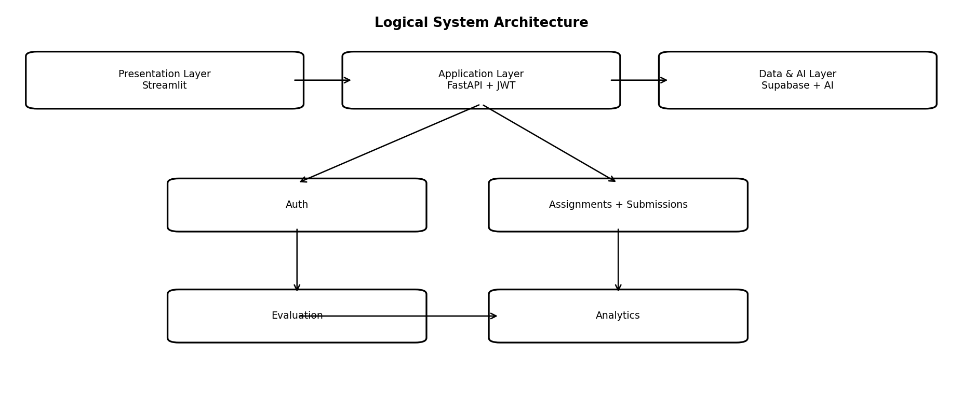

8. Functional Requirements
ID | Requirement | Description
FR-01 | Authentication | Secure login for students, faculty and administrators.
FR-02 | Authorization | Role-based permissions for protected resources.
FR-03 | Course Management | Create, update, view and manage courses.
FR-04 | Assignment Management | Questions, marks, deadlines, submission modes, rubrics and CO/PO mappings.
FR-05 | Submission | Submit text and supported files.
FR-06 | Storage | Metadata in PostgreSQL; files in object storage.
FR-07 | Content Extraction | Extract text/OCR/transcribe supported media.
FR-08 | Similarity | Semantic similarity between selected submissions/reference answers.
FR-09 | Rubric Evaluation | Criterion-level AI-assisted evaluation.
FR-10 | Feedback | Strengths, weaknesses and improvement suggestions.
FR-11 | Faculty Review | Accept, edit or override AI scores/feedback.
FR-12 | Final Evaluation | Persist final scores and evidence.
FR-13 | Learning Curve | Individual and batch performance trends.
FR-14 | Skill Tracking | Skill/competency indicators.
FR-15 | CO Attainment | Aggregate question-level results into CO attainment.
FR-16 | PO Attainment | Calculate PO attainment from CO/PO relationships.
FR-17 | Dashboards | Role-specific analytics and evaluation information.
FR-18 | Monitoring | Expose measurable performance trends/attention indicators.
FR-19 | Containerization | Run services through defined Docker images and Compose configuration.

9. Multimodal Processing Requirements
Input | Technology | Processing | Reason
Text | Python NLP | Cleaning, normalization, embeddings | Directly usable in evaluation.
PDF/DOCX | PyMuPDF / python-docx | Extract text | Machine-readable content.
Image | EasyOCR / Tesseract | OCR | Scanned/photographed answers.
Audio | Whisper | Speech-to-text | Spoken answers become text.
Video | FFmpeg + Whisper | Audio extraction + transcription; optional key frames | Practical 3-day MVP path.

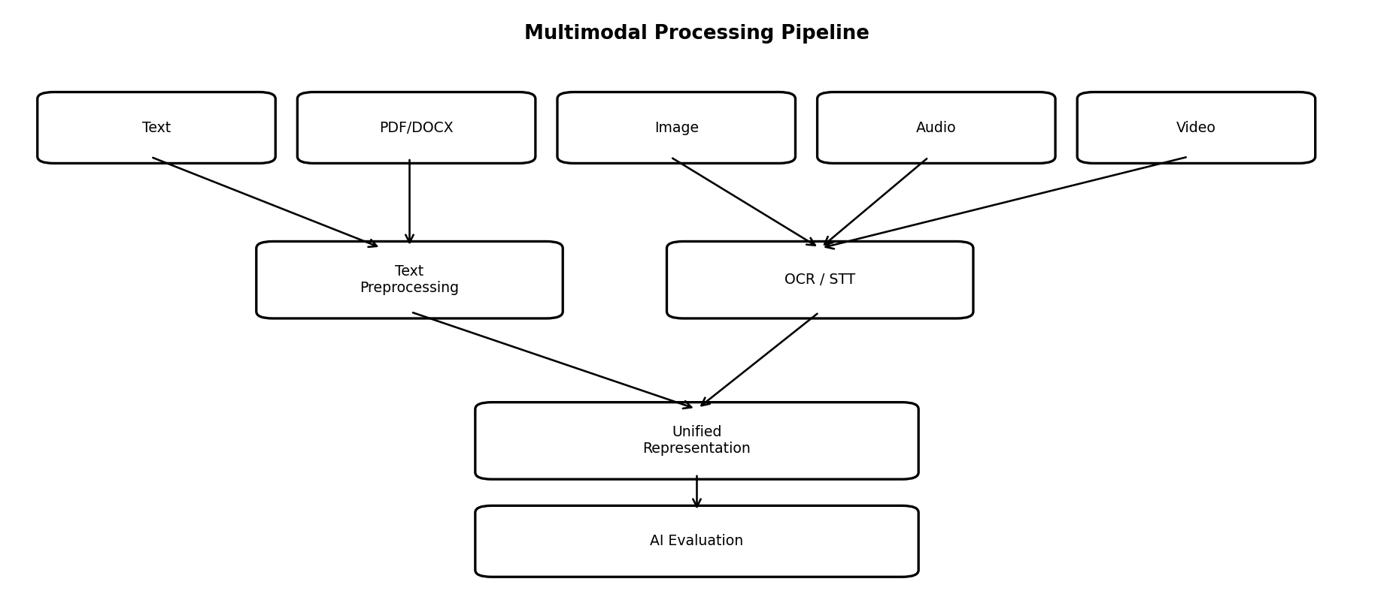

10. AI-Assisted Evaluation

10.1 Evaluation Pipeline
Submission → Extraction → Preprocessing → Embeddings / Concepts → Similarity + Rubric → Score + Feedback → Faculty Review → Final Score

10.2 Similarity Analysis
- Semantic embeddings.
- Cosine similarity.
- Student-to-student review flags.
- Student-to-reference semantic alignment.
- Similarity is evidence for review, not automatic proof of misconduct.

10.3 Rubric-Based Scoring
Criterion | Example Weight | Purpose
Concept Understanding | 40% | Required concept understanding.
Technical Accuracy | 30% | Correctness and terminology.
Explanation | 20% | Clarity and reasoning.
Completeness | 10% | Coverage of expected components.

10.4 Human-in-the-Loop
AI Evaluation → Suggested Score → Faculty Review → Accept / Modify → Final Score

10.5 Structured Output
{"score":82,"criterion_scores":{},"strengths":[],"weaknesses":[],"feedback":"...","recommended_topics":[]}

11. Learning Analytics
Evaluation records become evidence for longitudinal learning analysis at student, assignment, course, batch, skill, CO and PO levels.
- Individual assignment performance
- Improvement across assignments
- Batch average/distribution
- Skill progression
- CO attainment
- PO attainment
- Trend analysis
- Measurable performance indicators

12. CO/PO Attainment
Questions can be mapped to COs and COs to POs. The configured institutional attainment methodology determines the aggregation.
Question → CO → PO → Attainment → Dashboard
Question | CO | PO | Example Evidence
Q1 | CO1 | PO1 | Concept score
Q2 | CO2 | PO1, PO2 | Technical accuracy
Q3 | CO3 | PO3 | Problem-solving

13. Dashboards

13.1 Student Dashboard
- Overall performance
- Assignment history
- Learning curve
- Skill progress
- Personalized feedback
- Recommended learning areas

13.2 Faculty Dashboard
- Submission overview
- AI evaluation status
- Average scores
- Learning trends
- CO/PO attainment
- Skill gaps
- Students requiring attention
- Evaluation review/override

13.3 Administrator Dashboard
- Course/batch overview
- Institution metrics
- CO/PO analytics
- Course/semester trends
- User/course management

14. Database Requirements
Entity | Key Fields | Purpose
Users | id, name, email, password_hash, role | Identity/access.
Courses | id, name, code, faculty_id | Course information.
Enrollments | course_id, student_id | Membership.
Assignments | id, course_id, title, deadline, total_marks | Assignment configuration.
Questions | id, assignment_id, text, max_marks, co_id | Question mapping.
Rubrics | id, assignment_id, criterion, weight | Evaluation criteria.
Submissions | id, student_id, assignment_id, type, file_url | Submission metadata.
Evaluations | submission_id, ai_score, faculty_score, final_score, feedback | Evaluation results.
Skills | id, name, description | Competency definitions.
Student Skills | student_id, skill_id, score, evidence | Skill progression.
COs / POs | id, code, description | Outcome definitions.
Feedback | evaluation_id, strengths, weaknesses, recommendations | Learning feedback.

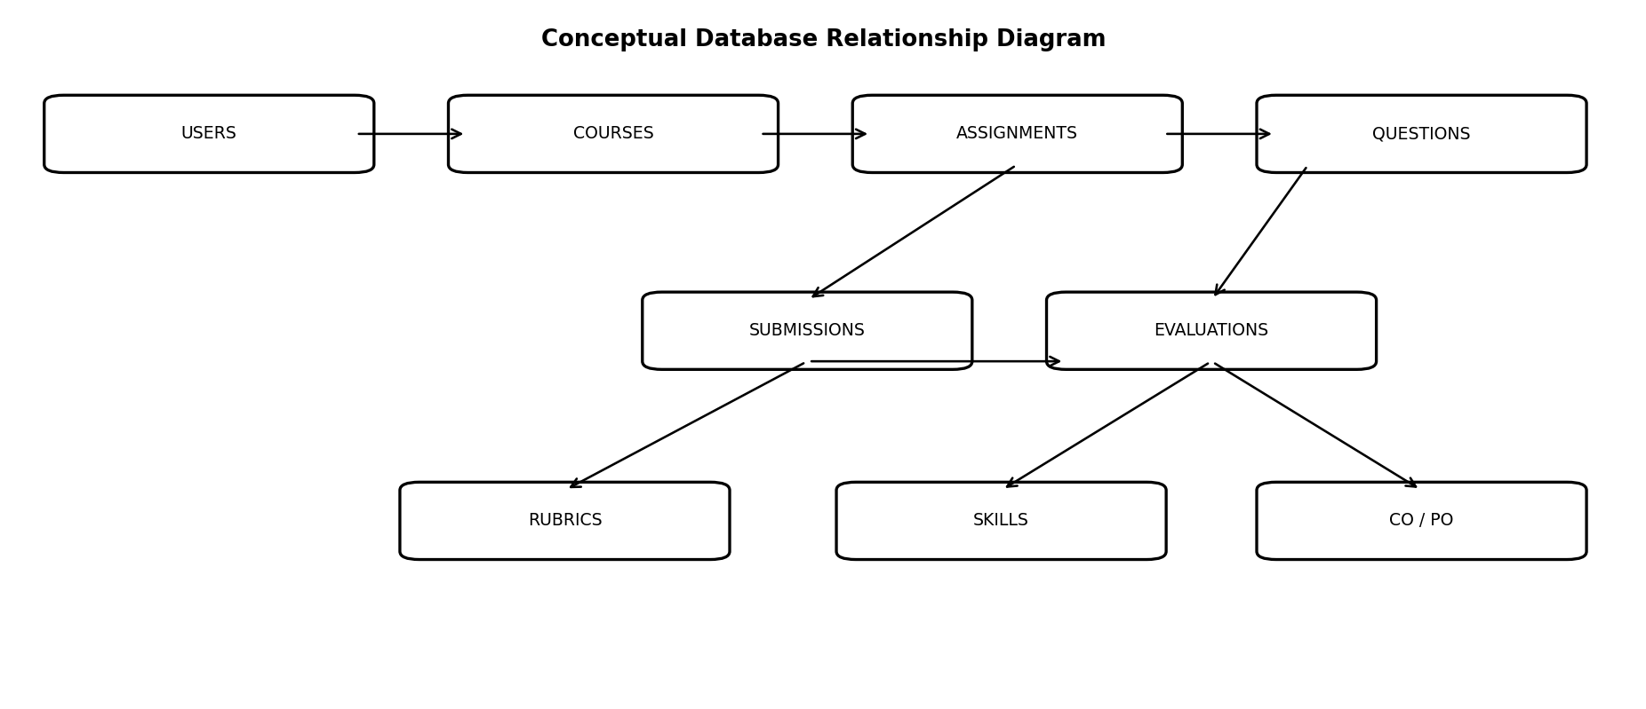

15. API Requirements
Module | Endpoint Examples | Purpose
Auth | POST /auth/register, POST /auth/login, GET /auth/me | Authentication.
Courses | POST /courses, GET /courses | Course management.
Assignments | POST /assignments, GET /assignments/{id} | Assignment management.
Submissions | POST /submissions, GET /submissions/{id} | Submission workflow.
Evaluation | POST /evaluation/{submission_id}, PUT /evaluation/{submission_id} | AI evaluation and finalization.
Analytics | GET /analytics/student/{id}, GET /analytics/course/{id} | Learning and batch analytics.
CO/PO | GET /analytics/course/{id}/co-attainment | Outcome attainment.

16. Technology Stack
Layer | Technology | Why
Frontend | React + Vite | Fast Python UI, forms, file upload and analytics; ideal for a 3-day prototype.
Charts | Plotly / React + Vite charts | Interactive learning curves, trends and attainment.
Backend | FastAPI + Python | REST APIs, business logic and AI/ML integration.
Database | PostgreSQL / Supabase | Relational academic data and SQL analytics.
Storage | Supabase Storage | Large assignment files.
Authentication | JWT | Stateless API authentication.
Similarity | sentence-transformers | Semantic embeddings.
OCR | EasyOCR / Tesseract | Image text extraction.
Speech | Whisper | Audio/video transcription.
Documents | PyMuPDF / python-docx | Document extraction.
Data Analysis | Pandas + SQL | Aggregation.
Containerization | Docker | Reproducible isolated runtime.
Orchestration | Docker Compose | Run frontend/backend together.
Deployment | Docker-compatible host + Supabase | Containerized app with managed data/storage.
Version Control | GitHub | Source control and deployment integration.

17. System Architecture
React + Vite is the presentation layer; FastAPI is the application/API layer; Supabase provides managed PostgreSQL and object storage; AI services provide OCR, speech and semantic/LLM capabilities. Docker packages the application services for reproducibility.
Browser → React + Vite Container → FastAPI Container → PostgreSQL / Storage / AI Services

18. Docker Container Architecture
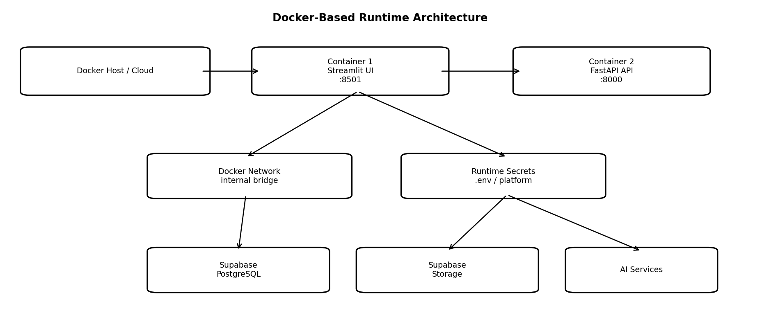

18.1 Container Responsibilities
Container | Port | Responsibilities
React + Vite-ui | 8501 | Dashboards, forms, file upload and API calls.
fastapi-api | 8000 | Auth, business logic, submissions, AI orchestration and analytics.
Optional worker | Internal | Long-running OCR/transcription/embedding jobs when needed.
Optional local PostgreSQL | 5432 | Local-only alternative if not using Supabase.

18.2 Docker Compose
Docker Compose shall run the React + Vite and FastAPI services together for local/integration environments. Supabase may remain managed externally.
services:
frontend:
build: ./frontend
ports: ["8501:8501"]
depends_on: [backend]
backend:
build: ./backend
ports: ["8000:8000"]
env_file: .env
healthcheck: ...

18.3 Dockerfile Requirements
- Use an appropriate small Python base image.
- Install only required dependencies.
- Optimize layer caching where practical.
- Expose only required ports.
- Use an explicit application command.
- Prefer a non-root runtime user.
- Never bake secrets into images.
- Use .dockerignore.

18.4 Environment Configuration
SUPABASE_URL=...
SUPABASE_SERVICE_ROLE_KEY=...
DATABASE_URL=...
JWT_SECRET=...
AI_API_KEY=...
BACKEND_URL=http://backend:8000
The .env file must not be committed. Production secrets should be configured through the hosting platform.

19. Data Flow Diagrams

19.1 Level 0
[Student] → [React + Vite UI] → [FastAPI] → [Evaluation Engine]
│ │
▼ ▼
[Database] [Analytics]
│
▼
[Dashboards]

19.2 Level 1
Student → React + Vite Submission → FastAPI → Storage
│
▼
Processing Pipeline
┌────────┼─────────┐
▼ ▼ ▼
Text OCR Whisper/STT
└────────┼─────────┘
▼
AI Evaluation
▼
Faculty Review
▼
Final Score
▼
Analytics Engine
┌─────┼─────┐
▼ ▼ ▼
CO PO Skills

20. Security Requirements
- Securely hash passwords.
- Use JWT for API access.
- Enforce role-based authorization.
- Restrict student data access.
- Restrict faculty to authorized courses.
- Validate file type and size.
- Use environment variables/secrets.
- Use HTTPS in production.
- Do not store credentials in Docker images.
- Run containers with least privilege where practical.
- Do not lose submissions if AI processing fails.
- Maintain evaluation audit information.

21. Non-Functional Requirements
Category | Requirement
Performance | MVP should support 100+ students and multiple assignments.
Scalability | UI, API, AI processing and storage can scale independently later.
Availability | Web application accessible through browser.
Usability | Simple role-specific workflows.
Maintainability | Domain-separated backend modules.
Reliability | Persist submission before AI processing.
Explainability | Expose rubric evidence and feedback.
Portability | Docker provides reproducible environments.
Security | Authentication, authorization, validation, secrets and HTTPS.

22. Deployment Architecture
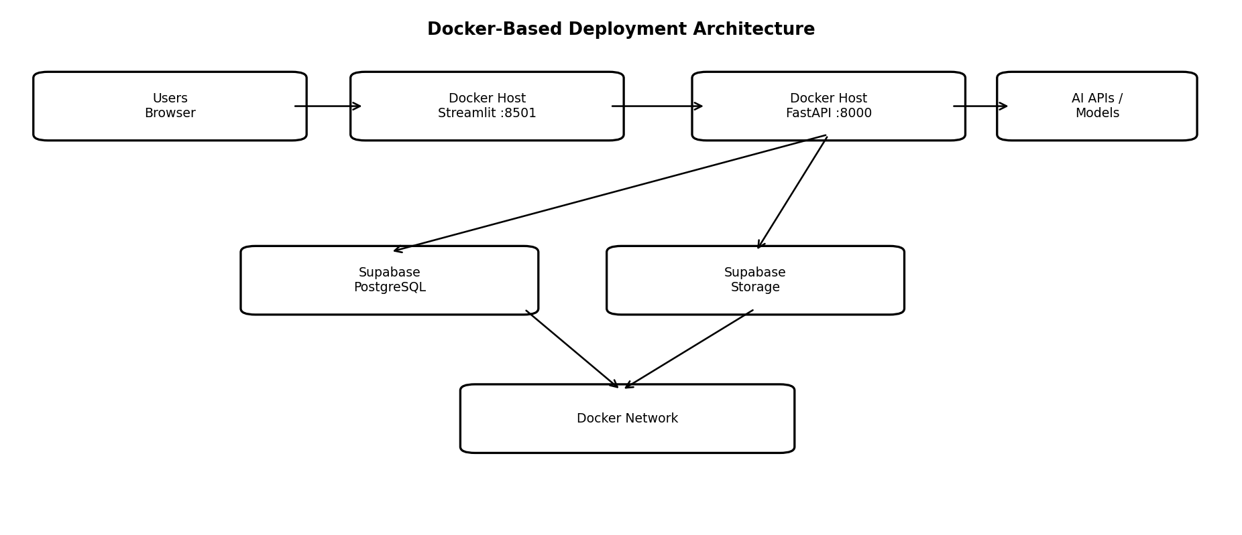

22.1 Deployment Flow
GitHub → Docker Build → Image Registry / Deployment Host → Docker Runtime
│
┌───────────┴───────────┐
▼ ▼
React + Vite UI FastAPI API
└───────────┬───────────┘
▼
Supabase + AI Services

23. Docker Requirements

23.1 Recommended Project Structure
project/
├── frontend/
│ ├── app.py
│ ├── pages/
│ ├── components/
│ ├── requirements.txt
│ └── Dockerfile
├── backend/
│ ├── app/
│ │ ├── routes/
│ │ ├── services/
│ │ ├── models/
│ │ └── config/
│ ├── requirements.txt
│ └── Dockerfile
├── docker-compose.yml
├── .env.example
├── .dockerignore
└── README.md

23.2 Health Checks
- FastAPI exposes GET /health.
- Container health checks verify process responsiveness.
- External dependency health should be distinguishable from application health.

23.3 Networking
- React + Vite and FastAPI communicate over a Docker network.
- Use the backend service name instead of localhost for container-to-container calls.
- Publish only required ports.
- Do not embed database/API credentials in images.

23.4 Logging
- Write logs to stdout/stderr.
- Include IDs useful for debugging without exposing secrets.
- Avoid unnecessary sensitive student data in logs.

24. 3-Day MVP Development Plan

Day 1 — Foundation, Docker and Submission
- Repository/project structure.
- React + Vite + FastAPI setup.
- Dockerfiles and Docker Compose.
- Verify frontend/backend container networking.
- Supabase schema.
- JWT and roles.
- Course/assignment creation.
- Questions, rubrics and CO/PO mapping.
- Student assignment listing.
- Submission upload + Storage.
- Checkpoint: docker compose up → assignment → submission → persistence.

Day 2 — AI Evaluation
- PDF/DOCX extraction.
- Image OCR.
- Whisper transcription.
- Text preprocessing.
- Embeddings + similarity.
- Rubric-based AI evaluation.
- Structured feedback.
- Faculty review/override.
- Rebuild/test images.
- Checkpoint: submission → processing → AI score → feedback → review.

Day 3 — Analytics, Hardening and Deployment
- Learning curve.
- Batch trends.
- Skill progress.
- CO/PO attainment.
- Student/faculty dashboards.
- Performance indicators.
- 100+ synthetic records.
- Final Docker images.
- Deploy containerized services.
- Production environment variables/secrets.
- HTTPS/reverse proxy where required.
- Documentation and demo.

25. Testing Requirements
Area | Examples
Authentication | Valid/invalid login, expired token, role restriction.
Assignment | Create/edit, deadlines, rubric and CO/PO mapping.
Submission | Types, size limits, duplicate/late submission.
AI | Extraction, OCR, transcription, similarity, structured scoring.
Faculty Review | Accept, modify, finalize.
Analytics | Learning curve, CO/PO, averages, trends.
Docker | Build, startup, health check, networking, environment injection.
Security | Cross-student access, unauthorized API, secret exposure.
Deployment | CORS, HTTPS, database/storage connectivity, restart behavior.

26. Future Enhancements
- Advanced video understanding.
- Handwriting recognition.
- Code evaluation.
- Adaptive recommendations.
- Knowledge/competency graphs.
- Advanced predictive models.
- Institution-wide analytics.
- Semester comparison.
- Mobile application.
- GPU-enabled AI worker containers.
- Celery/RQ + Redis background jobs.
- CI/CD for Docker images.
- Kubernetes when scale requires it.

27. Conclusion
The IIPS Multimodal Student Assignment Analysis, Evaluation & Learning Curve Analytics System is an end-to-end academic assessment and learning improvement platform. Its value is the transformation of repeated assignment evidence into structured information about learning, competencies, skills, CO/PO attainment and performance trends.
For the three-day MVP, the recommended architecture is React + Vite + FastAPI + Supabase, packaged using Docker. React + Vite accelerates academic dashboards and forms, FastAPI provides a clean API/business-logic boundary, Supabase provides managed relational storage and file storage, and Docker ensures reproducible development and deployment. The design remains extensible for background AI workers, advanced multimodal models, predictive analytics and institution-wide deployment.

