Instructions for Configuration and use of KatanaPIM Magento 2 Module

The following are the instructions for the configuration of Magento 2 KatanaPIM integration module.

The module is designed to import products and specifications (known as attributes in Magento 2) from KatanaPim into your Magento 2 store.

Configuration

In order to establish a connection to your KatanaPIM instance you must enter a URL and Key in your Magento Admin Panel under:

Stores > Setting > Configuration > KATANA PIM > Katana PIM > Katana PIM Api > Url
Stores > Setting > Configuration > KATANA PIM > Katana PIM > Katana PIM Api > Key

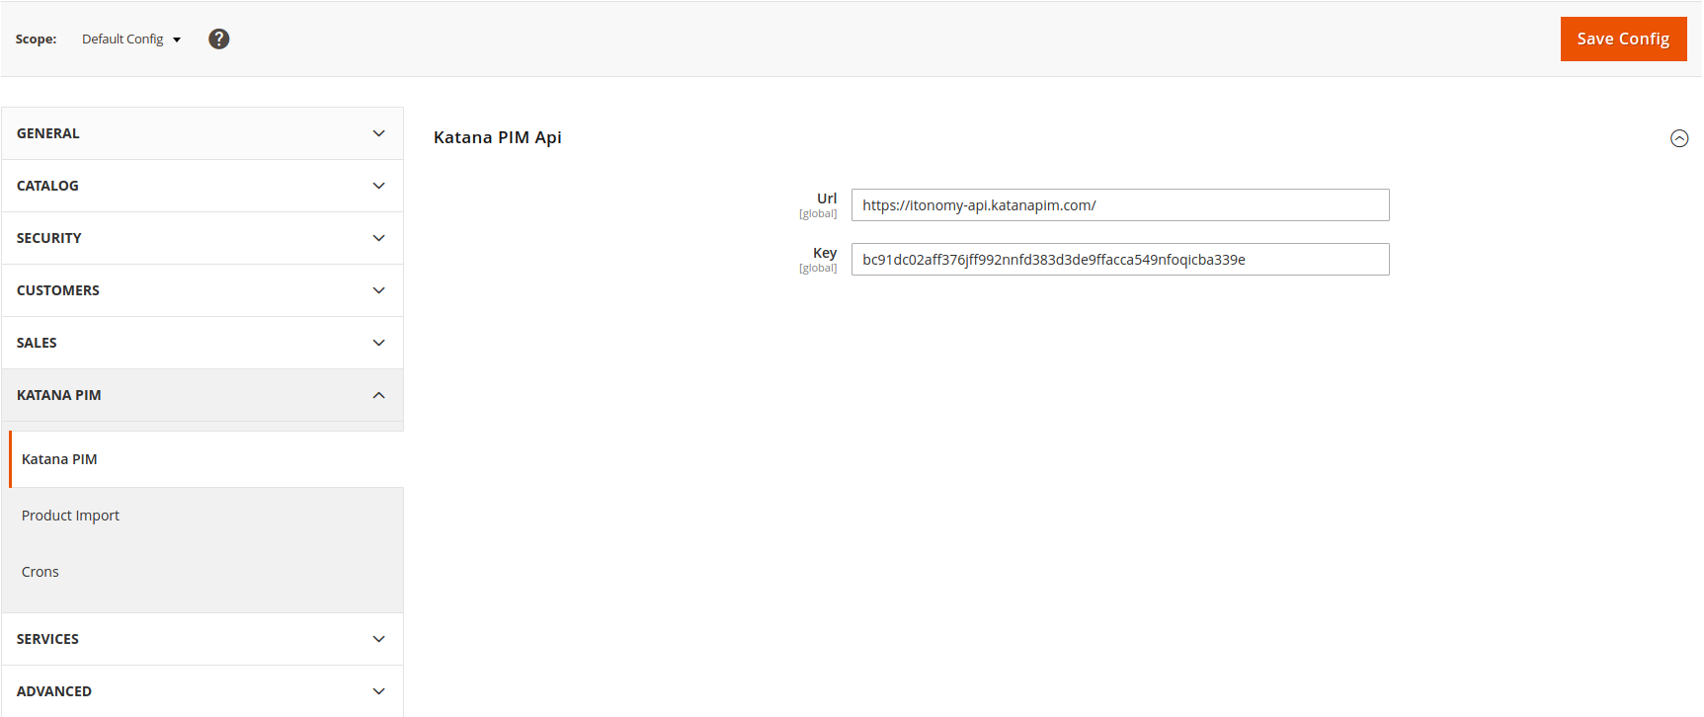

Enable/Disable the Product Import under:
Stores > Setting > Configuration > KATANA PIM > Product Import > General > Enable Product Import

Images are stored in a temporary folder before they are assigned to products. Existing images are not re-downloaded. Enabling this option will save disk-space and will ensure that corrupt/partially-downloaded images are not kept, but it will slow down subsequent imports. This can be configured under:
Stores > Setting > Configuration > KATANA PIM > Product Import > General > Enable Product Import

The relationship between KatanaPIM language and Magento store view for localized attributes such as Description, Product Name, etc. can be configured under:
Stores > Setting > Configuration > KATANA PIM > Product Import > Store Languages > Store Language Mapping

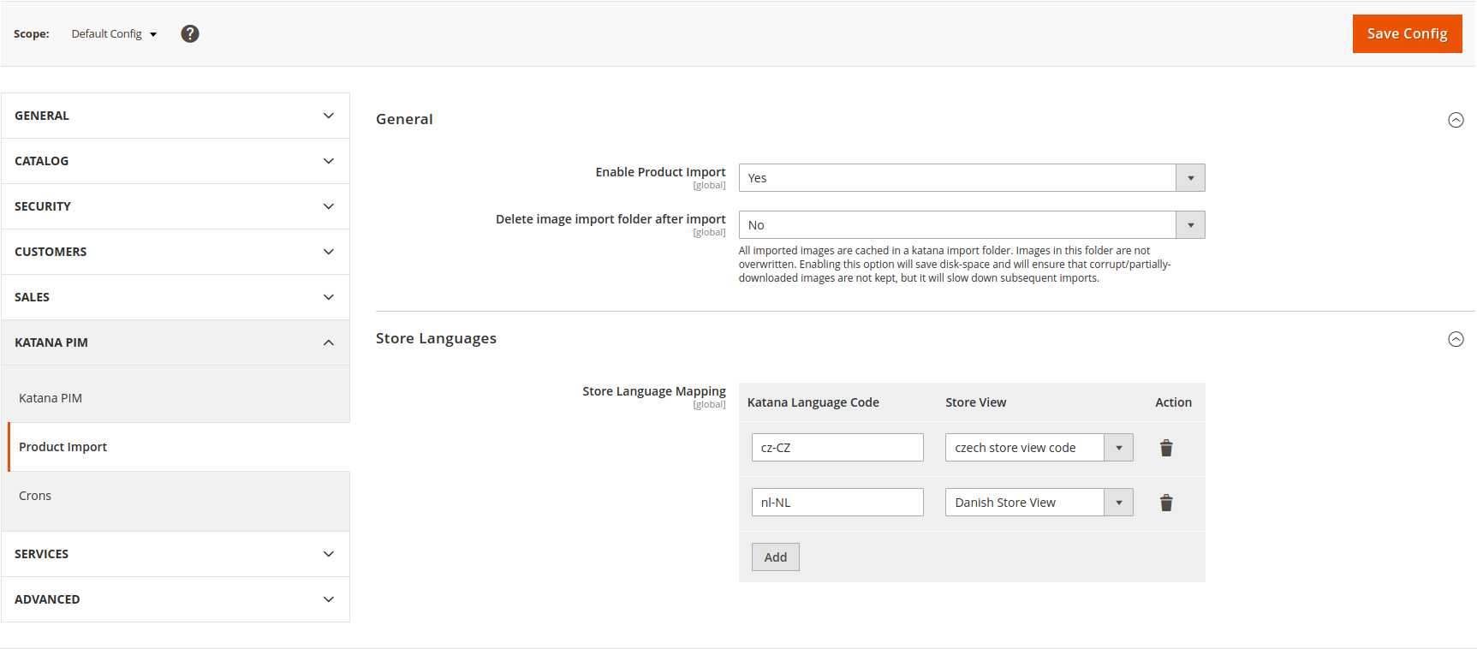
The cronjob timings for the Import Jobs can be configured under:
Stores > Setting > Configuration > KATANA PIM > Crons > Crons > [..]
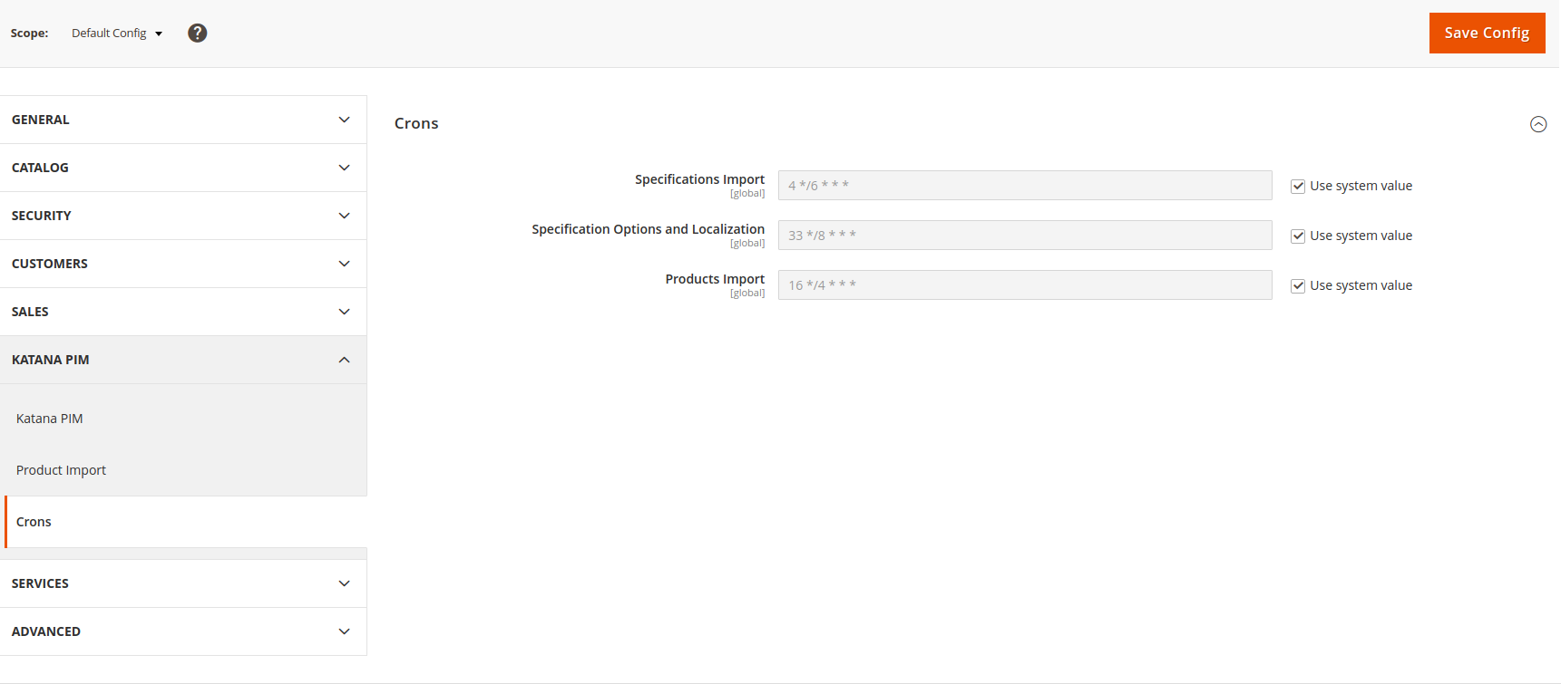

Specifications Import

Before the product import starts, the import and mapping of specifications must be complete. In magento we call these attributes.

The first step is importing specifications from KatanaPIM. This can be done via cronjob mentioned above or via a CLI command: katana:import:specifications

After running this import is done, a list of rows should be visible in the KatanaPIM Attributes Mapping grid under KatanaPim tab (Katana PIM > Attributes Mapping):

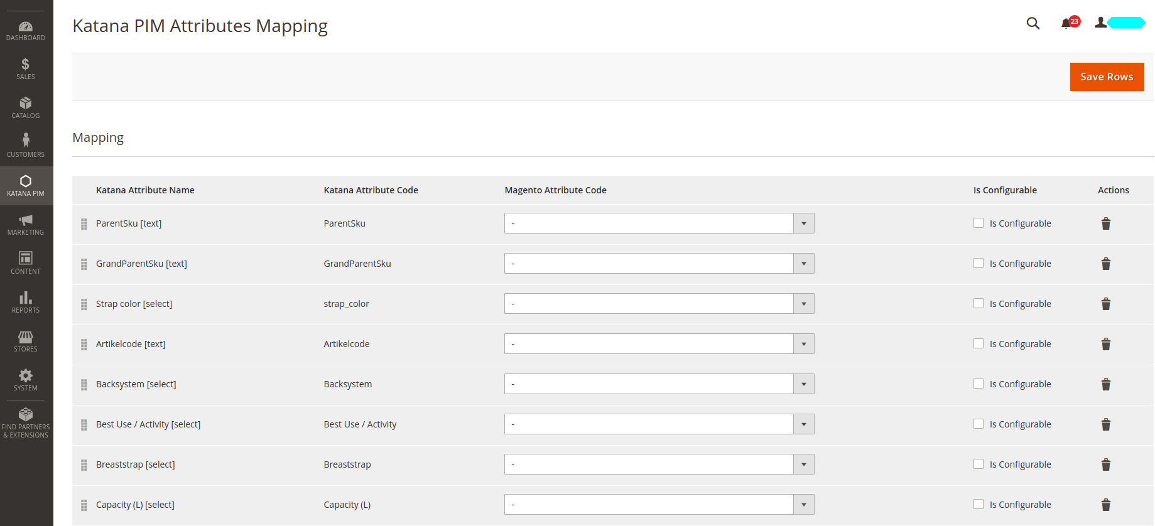

Next the dropdown values under Magento Attribute Code should be filled with corresponding magento attribute codes. Not all dropdown values have to be filled – only the ones which apply.

The ticks under Is Configurable mark the configurable attributes which will be used for configurable product variations (simple products).

Specification Options and Translations Import

After the specifications have been defined and mapped, the attribute options, attribute translations and attribute option translations can be imported. This can be done via cronjob mentioned above or via a CLI command: katana:import:specifications:localization

After this is done you should check to verify that the attribue options in magento are imported as expected. For example here we have Color attribute with 4 options, one of which is translated in Danish Store View.
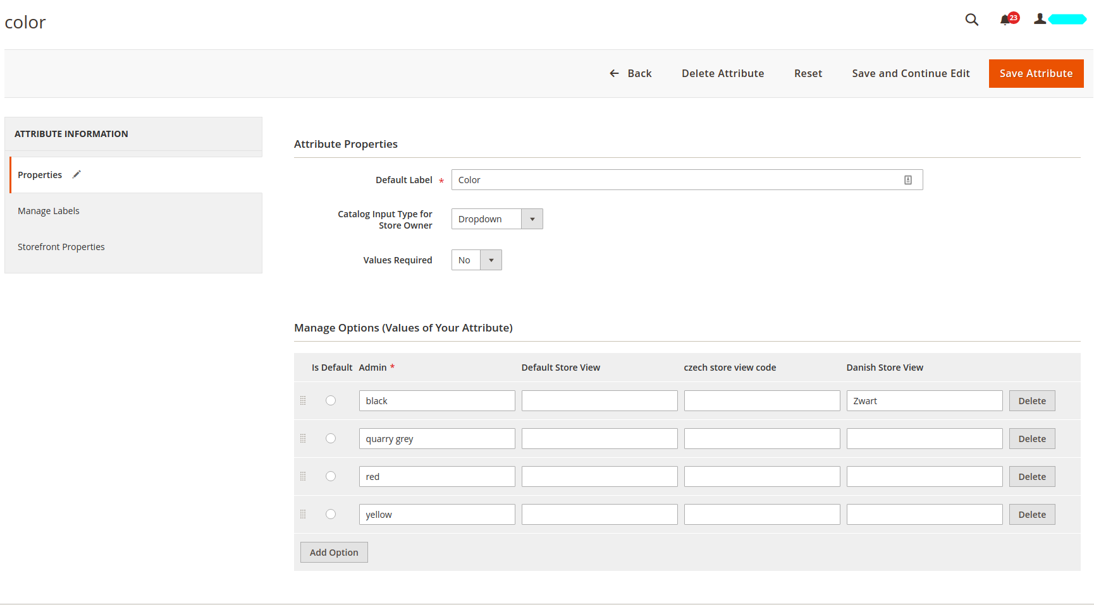

Product Import

After the magento 2 attributes have been mapped to KatanaPIM Specifications as mentioned above, the product import can be done. This can be done via cronjob mentioned above or via a CLI command: katana:import:products

After the product import is complete clear the cache, ensure that the indexers have been ran. You should have successfully imported your products now.

Configurable Products Import

Because of the difference in data structures between KatanaPIM and Magento, creating configurable products requires several steps and careful attention to detail. For this example we will Assume that Product S is our child product (simple) and Product P a parent product (configurable). We will assume that the products are supposed to be linked together by “Color” attribute in magento. In order to link the two together in Magento, the following prerequisites must be met:
- Product S is a simple product in KatanaPIM and Product P a parent product of Product S
- Product S and Product P should bot h contain Specification Group XYZ, where Specification Group XYZ contains Specification “Color” in KatanaPIM. Other specifications can also be part of this specification group, but it must contain the specifications which will be used for linking.
- Specification/Attribute “Color” must be imported in magento and mapped to an attribute. The attribute must be a global attribute and a dropdown attribute.
- Specification/Attribute “Color” must be marked as configurable in the Magento2 Attribute Mapping configuration (Katana PIM > Attributes Mapping)
- Product S must contain a valid value in “Color” Specification/Attribute in KatanaPIM.

Categories Import and assignment to products

There is a configuration in magento that must be switched on in order to ensure that categories are successfully assigned to their products. This can be configured under:
Stores > Setting > Configuration > KATANA PIM > Product Import > General > Import Categories
and is set to Yes by default.
Common issues / Troubleshooting / Known issues

Issue: Unable to save KatanaPIM Attribute Mapping from admin panel. Clicking “Save” redirects to admin/index.

Cause:
This is a known issue in Apache systems. It appears when there are a lot of Attributes and the “Save” request passes all of them to the Controller. Check your logs and see if they contain the following warning:
PHP Warning: Unknown: Input variables exceeded <n> [..]

Solution:
Increase the php configuration value max_input_vars for your server. The exact value depends on how many attributes you are trying to save. Increase until the error dissapears.

Issue: Images not appearing on frontend. Error:
Error: Imported resource (image) could not be downloaded from external resource due to timeout or access permissions SKU = [..] KatanaPIM ID = [..]

Cause: Sometimes network issues / connectivity issues / unknown interruption may cause an image to become corrupted during the download process. If this happens, magento will be unable to assign this corrupted image to a product. The corrupted image will also remain cached until it is manually cleared.

Solution 1: Check the error to determine which product is it, find the faulty image which should be assigned to the product in [..]/pub/media/import/[..] and delete the corrupted image. Repeat import.

Solution 2: Go to Stores > Setting > Configuration > KATANA PIM > Product Import > General and switch the “Delete image import folder after import” to Yes. This will disable image caching and the images will get deleted after your next import.

Solution 3: Delete [..]/pub/media/import/ folder contents.

Issue: Products are not getting translated.

Cause/Solution 1: Check that the language is set to the corresponding value in KatanaPim under Stores > Setting > Configuration > KATANA PIM > Product Import > Store Lanuages

Cause/Solution 2: If any product import fails for global scope (image is corrupted, url-key duplicate, etc..) the sayd product will not import translations. Make sure such errors are solved first. They should be visible in the logs.

