Software Requirements Specification

for

VCon: A Video Consultation of Medical and Psychological Support for Covid-19 Patients

**Version 1.0 approved**

**Prepared by Clarence Bulaclac, Rosemarie Adoptante and Kimberly Ann Dela Cruz**

**Team NAMBAWAN**

**July 8, 2021**

**Table of Contents**

**Table of Contents ii**

**Revision History ii**

**1. Introduction 1**

1.1 Purpose 1

1.2 Document Conventions 1

1.3 Intended Audience and Reading Suggestions 1

1.4 Project Scope 1

1.5 References 1

**2. Overall Description 2**

2.1 Product Perspective 2

2.2 Product Features 2

2.3 User Classes and Characteristics 2

2.4 Operating Environment 2

2.5 Design and Implementation Constraints 2

2.6 User Documentation 2

2.7 Assumptions and Dependencies 3

**3. System Features 3**

3.1 System Feature 1 3

3.2 System Feature 2 (and so on) 4

**4. External Interface Requirements 4**

4.1 User Interfaces 4

4.2 Hardware Interfaces 4

4.3 Software Interfaces 4

4.4 Communications Interfaces 4

**5. Other Nonfunctional Requirements 5**

5.1 Performance Requirements 5

5.2 Safety Requirements 5

5.3 Security Requirements 5

5.4 Software Quality Attributes 5

**6. Other Requirements 5**

**Appendix A: Glossary 5**

**Appendix B: Analysis Models 6**

**Appendix C: Issues List 6**

**Revision History**

|  |  |  |  |
| --- | --- | --- | --- |
| **Name** | **Date** | **Reason For Changes** | **Version** |
| Clarence Bulaclac | 07/08/21 |  |  |
| Rosemarie Adoptante | 07/08/21 |  |  |
| Kimberly Ann Dela Cruz | 07/08/21 |  |  |

# Introduction

## Purpose

The VCon: A Video Consultation of Medical and Psychological Support for Covid-19 Patients is a system that connects patients to available doctors for online consultation. The purpose of this project is to help people who are tested to positive covid-19 that still need to monitor by the doctors. We are living in a new normal because of the covid-19 pandemic where the government forbids us to have physical contact with other people to avoid the virus because we never know if that person has a virus(covid-19) or not. This project will be helpful to the people and doctors.

The proposed system can assist with the support of the healthcare system for COVID-19 patients, doctors/physicians, psychologist, and medical institutions. VCon system can be used to provide remote doctor visits, improve medical care and service efficiency, and remotely track health conditions. The use of Vcon improves the provision of health services. Therefore, Vcon should be an important tool in caring services while keeping patients and health providers safe during COVID-19 outbreak.

**1.2 Document Conventio****n**

When writng SRS document for VCon: A Video Consultation of Medical and Psychological Support for Covid-19 Patients we used best font style, headings and style to make it more readable.

**1.3 Intended Audience and Reading Suggestions**

This project is a prototype for the online consultation between doctors and patients who are home quarantine because of being positive for covid-19. This has been implemented under the guidance of college professors. This document is written for the researchers, future reseacrhers, project manager, programmer, and user who is involved in the project VCon: A Video Consultation of Medical and Psychological Support for Covid-19 Patients.

**1.4 Project Scope**

The project will introduce a web-based system, including:

* Internet Access
* Person who is on the go can easily contact the staff if they want to ask questions.
* Doctors who can easily reach out the patients who are tested positive of covid-19 who needed to be monitored.
* Urban hospitals can reach remote patients.
* Provide benefits for patients and doctors to avoid travel cost.

## References

<https://nevonprojects.com/e-healthcare-online-consultation-and-medical-subscription/>

https://bmcpublichealth.biomedcentral.com/articles/10.1186/s12889-020-09301-4

# Overall Description

## Product Perspective

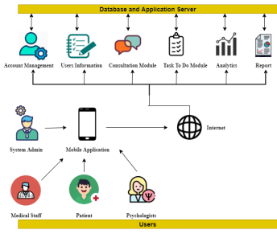

Figure 1.1

This figure shows the system architecture of the VCon: A Remote Video Consultation of Medical and Psychological Support for Covid-19 Patients mobile application. The primary users of the system are the System Administrator, Medical Staff, Psychologists, and Patients. In the middle part is the platform that is going to be used to fully access the mobile application. And for the last part of the figure is the Account Management, User Information, Consultation Module, Task To-Do Module, Analytics, and Report.

## Product Features

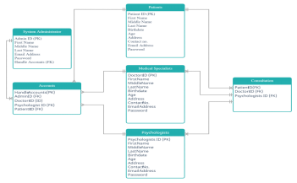

Figure 1.2 Entity Relationship Diagram of the VCon System

  Figure 1.2 shows that the entity-relationship of the patients to medical staff and psychologists. However, the diagram shows the relationship of other entities of the system.

## User Classes and Characteristics

There are three types of user: The Doctors, Covid-19 Patients and Psychologists

* The Doctors: These are the administrator that is responsible for up-keep data, monitoring the patients, updating and deleting records.
* Covid-19 Patients: These will be the users who will use our system.
* Psychologists. They will give medical advice to COVID-19 patients to help them understand treatment options, and to collaborate in order to achieve wellness and relief goals.

## Design and Implementation Constraints

The following constraints apply to the project. As project planning begins and more constraints are identified, they will be added accordingly.

* There are limited IT resources available to support the project and others, we are yet to find the institution that will help us.
* Time required to get a useful survey about the system right now, we can’t afford to go outside.
* As implementation will be done internally and not by the product developers or vendors, there will be limited support from the hardware/software providers.
* Healthcare project management stakes are high because effective project management will benefit from reduced costs and improved outcomes plus patient well-being is also a factor.

## User Documentation

* This system is a user-friendly
* Created with an easy environment to use. Will not have difficulties to use even if its yor first time in the system.

## Assumptions and Dependencies

The following assumptions apply to the project. As project planning begins and more assumptions are identified, they will be added accordingly:

* We need to collect all staff and employees for their respective data entry.
* All department heads will provide necessary support for successful project completion.
* Project has executive-level support and backing.

# System Features

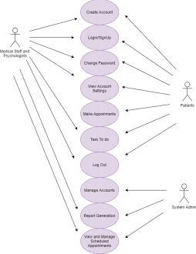

Figure 1.3 Use Case diagram

Figure 1.3 shows the actors or users of the VCon system which includes the patients, medical staff, psychologists, and system administrator. The figure also shows the different processes that can only be accessed by specified users.

## Front Page

*<Don’t really say “System Feature 1.” State the feature name in just a few words.>*

3.1.1 Description and Priority

The VCon: A Remote Video Consultation of Medical and Psychological Support for Covid-19 Patients maintain to still monitor their patients who is suffering home quarantine because of covid-19. This prjet is high priority because it would really help our frontliner or doctors to be safe.

3.1.2 Stimulus/Response Sequences

The user can book an appointment to their doctor for their consultation and the Doctors will receive a notification in their profile if their will be a patient that book an appointment in their respected date and time. User who will interact in the system should fill the forms for validation information then account profile will be displayed and they can now book an appointment to the doctors who is available. Then will be received a notification that the time of their consultation will proceed.

3.1.3 Functional Requirements

The user will be able to register for the booking for appointment where they can create ann account and login.

REQ-1: Create an account and LogIn, the users will create an account to login and to be able to use the system

REQ-2: Users can now book an appointment to the available doctors and pschologist.

REQ-3: They will notif you on your time of appointment

# External Interface Requirements

## User Interfaces

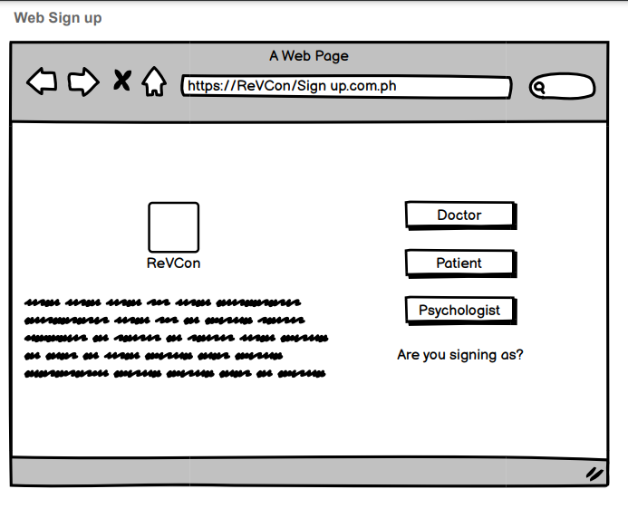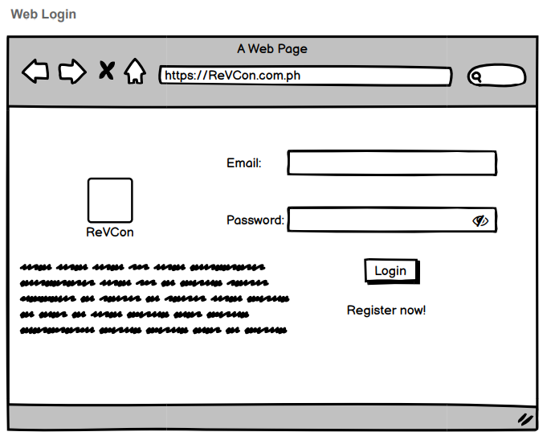

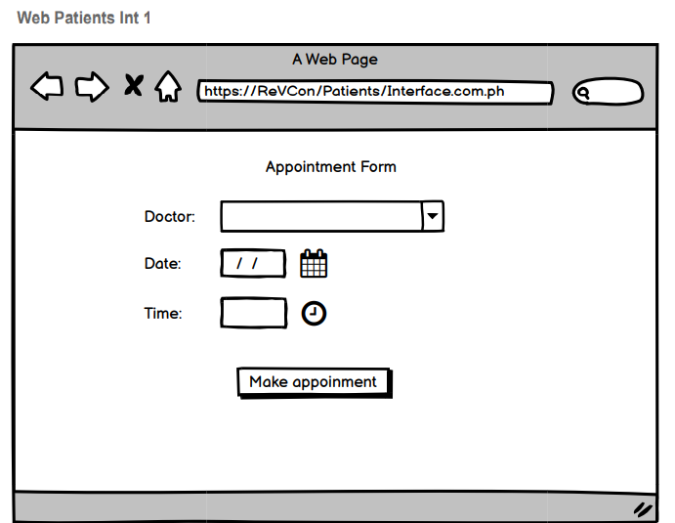

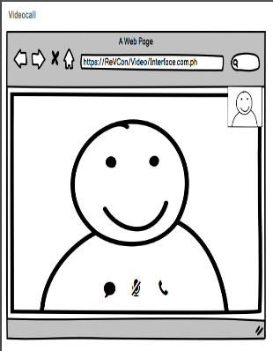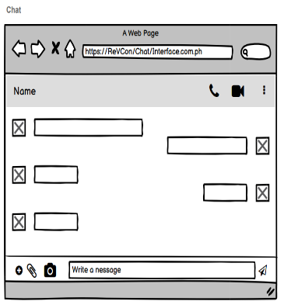

## Hardware Interfaces

* The only hardware needed is the android phone and the laptop or computer.
* The system will use the standard hardware and software resources.

## Software Interfaces

**OS:** Windows 10

We choose the Windows operating system because it is applicable to everyone and it’s easy to use.

**Developing Sotfware:** Php, MySQL and CSS

We used this because it is easy to used and we been used this before. So we have a little knowledge in using these.

**Browser:** Google Chrome

We used this because it is common for web pages.

## Communications Interfaces

* The system uses Email and Video chat for communication to send an updates for the user for services.

# Other Nonfunctional Requirements

## Performance Requirements

*<If there are performance requirements for the product under various circumstances, state them here and explain their rationale, to help the developers understand the intent and make suitable design choices. Specify the timing relationships for real time systems. Make such requirements as specific as possible. You may need to state performance requirements for individual functional requirements or features.>*

## Safety Requirements

* Their personal information will be safely kept by our system and it will not go for public.

## Security Requirements

* For Security Requirments, the user will need to have an email account to create an account in our system.

## Software Quality Attributes

* **Availability:** The system is available everyday with the specified dates and time.
* **Correctness:** The user should be ready before the time of consultant between the doctor or the pschologist.
* **Maintainability:** The administrator should update all the data to maintain the correct schedule and availability of the systems performance.
* **Usabilty:** The system should satisfy the user and admin in their expectation.

# Other Requirements

*<Define any other requirements not covered elsewhere in the SRS. This might include database requirements, internationalization requirements, legal requirements, reuse objectives for the project, and so on. Add any new sections that are pertinent to the project.>*

**Appendix A: Glossary**

Php - a server side scripting language that is embedded in HTML. It is used to manage dynamic content, databases, session tracking, even build entire e-commerce sites. It is integrated with a number of popular databases, including MySQL, PostgreSQL, Oracle, Sybase, Informix, and Microsoft SQL Server.

MySQL *-* MySQL was originally developed to handle large databases quickly. Although MySQL is typically installed on only one machine, it is able to send the database to multiple locations, as users are able to access it via different MySQL client interfaces. These interfaces send SQL statements to the server and then display the results.

CSS - stands for Cascading Style Sheets. It is a style sheet language which is used to describe the look and formatting of a document written in markup language. It provides an additional feature to HTML. It is generally used with HTML to change the style of web pages and user interfaces.

**Appendix B: Analysis Models**



Entity Relationship Diagram



Use Case Diagram

**Appendix C: Issues List**

* Communication Breakdown
* Mismanage Timeline
* Integration Issues