RURALHEALTH VISION
A Transformer-Based Healthcare Information and Educational Image Generation System for Rural Communities
MINOR PROJECT REPORT
Submitted in partial fulfillment of the requirements for the degree of
Bachelor of Technology in Computer Science and Engineering
INDIAN INSTITUTE OF INFORMATION TECHNOLOGY BHOPAL (M.P.)

Submitted by Submitted to

Naitik Shrivastava 24U023004 Dr. Ringki Das
Akshat Sharma 24U023008

Under the guidance of
[Guide Name and Designation]

TABLE OF CONTENT

S.no | Title | Page No.
 | Certificate
 | Declaration
 | Abstract
1 | Introduction | 1
2 | Literature review or Survey | 3
3 | Methodology & Work Description | 6
4 | Proposed algorithm | 8
5 | Proposed flowchart/ DFD/ Block Diagram | 12
6 | Tools & Technology Used | 13
7 | Implementation & Coding | 15
8 | Result Analysis | 20
9 | Conclusion & Future Scope | 27
10 | References | 29

INDIAN INSTITUTE OF INFORMATION TECHNOLOGY BHOPAL (M.P.)


This is to certify that the work embodied in this report entitled “RURALHEALTH VISION” has been satisfactorily completed by Naitik Shrivastava 24U023004 & Akshat Sharma 24U023008 .It is a bonafide piece of work, carried out under our guidance in the Department of Computer Science and Engineering, Indian Institute of Information Technology, Bhopal for the partial fulfillment of the Bachelor of Engineering during the academic year 2026-27.

Date:

Name of Supervisor(s), Head/Department Coordinator,
Designation, Department, Department of CSE,
IIIT Bhopal (M.P.) IIIT Bhopal (M.P.)

DECLARATION
We hereby declare that the following minor project report entitled “RURALHEALTH VISION” presented in the is the partial fulfillment of the requirements for the award of the degree of Bachelor of Technology in Computer Science and Engineering. It is an authentic documentation of our original work carried out under the able guidance of ”Dr. Ringki Das”. The work has been carried out entirely at the Indian Institute of Information Technology, Bhopal. The project work presented has not been submitted in part or whole to award of any degree or professional diploma in any other institute or organization.
We, with this, declare that the facts mentioned above are true to the best of our knowledge. In case of any unlikely discrepancy that may occur, we will be the ones to take responsibility.

Name of the student1 (Scholar number) Sign of student1 Name of the student2 (Scholar number) Sign of student2
ACKNOWLEDGEMENT

We, Naitik Shrivastava and Akshat Sharma, would like to express our sincere gratitude to everyone who supported and guided us throughout the successful completion of our minor project titled " RURALHEALTH VISION”.
First and foremost, we would like to extend our heartfelt thanks to our esteemed Director,
Dr. Ashutosh Kumar Singh, for providing us with the necessary resources and facilities for conducting our project. His encouragement and vision played a key role in helping us accomplish our goals.
We are deeply grateful to our Project Guide, Dr. Ringki Das, for her constant guidance, invaluable suggestions, and expert advice throughout the project. Her knowledge and insights helped us enhance the quality of our work, and her support kept us motivated during difficult times.
Our sincere thanks to the Department Coordinator, Dr. Rahul Chaurasia, for the valuable support and encouragement provided during completion of the project.
We would also like to express our gratitude to all the faculties of the Computer Science and Engineering for their valuable guidance and support in clarifying doubts and providing us with the right direction throughout the smooth execution of our project.
A special thanks to our friends for their continuous support, valuable suggestions, and helping us during various stages of the project. Their insights and encouragement motivated us to keep working on the project with enthusiasm.
Last but certainly not the least, we would like to express our deepest gratitude to our parents and family members for their love, patience, and continuous moral support throughout the course of this project. Their understanding and encouragement were the driving force behind our efforts.
We are truly thankful to everyone who directly or indirectly contributed to the success of this project. Without their assistance and support, this project would not have been possible.
Naitik Shrivastava – 24U023004
Akshat Sharma – 24U023008

ABSTRACT
RuralHealth Vision is a student-built web prototype for finding and sharing basic, source-linked health information. A user types a disease or health topic and a question. The local Flask application searches a JSONL collection of health passages, uses a saved DistilBERT question-answering checkpoint to select a possible answer span, and returns source links and a safety note. When requested and available, an active Google Colab runtime uses a Stable Diffusion pipeline to make artwork. The Windows app then adds a short summary and selected health facts to the illustration. The image model does not write or verify the medical text. The current data file contains 2,967 passages, 1,017 distinct topic labels, and 1,022 source URLs. Most imported MedlinePlus records are explicitly marked as not human reviewed. The project has no completed held-out QA benchmark, citation review, image relevance study, or end-to-end timing study. It is an educational prototype and must not be used for diagnosis or treatment decisions. Future work includes professional review of the data, checked QA examples, measured evaluation, support for Hindi and other Indian languages, voice input, accessibility improvements, and a more dependable image service.

1. INTRODUCTION

Background
People need health information that is easy to read, comes from a source they can check, and makes clear when professional care is needed. Finding this information can take time when a reader is not sure which website is trustworthy, when a page uses unfamiliar medical terms, or when internet access is slow. A small local collection of passages can make common information easier to find, but only if the passage remains connected to its original source and is kept up to date.
RuralHealth Vision is a student project that brings together a local web application, a health information collection, a question-answering model, and an optional poster generator. It is designed as a learning and awareness prototype. It does not examine a patient, understand a person's full health history, or replace a doctor, nurse, or community health worker. The World Health Organization's digital health strategy describes the need to use digital tools in a way that supports health systems and access, while its guidance on AI stresses safety, human oversight, equity, and accountability [10], [11]. Those principles are important in this project because clear sources and honest limits matter more than a confident-looking answer.

Project Overview
A user enters a health topic and a question such as “How can dengue be prevented?” The Flask app checks the input and searches a JSONL file containing health passages. It ranks passages by overlap between words in the question and words in each record, adds a boost for the selected topic, and may add a section boost for intents such as prevention or treatment. The top passages are given to a local DistilBERT extractive question-answering checkpoint. The model predicts a possible text span; the app also keeps the passage and source URL available so the answer can be checked.
If the user asks for a poster, the Windows app can send only the disease name and a fixed image topic to a small authenticated service in Google Colab. The Colab notebook uses a Stable Diffusion pipeline to return artwork without words. The local app then places a short summary and selected facts on the artwork. This separation is deliberate: the image model is not asked to spell medical advice or decide what a patient should do. When the tunnel or GPU is unavailable, the app can produce a local SVG infographic instead. Colab is a temporary notebook service with changing resource availability and limits; it should not be described as a permanent hosting service [25], [26].

Why This Project Was Built
The project addresses a practical information problem: a person may know the name of a health topic but not the best phrase to search, and a long source page can be difficult to turn into a short poster. A source-linked interface can help a learner move from a question to a relevant passage and then open the source. A poster can make a small number of key ideas easier to discuss in a classroom or community session. The project does not claim that the system improves clinical outcomes, reduces disease, or serves every rural user. These are questions for later field work, not results established by the current code.

Aim and Scope
The aim is to build a working prototype that finds basic health information from a local passage collection, shows source links, and optionally prepares an educational visual. The current implementation is in English. It accepts typed questions, filters by a topic name, and uses keyword retrieval with a saved extractive QA model. Poster artwork is optional and depends on the active Colab and ngrok session. The project does not use a vector database, a clinical knowledge graph, a diagnosis model, or a permanent GPU service. It has not completed a formal medical review or a clinical evaluation.

Report Roadmap
The report first reviews health information sources, extractive question answering, retrieval, diffusion image generation, and safety. It then states the problem and objectives, explains the data and application workflow, and gives pseudocode and original diagrams. The implementation chapter describes the actual files and selected code patterns. Results separate verified counts and the small retrieval check from evaluations that have not been carried out. The report closes with limitations, future work, references, publication status, and spaces for project screenshots and the Turnitin report.

2. LITERATURE REVIEW

Trusted Health Information
Health information is most useful when it can be traced to an identifiable publisher and the reader can follow the link to the original page. The World Health Organization publishes fact sheets on conditions such as dengue, malaria, tuberculosis, cholera, and rabies [1]–[5]. These pages explain public health facts, spread, prevention, and when care matters. In India, ICMR's Standard Treatment Workflows provide structured clinical workflows for many conditions [8], and the National Centre for Vector Borne Diseases Control publishes information and programme material for vector-borne diseases [9]. Such sources are not interchangeable: a public fact sheet is written for general information, while a treatment workflow may be aimed at health workers. The system therefore displays a source name and URL instead of presenting an extracted passage as if it were a new clinical guideline.
MedlinePlus is maintained by the U.S. National Library of Medicine and provides public health topic pages with summaries and links to further information [6]. Its topic XML format describes fields such as topic name, URL, and full summary [7]. RuralHealth Vision's importer uses this XML route to prepare passages, retains each topic's URL, and separates overview, cause, treatment, and prevention passages when the source text contains sentences that match the relevant section patterns. This is a useful way to expand a demonstration corpus. It is not equivalent to a clinical editorial process: the importer marks these records `NOT_HUMAN_REVIEWED`, and records must be checked before being used in a public health setting.

Transformer Models and DistilBERT
The Transformer architecture uses attention to relate parts of a sequence to one another, rather than processing words only in a fixed left-to-right recurrent path [12]. BERT showed that a bidirectional Transformer encoder, first trained on large text collections and then adapted to a task, can be used for language understanding [13]. DistilBERT is a smaller student model trained by distillation from BERT. Its authors describe a reduced model that is faster and smaller while retaining much of the teacher's benchmark performance [14]. This makes DistilBERT a reasonable starting point for an educational prototype where a full-size model would be harder to run locally.
In this project the model type is extractive question answering. The input is a question and a passage. The model assigns scores to possible start and end tokens, and a selected span from that passage becomes a candidate answer. The application code loads the tokenizer and `AutoModelForQuestionAnswering` from the local `models/ruralhealth-qa` folder and runs inference without gradient updates. The user interface can still show the source passage when a clear span is not returned. The result should not be confused with a generative model that writes a new medical explanation from its own memory.

Extractive Question Answering
The Stanford Question Answering Dataset (SQuAD) established a widely used format for reading-comprehension questions whose answers are spans inside a supplied passage [15]. SQuAD-style data fits this project's extractive approach: each example contains a question, a context, an answer string, and the answer's character start position. The training script turns the character location into token start and end labels. The starter train and validation files in the project are examples only and still contain replacement text; they are not a valid training or evaluation set.
SQuAD 2.0 added questions that cannot be answered from the provided passage, because a model that is forced to choose some span may guess when evidence is missing [16]. This is directly relevant to health information. A production system should include carefully written unanswerable examples and a calibrated abstention rule. The current project displays a cautious fallback when the model cannot extract a direct answer, but this fallback has not been measured against a held-out set. Hugging Face's question-answering documentation describes the standard model and tokenizer workflow [17], and its Trainer API supplies a training loop and evaluation hooks [18]. These tools help implement the model but do not guarantee that the project's medical data or predictions are correct.

Passage Retrieval and Evidence
Question answering needs a relevant passage before a model can select an answer. A simple retrieval method can compare the words in a query with the words in candidate records and rank records by overlap. RuralHealth Vision uses this lightweight baseline, filters records using the entered topic, and gives extra weight to some section labels when a question asks about prevention, causes, treatment, or urgent care. It can run on a normal laptop without downloading an embedding model or setting up a vector database.
The trade-off is that keyword overlap is sensitive to wording. “Spread” and “transmission” may be related but do not necessarily share tokens. A broad topic such as “carbohydrates” may match an overview even when a user wants a specific section. The code's small retrieval check illustrates this limitation: in the checked three-query smoke test, the expected section was found for malaria and rabies but not for dengue prevention. That 2/3 result is a narrow check of expected-section retrieval, not a reliable estimate of real-world Recall@5. A next version should compare the current baseline with BM25 and multilingual or biomedical sentence embeddings on a labelled query set, with queries and documents split carefully to avoid leakage.

Diffusion Models for Poster Artwork
Diffusion models generate an image through a sequence of denoising steps. Ho, Jain, and Abbeel describe a probabilistic diffusion process that learns to reverse a gradual noising process [19]. Latent diffusion models perform much of this work in a compressed image representation, which can reduce computation while supporting high-resolution image synthesis [20]. Stable Diffusion pipelines use text conditioning to guide a generated image, and Hugging Face Diffusers provides the pipeline interface used by the Colab notebook [21]. The project code may vary the art direction and asks for one portrait scene without words, labels, logos, or medical claims.
The image is an illustration, not evidence. Diffusion systems may produce irrelevant objects, culturally unsuitable scenes, visual artifacts, or inaccurate visual cues. They are also poor at rendering exact text. RuralHealth Vision therefore keeps the health copy out of the prompt and composes the poster text locally using Pillow [24]. This preserves readable text and lets source links be shown separately. The team has not performed a human relevance or cultural-fit rating study. A future LoRA experiment could adapt a base image model to a carefully licensed visual style, but it would require a curated image set, permission checks, and separate safety review [22].

Flask, Colab, and Temporary Tunnels
Flask is a small Python web framework that supports URL routes, request handling, and JSON responses [23]. The local app uses it for the form and its `/api/health-explain` endpoint. In this architecture, the model and data stay on Windows, while Colab supplies optional GPU inference for illustration. The notebook creates a temporary local web service and pyngrok exposes a public tunnel to the active notebook [26]. The tunnel address can change after restart, tokens must match on both sides, and a running notebook is required. Colab documents dynamic resource limits and says that runtimes can terminate; its managed free runtimes also restrict certain persistent web-service use [25]. The current tunnel should be used only for a controlled demo that complies with the current service terms, not as a stable public deployment.

Safety, Accessibility, and the Project Gap
WHO guidance on AI for health calls for human autonomy, safety, transparency, accountability, inclusion, and continuing assessment [11]. For this prototype those ideas translate into practical requirements: show the sources, keep a visible educational-use warning, do not claim diagnosis, do not invent missing answers, and have a person review imported passages. The user interface should be usable with keyboard navigation, clear labels, readable contrast, and text alternatives for images. WCAG 2.2 gives accessibility criteria that can guide a later interface review [28].
The project gap is not the absence of health pages or image models. The challenge is connecting local source passages, a question interface, an answer span, attribution, and optional poster art without blending these roles. RuralHealth Vision demonstrates that connection in a local student prototype. Its contribution should be described as an implemented workflow and a starting point for evaluation, not as a validated health information service. The present review also shows a gap in the project's evidence: the repository has no completed QA benchmark, no clinical content review, and no poster rating data.

3. PROBLEM DEFINITION AND OBJECTIVES

Problem Definition
A user may ask a short question about a disease but receive a long page, an irrelevant search result, or a response that is hard to verify. A simple poster can help communicate a few facts, but image generators often make misspelled or invented words. A local health application must therefore retrieve a useful passage, show the source behind it, keep the answer within the evidence, and separate illustration from medical text. The problem addressed by this project is to build and demonstrate this connected workflow on a Windows laptop, using a temporary Colab GPU service only when an illustration is requested.

Project Objectives
- Provide a web form where a user can type a health topic and a plain-language question.
- Search a local JSONL collection and rank topic-matched passages using the current keyword and section-weight baseline.
- Use a local DistilBERT extractive QA checkpoint to select a possible answer span from retrieved evidence.
- Return source names and links so users can inspect the original health pages.
- Offer a short educational poster that overlays source-based text on generated artwork when the Colab service is available.
- Keep an SVG poster fallback for times when image generation is not configured or the temporary service fails.
- Show clear limitations and avoid presenting the prototype as a diagnosis, treatment plan, or emergency triage service.

Scope and Non-Goals
The current scope is an English-language demonstration using a local data file, local retrieval, local QA inference, and optional remote image generation. It does not collect patient records, personalize advice, prescribe medicines, confirm a disease, send a patient to a clinic, or guarantee that every topic has a section-specific source. It is not a substitute for official guidance or trained health staff. The prototype does not include Hindi or voice input yet; these are future goals. It also does not provide an always-on public Colab API. Any extension must be reviewed for privacy, service terms, reliability, and medical safety before real users depend on it.
Table 1. Project objectives and evidence in the current build
Objective | Implementation evidence | Current status
Typed question interface | Flask page and POST endpoint | Implemented
Topic-based source search | Keyword overlap, topic filter, section weights | Implemented; limited smoke check
Extractive QA | Local DistilBERT checkpoint folder | Loads from local path; no held-out score
Source attribution | Document source name and URL in response | Implemented; no human citation audit
Poster artwork | Optional Colab Diffusers + ngrok bridge | Works only during active session
Hindi, voice, and offline image service | Not present in current build | Future work

4. PROPOSED METHODOLOGY AND WORK

Overall Method
The project is organized as a small set of connected steps rather than one model that performs every task. First, source pages are prepared as local passages with identifiers, topic labels, sections, publisher names, and URLs. Second, the web app validates the user's topic and question. Third, retrieval selects passages from the local file. Fourth, the QA model proposes a span from one selected passage. Fifth, the response returns the answer together with the evidence and safety notice. If a poster is requested, image generation supplies art only; the local app adds text and source labels. This division makes it easier to find which stage failed and reduces the chance that the image generator will create health instructions.

Data Collection and Source Fields
The main data file is `data/medical_documents.jsonl`. Each non-empty line is a JSON record containing a document identifier, disease or health-topic label, section, text, source name, source URL, and language. The current file also keeps a `last_verified` value. A source row should be traceable to the page from which its wording came. A stable identifier helps avoid accidental duplicates and supports later updates. URLs are retained as source links rather than converted into untraceable generated citations.
The collection currently contains 2,967 passages with 450,137 whitespace-separated words, 1,017 distinct topic labels, and 1,022 unique source URLs. Of the passages, 2,943 are MedlinePlus imports and 24 have the source name World Health Organization. All records are marked English. The imported records are marked `NOT_HUMAN_REVIEWED`; only a small portion of manually curated records have review markers or a verification placeholder. These counts describe the file, not the number of medically validated diseases. A topic label may represent a condition, symptom, or general health subject.

Importing MedlinePlus Topics
The importer in `scripts/import_medlineplus_topics.py` reads the official MedlinePlus XML download page, locates the latest compressed topic archive, extracts the topic XML, and selects English entries with a sufficiently long summary. It uses an HTML parser to remove embedded markup while keeping readable words. It writes an overview record and creates cause, treatment, or prevention records only when a sentence contains wording associated with that section. It also preserves prior non-MedlinePlus records when refreshing the imported data. This process is useful for preparing a larger search collection, but phrase matching is only a rough classification method. It can put a sentence in a section that needs correction, miss relevant text, or preserve wording that has since changed. Each imported passage needs human review before public use [6], [7].

4.4 Cleaning and Dataset Checks
Cleaning converts the source summary into plain text and collapses extra whitespace. The application uses `clean_passage` before the text is shown or searched. The data validator checks that required fields exist, document IDs are unique, URLs use HTTPS, and records are not suspiciously short. It does not decide whether a medical claim is accurate, whether a source is still current, or whether the passage answers the right question. In the current file there are 87 passages with fewer than eight whitespace-separated words; these should be reviewed because the validator flags them as suspicious. The number of records tagged `NOT_HUMAN_REVIEWED` is 2,943, which should remain visible in project materials.
Table 2. Current local dataset profile
Field or check | Observed value | Meaning
Passages | 2,967 | One JSONL record per passage
Text word count | 450,137 | Whitespace-separated count; not a clinical quality measure
Topic labels | 1,017 | Includes general health topics as well as diseases
Unique source URLs | 1,022 | Links recorded in the data
MedlinePlus records | 2,943 | Imported; flagged not human reviewed
WHO records | 24 | Existing project passages
Not human reviewed | 2,943 | Must be checked before public health use
Short records (<8 words) | 87 | Review before relying on them

QA Training Data and Fine-Tuning
The project includes `training/train_qa.py` and two SQuAD-style example files. The example files still contain replacement instructions, so they must not be treated as completed labelled data. A valid example needs a real question, a reviewed source passage, the exact answer text copied from that passage, and the character index where the answer begins. Questions should include cases where the passage does not provide an answer, so the model can learn to abstain rather than guess [15], [16]. Training and held-out examples should be split by source document, not merely shuffled sentence rows, to reduce leakage between nearly identical passages.
The starter script loads `distilbert/distilbert-base-uncased` as an extractive QA model. It tokenizes question and context, truncates the context to a maximum length of 384 tokens with an overlap stride of 96, maps answer character offsets to token positions, and runs Hugging Face Trainer for three epochs with a learning rate of 3×10⁻⁵, batch size 8, and weight decay 0.01. It evaluates at each epoch and uses half precision when CUDA is available. The script saves model and tokenizer files. These are the settings in the current script, not a measured experiment report. The presence of a local checkpoint folder does not prove which training data produced it; a run log, seed, data version, and held-out evaluation must be kept for reproducibility.

4.6 Query Processing and Retrieval
When a request arrives, the app limits the lengths of the topic and question. `resolve_disease` normalizes capitalization and punctuation, looks for a normalized exact topic, and then uses a sequence-similarity score to select a close label when the score is high enough. The user is shown a note when the app has chosen a closest match. This is a convenience feature, not disease identification. A topic with several similar names should be checked by the user.
The retrieval function tokenizes the query and each record's topic, section, and text. It computes the fraction of query tokens found in the record, adds a topic match bonus, and adds section weighting for detected intent. It returns a small number of records for the QA stage. This baseline is easy to inspect and does not require an external embedding service. Its weakness is lexical matching: synonyms and spelling variations can lower the score. The project should compare it with a labelled baseline before claiming improved search quality.

Answer Extraction and Source Return
For each candidate passage, the tokenizer encodes the question and passage together. The model returns start and end logits; a softmax and a selection rule identify a possible span. The output is constrained to tokens belonging to the context. If the model cannot find a usable answer or the model files cannot load, the app can show a cautious fallback and relevant source excerpt. It should not turn the fallback into a confident claim. The source record travels with the passage so the response can show the publisher and URL beside the answer. The original source remains the place for confirmation.

Poster Creation and Failure Handling
For a poster, the app first builds a short summary and selects a few section-specific facts. The image prompt asks for one portrait community-health illustration and forbids words, numbers, labels, and medical claims. The Colab endpoint checks a bearer token, limits the accepted topic values, runs the loaded Diffusers pipeline, and returns a PNG. The local application receives the PNG and composes the text and source labels. This process distinguishes AI-generated artwork from source-based health copy. A generated image can still be irrelevant or misleading, so it should be reviewed before showing it as a public education material.
If the tunnel gives a 401, the local image token and Colab secret do not match. If it gives a 404, the base URL and endpoint path may have been combined twice. If the port is already in use, the notebook likely still has a server bound to that port. A 500 response indicates that image generation failed inside the service. The local app records an image error and can use its SVG fallback. Restarting Colab changes runtime state; the user must rerun the service cell and copy the new printed tunnel base URL. Google describes Colab as an interactive compute service with dynamic limits and restrictions, so it should not be relied upon as continuous application hosting [25].

Human Review and Content Safety
Before the data is used in a class or community event, a health professional should check the accuracy, reading level, age relevance, and source date of the passage. A community health worker can review whether wording is understandable and culturally appropriate. Emergency warning signs should be handled conservatively and point users to local medical care. The AI system should never be the only source of a treatment decision. WHO's guidance on responsible AI supports transparency, safety, human control, and ongoing review [11].

5. ALGORITHM

Main Query Algorithm
The following pseudocode describes the current request path. The image branch is optional and runs after the source-grounded text has been prepared.
INPUT: typed topic, question, optional poster request
1. Check that the topic and question are present and within length limits.
2. Normalize topic spelling and case; show a closest-match note if selected.
3. Detect question intent such as causes, treatment, prevention, or urgent care.
4. Filter local passages by topic and score each passage by query-word overlap.
5. Add topic and section-intent weights; keep the highest-ranked passages.
6. For each selected passage, run local DistilBERT extractive QA.
7. If a valid span is returned, pair it with its source name and URL.
8. If no clear span is returned, show a cautious fallback and evidence excerpt.
9. If poster requested: send only topic and fixed art topic to active Colab service.
10. If PNG returned, overlay short sourced text locally; otherwise compose SVG fallback.
11. Return answer, source links, safety note, and optional poster to the browser.
OUTPUT: educational information with traceable sources; no diagnosis or prescription.

Fine-Tuning Algorithm
- Prepare checked question, passage, answer, and answer-start records in SQuAD-style JSONL.
- Split by source document into training, validation, and held-out test sets.
- Tokenize question and passage, keeping overlapping windows for long contexts.
- Map answer character positions to start and end token indices; flag examples that do not align.
- Fine-tune the pretrained DistilBERT QA head on our healthcare dataset and save the tokenizer and checkpoint.
- Run exact match and token F1 on the held-out set, then review failures by topic and question type.
- Do not release the checkpoint until source content, privacy, and safety have been reviewed.

Error and Abstention Rules
The app should reject empty or oversized input, explain when a topic match is approximate, avoid inventing content for a missing topic, and show an evidence excerpt when an answer span is uncertain. Image errors should not block the health text response. The current project implements parts of this behavior, but it does not have a calibrated confidence threshold derived from a held-out medical QA evaluation. Any threshold in a later version must be chosen from measured results and checked by a health professional.

6. PROPOSED FLOWCHART, BLOCK DIAGRAM AND DFD

System Block Diagram
The system is split into a local answer path and an optional remote artwork path. The local path can return sourced text without the Colab service. The remote path returns an illustration, not medical advice.
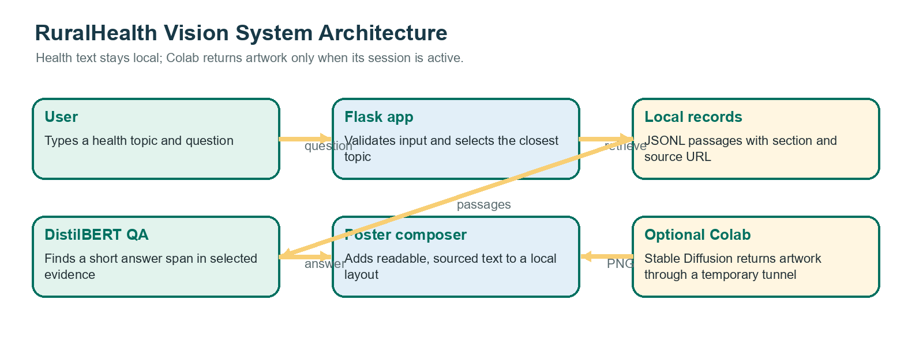
Figure 1. RuralHealth Vision system architecture designed for this report.

Data Flow Diagram Level 0
At Level 0, the user is the source of the topic and question and the recipient of the response. The app reads the local health corpus and QA checkpoint. When the user requests an image and the service is active, the app also exchanges an artwork request and PNG with Colab. The returned source references are part of the response, while user symptoms or other personal health details are not required by the image service.
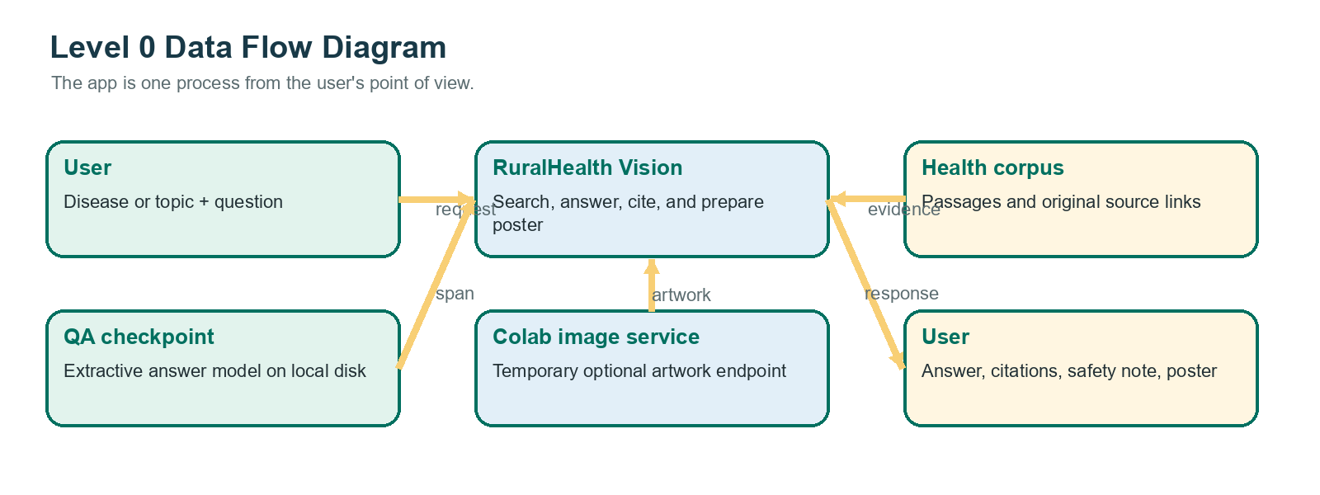
Figure 2. Level 0 data flow diagram with local data and optional Colab artwork.

Data Flow Diagram Level 1
The detailed flow separates input checks, retrieval, answer extraction, source return, image generation, and final composition. If step 5 fails, step 6 can still create a fallback infographic. This keeps a temporary image outage from hiding the answer and citations.
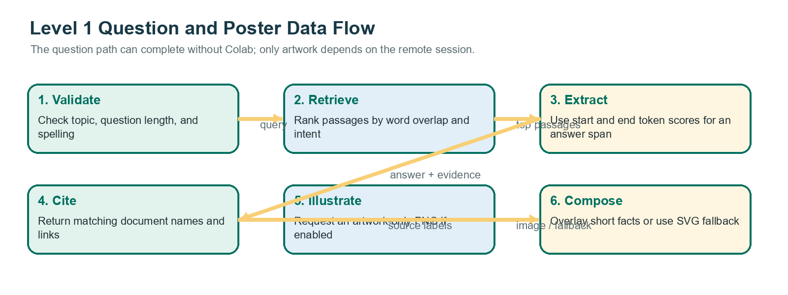
Figure 3. Level 1 flow from user question to source-linked answer and optional poster.

QA Training Flow
The training path begins with a source passage and human-checked answer span. It then converts the text into model tokens and trains the QA head. Only a held-out evaluation can show whether the model answers unseen questions accurately. The existing training template files are placeholders and must be replaced before this process can produce a valid project result.
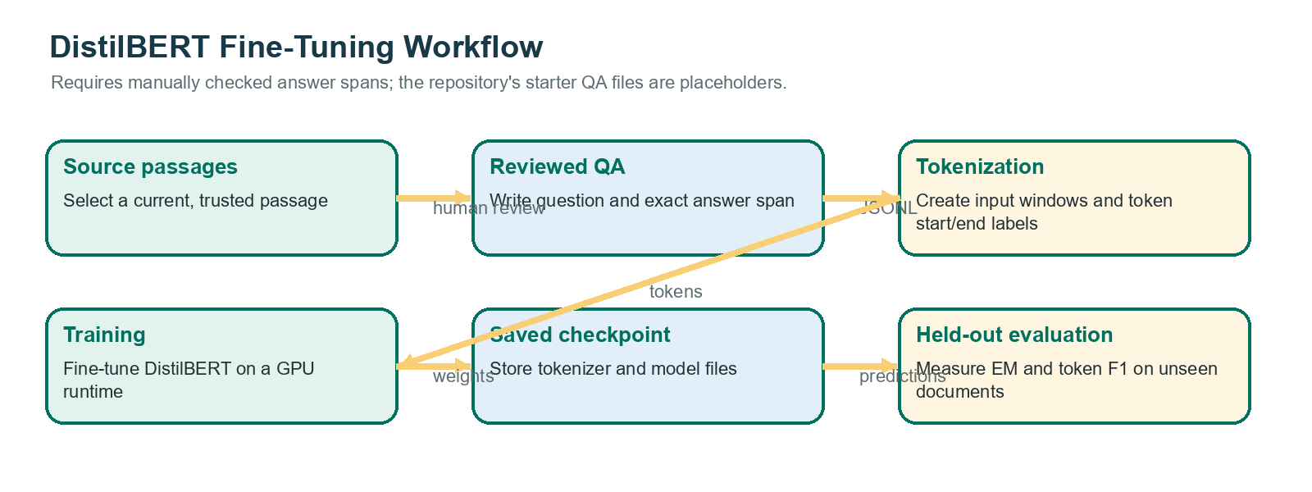
Figure 4. QA training and evaluation workflow designed for this report.

7. TOOLS, TECHNOLOGY AND IMPLEMENTATION DETAILS

Languages and Web Interface
Python is used for the Flask application, data import, retrieval, QA inference, image-service helper, and poster composition. HTML provides the page structure; CSS controls layout; JavaScript submits the request and displays the result. The UI lets a person type the health topic rather than choose from a fixed list. Text details and sources can be expanded separately from the poster. Flask routes the page and the JSON request, and its template layer is used to build the response [23].

Local Passage Store
The project uses JSON Lines instead of a database server. One line represents one passage, so the data can be inspected with a text editor and versioned. It is suitable for a small prototype but the app loads and searches records in process. At 2,967 passages this is a manageable demonstration, but more data or several users would justify a database and precomputed search index. The current importer and validation scripts are in the `scripts` folder. They should be run from the project root and the Flask process restarted after the data file changes.

DistilBERT and Transformers
The application imports `AutoTokenizer` and `AutoModelForQuestionAnswering` from Transformers when the model is first needed. It reads files only from `models/ruralhealth-qa`, uses local-only loading, and calls `model.eval()` before inference. PyTorch inference mode avoids recording gradients for this prediction-only call [27]. If the checkpoint is missing or dependencies fail, the app keeps running and records a model-loading error rather than crashing during module import. The saved model files occupy approximately 253 MiB for the safetensors weights in the checked project folder. No claim is made that this is a measured quality advantage over another model.

Retrieval Baseline
The current `retrieve` function is readable and has no external service dependency. It performs a simple token overlap calculation, topic match, and intent-based section weighting. It returns up to six passages in the Flask request path. That makes it useful as a baseline and straightforward to explain to a project evaluator. It is not semantic search: it may miss synonyms and can return a passage that shares common words but does not directly answer the question. The next comparison should use labelled topic-query pairs and report Recall@5 with a sample size.

Image Pipeline and Poster Composition
The image helper first checks `COLAB_IMAGE_API_URL` and `COLAB_IMAGE_API_TOKEN`. It posts JSON containing the topic and a fixed allowed image subject to the `/generate` route with bearer authentication. It expects `image/png` and times out after a bounded request period. If the environment variable is absent, the local Diffusers path is only enabled when `ENABLE_DIFFUSION=1` and a CUDA GPU is available. The user's Windows app can therefore use Colab without downloading Stable Diffusion weights onto the laptop. The actual Colab endpoint uses the pipeline already loaded by the notebook.
The Colab server validates the bearer token with a constant-time comparison, checks the disease name and allowed topic, and calls the already loaded pipeline. It saves the first generated image to an in-memory PNG response. The Windows app composes the poster locally and may use an SVG design if the PNG request fails. Ngrok's authtoken and RuralHealth image token serve different purposes: one authenticates the tunnel agent, and the other authenticates requests to the image endpoint. Neither secret belongs in source control. Colab's dynamic runtime behavior and restrictions mean that a stable production deployment requires a different hosting plan or service [25], [26].

Environment and Project Layout
The project separates data, model files, training, image integration, templates, static assets, and generated output. A simplified view of the current structure is shown below. The report keeps the actual files instead of suggesting a large refactor that has not been implemented.
RuralHealthVision/
├── app.py Flask API, retrieval, QA and poster composition
├── image_generation.py Windows-side image request client
├── colab_image_service.py Colab Flask endpoint and ngrok tunnel
├── data/medical_documents.jsonl Health passages with source links
├── models/ruralhealth-qa/ Saved local QA checkpoint and tokenizer
├── scripts/
│ ├── import_medlineplus_topics.py
│ └── validate_dataset.py
├── training/
│ ├── train_qa.py
│ ├── qa_train_template.jsonl
│ └── qa_validation_template.jsonl
├── evaluation/evaluate_retrieval.py
├── templates/ HTML page
├── static/ JavaScript and CSS
└── generated/ Poster files produced during use

Selected Implementation Code
The code extracts below are shortened from the project files to show the key design choices. They are examples of the implementation, not a complete replacement for the full source files.

Passage retrieval
def retrieve(query, disease=None, limit=5, intent=None):
qtokens = tokenize(query)
scored = []
for doc in DOCS:
if disease and disease.lower() not in doc["disease"].lower():
continue
dtokens = tokenize(doc["disease"] + " " + doc["section"] + " " + doc["text"])
score = len(qtokens & dtokens) / max(1, len(qtokens))
if disease and disease.lower() in doc["disease"].lower():
score += 0.6
if intent == "prevention" and doc["section"] == "prevention":
score += 0.8
scored.append((score, doc))
scored.sort(key=lambda item: item[0], reverse=True)
return [doc for score, doc in scored[:limit]]

Local extractive QA inference
tokenizer, model = get_qa_model()
encoded = tokenizer(
question, doc["text"], return_tensors="pt",
truncation="only_second", max_length=512,
return_offsets_mapping=True,
)
offsets = encoded.pop("offset_mapping")[0].tolist()
with torch.inference_mode():
outputs = model(**encoded)
start = torch.softmax(outputs.start_logits[0], dim=0)
end = torch.softmax(outputs.end_logits[0], dim=0)
# Select a context-only start/end span, then return it with the source record.

Colab authenticated generation route
@api.post("/generate")
def generate():
auth = request.headers.get("Authorization", "")
supplied = auth.removeprefix("Bearer ").strip()
if not hmac.compare_digest(supplied, token):
return jsonify({"error": "unauthorized"}), 401
payload = request.get_json(silent=True) or {}
disease = str(payload.get("disease", "")).strip()
topic = str(payload.get("topic", "")).strip().lower()
if not disease or topic not in _ALLOWED_TOPICS:
return jsonify({"error": "invalid disease or topic"}), 400
image = pipe(prompt=_prompt(disease, topic)).images[0]
buffer = BytesIO()
image.save(buffer, format="PNG")
buffer.seek(0)
return send_file(buffer, mimetype="image/png")

QA training settings
args = TrainingArguments(
output_dir=OUT_DIR,
learning_rate=3e-5,
per_device_train_batch_size=8,
per_device_eval_batch_size=8,
num_train_epochs=3,
weight_decay=0.01,
eval_strategy="epoch",
save_strategy="epoch",
fp16=torch.cuda.is_available(),
report_to="none",
)print("Pipeline ready on", pipe.device)

Image Generation model
import torch
from diffusers import StableDiffusionPipeline

assert torch.cuda.is_available(), "Select a GPU runtime in Runtime > Change runtime type."

MODEL_ID = "stable-diffusion-v1-5/stable-diffusion-v1-5"

pipe = StableDiffusionPipeline.from_pretrained(
MODEL_ID,
torch_dtype=torch.float16,
use_safetensors=True,
).to("cuda")

pipe.enable_attention_slicing()
print("Pipeline ready on", pipe.device)

Running the Local Application
A local Windows run uses a Python virtual environment, installs the basic requirements, and starts `python app.py` from the project directory. If image generation is enabled, the active PowerShell window must also contain the current Colab base URL and matching image token. These values should be stored outside the source code and should be changed if a token is exposed. The page can still return health text if Colab is not connected. A 401 means authentication failed; a 404 often means `/generate` was appended twice; and a 500 means the Colab handler reached an error while generating the image.

Security and Privacy Notes
The demo should not collect patient identifiers or send personal health details to the image service. Only the topic name and a fixed allowed art topic are intended for that request. Tokens should be placed in notebook secrets and local environment variables, not committed to Git or pasted into public screenshots. The development Flask server should remain local for demonstration and should not be exposed to the public internet with debug mode enabled [23]. A production system would need user authentication where appropriate, request limits, secure secret storage, logging rules, a privacy notice, backups, monitoring, and a service agreement for remote processing.

8. RESULTS AND COMPARATIVE ANALYSIS

Implemented Outputs
The current project folder contains the Flask application, the local JSONL corpus, a DistilBERT QA checkpoint directory, a Colab image-service helper, a Windows-side image client, templates, static assets, and generated output files. The interface can return source-linked health information and can show an educational poster. When the Colab connection works, the poster uses generated artwork with locally added text; if it does not, the app can return a local infographic fallback. These are observed implementation features. They do not by themselves prove that the retrieved answer is correct, the image is culturally appropriate, or the system is useful to community members.

Dataset Results
A direct count of the current `medical_documents.jsonl` file gives 2,967 records, 450,137 whitespace-separated words, 1,017 distinct topic labels, and 1,022 unique URLs. The records include 2,943 MedlinePlus passages and 24 WHO passages. A total of 2,943 entries carry the `NOT_HUMAN_REVIEWED` marker. These statistics show that the file is substantially larger than the original small starter collection, but the many imported summaries require review. The word count is a count of whitespace-delimited tokens, not a quality or coverage score.

Question-Answering Evaluation
The model folder contains a saved QA checkpoint and tokenizer, but no completed held-out medical question set or saved Exact Match and token F1 scores were found in the project. The training and validation JSONL files still contain placeholder text. Therefore QA Exact Match and QA Token F1 are not measured in this report. The next evaluation should use manually checked questions with exact answer spans, source-document-level splits, and unanswerable examples. Exact Match should count a prediction correct only when the normalized answer matches a reference answer exactly; token F1 should measure token overlap. Both should be reported with the number of test examples and a breakdown by question type [15]–[18].

Retrieval Smoke Check
The repository includes a three-query retrieval smoke check. It asks for dengue prevention, malaria transmission, and rabies after-bite guidance, then checks whether an expected section appears in the returned top five. The current run found the expected section for malaria and rabies but did not find the expected prevention section for dengue. This gives 2 of 3 checks, or 66.7%, for this tiny smoke test. It is not a reliable Recall@5 estimate because the query set has only three examples and is not a reviewed, representative test set. The miss is useful because it shows that the current keyword search can fail even for a familiar topic.
Table 3. Evaluation measures available from the project
Measure | Observed result | Interpretation
Dataset words | 450,137 | Measured from current JSONL text
QA Exact Match | Not measured | No completed held-out QA labels
QA token F1 | Not measured | No completed held-out QA labels
Retrieval smoke check | 2/3 (66.7%) | Expected section in top 5; tiny unlabelled prototype check
Citation support | Not measured | No human-reviewed citation sample
Image relevance | Not measured | No human scoring rubric or ratings
End-to-end latency | Not measured | No timed test log; Colab availability changes

Medical Grounding and Citation Review
The app attaches the original source name and URL to the retrieved passage. This makes claims easier to check, but the project has not yet counted whether every citation directly supports each displayed statement. Citation support must be evaluated by a person who reads the linked page, checks whether the poster paraphrase is faithful, and records pass, partial support, or unsupported. A sample should include different publishers and topics and should be reviewed by at least two people when possible. Until such an audit is done, the correct result is “not measured.” The 2,943 unreviewed MedlinePlus records are an additional reason not to describe the corpus as medically validated.

Poster and Image Results
The poster compositor places a short answer summary and selected source facts on the image using Pillow. The image-generation prompt explicitly requests artwork without words, so the diffusion model is responsible for visual illustration only. This is preferable to relying on the image model to draw long text. However, there is no documented user-rating study or image relevance score in the project. A human review should score whether the visual matches the topic, avoids frightening or misleading content, respects local culture, and leaves enough contrast for text. The exact model ID and version used in the Colab notebook should be copied into the final project log because the code only proves that a Stable Diffusion pipeline is used, not which checkpoint produced each image.
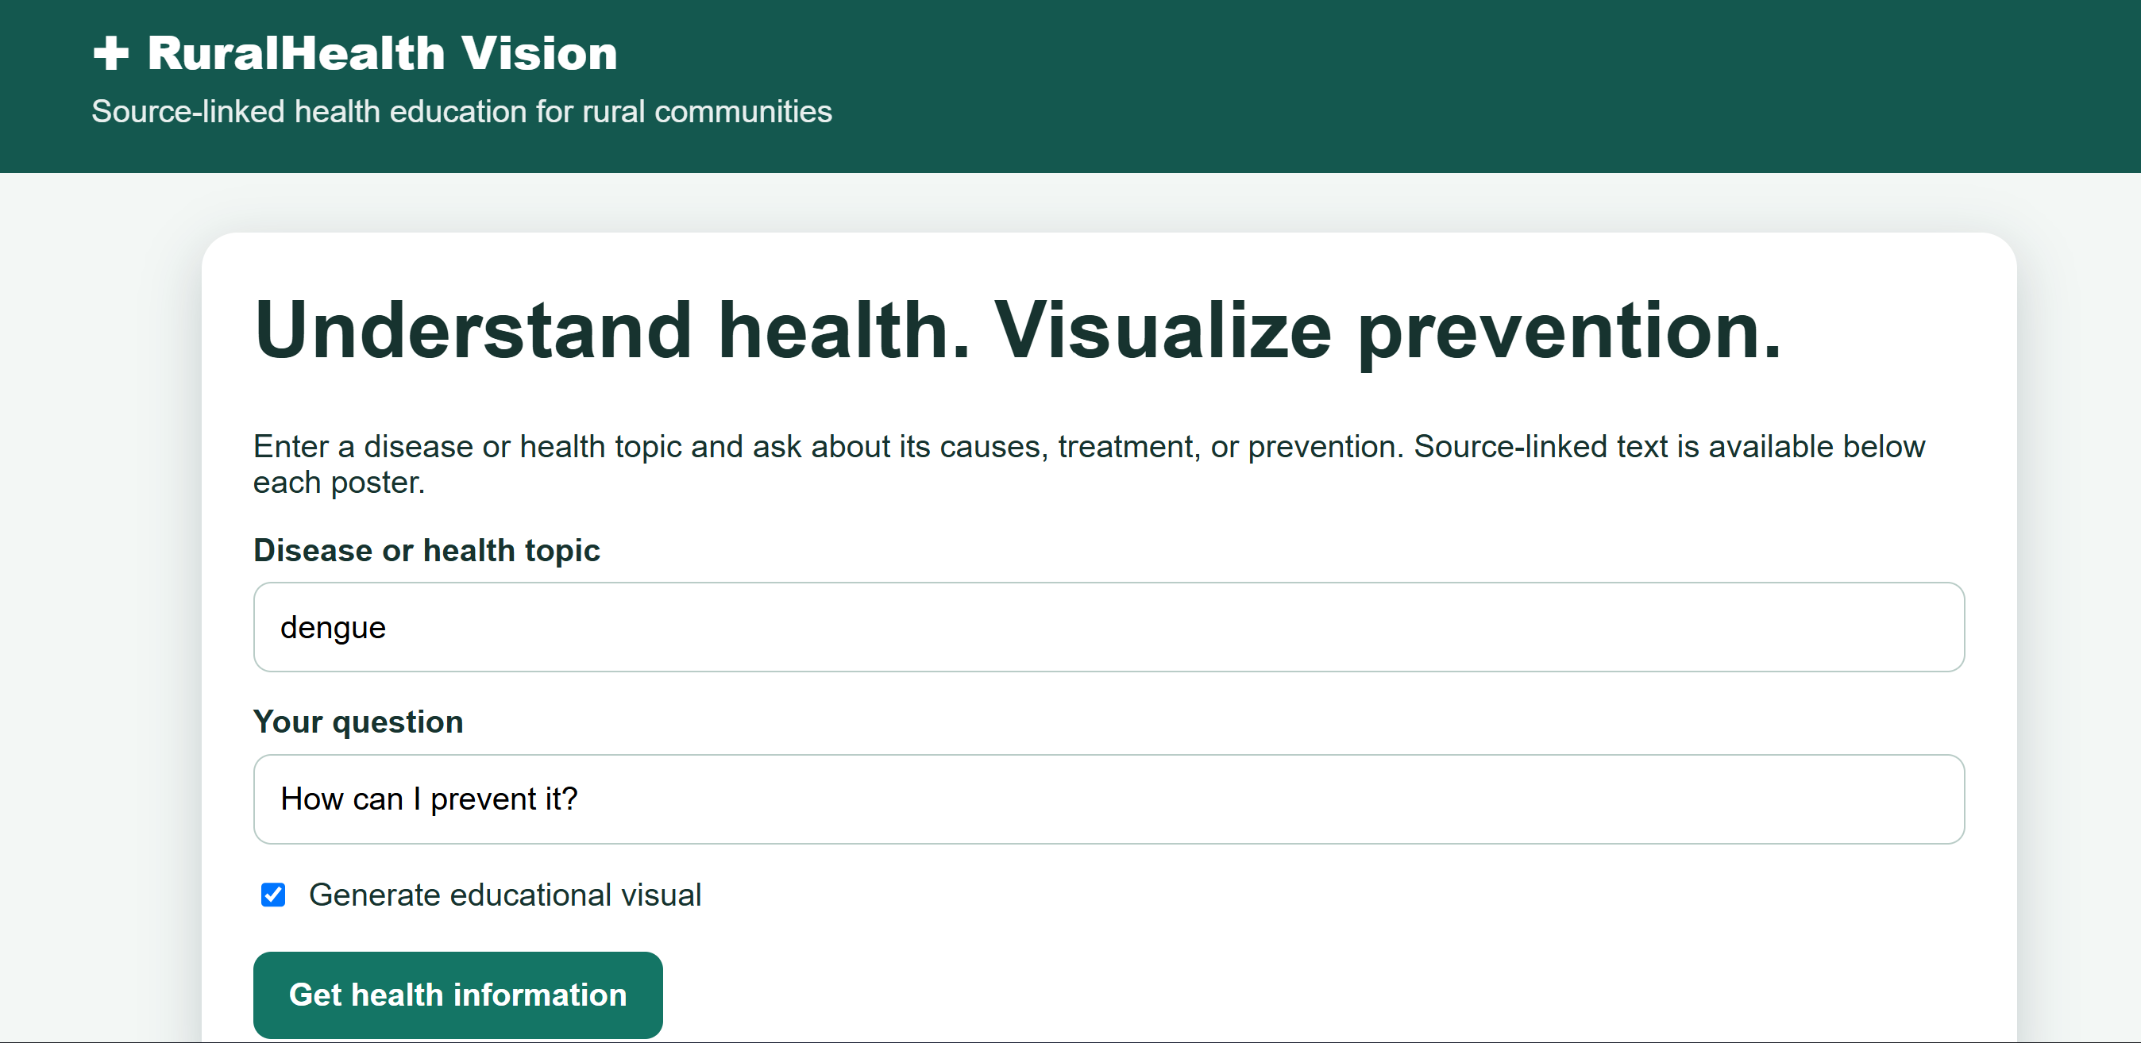
Figure 5. Insert a screenshot of the working RuralHealth Vision form.
Figure 6. Insert a screenshot of a source-linked response from the local app.
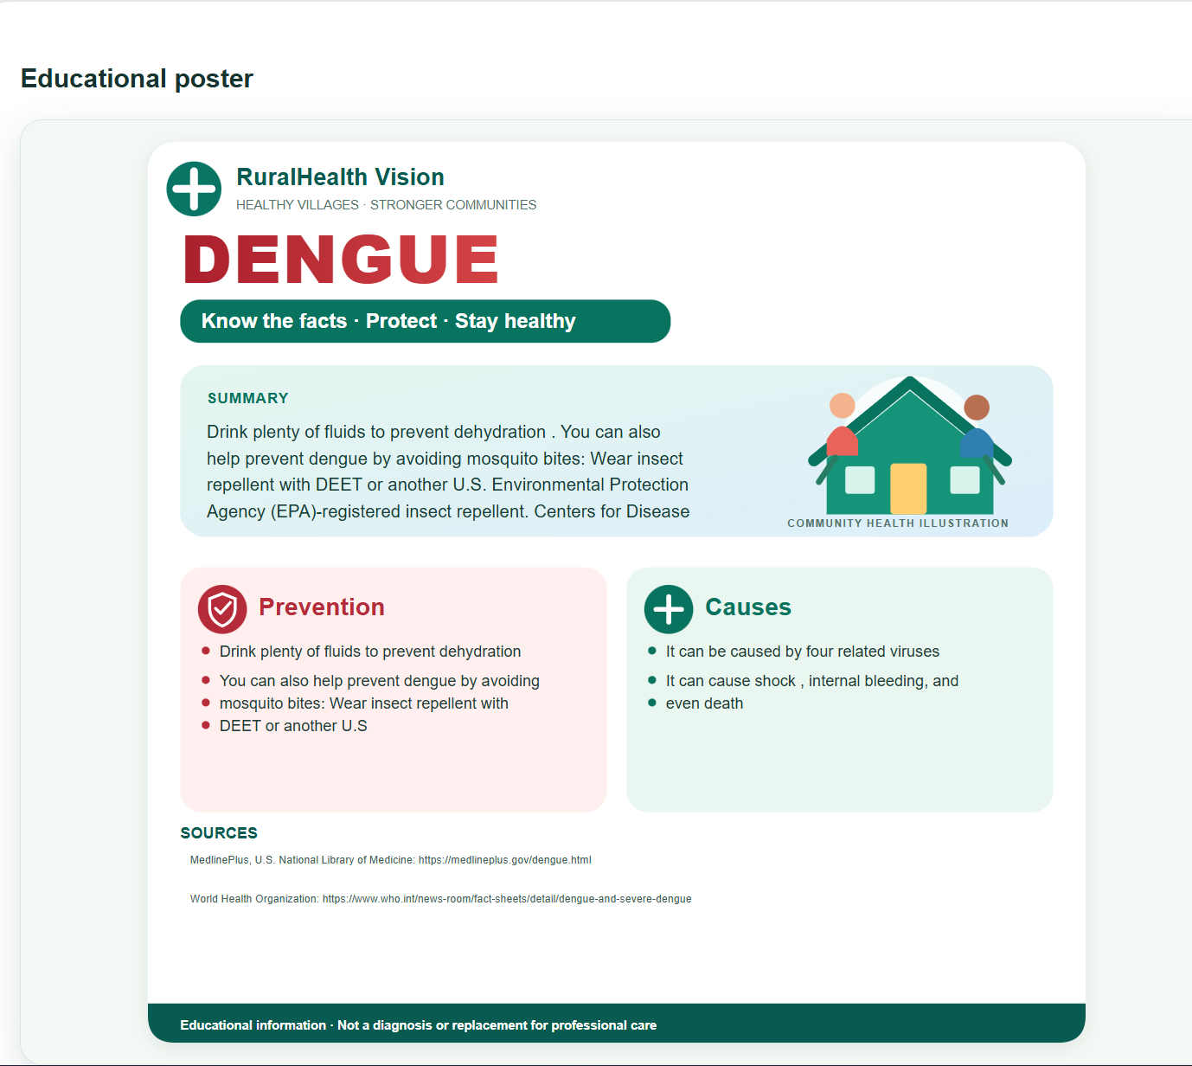
Figure 7. Insert a genuine generated poster after checking all text and source links.
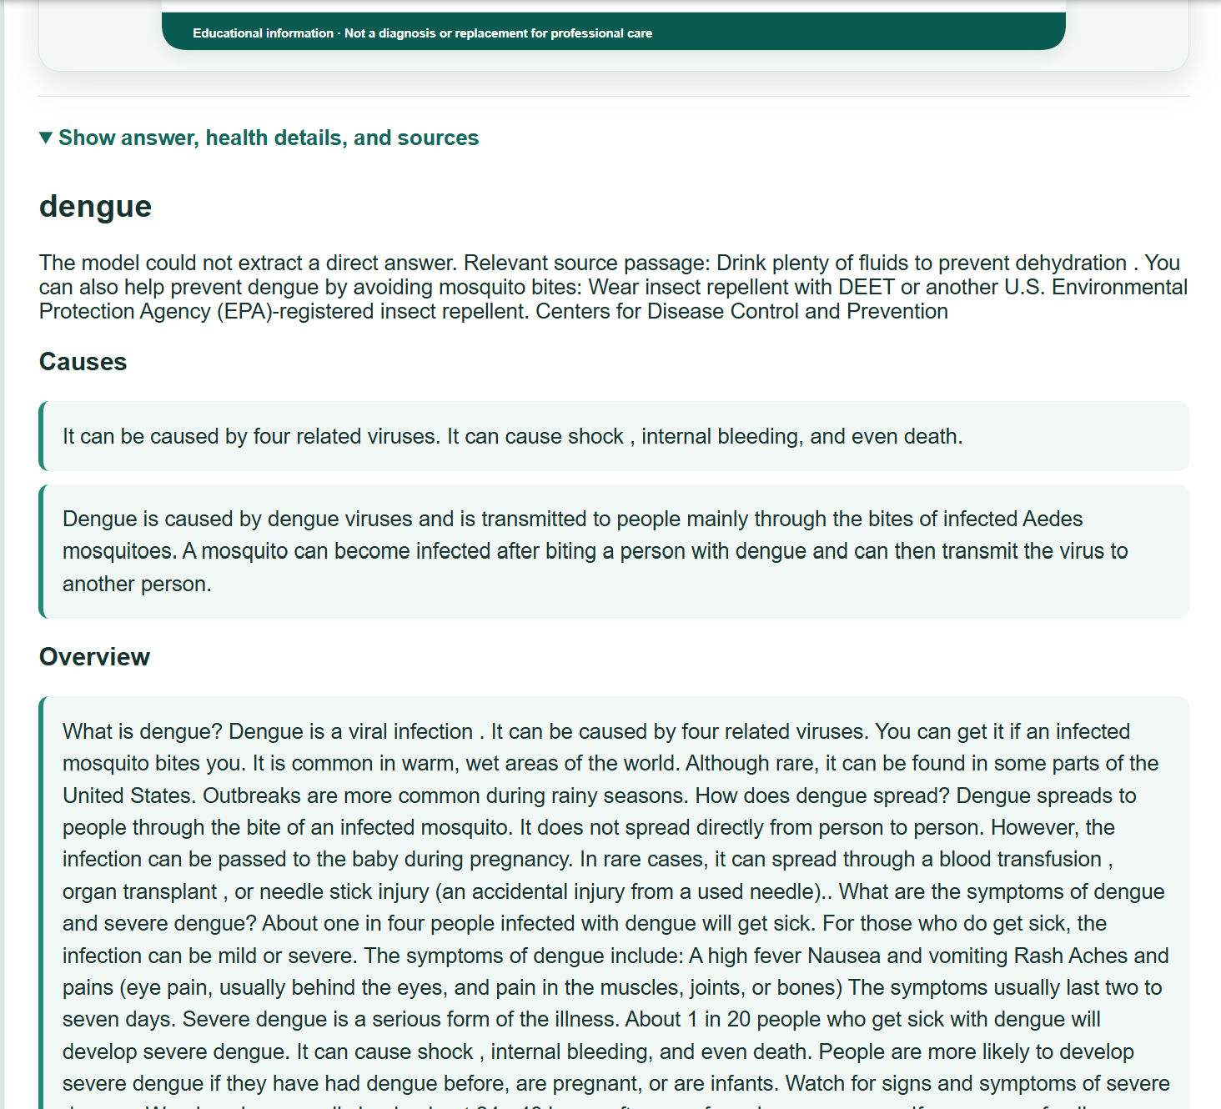

Comparative Analysis
The comparison below is qualitative. It compares design choices in this prototype and does not claim a benchmark improvement over other systems. The purpose is to show what changed when source links, local poster composition, and an optional image service were connected.
Table 4. Qualitative comparison of prototype design choices
Area | Simple alternative | RuralHealth Vision approach | Remaining gap
Health answer | Show a raw search result | Retrieve a passage and show a possible extractive span with link | No QA accuracy benchmark
Text in image | Ask diffusion model to draw poster words | Compose readable health text locally on the artwork | Needs layout and human readability review
GPU image generation | Download large model to the laptop | Use active Colab runtime when available | Temporary, not always available
Data size | Small hand-entered starter set | Imported MedlinePlus summaries plus curated records | Most imported content needs human review
Failure response | Fail the whole request | Keep source text and use SVG fallback when art fails | Need repeated failure-rate measurement

Latency, Reliability, and Limitations
No end-to-end latency or image failure rate was recorded. A useful timed study should separately record local retrieval time, model loading time, QA inference time, Colab queue and generation time, and total browser response time. It should include the number of runs, warm versus cold start, hardware, image dimensions, inference steps, date, and the active model ID. Colab runtime termination and the ngrok tunnel are outside the local Flask process, so their failures should be counted separately from Flask errors [25], [26].
The main limits are the unreviewed data, keyword-based retrieval, lack of held-out QA labels, unscored poster art, unknown model provenance, and reliance on a temporary remote runtime. A saved checkpoint is not evidence of accuracy. A cited link is not evidence that the displayed statement has been clinically checked. The project should be presented as a working prototype with known gaps, and not as a tested clinical tool.

Proposed Test Plan
- Create a clinician-reviewed test set of at least 100 topic-question pairs, split by source document; include answerable and unanswerable questions.
- Report QA Exact Match and token F1 with the test sample size and examples of common errors.
- Label a separate query set with relevant source passages and report Recall@5, including the baseline search method.
- Review a random sample of answer statements and citations against the cited page and record supported, partial, or unsupported outcomes.
- Have reviewers score poster relevance, text readability, cultural fit, and safety using a written rating scale.
- Time at least 30 end-to-end requests and report median and 95th percentile, separating local and Colab time; count failures by cause.

9. CONCLUSION AND FUTURE SCOPE
RuralHealth Vision is a working student prototype that searches a local collection of health passages, shows source links, and can create an educational poster using an image model running in Google Colab. The poster artwork comes from Stable Diffusion, while the local app adds the health text so it stays readable. The local data file contains 2,967 passages across 1,017 topic labels. The system demonstrates how a Flask application, passage retrieval, extractive question answering, and optional image generation can be connected.
The project has not measured answer accuracy or poster quality, and most imported health passages still need human review. Its search can miss relevant passages, the QA files are not a completed evaluation set, and the Colab service is temporary. The prototype is useful for demonstrating a software workflow, but it should not be used to diagnose a condition or decide treatment. A human should check the source pages and consult a qualified health professional for medical concerns.

Next Steps
- Ask a health professional to review imported passages and their source dates, and involve community health workers in checking clarity and local fit.
- Replace placeholder QA examples with verified questions and answers, then measure answer and search quality on a held-out set.
- Review poster wording, image relevance, cultural fit, and readability; record the exact image checkpoint, generation time, and failure rate.
- Add Hindi and other Indian languages after building reviewed translations and multilingual evaluation sets.
- Add voice input and accessible controls, guided by user testing and WCAG 2.2 criteria [28].
- Improve search and generation only after comparing alternatives on documented test sets; consider LoRA adaptation as an optional, separately evaluated image experiment [22].
- Add more verified health topics and plan an offline mode for text search and cached materials where licensing permits.
- Replace the temporary Colab tunnel with a stable image service whose hosting and use conditions fit the intended deployment [25].

10. REFERENCES
The numbered references below are cited in the report text. Online health pages should be checked again before a public demonstration because guidance can change.
[1] World Health Organization, “Dengue and severe dengue,” Aug. 21, 2025. [Online]. Available: https://www.who.int/news-room/fact-sheets/detail/dengue-and-severe-dengue. [Accessed: Oct. 28, 2026].
[2] World Health Organization, “Malaria,” Dec. 4, 2025. [Online]. Available: https://www.who.int/news-room/fact-sheets/detail/malaria. [Accessed: Oct. 28, 2026].
[3] World Health Organization, “Tuberculosis,” 2025. [Online]. Available: https://www.who.int/news-room/fact-sheets/detail/tuberculosis. [Accessed: Oct. 28, 2026].
[4] World Health Organization, “Cholera,” 2026. [Online]. Available: https://www.who.int/news-room/fact-sheets/detail/cholera. [Accessed: Oct. 28, 2026].
[5] World Health Organization, “Rabies,” 2024. [Online]. Available: https://www.who.int/news-room/fact-sheets/detail/rabies. [Accessed: Oct. 28, 2026].
[6] U.S. National Library of Medicine, “Health Topics: MedlinePlus.” [Online]. Available: https://medlineplus.gov/healthtopics.html. [Accessed: Oct. 28, 2026].
[7] U.S. National Library of Medicine, “MedlinePlus Health Topic XML File Description.” [Online]. Available: https://medlineplus.gov/xmldescription.html. [Accessed: Oct. 28, 2026].
[8] Indian Council of Medical Research, “Standard Treatment Workflows.” [Online]. Available: https://www.icmr.gov.in/standard-treatment-workflows-stws. [Accessed: Oct. 28, 2026].
[9] National Centre for Vector Borne Diseases Control, Government of India, “About Us.” [Online]. Available: https://ncvbdc.mohfw.gov.in/. [Accessed: Oct. 28, 2026].
[10] World Health Organization, “Global Strategy on Digital Health 2020–2025,” Geneva, Switzerland, 2021. [Online]. Available: https://www.who.int/publications/b/57220. [Accessed: Oct. 28, 2026].
[11] World Health Organization, Ethics and Governance of Artificial Intelligence for Health: WHO Guidance. Geneva, Switzerland: WHO, 2021. [Online]. Available: https://www.who.int/publications/i/item/9789240029200. [Accessed: Oct. 28, 2026].
[12] A. Vaswani et al., “Attention is all you need,” in Proc. Advances in Neural Information Processing Systems, 2017. [Online]. Available: https://arxiv.org/abs/1706.03762. [Accessed: Oct. 28, 2026].
[13] J. Devlin, M.-W. Chang, K. Lee, and K. Toutanova, “BERT: Pre-training of deep bidirectional transformers for language understanding,” in Proc. NAACL-HLT, 2019, pp. 4171–4186. [Online]. Available: https://aclanthology.org/N19-1423/. [Accessed: Oct. 28, 2026].
[14] V. Sanh, L. Debut, J. Chaumond, and T. Wolf, “DistilBERT, a distilled version of BERT: Smaller, faster, cheaper and lighter,” arXiv:1910.01108, 2019. [Online]. Available: https://arxiv.org/abs/1910.01108. [Accessed: Oct. 28, 2026].
[15] P. Rajpurkar, J. Zhang, K. Lopyrev, and P. Liang, “SQuAD: 100,000+ questions for machine comprehension of text,” in Proc. EMNLP, 2016, pp. 2383–2392. [Online]. Available: https://aclanthology.org/D16-1264/. [Accessed: Oct. 28, 2026].
[16] P. Rajpurkar, R. Jia, and P. Liang, “Know what you don’t know: Unanswerable questions for SQuAD,” in Proc. ACL, 2018. [Online]. Available: https://arxiv.org/abs/1806.03822. [Accessed: Oct. 28, 2026].
[17] Hugging Face, “Question answering,” Transformers documentation. [Online]. Available: https://huggingface.co/docs/transformers/main/tasks/question_answering. [Accessed: Oct. 28, 2026].
[18] Hugging Face, “Trainer,” Transformers documentation. [Online]. Available: https://huggingface.co/docs/transformers/main_classes/trainer. [Accessed: Oct. 28, 2026].
[19] J. Ho, A. Jain, and P. Abbeel, “Denoising diffusion probabilistic models,” in Proc. Advances in Neural Information Processing Systems, 2020. [Online]. Available: https://arxiv.org/abs/2006.11239. [Accessed: Oct. 28, 2026].
[20] R. Rombach, A. Blattmann, D. Lorenz, P. Esser, and B. Ommer, “High-resolution image synthesis with latent diffusion models,” in Proc. IEEE/CVF Conf. Computer Vision and Pattern Recognition, 2022, pp. 10684–10695. [Online]. Available: https://arxiv.org/abs/2112.10752. [Accessed: Oct. 28, 2026].
[21] Hugging Face, “Stable Diffusion text-to-image pipeline,” Diffusers documentation. [Online]. Available: https://huggingface.co/docs/diffusers/api/pipelines/stable_diffusion/text2img. [Accessed: Oct. 28, 2026].
[22] Hugging Face, “LoRA training,” Diffusers documentation. [Online]. Available: https://huggingface.co/docs/diffusers/training/lora. [Accessed: Oct. 28, 2026].
[23] Pallets Projects, “Flask Quickstart,” Flask 3.1 documentation. [Online]. Available: https://flask.palletsprojects.com/en/stable/quickstart/. [Accessed: Oct. 28, 2026].
[24] A. Clark, “Pillow documentation.” [Online]. Available: https://pillow.readthedocs.io/en/stable/. [Accessed: Oct. 28, 2026].
[25] Google, “Frequently asked questions: Google Colaboratory.” [Online]. Available: https://research.google.com/colaboratory/faq.html. [Accessed: Oct. 28, 2026].
[26] Pyngrok, “pyngrok documentation.” [Online]. Available: https://pyngrok.readthedocs.io/en/latest/. [Accessed: Oct. 28, 2026].
[27] PyTorch, “Inference mode,” PyTorch documentation. [Online]. Available: https://docs.pytorch.org/docs/stable/generated/torch.autograd.grad_mode.inference_mode.html. [Accessed: Oct. 28, 2026].
[28] World Wide Web Consortium, “Web Content Accessibility Guidelines (WCAG) 2.2,” W3C Recommendation, Oct. 2023. [Online]. Available: https://www.w3.org/TR/WCAG22/. [Accessed: Oct. 28, 2026].

11. LIST OF PUBLICATIONS
No project publication has been reported as published, accepted, or submitted at the time this report was prepared. If a paper, poster abstract, or conference submission is made later, add its full citation and status here. Do not list an item until the authors can verify its status.

