**Lab 3: Using EF Core CLI to Create and Apply Migrations**

1. **Install EF Core CLI**

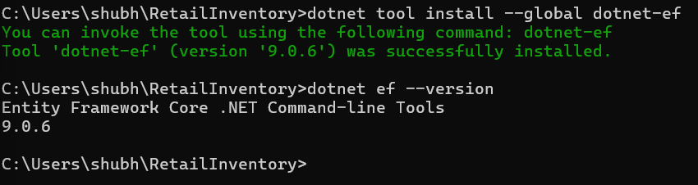

1. **Create Initial Migration**

1. **Apply Migration**

1. **Verify in SQL Server**

