**Lab 5: Retrieving Data from the Database**

1. **Retrieve All Products ( Program.cs )**

1. **Find by ID**

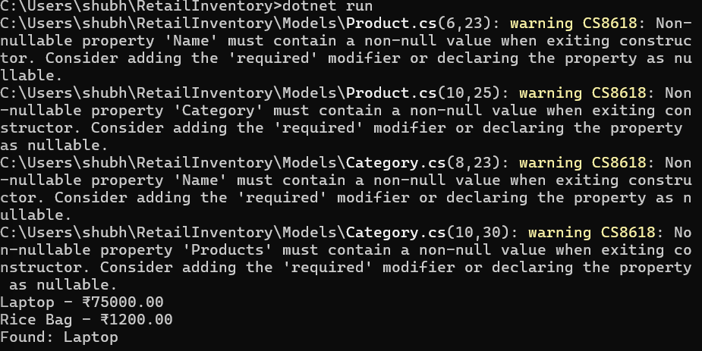

1. **FirstOrDefault with Condition**

**Program.cs**using RetailInventory;

using RetailInventory.Models;

using Microsoft.EntityFrameworkCore;

var context = new AppDbContext();

*// Get all products*

var products = await context.Products.ToListAsync();

foreach (var p in products)

{

    Console.WriteLine($"{p.Name} - ₹{p.Price}");

}

*// Find product by ID*

var product = await context.Products.FindAsync(1);

Console.WriteLine($"Found: {product?.Name}");

*// FirstOrDefault with condition*

var expensive = await context.Products.FirstOrDefaultAsync(p => p.Price > 50000);

Console.WriteLine($"Expensive: {expensive?.Name}");