**Week 8 (GIT)**

**1.Git-HOL**

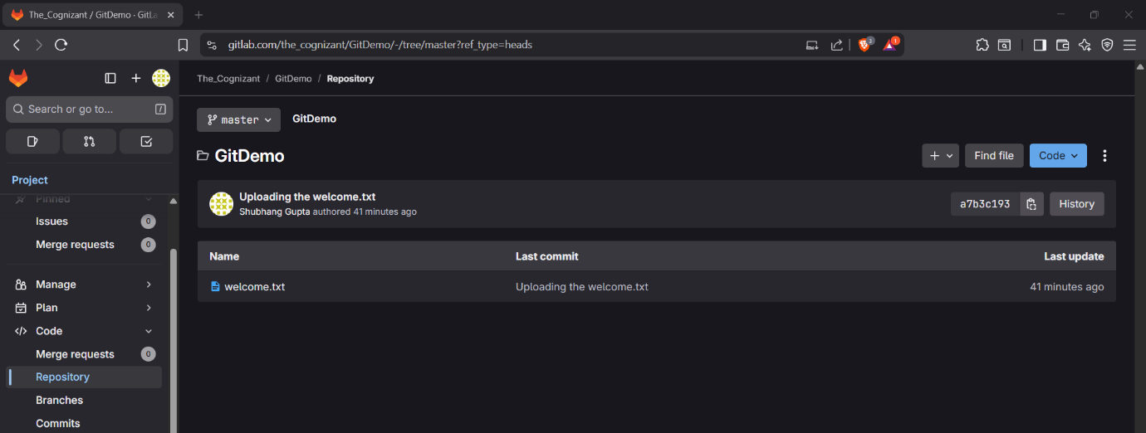

**2. Git-HOL**

**5. Git-HOL**

