**Lab Notes for Java Term Project**

In this exercise, we’re going to start using the NetBeans IDE for doing Java development as well as a portal to the Derby database. But first we have to do a little setup with NetBeans.

1. Create a new project, call it what you will:
   1. File menu
   2. New Project:

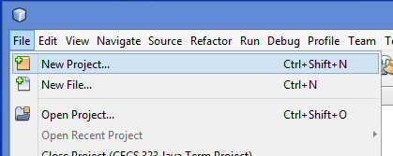

* 1. Which will then open up the following window:

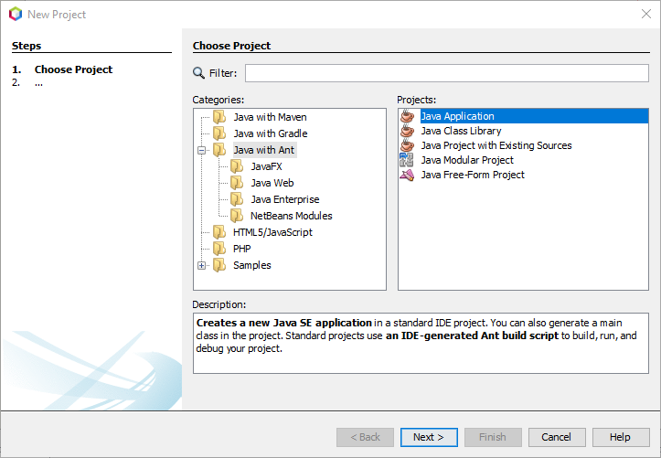

* 1. Select the “Java with Ant” category on the left, and “Java Application” under “Projects”.
  2. Hit the “Next” button.

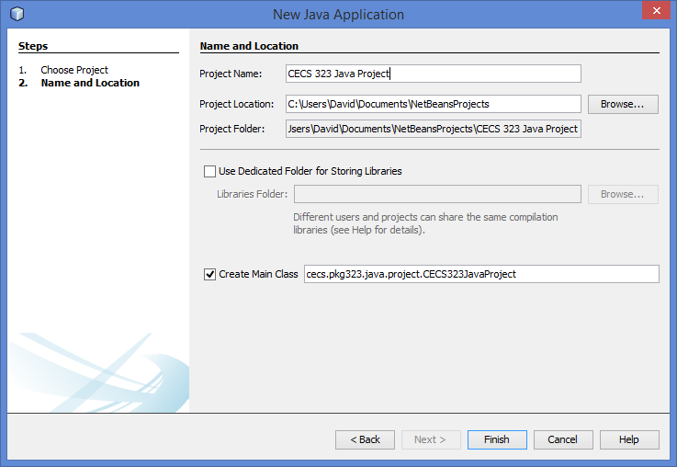

* 1. Don’t worry about the check box for “Create Main Class”, we’ll be overriding that anyway.
  2. Hit Finish.

1. Now, we need to add some libraries to your new project so that we can compile the Java:
   1. The first thing to do is to make sure that your Java database server is running:

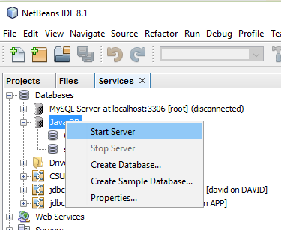

* 1. Now NetBeans will have the library that we need loaded, and we can add that to the project. In the navigator pane to the left of your NetBeans window there will be a node for your new project. Expand that.
  2. Under the project node, there will be a Libraries node:



* 1. Right click that Libraries node and select “Add Library”. That will bring up:

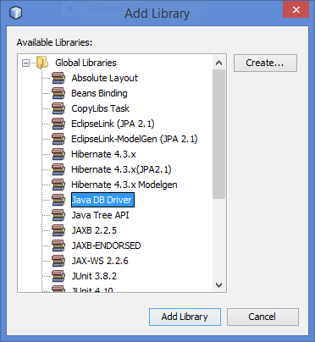

* 1. Select Java DB Driver as shown, and click the “Add Library” button.

1. At this point, we’re ready to do some coding.
   1. Go to your new project, right click the Source Packages node under that, and select New | Java Class:

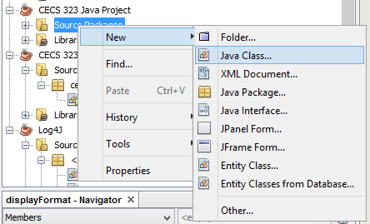

* 1. This will allow you to create a new Java class in your new project that you’ve just equipped with the Java DB driver library.
     1. Call the class whatever you like, but make sure that the class name that you give it matches the class name in the source code [here](http://web.csulb.edu/~dbrown/CECS323/Projects/JDBC/JDBC%20Project%20Sample%20Source.java) (<http://web.csulb.edu/~dbrown/CECS323/Projects/JDBC/JDBC%20Project%20Sample%20Source.java>).
     2. Download the Java code above to your PC, and replace the code that NetBeans gives you for the above class with this code.
  2. There are a few things that you need to know about this code:
     1. As it stands, it prompts you for the database name, the username and the password. You can change the database URL in the code to not include the username and password if your database doesn’t have one.
     2. I use printf to give the output data a nice tabular format. The specification for how printf lays the data out is hard coded near the top of the outermost class. Feel free to change that. In fact, you might even prompt the user for that string if you’re feeling frisky.
     3. Right now, the SQL statement that it has just prints out the author names and phone numbers. You’ll have to customize it for the statements called for in the project.

1. At this point, you should be able to run the Java project, connect to the database, and start getting results.
   1. Remember, code and test your SQL in the NetBeans window before going to the trouble of putting into your Java application. It will save you time in the long run.
   2. You might consider reading the statements in from a file as a way of cutting your debugging time down, rather than having to go into the code every time you have a tweak that you want to make to the SQL code.
   3. Don’t forget to start your Derby database:

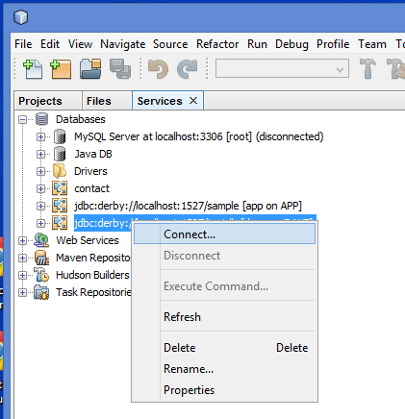

* 1. Click on the Services tab at the left of your NetBeans window, right click the database that you want to open, and select “Connect…”.

Accessing your database from Java will change your life!

**Latest Update:** **10/9/2019 9:16 PM**

David.brown@csulb.edu