**Task: Spike Installation**

1. **Your terminal output when you run main.c**

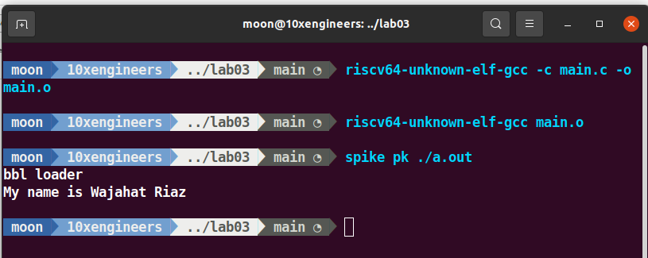

1. **Terminal output when you run risc V assembly program**

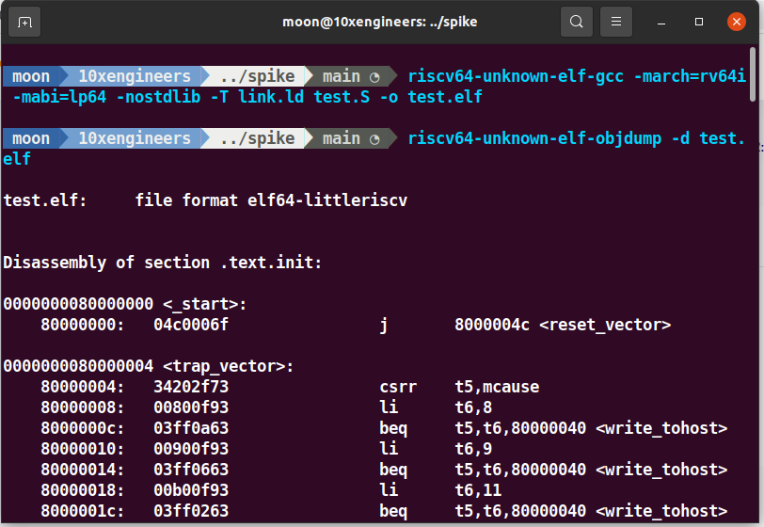

1. **Terminal output when you run risc V assembly program compatible to RiscOf**

