OOPJ LAB ASSIGNMENT – 7
Name – Nishant Nahar
Roll Number – 241551078
- Write a program to handle ArithmeticException during division of two integers.
class Q1 {
public static void main(String[] args) {
System.out.println("Nishant Nahar - 241551078");
try {
int a = 10 / 0;
} catch (ArithmeticException e) {
System.out.println(e);
}}}
OUTPUT
- Write a program to demonstrate and handle ArrayIndexOutOfBoundsException.
class Q2 {
public static void main(String[] args) {
System.out.println("Nishant Nahar - 241551078");
int[] a = {1, 2, 3};
try {
System.out.println(a[5]);
} catch (ArrayIndexOutOfBoundsException e) {
System.out.println(e);
}}}
OUTPUT
- Write a program to handle NumberFormatException when converting a string to an integer.
class Q3 {
public static void main(String[] args) {
System.out.println("Nishant Nahar - 241551078");
try {
int n = Integer.parseInt("abc");
} catch (NumberFormatException e) {
System.out.println(e);
}}}
OUTPUT
- Write a program that safely handles NullPointerException while accessing object methods.
class Q4 {
public static void main(String[] args) {
System.out.println("Nishant Nahar - 241551078");
try {
String s = null;
System.out.println(s.length());
} catch (NullPointerException e) {
System.out.println(e);
}}}
OUTPUT
- Write a program to handle InputMismatchException using the Scanner class.
import java.util.*;
class Q5 {
public static void main(String[] args) {
System.out.println("Nishant Nahar - 241551078");
Scanner sc = new Scanner(System.in);
try {
int x = sc.nextInt();
} catch (InputMismatchException e) {
System.out.println(e);
}}}
OUTPUT
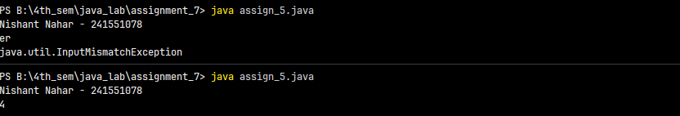
- Write a program that uses multiple catch blocks for different runtime exceptions.
class Q6 {
public static void main(String[] args) {
System.out.println("Nishant Nahar - 241551078");
try {
int[] a = new int[2];
a[3] = 23 / 0;
} catch (ArithmeticException e) {
System.out.println(e);
} catch (ArrayIndexOutOfBoundsException a) {
System.out.println(a);
}}}
OUTPUT
- Write a program to demonstrate the importance of catch block order in exception handling.
class Q7 {
public static void main(String[] args) {
System.out.println("Nishant Nahar - 241551078");
try {
int a = 10 / 0;
} catch (ArithmeticException e) {
System.out.println(e);
} catch (Exception a) {
System.out.println(a);
}}}
OUTPUT
- Write a program that catches a parent exception class instead of child exceptions and analyze the effect.
class Q8 {
public static void main(String[] args) {
System.out.println("Nishant Nahar - 241551078");
try {
int a = 10 / 0;
} catch (Exception e) {
System.out.println(e);
}}}
OUTPUT
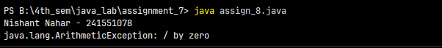
- Write a program that shows how exception hierarchy works using built-in exceptions.
class Q9 {
public static void main(String[] args) {
System.out.println("Nishant Nahar - 241551078");
try {
String s = null;
s.length();
} catch (RuntimeException e) {
System.out.println(e);
}}}
OUTPUT
- Write a program to demonstrate multi-catch (|) introduced in Java 7.
class Q10 {
public static void main(String[] args) {
System.out.println("Nishant Nahar - 241551078");
try {
int[] a = new int[2];
a[3] = 5; // 1st Run
a[3] = 5 / 0; // 2nd Run
} catch (ArithmeticException | ArrayIndexOutOfBoundsException e) {
System.out.println(e);
}}}
OUTPUT
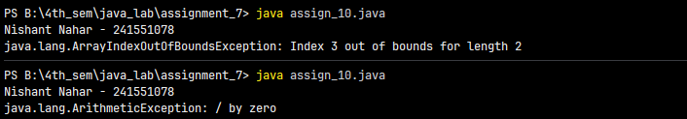
- Write a program to show that the finally block executes even when an exception occurs.
class Q11 {
public static void main(String[] args) {
System.out.println("Nishant Nahar - 241551078");
try {
int a = 10 / 0;
} finally {
System.out.println("Execption");
}}}
OUTPUT
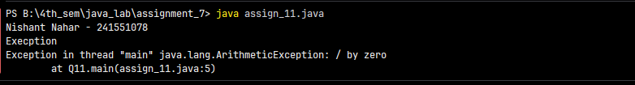
- Write a program to demonstrate that finally executes even if a return statement is present.
class Q12 {
public static void main(String[] args) {
System.out.println("Nishant Nahar - 241551078");
System.out.println(test());}
static int test() {
try {
return 10;
} finally {
System.out.println("runs");
}}}
OUTPUT
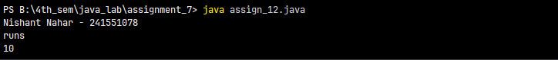
- Write a program to show that finally executes when no exception occurs.
class Q13 {
public static void main(String[] args) {
System.out.println("Nishant Nahar - 241551078");
try {
int a = 10 / 2;
} finally {
System.out.println("Finally executed");
}}}
OUTPUT
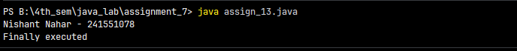
- Write a program where the finally block does not execute and explain the reason.
OUTPUT
- Write a program that explicitly throws an exception using the throw keyword.
class Q15 {
public static void main(String[] args) {
System.out.println("Nishant Nahar - 241551078");
int age = 15;
if (age < 18) {
throw new ArithmeticException("Not eligible to vote");
}
System.out.println("Eligible to vote");}}
OUTPUT
- Write a program that uses throws to declare a checked exception in a method.
OUTPUT
- Write a program demonstrating the difference between throw and throws.
class Q17 {
static void test() throws Exception {
throw new Exception("Thrown");
}
public static void main(String[] args) {
System.out.println("Nishant Nahar - 241551078");
try {
test();
} catch (Exception e) {
System.out.println(e);
}}}
OUTPUT
- Write a program where a method throws multiple exceptions using throws.
class Q18 {
static void test(int a) throws ArithmeticException, ArrayIndexOutOfBoundsException {
int[] arr = {1, 2};
System.out.println(arr[a]);
System.out.println(10 / a);
}
public static void main(String[] args) {
System.out.println("Nishant Nahar - 241551078");
test(0);
}}
OUTPUT
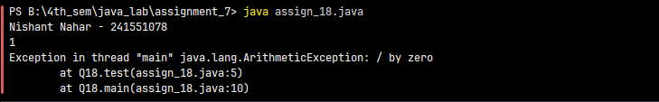
- Create a custom checked exception and use it in a validation program.
OUTPUT
- Create a custom unchecked exception for a real-world scenario (e.g., insufficient balance).
OUTPUT
- Write a program that passes a message to a user-defined exception.
OUTPUT
- Write a program to demonstrate exception propagation across multiple method calls.
class Q22 {
static void first() {
int a = 10 / 0;
}
static void second() {
first();
}
public static void main(String[] args) {
System.out.println("Nishant Nahar - 241551078");
second();
}}
OUTPUT
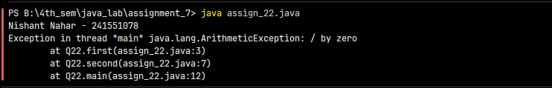
- Modify the above program to handle the exception at an intermediate method.
class Q23 {
static void first() {
int a = 10 / 0;
}
static void second() {
try {
first();
} catch (ArithmeticException e) {
System.out.println("Exception handled in second()");
}}
public static void main(String[] args) {
System.out.println("Nishant Nahar - 241551078");
second();
}}
OUTPUT
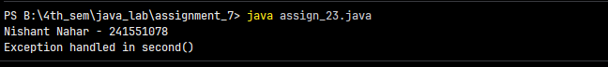
- Write a program where an exception is thrown in both try and finally blocks. Observe the output.
class Q24 {
public static void main(String[] args) {
System.out.println("Nishant Nahar - 241551078");
try {
int a = 10 / 0;
} finally {
int b = 20 / 0;
}}}
OUTPUT
- Write a program to demonstrate rethrowing an exception after partial handling.
OUTPUT
- Write a program to show how try-with-resources works with file handling.
OUTPUT
- Write a program to demonstrate suppressed exceptions in try-with-resources.
OUTPUT
- Write a program to demonstrate custom exception chaining using initCause().
OUTPUT
- Write a program to show the difference between checked and unchecked exceptions at compile time.
OUTPUT
- Write a program that demonstrates why catching Throwable is discouraged.
OUTPUT

