OOPJ LAB ASSIGNMENT – 6
Name – Nishant Nahar
Roll No – 241551078
- Write a Java program using an abstract class that contains:
  - An abstract method
  - A non-abstract method (Demonstrate method implementation in a subclass.)
abstract class Animal {
abstract void so();
void eat() {
System.out.println("Eating");
}}
class Dog extends Animal {
void so() {
System.out.println("Bark");
}
public static void main(String[] args) {
System.out.println("Nishant Nahar - 241551078");
Animal a = new Dog();
a.so();
a.eat();
}}
OUTPUT
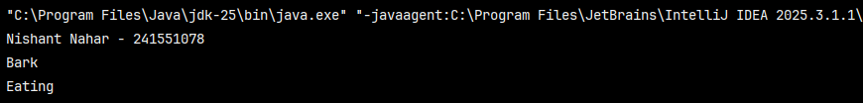
- Create an abstract class with a constructor and show how it is invoked during object creation.
abstract class Bas {
Bas() {
System.out.println("Abstract");
}}
class Unbase extends Bas {
Unbase() {
System.out.println("Unbase");
}
public static void main(String[] args) {
System.out.println("Nishant Nahar - 241551078");
new Unbase();
}}
OUTPUT
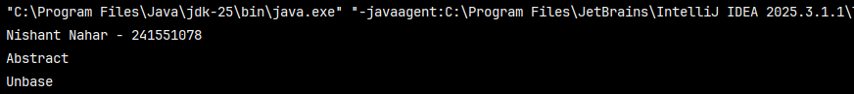
- Write a program where an abstract class has:
  - Instance variables
  - Final methods Show how subclasses interact with them.
abstract class S_1 {
int sides = 4;
final void show() {
System.out.println("Sides: " + sides);
}}
class Square extends S_1 {
public static void main(String[] args) {
System.out.println("Nishant Nahar - 241551078");
Square s = new Square();
s.show();
}}
OUTPUT
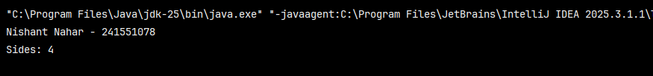
- Demonstrate partial abstraction using an abstract class and explain why complete abstraction is not possible.
abstract class Gaddi {
abstract void mv();
void ff() {
System.out.println("Hello");
}}
class bmw extends Gaddi {
void mv() {
System.out.println("bmw");
}
public static void main(String[] args) {
System.out.println("Nishant Nahar - 241551078");
Gaddi g = new bmw();
g.mv();
g.ff();
}}
OUTPUT
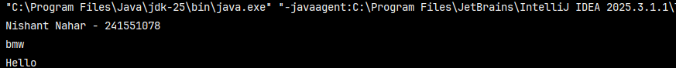
- Write a program to show that an abstract class can have:
  - Static methods
  - Static blocks and demonstrates their execution.
abstract class assi_5 {
static {
System.out.println("block");
}
static void show() {
System.out.println("method");
}
public static void main(String[] args) {
System.out.println("Nishant Nahar - 241551078");
assi_5.show();
}}
OUTPUT
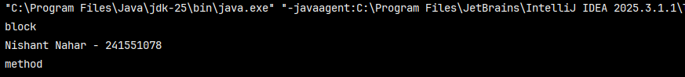
- Create an abstract class with a template method pattern and implement different behaviors in subclasses.
abstract class Game {
final void play() {
start();
move();
end();
}
abstract void move();
void start() {
System.out.println("Start");
}
abstract void end();
}
class VC extends Game {
void move() {
System.out.println("Move");
}
void end() {
System.out.println("End");
}
public static void main(String[] args) {
System.out.println("Nishant Nahar - 241551078");
Game g = new VC();
g.play();
}}
OUTPUT
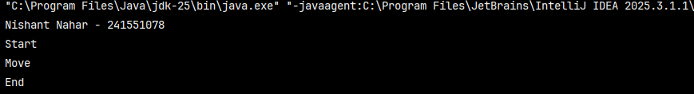
- Write a program to show runtime polymorphism using an abstract class reference.
abstract class A7 {
abstract void f();
}
class T7 extends A7 {
void f() {
System.out.println("run");
}
public static void main(String[] a) {
System.out.println("Nishant Nahar - 241551078");
A7 r = new T7();
r.f();
}}
OUTPUT
- Demonstrate why an abstract class cannot be instantiated, but its reference can be used.
abstract class U {
void f() {
System.out.println("ok");
}}
class V1 {
public static void main(String[] a) {
System.out.println("Nishant Nahar - 241551078");
U u = new U();
u.f();
}}
OUTPUT
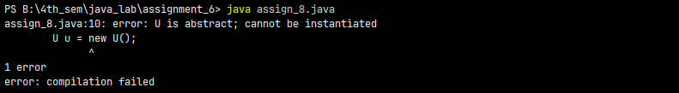
- Write a program where an abstract class implements an interface and a subclass completes the implementation.
interface inti {
void f();
}
abstract class W implements inti {
abstract void g();
}
class X extends W {
public void f() {
System.out.println("f");
}
void g() {
System.out.println("g");}
public static void main(String[] args) {
System.out.println("Nishant Nahar - 241551078");
X x = new X();
x.f();
x.g();
}}
OUTPUT
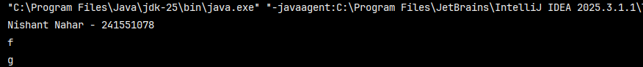
- Show how abstract classes help avoid code duplication using inheritance.
abstract class ani {
void bre() {
System.out.println("Hello NEWS");
}}
class dni extends ani {}
class cni extends ani {
public static void main(String[] args) {
System.out.println("Nishant Nahar - 241551078");
dni d = new dni();
cni c = new cni();
d.bre();
c.bre();
}}
OUTPUT
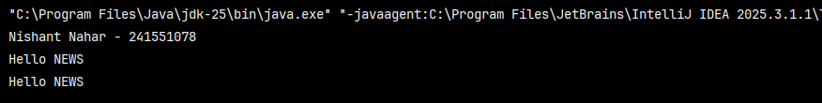
- Write a Java program to demonstrate:
  - Multiple inheritance using interfaces
  - Conflict resolution of default methods.
interface ina {
void hello();
}
interface inb {
void bye();
}
class MyClass implements ina, inb {
public void hello() {
System.out.println("Hello");
}
public void bye() {
System.out.println("Bye");
}
public static void main(String[] args) {
System.out.println("Nishant Nahar - 241551078");
MyClass obj = new MyClass();
obj.hello();
obj.bye();
}}
OUTPUT
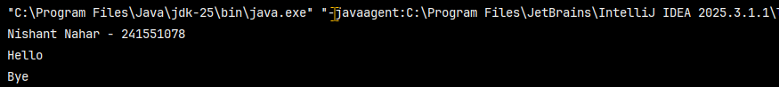
- Create an interface with:
  - Constants
  - Abstract methods and show how they are accessed in implementing classes.
interface shp {
int sd = 0;
void draw();
}
class crl implements shp {
public void draw() {
System.out.println("Drawing Circle");
System.out.println("Sides: " + sd);
}
public static void main(String[] args) {
System.out.println("Nishant Nahar - 241551078");
crl c = new crl();
c.draw();
}}
OUTPUT
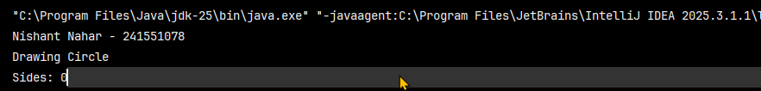
- Write a program to demonstrate functional interfaces and lambda expressions.
interface Operation {
int calculate(int a, int b);
}
class LambdaExample {
public static void main(String[] args) {
System.out.println("Nishant Nahar - 241551078");
Operation add = (a, b) -> a + b;
Operation multiply = (a, b) -> a * b;
System.out.println("Sum: " + add.calculate(5, 3));
System.out.println("Product: " + multiply.calculate(5, 3));
}}
OUTPUT
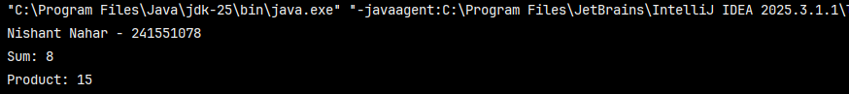
- Show that an interface reference can refer to different implementing class objects and invoke overridden methods.
interface assi_1 {
void sound();
}
class d1 implements assi_1 {
public void sound() {
System.out.println("Bark");
}}
class c1 implements assi_1 {
public void sound() {
System.out.println("Meow");
}
public static void main(String[] args)
System.out.println("Nishant Nahar - 241551078");
assi_1 ar;
ar = new d1();
ar.sound();
ar = new c1();
ar.sound();
}}
OUTPUT
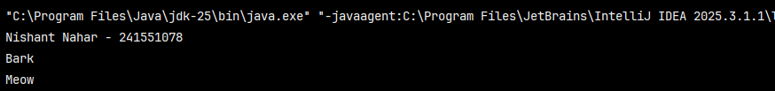
- Write a program to demonstrate marker interfaces and their use in Java.
interface Marked {}
class pp implements Marked {}
class Test15 {
public static void main(String[] args) {
System.out.println(“Nishant Nahar – 241551078”);
pp p = new pp();
System.out.println(p instanceof Marked);
}}
OUTPUT
- Create two interfaces with the same method signature and implement them in a single class.
interface inta {
void show();
}
interface intb {
void show();
}
class clc implements inta, intb {
public void show() {
System.out.println("Same method implemented");
}
public static void main(String[] args) {
System.out.println("Nishant Nahar - 241551078");
clc obj = new clc();
obj.show();
}}
OUTPUT
- Demonstrate default and static methods in interfaces.
interface myia {
default void helo() {
System.out.println("Hello");
}
static void msgg() {
System.out.println("Static Method");
}}
class deda implements myia {
public static void main(String[] args) {
System.out.println("Nishant Nahar - 241551078");
deda d = new deda();
d.helo();
myia.msgg();
}}
OUTPUT
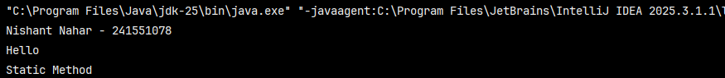
- Write a program where an interface extends another interface and a class implements the child interface.
interface pp1 {
void show();
}
interface cc1 extends pp1 {
void display();
}
class tt1 implements cc1 {
public void show() {
System.out.println("Show");
}
public void display() {
System.out.println("Display");
}
public static void main(String[] args) {
System.out.println("Nishant Nahar - 241551078");
tt1 t = new tt1();
t.show();
t.display();
}}
OUTPUT
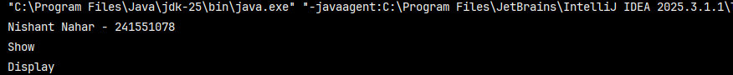
- Show the difference between interface and abstract class using a program.
interface Ia {
void m1();
}
abstract class Ib {
abstract void m2();
}
class a19 extends Ib implements Ia {
public void m1() {
System.out.println("Interface");
}
public void m2() {
System.out.println("Abstract");
}
public static void main(String[] args) {
System.out.println("Nishant Nahar - 241551078");
a19 t = new a19();
t.m1();
t.m2();
}}
OUTPUT
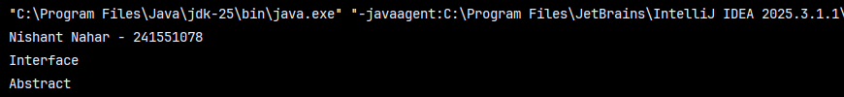
- Write a program to demonstrate tight vs loose coupling using interfaces.
class deed {
static class K {
void type() {
System.out.println("Tight");
} }
static class CT {
void work() {
new K().type();
} }
interface I {
void input();
}
static class KL implements I {
public void input() {
System.out.println("Loose");
} }
static class CL {
void work(I i) {
i.input();
} }
public static void main(String[] args) {
System.out.println("Nishant Nahar - 241551078");
new CT().work();
new CL().work(new KL());
}}
OUTPUT
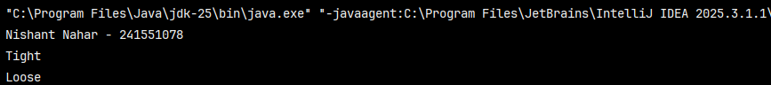
- Create a user-defined package, compile it, and access its classes from another package.
package mypack;
public class assign_21 {
public void msg() {
System.out.println("Hello Package");
}}
import mypack.assign_21;
class Test21 {
public static void main(String[] args) {
System.out.println("Nishant Nahar - 241551078");
assign_21 h = new assign_21();
h.msg();
}}
OUTPUT
- Write a program to demonstrate access control (public, default, protected) across packages.
package pack1;
public class assign_22 {
public static void show() {
System.out.println("Public Method");
}}
import pack1.assign_22;
class Test22 {
public static void main(String[] args) {
System.out.println("Nishant Nahar - 241551078");
assign_22 a = new assign_22();
assign_22.show();
}}
OUTPUT
- Create a package containing both interface and abstract class, and implement them in another package.
  - P1
package p1;
public interface assign_23 {
void show();
}
  - P1
package p1;
public abstract class assign_23_1 {
public abstract void display();
}
  - Code
class Test23 extends p1.assign_23_1 implements p1.assign_23 {
public void show() {
System.out.println("Show");}
public void display() {
System.out.println("Display");}
public static void main(String[] args) {
System.out.println("Nishant Nahar - 241551078");
Test23 t = new Test23();
t.show();
t.display();
}}
OUTPUT
- Write a program to show how protected members behave in inheritance across packages.
package p3;
public class assign_24 {
protected void msg() {
System.out.println("Protected Method");}}
import p3.assign_24;
public class assign_24_1 extends assign_24 {
public static void main(String[] args) {
assign_24_1 b = new assign_24_1();
b.msg();}}
OUTPUT
- Demonstrate name conflict resolution using packages.
package pack2;
public class assign_25 {
public void print() {
System.out.println("pack2");}}
package pack3;
public class assign_25_1 {
public void print() {
System.out.println("pack3");}}
import pack2.assign_25;
class Main {
public static void main(String[] args) {
System.out.println("Nishant Nahar - 241551078");
assign_25 p1 = new assign_25();
p1.print();
pack3.assign_25_1 p2 = new pack3.assign_25_1();
p2.print(); }}
OUTPUT
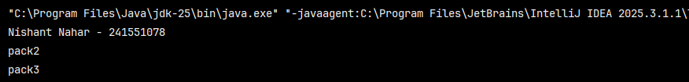
- Write a program to organize a project using multiple packages and explain its benefits.
class Ma {
public static void main(String[] args) {
System.out.println("Nishant Nahar - 241551078");
pack1.assign_22.show();
pack2.assign_25 c = new pack2.assign_25();
c.print();
pack3.assign_25_1 h = new pack3.assign_25_1();
h.print();}}
OUTPUT
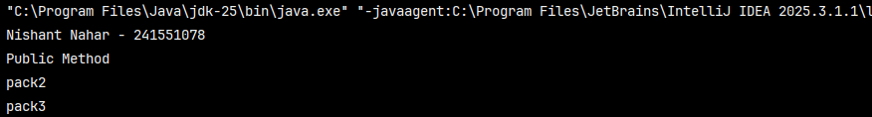
- Show how to use static import and explain when it is useful.
import static java.lang.Math.*;
class mm {
public static void main(String[] args) {
System.out.println("Nishant Nahar - 241551078");
System.out.println(sqrt(16));
System.out.println(PI);
}}
OUTPUT
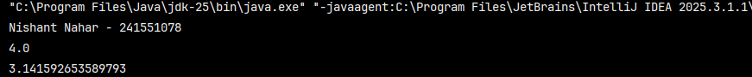
- Write a program to show class loading behavior across packages.
package pkg1;
public class assign_30 {
static {
System.out.println("Target loaded");
}}
package pkg2;
import pkg1.assign_30;
public class assign_30_1 {
public static void main(String[] args) {
System.out.println("Nishant Nahar - 241551078");
System.out.println("Main started");
new assign_30();
}}
OUTPUT
