OOPJ LAB ASSIGNMENT – 9
Name – Nishant Nahar
Roll No – 241551078
- Write a Java program to demonstrate System.out, System.err, and System.in streams with appropriate console interaction.
import java.util.Scanner;
class as_9_q_1 {
public static void main(String[] args) {
System.out.println("Nishant Nahar - 241551078");
Scanner sc = new Scanner(System.in);
System.out.println("Name:");
String name = sc.nextLine();
System.out.println("Name - " + name);
System.err.println("Error Message Here !!");
}}
OUTPUT
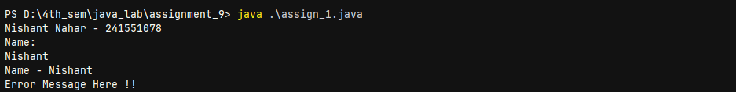
- Write a program to read a single character using System.in.read() and display its ASCII value and character representation.
import java.io.*;
class as_9_q_2 {
public static void main(String[] args) throws IOException {
System.out.println("Nishant Nahar - 241551078");
System.out.println("Type one character:");
int ch = System.in.read();
System.out.println("ASCII Value: " + ch);
System.out.println("Character: " + (char) ch);
}}
OUTPUT
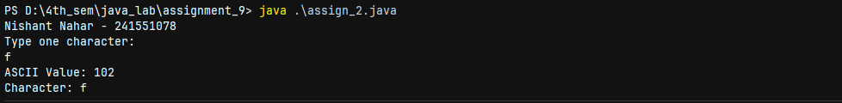
- Write a program to read multiple characters from System.in until newline and display them.
import java.io.*;
class as_9_q_3 {
public static void main(String[] args) throws IOException {
System.out.println("Nishant Nahar - 241551078");
System.out.println("Word Enter");
int ch;
while ((ch = System.in.read()) != '\n') {
System.out.println((char) ch);
}}
}
OUTPUT
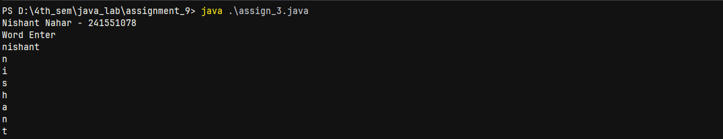
- Write a Java program to write a single byte value into a file using FileOutputStream and verify the stored character.
import java.io.*;
public class as_9_q_4 {
public static void main(String[] args) throws Exception {
System.out.println("Nishant Nahar - 241551078");
FileOutputStream ff = new
FileOutputStream("D:\\4th_sem\\java_lab\\assignment_9\\assign_4.txt");
ff.write(65);
ff.close();
}}
OUTPUT
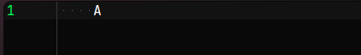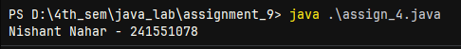
- Write a program to write a user-entered string into a file by converting it into a byte array using getBytes().
import java.io.*;
import java.util.Scanner;
class as_9_q_5 {
public static void main(String[] args) throws IOException {
System.out.println("Nishant Nahar - 241551078");
Scanner sc = new Scanner(System.in);
System.out.println("Name - ");
String grd = sc.nextLine();
FileOutputStream grdd = new
FileOutputStream("D:\\4th_sem\\java_lab\\assignment_9\\assign_5.txt");
grdd.write(grd.getBytes());
grdd.close();
}}
OUTPUT
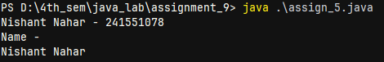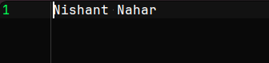
- Write a Java program to append text to an existing file using FileOutputStream in append mode.
import java.io.*;
import java.util.Scanner;
class as_9_q_6 {
public static void main(String[] args) throws Exception {
System.out.println("Nishant Nahar - 241551078");
Scanner sc = new Scanner(System.in);
System.out.println("What to append");
String d = sc.nextLine();
FileOutputStream fos = new
FileOutputStream("D:\\4th_sem\\java_lab\\assignment_9\\assign_5.txt", true);
fos.write(d.getBytes());
fos.close();
}}
OUTPUT
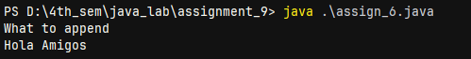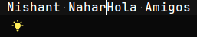
- Write a program to write multiple lines into a file using FileOutputStream and proper newline characters.
import java.io.*;
class as_9_q_7 {
public static void main(String[] args) throws IOException {
System.out.println("Nishant Nahar - 241551078");
FileOutputStream fos = new
FileOutputStream("D:\\4th_sem\\java_lab\\assignment_9\\assign_7.txt");
String text = "Hello\nMy\nName\nis\nNishant\nNahar";
fos.write(text.getBytes());
fos.close();
}}
OUTPUT
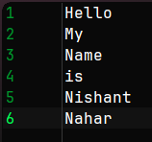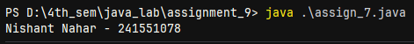
- Write a Java program to read the first character from a file using FileInputStream and display it.
import java.io.*;
public class as_9_q_8 {
public static void main(String[] args) throws Exception {
System.out.println("Nishant Nahar - 241551078");
FileInputStream n = new
FileInputStream("D:\\4th_sem\\java_lab\\assignment_9\\assign_7.txt");
int ch = n.read();
if (ch != -1) System.out.println("First character is: " + (char) ch);
else System.out.println("File is empty!");
n.close();
}}
OUTPUT
- Write a program to read and display all characters from a file using FileInputStream until end-of-file (-1).
import java.io.*;
class as_9_q_9 {
public static void main(String[] args) throws IOException {
System.out.println("Nishant Nahar - 241551078");
FileInputStream reads = new
FileInputStream("D:\\4th_sem\\java_lab\\assignment_9\\assign_5.txt");
int ch;
while ((ch = reads.read()) != -1) {
System.out.print((char) ch);}
reads.close();
}}
OUTPUT
- Write a Java program to count total characters present in a file using FileInputStream.
import java.io.*;
class as_9_q_10 {
public static void main(String[] args) throws Exception {
System.out.println("Nishant Nahar - 241551078");
FileInputStream fis = new
FileInputStream("D:\\4th_sem\\java_lab\\assignment_9\\assign_7.txt");
int ch;
int count = 0;
while ((ch = fis.read()) != -1) {
count++;}
fis.close();
System.out.println("Total characters in file: " + count);
}}
OUTPUT
- Write a program to count number of vowels, consonants, digits, and special characters in a file.
import java.io.*;
class as_9_q_11 {
public static void main(String[] args) throws Exception {
System.out.println("Nishant Nahar - 241551078");
FileInputStream f = new
FileInputStream("D:\\4th_sem\\java_lab\\assignment_9\\assign_7.txt");
int ch, v = 0, c = 0, d = 0, s = 0;
while ((ch = f.read()) != -1) {
char x = (char) ch;
if (x == 'a' || x == 'e' || x == 'i' || x == 'o' || x == 'u' ||
x == 'A' || x == 'E' || x == 'I' || x == 'O' || x == 'U') {
v++;
} else if ((x >= 'a' && x <= 'z') || (x >= 'A' && x <= 'Z')) {
c++;
} else if (x >= '0' && x <= '9') {
d++;
} else {
s++;
}}
f.close();
System.out.println("Vowels : " + v);
System.out.println("Cons : " + c);
System.out.println("Digits : " + d);
System.out.println("Special : " + s);
}}
OUTPUT
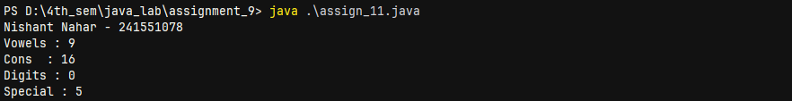
- Write a Java program to copy contents of one file into another using FileInputStream and FileOutputStream.
import java.io.*;
public class as_9_q_12 {
public static void main(String[] args) throws Exception {
System.out.println("Nishant Nahar - 241551078");
FileInputStream f1 = new
FileInputStream("D:\\4th_sem\\java_lab\\assignment_9\\assign_12.txt");
FileOutputStream f2 = new
FileOutputStream("D:\\4th_sem\\java_lab\\assignment_9\\assign_12_1.txt");
int ch;
while ((ch = f1.read()) != -1) {
f2.write(ch);}
f1.close();
f2.close();
}}
OUTPUT
 --- assign_12.txt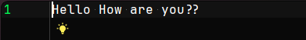--- assign_12_1.txt (COPY)
- Write a program to merge contents of two files into a third file.
import java.io.*;
public class as_9_q_13 {
public static void main(String[] args) throws Exception {
System.out.println("Nishant Nahar - 241551078");
FileInputStream f1 = new
FileInputStream("D:\\4th_sem\\java_lab\\assignment_9\\assign_12.txt");
FileInputStream f2 = new
FileInputStream("D:\\4th_sem\\java_lab\\assignment_9\\assign_13_1.txt");
FileOutputStream f3 = new
FileOutputStream("D:\\4th_sem\\java_lab\\assignment_9\\assign_13.txt");
int ch;
while((ch = f1.read()) != -1){
f3.write(ch);}
while((ch = f2.read()) != -1){
f3.write(ch);}
f1.close(); f2.close(); f3.close();
}}
OUTPUT
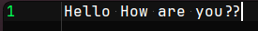
Merged --
- Write a Java program to compare contents of two files and display whether they are identical or not.
import java.io.*;
class as_9_q_14 {
public static void main(String[] args) throws Exception {
System.out.println("Nishant Nahar - 241551078");
FileInputStream f1 = new
FileInputStream("D:\\4th_sem\\java_lab\\assignment_9\\assign_12.txt");
FileInputStream f2 = new
FileInputStream("D:\\4th_sem\\java_lab\\assignment_9\\assign_12_1.txt");
int ch1, ch2;
boolean same = true;
while(true){
ch1 = f1.read();
ch2 = f2.read();
if(ch1 != ch2){
same = false;
break;}
if(ch1 == -1) break;}
f1.close();
f2.close();
if(same) System.out.println("Identical");
else System.out.println("Different");
}}
OUTPUT
- Write a program to convert all lowercase characters in a file to uppercase and save into another file.
import java.io.*;
class as_9_q_15 {
public static void main(String[] args) throws Exception {
System.out.println("Nishant Nahar - 241551078");
FileInputStream f1 = new
FileInputStream("D:\\4th_sem\\java_lab\\assignment_9\\assign_12.txt");
FileOutputStream f2 = new
FileOutputStream("D:\\4th_sem\\java_lab\\assignment_9\\assign_15.txt");
int ch;
while((ch = f1.read()) != -1){
f2.write(Character.toUpperCase((char) ch));}
f1.close();f2.close();
}
}
OUTPUT
Lower -- Upper -- 
- Write a Java program to count number of lines and words in a text file.
import java.io.*;
public class as_9_q_16 {
public static void main(String[] args) throws Exception {
System.out.println("Nishant Nahar - 241551078");
FileInputStream f = new
FileInputStream("D:\\4th_sem\\java_lab\\assignment_9\\assign_7.txt");
int ch;
int lines = 0, words = 0;
boolean i = false;
while ((ch = f.read()) != -1) {
if (ch == '\n') lines++;
if (ch == ' ' || ch == '\n' || ch == '\t') {
i = false;
} else if (!i) {
words++;
i = true;}}
f.close();
System.out.println("Lines : " + lines);
System.out.println("Words : " + words);
}}
OUTPUT
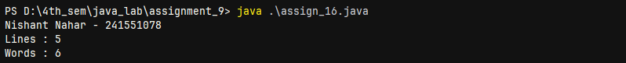
- Write a program to replace a specific word in a file with another word entered by the user.
import java.io.*;
import java.util.Scanner;
class as_9_q_17 {
public static void main(String[] args) throws Exception {
System.out.println("Nishant Nahar - 241551078");
Scanner sc = new Scanner(System.in);
System.out.print("replace word ");
String oldW = sc.nextLine();
System.out.print("new word");
String newW = sc.nextLine();
FileInputStream f = new
FileInputStream("D:\\4th_sem\\java_lab\\assignment_9\\assign_12.txt");
int ch;
String content = "";
while ((ch = f.read()) != -1) {
content += (char) ch;}
f.close();
content = content.replace(oldW, newW);
FileOutputStream out = new
FileOutputStream("D:\\4th_sem\\java_lab\\assignment_9\\assign_17.txt");
out.write(content.getBytes());
out.close();
}}
OUTPUT
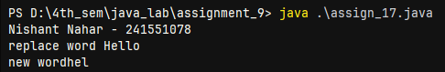
- Write a Java program that accepts a filename from user and checks whether the file exists, is readable, and writable.
import java.io.*;
import java.util.Scanner;
public class as_9_q_18 {
public static void main(String[] args) {
Scanner sc = new Scanner(System.in);
System.out.println("Nishant Nahar - 241551078");
System.out.print("File");
String name = sc.nextLine();
File f = new File("D:\\4th_sem\\java_lab\\assignment_9" + name);
if (f.exists()) System.out.println("File is present");
else System.out.println("File is not present");
if (f.canRead()) System.out.println("File can be read");
else System.out.println("File can't be read");
if (f.canWrite()) System.out.println("File can be written");
else System.out.println("File can't be written");
}}
OUTPUT
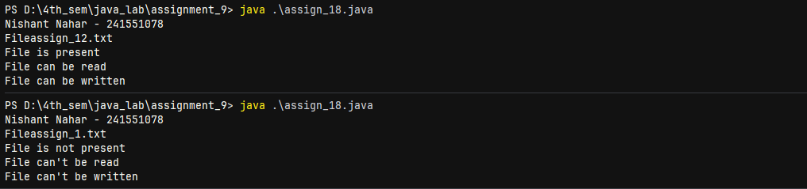
- Write a program to handle FileNotFoundException while attempting to open a non-existing file.
import java.io.*;
public class as_9_q_19 {
public static void main(String[] args) {
System.out.println("Nishant Nahar - 241551078");
try {FileInputStream f = new
FileInputStream("D:\\4th_sem\\java_lab\\assignment_9\\assign_1.txt");
f.close();
} catch (FileNotFoundException e) {System.out.println(e);
} catch (IOException e) {System.out.println(e);
}}}
OUTPUT
- Write a Java program to demonstrate difference between InputStream and OutputStream using practical file operations.
import java.io.*;
public class as_9_q_20 {
public static void main(String[] args) throws Exception {
System.out.println("Nishant Nahar - 241551078");
FileOutputStream out = new
FileOutputStream("D:\\4th_sem\\java_lab\\assignment_9\\assign_20.txt");
out.write("My Name is Nishant Nahar".getBytes());
out.close();
System.out.println("Data to be written in file");
FileInputStream in = new
FileInputStream("D:\\4th_sem\\java_lab\\assignment_9\\assign_20.txt");
int ch;
System.out.println("Data read from the file");
while ((ch = in.read()) != -1) {
System.out.print((char) ch);}
in.close();
}}
OUTPUT
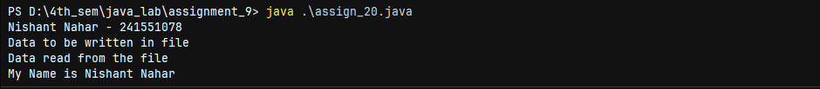
- Write a program to write formatted student details into a file using PrintWriter class.
import java.io.*;
public class as_9_q_21 {
public static void main(String[] args) throws Exception {
PrintWriter pw = new
PrintWriter("D:\\4th_sem\\java_lab\\assignment_9\\assign_21.txt");
pw.println("Name : Nishant Nahar");
pw.println("Roll : 241551078");
pw.println("Branch : CSE");
pw.println("Marks : 95/100");
pw.close();
}}
OUTPUT
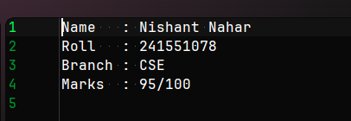
- Write a Java program to read file data and display both byte value and corresponding character for each byte.
import java.io.*;
class as_9_q_22 {
public static void main(String[] args) throws Exception {
System.out.println("Nishant Nahar - 241551078");
FileInputStream f = new
FileInputStream("D:\\4th_sem\\java_lab\\assignment_9\\assign_22.txt");
int ch;
while ((ch = f.read()) != -1) {
System.out.println("Byte: " + ch + " Character: " + (char) ch);}
f.close();
}}
OUTPUT
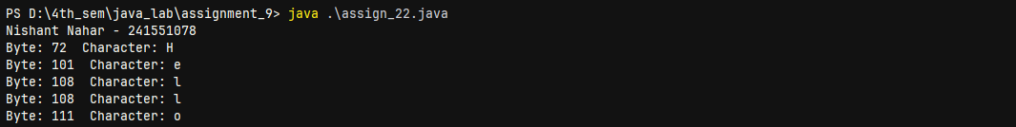
- Write a program to create a menu-driven file management system allowing write, read, append, and exit operations.
import java.io.*;
import java.util.Scanner;
public class as_9_q_23 {
public static void main(String[] args) throws Exception {
System.out.println("Nishant Nahar - 241551078");
Scanner sc = new Scanner(System.in);
int ch;
String path = "D:\\4th_sem\\java_lab\\assignment_9\\assign_23.txt";
do {System.out.println("\n1.Write 2.Append 3.Read 4.Exit");
ch = sc.nextInt();
sc.nextLine();
switch (ch) {
case 1:
System.out.print("Enter text: ");
String s1 = sc.nextLine();
FileOutputStream f1 = new FileOutputStream(path);
f1.write((s1 + "\n").getBytes());
f1.close();
break;
case 2:
System.out.print("Enter text: ");
String s2 = sc.nextLine();
FileOutputStream f2 = new FileOutputStream(path, true);
f2.write((s2 + "\n").getBytes());
f2.close();
break;
case 3:
FileInputStream f3 = new FileInputStream(path);
int c;
while ((c = f3.read()) != -1)
System.out.print((char) c);
f3.close();
System.out.println();
break;
case 4:
System.out.println("Exit");
break;
default:
System.out.println("Invalid Choice");
}
} while (ch != 4);
}
}
OUTPUT
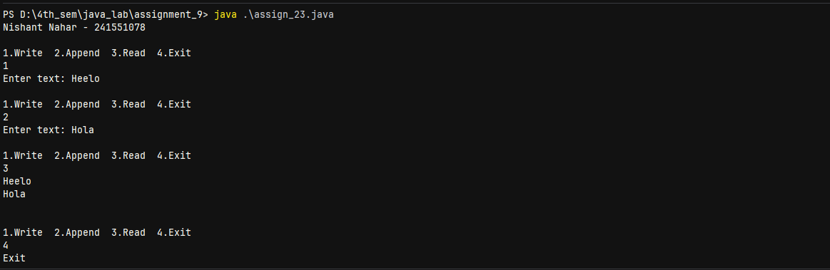
- Write a Java program to store 10 integers entered by the user into a file and then read them back to compute sum and average.
import java.io.*;
import java.util.Scanner;
public class as_9_q_24 {
public static void main(String[] args) throws Exception {
System.out.println("Nishant Nahar - 241551078");
Scanner sc = new Scanner(System.in);
FileOutputStream out = new
FileOutputStream("D:\\4th_sem\\java_lab\\assignment_9\\assign_24.txt");
System.out.print("Enter number: ");
for (int i = 1; i <= 10; i++) {
int n = sc.nextInt();
out.write((n + " ").getBytes());}
out.close();
FileInputStream in = new
FileInputStream("D:\\4th_sem\\java_lab\\assignment_9\\assign_24.txt");
Scanner s2 = new Scanner(in);
int sum = 0, count = 0;
while (s2.hasNextInt()) {
sum += s2.nextInt();
count++;}
in.close();
System.out.println("Sum = " + sum);
System.out.println("Average = " + (sum / (double) count));
}}
OUTPUT
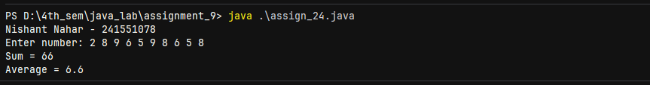
- Write a program to read a text file and display only those lines containing a specific keyword.
import java.io.*;
import java.util.Scanner;
public class as_9_q_25 {
public static void main(String[] args) throws Exception {
System.out.println("Nishant Nahar - 241551078");
Scanner sc = new Scanner(System.in);
System.out.print("Enter keyword: ");
String key = sc.nextLine();
Scanner file = new Scanner(new \ File("D:\\4th_sem\\java_lab\\assignment_9\\assign_7.txt"));
boolean found = false;
while (file.hasNextLine()) {
String line = file.nextLine();
if (line.contains(key)) {
System.out.println("Found");
System.out.println(line);
found = true;}}
if (!found) {System.out.println("Not found");}
file.close();
}}
OUTPUT
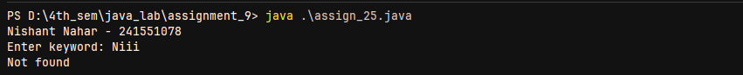
- Write a Java program to delete a file after checking its existence anddisplaying appropriate message.
import java.io.*;
public class as_9_q_26 {
public static void main(String[] args) {
System.out.println("Nishant Nahar - 241551078");
File f = new File("D:\\4th_sem\\java_lab\\assignment_9\\assign_26.txt");
if (f.exists()) {
if (f.delete()) System.out.println("File deleted successfully");
else System.out.println("File cannot be deleted");
} else { System.out.println("File does not exist");
}}}
OUTPUT
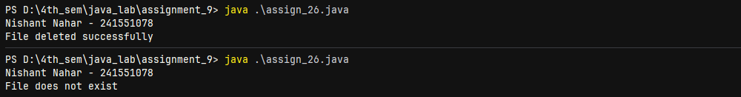
- Write a program to create a file and write current date and time into it using PrintWriter.
import java.io.*;
import java.util.Date;
class as_9_q_27 {
public static void main(String[] args) throws Exception {
PrintWriter pw = new
PrintWriter("D:\\4th_sem\\java_lab\\assignment_9\\assign_27.txt");
Date d = new Date();
pw.println("Current Date and Time:");
pw.println(d);
pw.close();
System.out.println("Date and Time written successfully ✔");
}
}

OUTPUT
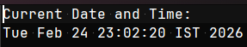
- Write a Java program to demonstrate buffering concept by reading file data byte-by-byte and printing performance difference.
import java.io.*;
public class as_9_q_28 {
public static void main(String[] args) throws Exception {
System.out.println("Nishant Nahar - 241551078");
long start1 = System.currentTimeMillis();
FileInputStream f1 = new
FileInputStream("D:\\4th_sem\\java_lab\\assignment_9\\assign_28.txt");
while (f1.read() != -1) {}
f1.close();
long end1 = System.currentTimeMillis();
long start2 = System.currentTimeMillis();
BufferedInputStream f2 = new BufferedInputStream(new
FileInputStream("D:\\4th_sem\\java_lab\\assignment_9\\assign_28.txt"));
while (f2.read() != -1) {}
f2.close();
long end2 = System.currentTimeMillis();
System.out.println("Without Buffer Time: " + (end1 - start1) + " ms");
System.out.println("With Buffer Time: " + (end2 - start2) + " ms");
}}
OUTPUT
- Write a program to encrypt file content by shifting each character by +1 ASCII value and store in another file.
import java.io.*;
class as_9_q_29 {
public static void main(String[] args) throws Exception {
System.out.println("Nishant Nahar - 241551078");
FileInputStream in = new
FileInputStream("D:\\4th_sem\\java_lab\\assignment_9\\assign_29.txt");
String data = "";
int ch;
while ((ch = in.read()) != -1) {
data += (char) (ch + 1);}
in.close();
FileOutputStream out = new
FileOutputStream("D:\\4th_sem\\java_lab\\assignment_9\\assign_29.txt", true);
out.write(("\n" + data).getBytes());
out.close();
System.out.println("Encrypted data appended");
}}
OUTPUT
- Write a Java program to decrypt the previously encrypted file and restore original content.
import java.io.*;
public class as_9_q_30 {
public static void main(String[] args) throws Exception {
System.out.println("Nishant Nahar - 241551078");
FileInputStream in = new
FileInputStream("D:\\4th_sem\\java_lab\\assignment_9\\assign_29.txt");
FileOutputStream out = new
FileOutputStream("D:\\4th_sem\\java_lab\\assignment_9\\assign_30.txt");
int ch;
while ((ch = in.read()) != -1) {
out.write(ch - 1);}
in.close();
out.close();
System.out.println("Decrypted successfully ✔");
}}
OUTPUT
