OOPJ ASSIGNMENT – 3
Name – Nishant Nahar
Roll No – 241551078
Section – CSE-25
- Write a Java program to demonstrate a default constructor that initializes data members with default values.
class Demo {
int a;
String b;
Demo() {
a = 241551078;
b = "Hello Nishant Here";
}
static void main(String[] args) {
System.out.println("Nishant Nahar : 241551078");
Demo a = new Demo();
System.out.println(a.a + " " + a.b);
}
}
OUTPUT
- Write a Java program using a parameterized constructor to initialize student details (roll, name, marks).
class Student_2 {
int roll;
String name;
int marks;
Student_2(int r, String n, int m) {
roll = r;
name = n;
marks = m;
}
public static void main(String[] args) {
System.out.println("nishant nahar 241551078");
Student_2 s = new Student_2(1, "Amit", 90);
System.out.println(s.roll + " " + s.name + " " + s.marks);
}
}
OUTPUT
- Create a class Employee with a constructor that takes employee id and salary and displays them.
class emp_01 {
int id;
double salary;
emp_01(int i, double s) {
id = i;
salary = s;
}
public static void main(String[] args) {
System.out.println("Nishant Nahar : 241551078");
emp_01 e = new emp_01(1, 234560);
emp_01 e1 = new emp_01(2, 75340);
System.out.println("ID " + e.id + " Salary " + e.salary);
System.out.println("ID " + e1.id + " Salary " + e1.salary);
}
}
OUTPUT
- Write a program to show constructor overloading using a Box class (cube and cuboid).
class Box_2 {
int area;
Box_2(int a) {
area = a * a;
}
Box_2(int l, int b) {
area = l * b;
}
public static void main(String[] args) {
System.out.println("Nishant Nahar : 241551078");
Box_2 cube = new Box_2(3);
Box_2 cuboid = new Box_2(2, 8);
System.out.println("The area of cube is " + cube.area);
System.out.println("The area of cuboid is " + cuboid.area);
}
}
OUTPUT

- Create a class Book with a constructor that calculates total price based on quantity and unit price
class Book {
double price_unit;
int quantity;
double total_price;
Book(double p, int q) {
price_unit = p;
quantity = q;
total_price = price_unit * quantity;
}
public static void main(String[] args) {
System.out.println("Nishant Nahar : 241551078");
Book b1 = new Book(234.99, 20);
Book b2 = new Book(560.87, 4);
System.out.println("The total price of b1 is " + b1.total_price);
System.out.println("The total price of b2 is " + b2.total_price);
}
}
OUTPUT
- Write a Java program where a constructor counts the number of objects created.
class Count {
static int count = 0; // so that it doesn't change back to 0
Count() {
count++;
}
public static void main(String[] args) {
new Count();
new Count();
new Count();
System.out.println(count);
}
}
OUTPUT
- Demonstrate constructor chaining using multiple constructors in the same class.
class Chaining {
Chaining() {
this(90);
System.out.println("Hello Guys");
}
Chaining(int a) {
System.out.println(a);
}
public static void main(String[] args) {
System.out.println("Nishant Nahar - 241551078");
new Chaining();
}
}
OUTPUT
- Write a program to show the difference between constructor and method using execution order.
class Diff {
Diff() {
System.out.println("It is a constructor");
}
void meth() {
System.out.println("It is a method");
}
public static void main(String[] args) {
System.out.println("Nishant Nahar - 241551078");
Diff d = new Diff();
d.meth();
}
}
OUTPUT
- Create a class Time with constructor to accept hours, minutes, seconds and normalize time.
class t {
int h, m, s;
t(int hr, int mi, int se) {
s = se % 60;
mi += se / 60;
m = mi % 60;
h = h + mi / 60;
}
public static void main(String[] args) {
System.out.println("Nishant Nahar - 241551078");
t ti = new t(1, 70, 80);
System.out.println(ti.h + ":" + ti.m + ":" + ti.s);
}
}
OUTPUT
- Write a Java program to initialize array elements using a constructor.
class arr {
int a[];
arr() {
a = new int[] { 1, 2, 3 };
}
public static void main(String[] args) {
System.out.println("Nishant Nahar - 241551078");
arr x = new arr();
for (int i = 0; i < x.a.length; i++) {
System.out.print(x.a[i] + " ");
}
}
}
OUTPUT
- Write a program demonstrating use of this to distinguish instance variables from parameters.
class demo_1 {
int x;
demo_1(int x) {
this.x = x;
}
public static void main(String[] args) {
System.out.println("Nishant Nahar - 241551078");
demo_1 d = new demo_1(10);
System.out.println(d.x);
}
}
OUTPUT
- Use this() to call another constructor within the same class.
class Cons {
Cons() {
this(34);
}
Cons(int x) {
System.out.println(x);
}
public static void main(String[] args) {
System.out.println("Nishant Nahar - 241551078");
new Cons();
}
}
OUTPUT
- Create a class where a method returns this reference.
class Ret {
Ret get() {
return this;
}

public static void main(String[] args) {
System.out.println("Nishant Nahar - 241551078");
Ret r = new Ret();
System.out.println(r.get());
}
}
OUTPUT
- Write a program to pass current object as method argument using this.
class Argu {
void hello(Argu a) {
System.out.println("Hello Ji");
}
void fail() {
hello(this);
}
public static void main(String[] args) {
System.out.println("Nishant Nahar - 241551078");
Argu a = new Argu();
a.fail();
}
}
OUTPUT
- Demonstrate method chaining using this.
class assign {
assign a1() {
System.out.println("a1");
return this;
}
assign a2() {
System.out.println("a2");
return this;
}
public static void main(String[] args) {
System.out.println("Nishant Nahar - 241551078");
new assign().a1();
new assign().a2();
}
}
OUTPUT
- Write a program showing how this improves code readability.
class A {
int x;
A(int x) {
this.x = x;
}
void d() {
System.out.println(x);
}
public static void main(String[] args) {
System.out.println("Nishant Nahar - 241551078");
A o = new A(10);
o.d();
}
}
OUTPUT
- Use this keyword inside constructor to avoid variable shadowing.
class B {
int a;
B(int a) {
this.a = a;
System.out.println(this.a);
}
public static void main(String[] args) {
System.out.println("Nishant Nahar - 241551078");
new B(5);
}
}
OUTPUT
- Write a program to show incorrect behaviour without using this and correct it.
class C {
int v;
void bad(int v) {
v = v;
System.out.println("Inside bad (shadowing): " + v);
}
void good(int v) {
this.v = v;
System.out.println("Inside good (using this):" + this.v);
}
public static void main(String[] args) {
System.out.println("Nishant Nahar - 241551078");
C o = new C();
o.bad(10);
o.good(20);
}
}
OUTPUT
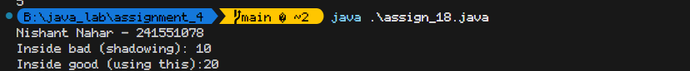
- Write a Java program to demonstrate single inheritance using Person and Student.
class Person {
String n = "Nishant";
}
class stud extends Person {
void d() {
System.out.println(n);
}
public static void main(String[] args) {
System.out.println("Nishant Nahar - 241551078");
new stud().d();
}
}
OUTPUT
- Create a program to show multilevel inheritance using Vehicle → Car → Electric Car.
class Person {
String n = "Nishant";
}
class stud extends Person {
void d() {
System.out.println(n);
}
public static void main(String[] args) {
System.out.println("Nishant Nahar - 241551078");
new stud().d();
}
}
OUTPUT
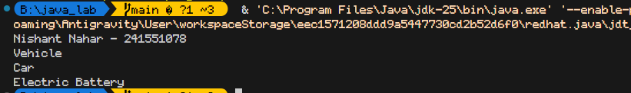
- Write a program showing constructor calling sequence in inheritance.
class P {
P() {
System.out.println("Parent");
}
}
class S extends P {
S() {
super();
System.out.println("Child");
}
public static void main(String[] args) {
System.out.println("Nishant Nahar - 241551078");
new S();
}
}
OUTPUT
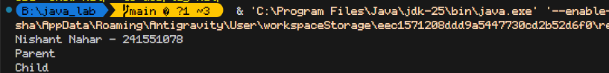
- Write a Java program to demonstrate aggregation using Address and Employee.
class Add {
String c = "City";
}
class Emp {
Add a;
Emp(Add a) {
this.a = a;
System.out.println("Address value: " + a.c);
}
public static void main(String[] args) {
System.out.println("Nishant Nahar - 241551078");
Add ad = new Add();
new Emp(ad);
}
}
OUTPUT
- Create a class Engine and aggregate it inside a Car class.
class Eng {
String t;
Eng(String t) {
this.t = t;
}
}
class car_1 {
String m;
Eng e;
car_1(String m, Eng e) {
this.m = m;
this.e = e;
}
void d() {
System.out.println(m + " has " + e.t);
}
public static void main(String[] args) {
System.out.println("Nishant Nahar - 241551078");
Eng en = new Eng("V8");
car_1 c = new car_1("Mustang", en);
c.d();
}
}
OUTPUT
- Write a program where a department has multiple Teacher objects.
class T {
String n;
T(String n) {
this.n = n;
}
}
class Dept {
String d;
T[] ts;
Dept(String d, T[] ts) {
this.d = d;
this.ts = ts;
}
void list() {
for (T t : ts)
System.out.println(d + " : " + t.n);
}
public static void main(String[] args) {
System.out.println("Nishant Nahar - 241551078");
T[] arr = { new T("Amit"), new T("Sumit") };
Dept d = new Dept("CS", arr);
d.list();
}
}
OUTPUT
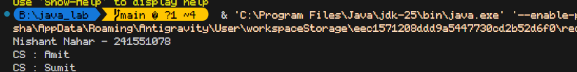
- Demonstrate aggregation using array of objects inside another class.
class Obj {
int id;
Obj(int i) {
id = i;
}
}
class Box {
Obj[] a;
Box(Obj[] a) {
this.a = a;
}
void show() {
for (Obj obj : a) {
System.out.println("ID: " + obj.id);
}
}
public static void main(String[] args) {
System.out.println("Nishant Nahar - 241551078");
Obj[] list = { new Obj(1), new Obj(2) };
new Box(list).show();
}
}
OUTPUT
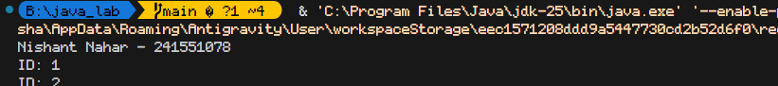
- Write a program showing difference between inheritance and aggregation.
class Base {
void run() {
System.out.println("Running");
}
}
class Inh extends Base {
public static void main(String[] args) {
System.out.println("Nishant Nahar - 241551078");
new Inh().run();
new Agg().b.run();
}
}
class Agg {
Base b = new Base();
}
OUTPUT
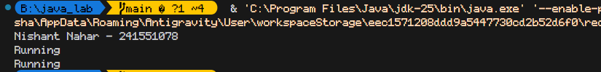
- Create a college class that contains Student objects using aggregation.
class Stu {
String n;
Stu(String n) {
this.n = n;
}
}
class Col {
Stu[] s;
Col(Stu[] s) {
this.s = s;
}
public static void main(String[] args) {
System.out.println("Nishant Nahar - 241551078");
Stu[] list = { new Stu("S1"), new Stu("S2") };
Col c = new Col(list);
for (Stu student : c.s) {
System.out.println(student.n);
}
}
}
OUTPUT
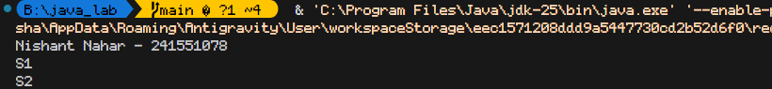
- Write a program to show HAS-A relationship using aggregation.
class CPU {
void op() {
System.out.println("CPU Op");
}
}
class PC {
CPU c = new CPU();
public static void main(String[] args) {
System.out.println("Nishant Nahar - 241551078");
PC p = new PC();
p.c.op();
}
}
OUTPUT
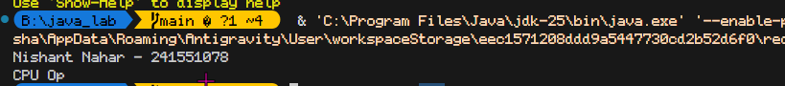
- Demonstrate aggregation with constructor-based object passing.
class Tool {
String type;
Tool(String t) {
type = t;
}
}
class Worker {
Tool t;
Worker(Tool t) {
this.t = t;
}

public static void main(String[] args) {
System.out.println("Nishant Nahar - 241551078");
Worker w = new Worker(new Tool("Drill"));
System.out.println(w.t.type);
}
}
OUTPUT
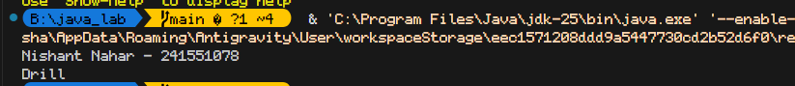
- Write a program where destroying parent object does not destroy aggregated object.
class Part {
void show() {
System.out.println("Part is alive");
}
}
class Whole {
Part p;
Whole(Part p) {
this.p = p;
}
}
public class assign_30 {
public static void main(String[] args) {
System.out.println("Nishant Nahar - 241551078");
Part part = new Part();
Whole whole = new Whole(part);
whole.p.show();
whole = null;
part.show();
}
}
OUTPUT
