OOPJ ASSIGNMENT 5
Name – Nishant Nahar
Roll No – 241551078
- Write a Java program where a child class calls a parameterized parent constructor using super().
class A_1 {
A_1(int x) {
System.out.println(x);
}
}
class B extends A_1 {
B(int x) {
super(x);
}
public static void main(String[] args) {
System.out.println("Nishant Nahar - 2415551078");
new B(5);
}
}
OUTPUT
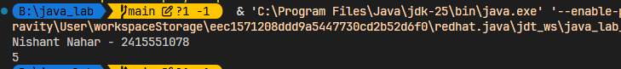
- Demonstrate accessing a hidden parent class variable using super.
class A_2 {
int x = 10;
}
class B_2 extends A_2 {
int x = 20;
void show() {
System.out.println(super.x);
}
public static void main(String[] args) {
System.out.println("Nishant Nahar - 241551078");
B_2 b = new B_2();
System.out.println(b.x);
b.show();
}
}
OUTPUT
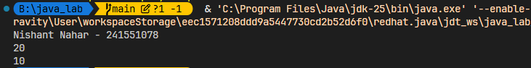
- Override a method in a child class and invoke the parent version using super.method().
class par {
void show() {
System.out.println("A");
}
}
class chi extends par {
void show() {
super.show();
System.out.println("B");
}
public static void main(String[] args) {
System.out.println("Nishant Nahar - 241551078");
new chi().show();
}
}
OUTPUT
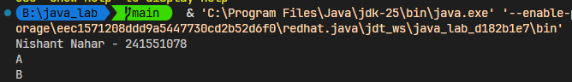
- Show that super() must be the first statement in a constructor. (ERROR Showing)
class A_0 {
A_0() {
System.out.println("A");
}
}
class B_0 extends A_0 {
B_0() {
System.out.println("B");
super();
}
public static void main(String[] args) {
System.out.println("Nishant Nahar - 241551078");
new B_0();
}
}
OUTPUT

- Demonstrate constructor execution order using super.
class A_3 {
A_3() {
System.out.println("A");
}
}
class B_1 extends A_3 {
B_1() {
super();
System.out.println("B");
}
}
class C_0 extends B_1 {
C_0() {
super();
System.out.println("C");
}
public static void main(String[] args) {
System.out.println("Nishant Nahar - 241551078");
new C_0();
}
}
OUTPUT
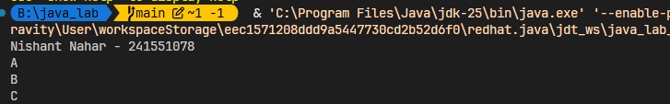
- Write a program where omission of super() causes a compilation error.
class par_1 {
par_1(int x) {
System.out.println(x);
}
}
class chi_1 extends par_1 {
chi_1() {
System.out.println("chi_1");
}
static public void main(String[] args) {
System.out.println("Nishant Nahar - 241551078");
chi_1 c = new chi_1();
}
}
OUTPUT
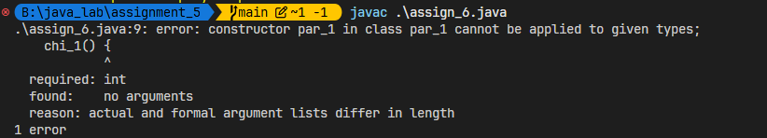
- Use super in multilevel inheritance.
class A_3 {
A_3() {
System.out.println("A");
}
}
class B_1 extends A_3 {
B_1() {
super();
System.out.println("B");
}
}
class C_0 extends B_1 {
C_0() {
super();
System.out.println("C");
}
public static void main(String[] args) {
System.out.println("Nishant Nahar - 241551078");
new C_0();
}
}
OUTPUT
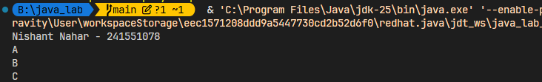
- Demonstrate variable shadowing and resolution using super.
class Parent {
int x = 10;
}
class Child extends Parent {
int x = 20;
void show() {
System.out.println(x);
System.out.println(super.x);
}
}
public class Main {
public static void main(String[] args) {
System.out.println("Nishant Nahar - 241551078");
new Child().show();
}
}
OUTPUT
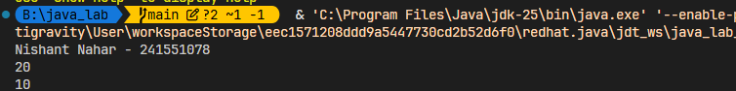
9. Show method and variable name conflict resolution using super.
10. Distinguish between this and super through a program.
11. Demonstrate that a final variable cannot be modified.
12. Initialize a final variable using a constructor.
13. Show that a final method cannot be overridden.
14. Demonstrate that a final class cannot be inherited.
15. Show behavior of a final reference variable.
16. Use final keyword with constructor parameters.
17. Demonstrate how final restricts runtime polymorphism.
18. Show compile-time error when overriding a final method.
19. Initialize a final variable inside an instance initializer block.
20. Write a program to demonstrate execution of an instance initializer block.
21. Show execution order of instance initializer block and constructor.
22. Demonstrate multiple instance initializer blocks and their execution order.
23. Show instance initializer block execution in inheritance.
24. Initialize instance variables using an instance initializer block.
25. Write a program to demonstrate runtime polymorphism using method overriding.
26. Demonstrate dynamic method dispatch using parent reference and child object.
27. Show that runtime polymorphism does not apply to instance variables.
28. Demonstrate runtime polymorphism in multilevel inheritance.
29. Show that constructors do not support runtime polymorphism.
30. Demonstrate that static methods are not polymorphic.
31. Show effect of final method on runtime polymorphism.
32. Demonstrate runtime binding of overridden methods.
33. Write a program where a parent reference invokes different child implementations.
34. Demonstrate polymorphism using arrays of parent-class references.
35. Show method call resolution when overridden methods throw exceptions.
36. Demonstrate polymorphism with method parameters and return types.
37. Write a program showing upcasting and its role in polymorphism.
38. Demonstrate why downcasting can cause ClassCastException.
39. Write a single program combining super + final + runtime polymorphism and explain the output.

