OOPJ LAB ASSIGNMENT – 8
Name – Nishant Nahar
Roll No - 241551078
- Write a Java program to create strings using literal and new keyword and compare them using == and .equals() methods.
class as_1_q_1 {
public static void main(String[] a) {
System.out.println("Nishant Nahar - 241551078");
String s1 = "Hell";
String s2 = "Hill";
String s3 = new String("Hell");
System.out.println(s1 == s2);
System.out.println(s1 == s3);
System.out.println(s1.equals(s3));
}}
OUTPUT
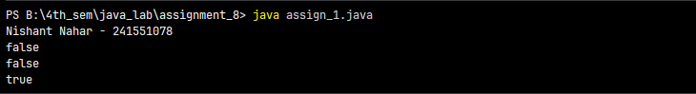
- Write a Java program to demonstrate immutability of the String class with suitable examples.
class as_1_q_2 {
public static void main(String[] a) {
System.out.println("Nishant Nahar - 241551078");
String s = "Hi";
String s2 = s.concat(" Nishant");
System.out.println(s);
System.out.println(s2);
}}
OUTPUT
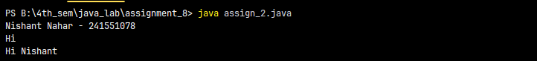
- Write a Java program to count vowels, consonants, digits, and special characters in a given string.
class as_1_q_3 {
public static void main(String[] a) {
System.out.println("Nishant Nahar - 241551078");
String s = "Abc123@$$5rwQiuo#";
int v = 0, c = 0, d = 0, sp = 0;
for (int i = 0; i < s.length(); i++) {
char ch = s.charAt(i);
if (ch == 'a' || ch == 'e' || ch == 'i' || ch == 'o' || ch == 'u' || ch == 'A' || ch == 'E' || ch == 'I' || ch == 'O' || ch == 'U')
v++;
else if ((ch >= 'a' && ch <= 'z') || (ch >= 'A' && ch <= 'Z')) c++;
else if (ch >= '0' && ch <= '9') d++;
else sp++;
}
System.out.println(v + " " + c + " " + d + " " + sp);
}}
OUTPUT
- Write a Java program to reverse a string using loop, StringBuilder, and recursion.
class as_1_q_4 {
static String r(String s) {
if (s.equals("")) return "";
return r(s.substring(1)) + s.charAt(0);
}
public static void main(String[] a) {
System.out.println("Nishant Nahar - 241551078");
String s = "Java";
System.out.println(r(s));
}}
OUTPUT
- Write a Java program to check whether a given string is a palindrome ignoring spaces and case sensitivity.
class as_1_q_5 {
public static void main(String[] a) {
System.out.println("Nishant Nahar - 241551078");
String s = "A man a plan a canal Panama".toLowerCase();
int i = 0, j = s.length() - 1;
boolean f = true;
while (i < j) {
char c1 = s.charAt(i);
char c2 = s.charAt(j);
if (c1 == ' ') {i++;continue;}
if (c2 == ' ') {j--;continue;}
if (c1 != c2) {f = false;break;}
i++;j--;}
System.out.println(f);
}}
OUTPUT
- Write a Java program to count the number of words in a sentence without using the split() method.
class as_1_q_6 {
public static void main(String[] a) {
System.out.println("Nishant Nahar - 241551078");
String s = "This is java code written by me ";
s = s.trim();
int c = 0;
for (int i = 0; i < s.length(); i++) {
if (s.charAt(i) == ' ') c++;}
System.out.println(c + 1);
}}
OUTPUT
- Write a Java program to remove duplicate characters from a string whilemaintaining insertion order.
class as_1_q_7 {
public static void main(String[] a) {
System.out.println("Nishant Nahar - 241551078");
String s = "programming";
String r = "";
for (int i = 0; i < s.length(); i++) {
char ch = s.charAt(i);
if (r.contains(ch + "") == false) {
r = r + ch;}}
System.out.println(r);
}}
OUTPUT
- Write a Java program to find the frequency of each character and display the character with maximum frequency.
class as_1_q_8 {
public static void main(String[] args) {
System.out.println("Nishant Nahar - 241551078");
String s = "nishant nahar";
int max = 0;
char cc = ' ';
for (int i = 0; i < s.length(); i++) {
int count = 0;
for (int j = 0; j < s.length(); j++) {
if (s.charAt(i) == s.charAt(j)) count++;}
if (count > max) {
max = count;
cc = s.charAt(i);
}}
System.out.println(cc + " " + max);
}}
OUTPUT
- Write a Java program to check whether two strings are anagrams withoutusing sorting.
class as_1_q_9 {
public static void main(String[] a) {
System.out.println("Nishant Nahar - 241551078");
String s1 = "listen";
String s2 = "silent";
if (s1.length() != s2.length()) {
System.out.println("Not Anagram");
return;}
int count = 0;
for (int i = 0; i < s1.length(); i++) {
char ch = s1.charAt(i);
for (int j = 0; j < s2.length(); j++) {
if (ch == s2.charAt(j)) {
s2 = s2.substring(0, j) + s2.substring(j + 1);
count = count + 1;
break;}}}
if (count == s1.length()) System.out.println("Anagram");
else System.out.println("Not Anagram");
}}
OUTPUT
- Write a Java program to find the first non-repeating character in a string.
class as_1_q_10 {
public static void main(String[] a) {
System.out.println("Nishant Nahar - 241551078");
String s = "swiss";
for (int i = 0; i < s.length(); i++) {
int count = 0;
for (int j = 0; j < s.length(); j++) {
if (s.charAt(i) == s.charAt(j)) count = count + 1;
}
if (count == 1) {
System.out.println(s.charAt(i));
break;
}}}}
OUTPUT
- Write a Java program to demonstrate the difference between String, StringBuffer, and StringBuilder with performance comparison.
class as_1_q_11 {
public static void main(String[] a) {
System.out.println("Nishant Nahar - 241551078");
long t = System.currentTimeMillis();
String s = "";
for (int i = 0; i < 10000; i++) s = s + "a";
System.out.println("String: " + (System.currentTimeMillis() - t));
t = System.currentTimeMillis();
StringBuffer sb = new StringBuffer();
for (int i = 0; i < 10000; i++) sb.append("a");
System.out.println("StringBuffer: " + (System.currentTimeMillis() - t));
t = System.currentTimeMillis();
StringBuilder sb2 = new StringBuilder();
for (int i = 0; i < 10000; i++) sb2.append("a");
System.out.println("StringBuilder: " + (System.currentTimeMillis() - t));
}}
OUTPUT
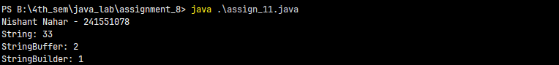
- Write a Java program to toggle the case of characters without using built- in case conversion methods.
class as_1_q_12 {
public static String toggleCase(String s) {
String r = "";
for (int i = 0; i < s.length(); i++) {
char ch = s.charAt(i);
if (ch >= 'a' && ch <= 'z') r = r + (char) (ch - 32);
else if (ch >= 'A' && ch <= 'Z') r = r + (char) (ch + 32);
else r = r + ch;}
return r;}
public static void main(String[] args) {
System.out.println("Nishant Nahar - 241551078");
String s = "Hola Amigos";
String t = toggleCase(s);
System.out.println(t);
}}
OUTPUT
- Write a Java program to replace multiple spaces in a sentence with a single space.
class as_1_q_13 {
public static String rmv(String s) {
boolean sp = false;
String temp = "";
for (int i = 0; i < s.length(); i++) {
char c = s.charAt(i);
if (c != ' ') {
temp = temp + c;
sp = false;
} else {
if (!sp) {
temp = temp + ' ';
sp = true;
}}}
s = temp;
return s;}
public static void main(String[] args) {
System.out.println("Nishant Nahar - 241551078");
String s = "How are you doing my buddy ?";
s = rmv(s);
System.out.println(s);
}}
OUTPUT
- Write a Java program to find the longest and shortest word in a given sentence.
class as_1_q_14 {
public static void main(String[] args) {
System.out.println("Nishant Nahar - 241551078");
String s = "Java programming is fun and powerful";
String[] w = s.split(" ");
String longWord = "", shortWord = w[0];
for (int i = 0; i < w.length; i++) {
if (w[i].length() > longWord.length()) longWord = w[i];
if (w[i].length() < shortWord.length()) shortWord = w[i];
}
System.out.println("Longest: " + longWord);
System.out.println("Shortest: " + shortWord);
}}
OUTPUT
- Write a Java program to implement basic string compression such as converting “aaabbcc” into “a3b2c2”
class as_1_q_15 {
public static void main(String[] args) {
System.out.println("Nishant Nahar - 241551078");
String s = "aabbccddggffrryt";
StringBuilder r = new StringBuilder();
int c = 1;
for (int i = 0; i < s.length(); i++) {
if (i + 1 < s.length() && s.charAt(i) == s.charAt(i + 1)) c++;
else {
r.append(s.charAt(i)).append(c);
c = 1;
}}
System.out.println(r);
}}
OUTPUT
- Write a Java program to validate a password based on length, uppercase, lowercase, digit, and special character rules.
class as_1_q_16 {
public static void main(String[] args) {
System.out.println("Nishant Nahar - 241551078");
String p = "Abc123$";
int count = 0;
if (p.length() >= 6) {
for (int i = 0; i < p.length(); i++) {
char c = p.charAt(i);
if (c >= 'A' && c <= 'Z') count++;
else if (c >= 'a' && c <= 'z') count++;
else if (c >= '0' && c <= '9') count++;
else if ("!@#$%^&*()".indexOf(c) != -1) count++;
}}
if (count >= 5) System.out.println("Valid");
else System.out.println("Invalid");
}}
OUTPUT
- Write a Java program to check whether one string is rotation of another using only one string operation.
class as_1_q_17 {
public static void main(String[] args) {
System.out.println("Nishant Nahar - 241551078");
String s1 = "nish";
String s2 = "shni";
int n = s1.length();
int found = 0;
if (s1.length() == s2.length()) {
for (int i = 0; i < n; i++) {
int j;
for (j = 0; j < n; j++) {
if (s1.charAt((i + j) % n) != s2.charAt(j)) break;}
if (j == n) {
found = 1;
break;
}}}
if (found == 1) System.out.println("Rotation");
else System.out.println("Not Rotation");
}}
OUTPUT
- Write a Java program to print all possible substrings of a given string and count them.
class as_1_q_18 {
public static void main(String[] args) {
System.out.println("Nishant Nahar - 241551078");
String s = "abcfd";
int count = 0;
for (int i = 0; i < s.length(); i++) {
for (int j = i + 1; j <= s.length(); j++) {
System.out.println(s.substring(i, j));
count++;
}}
System.out.println("Total substrings: " + count);
}}
OUTPUT
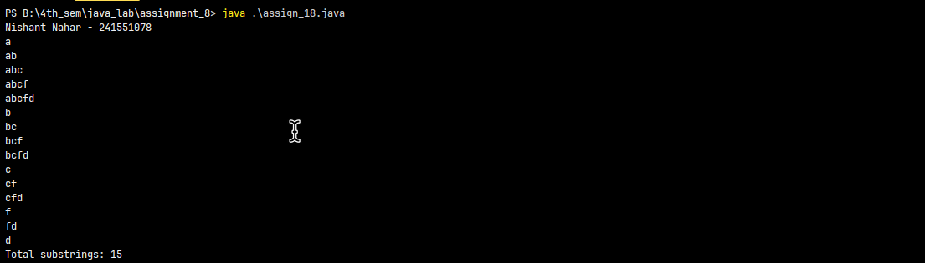
- Write a Java program to find the most repeated word in a paragraph ignoring case sensitivity.
class as_1_q_19 {
public static void main(String[] args) {
System.out.println("Nishant Nahar - 241551078");
String s = "Java is fun. Java is powerful. java was easy. Java is not good.".toLowerCase();
String[] w = s.split(" ");
String max = w[0];
int fmax = 0;
for (int i = 0; i < w.length; i++) {
int f = 0;
for (int j = 0; j < w.length; j++) {
if (w[i].equals(w[j])) f++;}
if (f > fmax) { fmax = f; max = w[i];}}
System.out.println(max);
}}
OUTPUT
- Write a Java program to check whether a string contains only unique characters.
class as_1_q_20 {
public static void main(String[] args) {
System.out.println("Nishant Nahar - 241551078");
String s = "abcdegwij";
int n = s.length();
int f = 0;
for (int i = 0; i < n; i++) {
for (int j = i + 1; j < n; j++) {
if (s.charAt(i) == s.charAt(j)) {
f = 1;
break;
}}
if (f == 1) break; }
if (f == 0) System.out.println("Unique");
else System.out.println("Not Unique");
}}
OUTPUT
- Write a Java program to determine whether a string is a valid IPv4 address.
class as_1_q_21 {
public static void main(String[] args) {
System.out.println("Nishant Nahar - 241551078");
String s = "192.168.1.1";
String[] p = s.split("\\.");
int f = 0;
if (p.length == 4) {
for (int i = 0; i < 4; i++) {
int n = Integer.parseInt(p[i]);
if (n < 0 || n > 255) {
f = 1;
break;}}
} else f = 1;
if (f == 0) System.out.println("Valid");
else System.out.println("Invalid");
}}
OUTPUT
- Write a Java program to implement your own version of index of() method without using built-in functions.
class as_1_q_22 {
public static void main(String[] args) {
System.out.println("Nishant Nahar - 241551078");
String s = "Nishant Pankaj Nahar";
String t = "Pankaj Nahar";
int n = s.length();
int m = t.length();
int index = -1;
for (int i = 0; i <= n - m; i++) {
int j;
for (j = 0; j < m; j++) {
if (s.charAt(i + j) != t.charAt(j)) break; }
if (j == m) { index = i; break; }}
System.out.println(index);
}}
OUTPUT
- Write a Java program to determine whether two strings differ by exactly one character.
class as_1_q_23 {
public static void main(String[] args) {
System.out.println("Nishant Nahar - 241551078");
String s1 = "hello";
String s2 = "hollo";
int n1 = s1.length();
int n2 = s2.length();
int f = 0;
if (n1 == n2) {
for (int i = 0; i < n1; i++) {
if (s1.charAt(i) != s2.charAt(i)) f++;}
} else f = -1;
if (f == 1) System.out.println("Yes, differ by 1");
else System.out.println("No");
}}
OUTPUT
- Write a Java program to generate all permutations of a given string.
class as_1_q_24 {
static void perm(String p, String up) {
if (up.length() == 0) {
System.out.println(p);
return;}
for (int i = 0; i < up.length(); i++) {
perm(p + up.charAt(i), up.substring(0, i) + up.substring(i + 1));}}
public static void main(String[] args) {
System.out.println("Nishant Nahar - 241551078");
String s = "abc";
perm("", s);
}}
OUTPUT
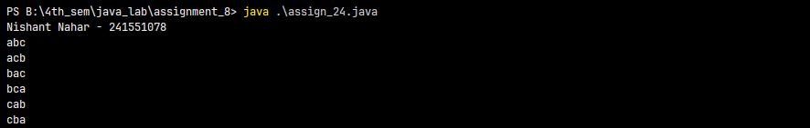
- Write a Java program to check whether a string follows a given pattern (e.g., “abba” matches “dog cat cat dog”).
class as_1_q_25 {
public static void main(String[] args) {
System.out.println("Nishant Nahar - 241551078");
String p = "abba";
String s = "dog cat cat dog";
String[] w = s.split(" ");
if (p.length() != w.length) {
System.out.println("No");
return;}
for (int i = 0; i < p.length(); i++) {
for (int j = i + 1; j < p.length(); j++) {
if (p.charAt(i) == p.charAt(j) && !w[i].equals(w[j])) {
System.out.println("No");
return;}
if (p.charAt(i) != p.charAt(j) && w[i].equals(w[j])) {
System.out.println("No");
return;
}}}
System.out.println("Yes");
}}
OUTPUT
- Write a Java program to calculate the edit distance between two strings.
class as_1_q_26 {
public static void main(String[] args) {
System.out.println("Nishant Nahar - 241551078");
String s1 = "horse";
String s2 = "ros";
int n = s1.length();
int m = s2.length();
int[][] dp = new int[n + 1][m + 1];
for (int i = 0; i <= n; i++) dp[i][0] = i;
for (int j = 0; j <= m; j++) dp[0][j] = j;
for (int i = 1; i <= n; i++) {
for (int j = 1; j <= m; j++) {
if (s1.charAt(i - 1) == s2.charAt(j - 1)) {
dp[i][j] = dp[i - 1][j - 1];
} else {
int replace = dp[i - 1][j - 1];
int delete = dp[i - 1][j];
int insert = dp[i][j - 1];
int min = replace;
if (delete < min) min = delete;
if (insert < min) min = insert;
dp[i][j] = 1 + min;
}}}
System.out.println(dp[n][m]);
}}
OUTPUT
- Write a Java program to detect whether a string is a valid palindrome considering only alphanumeric characters.
class as_1_q_27 {
public static void main(String[] args) {
System.out.println("Nishant Nahar - 241551078");
String s = "A man, a plan, a canal: Panama";
s = s.toLowerCase();
String clean = "";
for (int i = 0; i < s.length(); i++) {
char c = s.charAt(i);
if ((c >= 'a' && c <= 'z') || (c >= '0' && c <= '9')) clean += c;}
int i = 0, j = clean.length() - 1;
while (i < j) {
if (clean.charAt(i) != clean.charAt(j)) {
System.out.println("No");
return;}
i++;j--;}
System.out.println("Yes");
}}
OUTPUT
- Write a Java program to implement a simple Caesar Cipher encryption and decryption technique.
class as_1_q_28 {
public static void main(String[] args) {
System.out.println("Nishant Nahar - 241551078");
String s = "abcXYZ";
int shift = 2;
String enc = "";
for (int i = 0; i < s.length(); i++) {
char c = s.charAt(i);
if (c >= 'a' && c <= 'z') enc += (char) ((c - 'a' + shift) % 26 + 'a');
else if (c >= 'A' && c <= 'Z') enc += (char) ((c - 'A' + shift) % 26 + 'A');
else enc += c;}
System.out.println("Encrypted: " + enc);
}}
OUTPUT
- Write a Java program to find the longest palindromic substring in a given string.
class as_1_q_29 {
public static void main(String[] args) {
System.out.println("Nishant Nahar - 241551078");
String s = "bababd", r = "";
for (int i = 0; i < s.length(); i++) {
String o = e(s, i, i), v = e(s, i, i + 1);
if (o.length() > r.length()) r = o;
if (v.length() > r.length()) r = v;}
System.out.println(r);}
static String e(String s, int l, int r) {
while (l >= 0 && r < s.length() && s.charAt(l) == s.charAt(r)) {
l--;r++;}
return s.substring(l + 1, r);}}
OUTPUT
- Write a Java program to design a menu-driven String Utility System that performs multiple string operations using modular methods.
import java.util.Scanner;
class as_1_q_30 {
public static void main(String[] args) {
System.out.println("Nishant Nahar - 241551078");
Scanner sc = new Scanner(System.in);
String s = "Hello My Name is Nishant";
while (true) {
System.out.println("1.Length 2.Upper 3.Lower 4.Split 5.Reverse 6.Exit");
int ch = sc.nextInt();
sc.nextLine();
if (ch == 1) System.out.println(s.length());
else if (ch == 2) System.out.println(s.toUpperCase());
else if (ch == 3) System.out.println(s.toLowerCase());
else if (ch == 4) {
String[] t = s.split("");
for (String x : t) System.out.print(x + " ");
System.out.println();
} else if (ch == 5) System.out.println(r(s));
else break;}
sc.close();}
static String r(String s) {
String t = "";
for (int i = s.length() - 1; i >= 0; i--) t += s.charAt(i);
return t;}}
OUTPUT