OOPJ LAB ASSIGNMENT – 11
Name – Nishant Nahar
Roll No – 241551078
- Write a Java Swing program that creates a login form with username and password fields and validates the input when the login button is clicked.
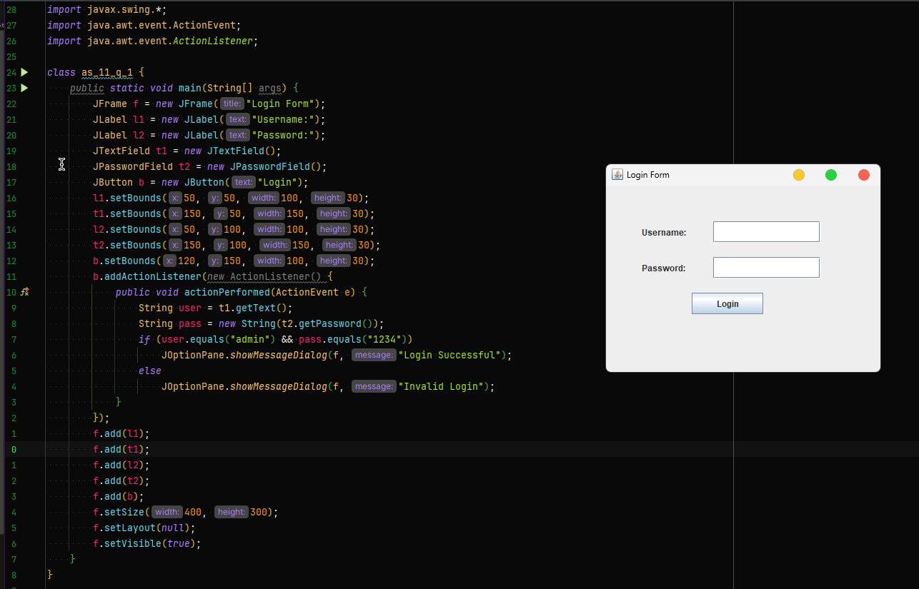
- Design a Swing application that changes the background color of the window randomly whenever a button is pressed.
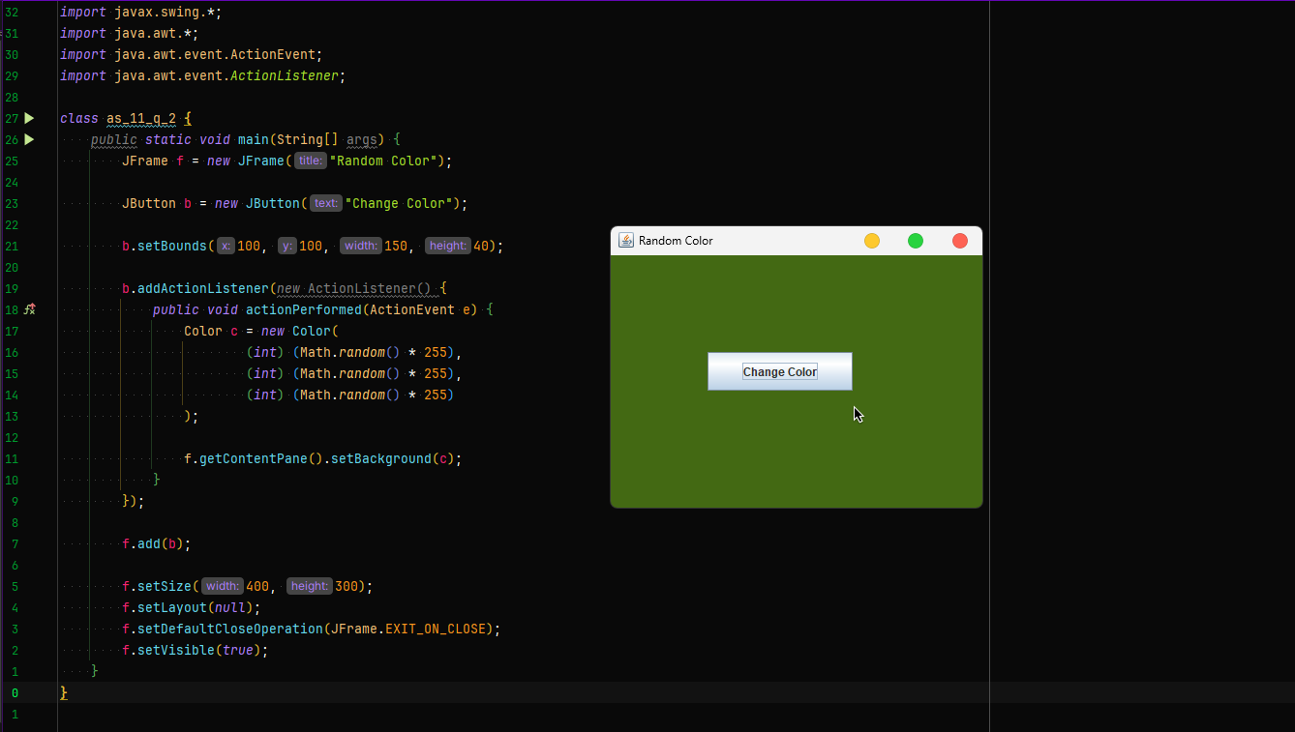
- Create a Swing program that displays the current system time and updates it every second.
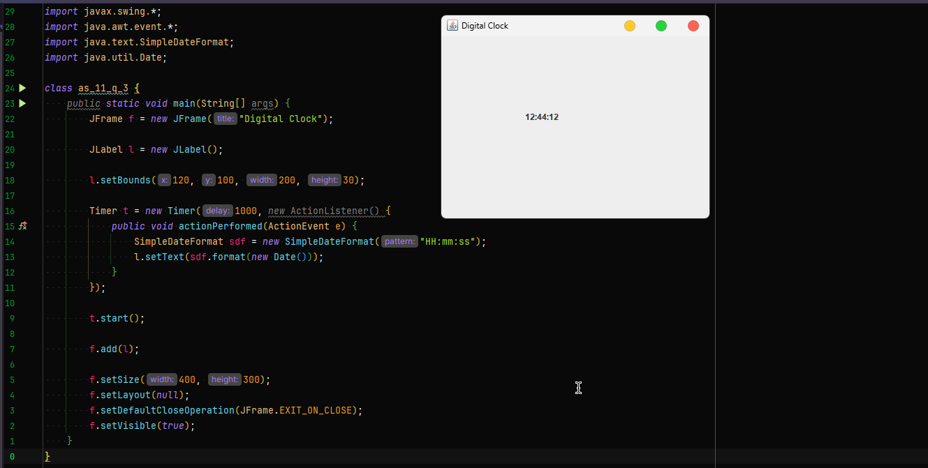
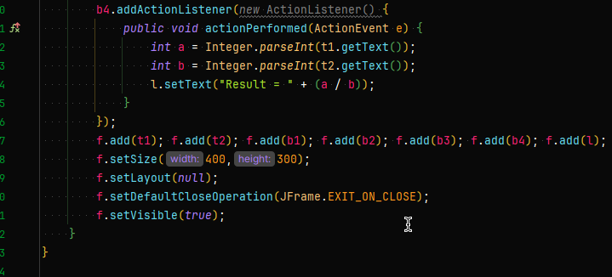
- Write a Swing application that accepts two numbers from text fields and performs arithmetic operations using buttons.
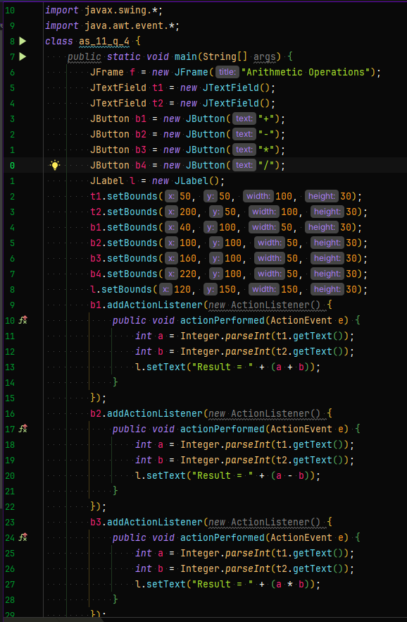
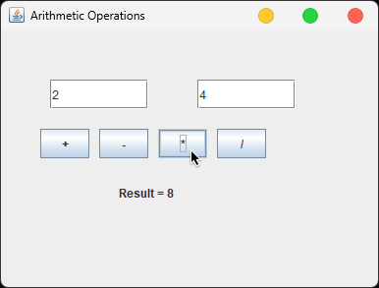

- Design a GUI where clicking a button dynamically adds new buttons to the window.
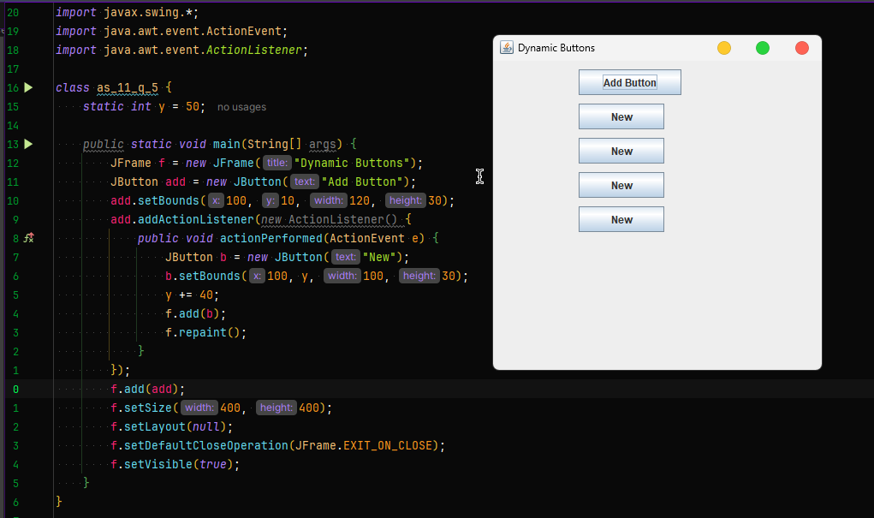
- Write a Swing program where a label moves across the screen when a button is pressed.
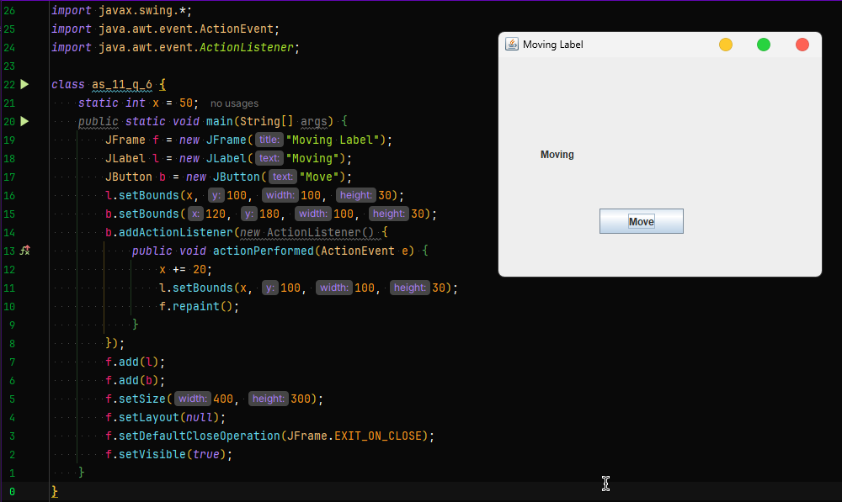

- Create a Swing application that counts how many times a button has been clicked.
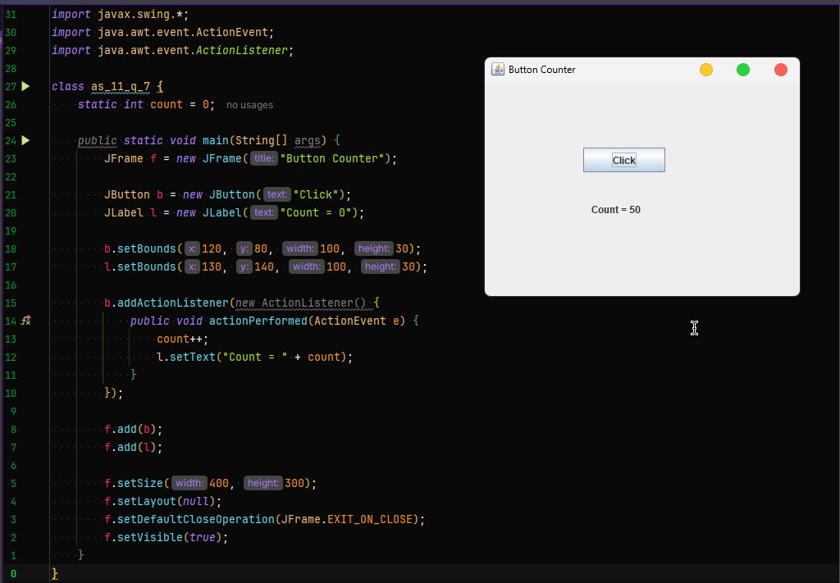
- Write a Swing program that enables or disables buttons depending on user interaction.
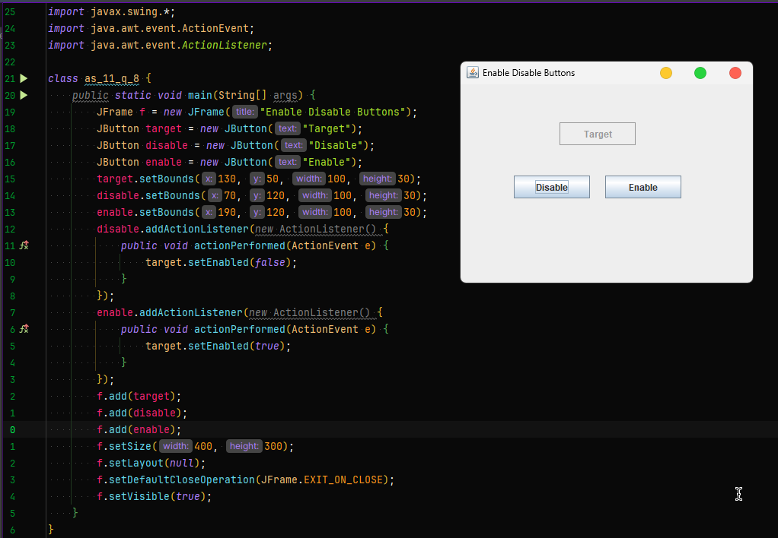
- Design a GUI that changes the font size and color of text dynamically based on user selection.
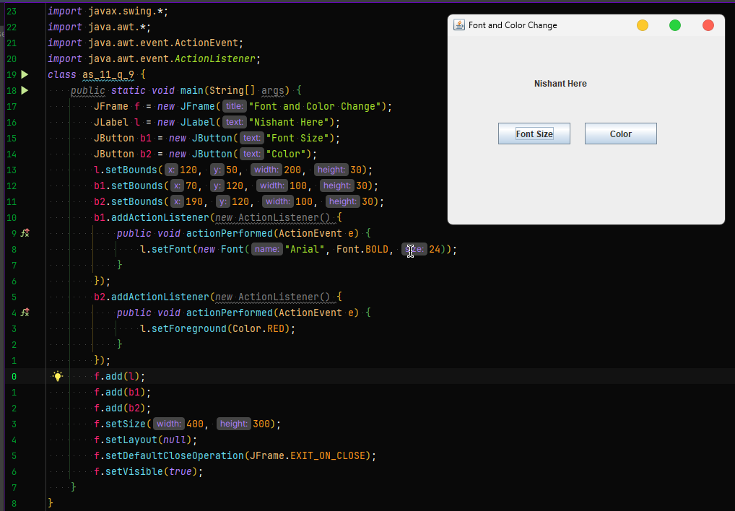
- Write a Swing application that displays a confirmation dialog before closing the window.
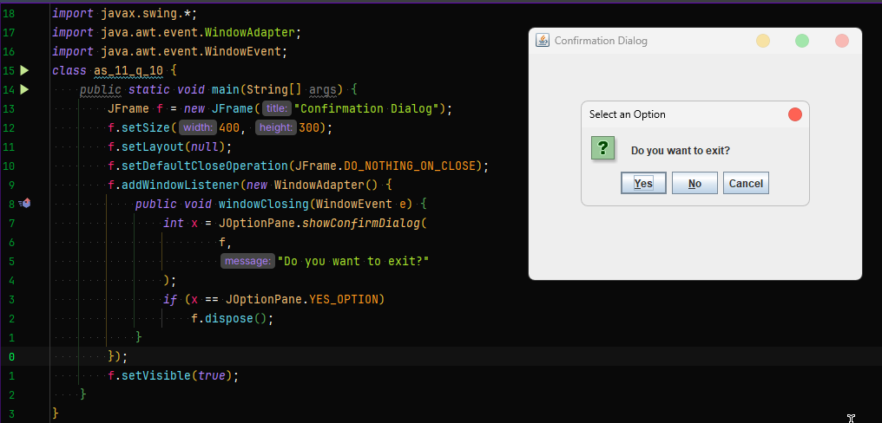

- Create a Swing program that implements a simple calculator supporting +, −, ×, ÷ operations.
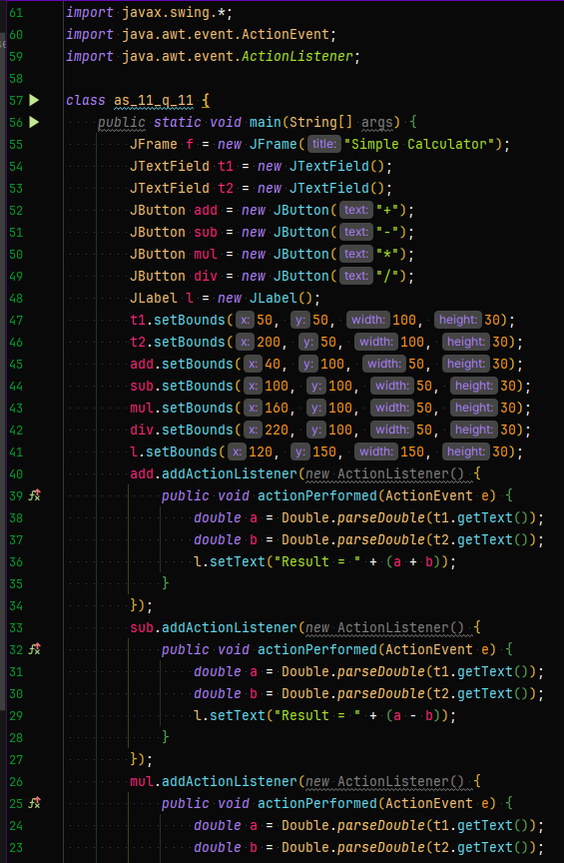
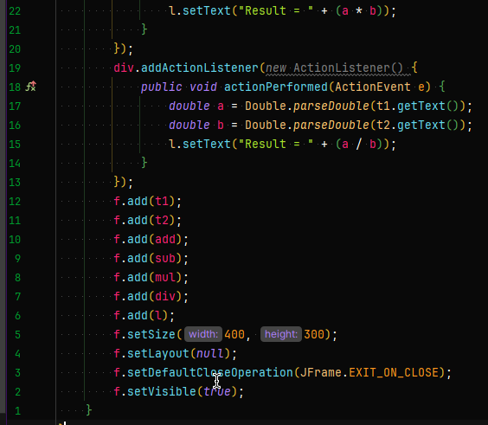
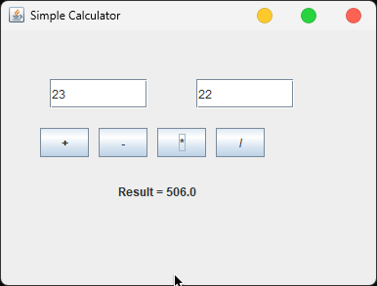

- Design a Swing application that generates a random number and asks the user to guess it.
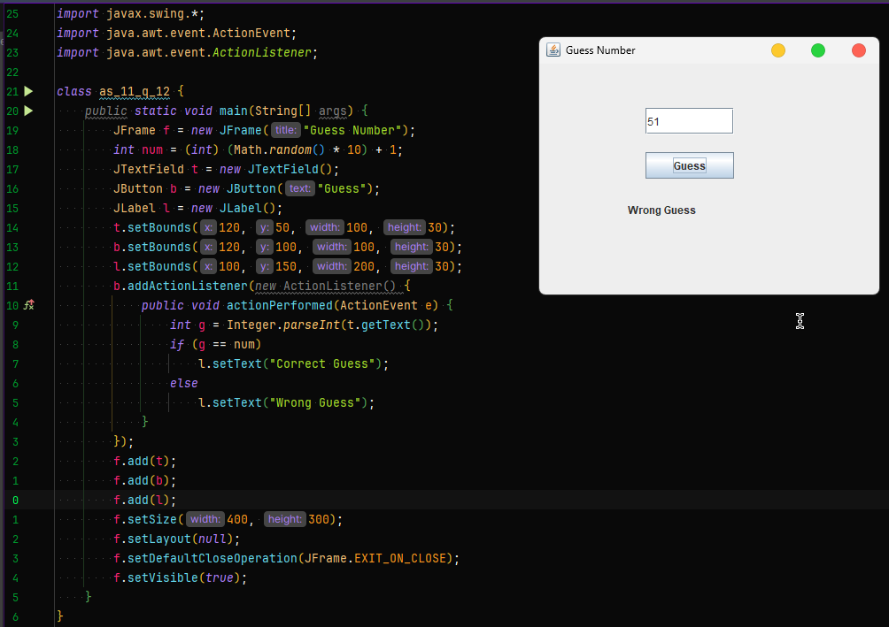
- Write a program that creates a dynamic menu bar where menu items trigger different actions.
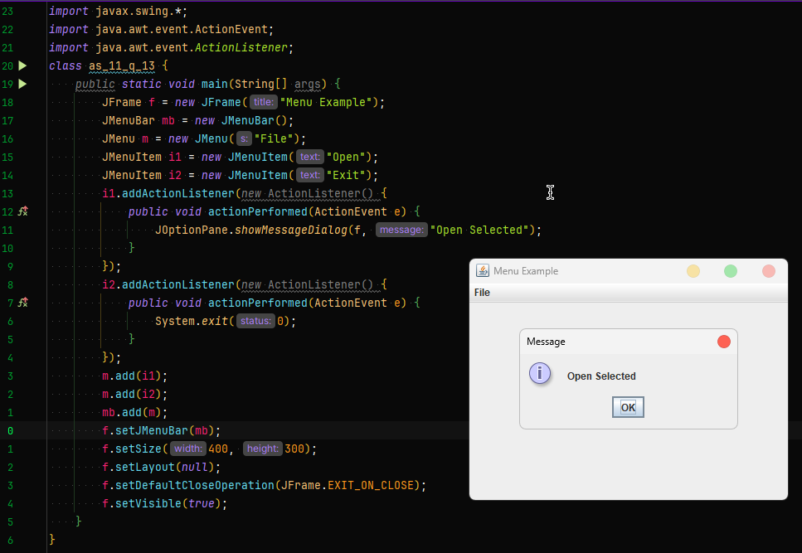
- Design a GUI that loads and displays an image selected by the user.
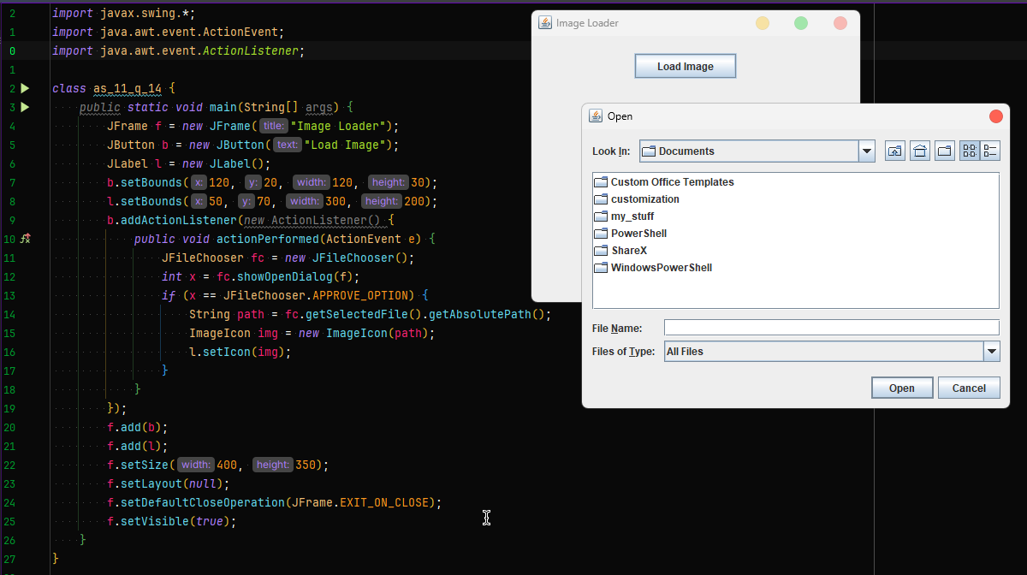

- Write a Swing application that changes the window theme using radio buttons.
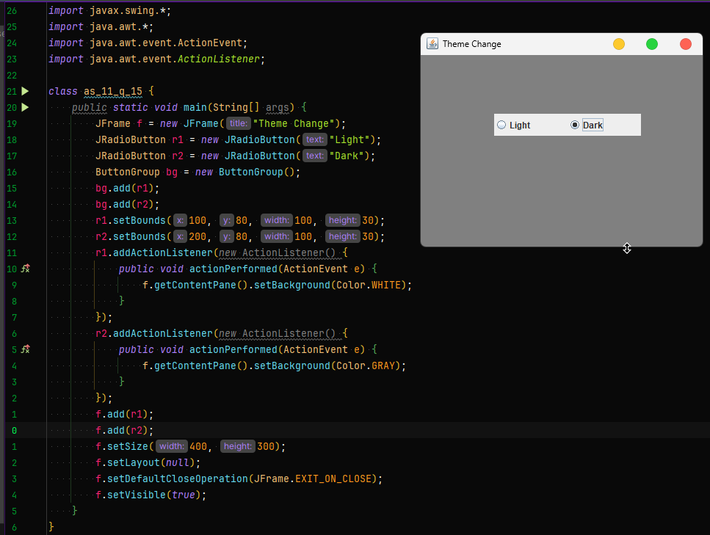
- Create a Swing program that validates a student registration form (name, email, age).
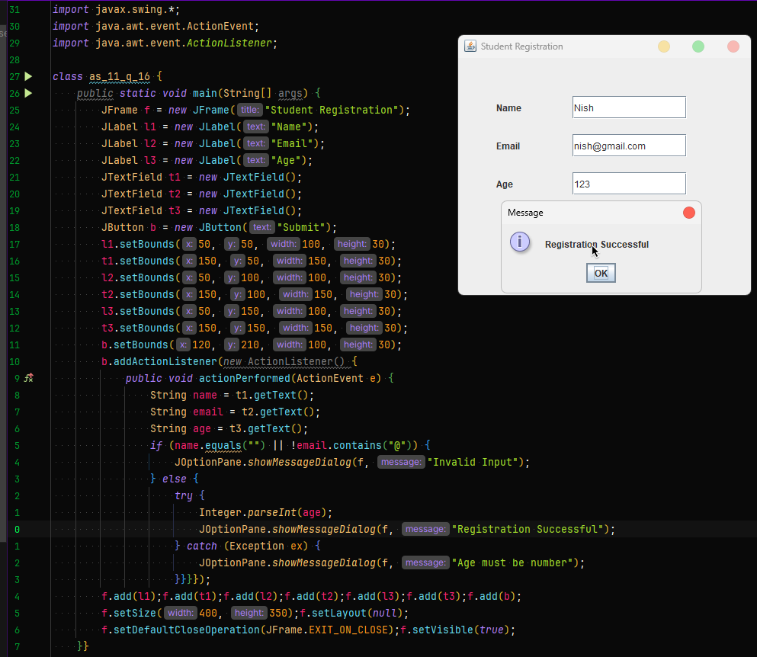
- Design a GUI that stores user input in a table (JTable) and displays it dynamically.
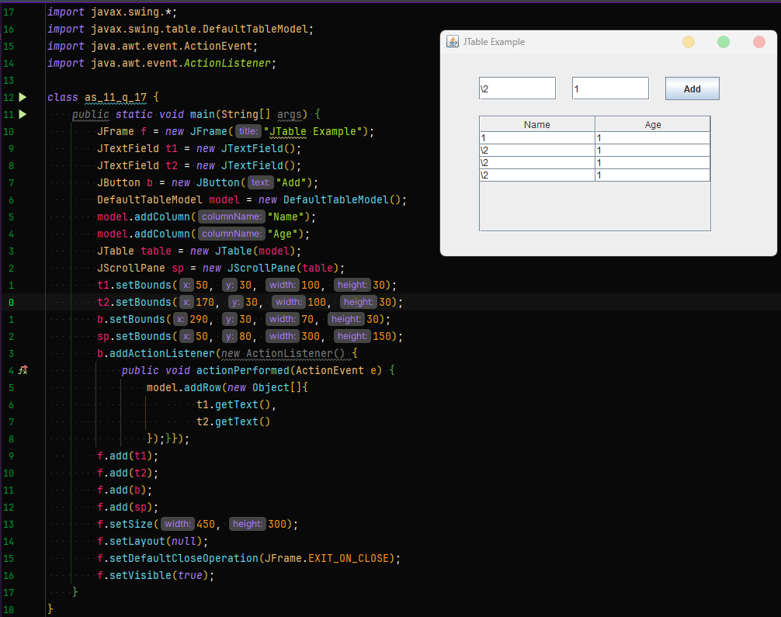
- Write a program where clicking different buttons displays different panels using CardLayout.
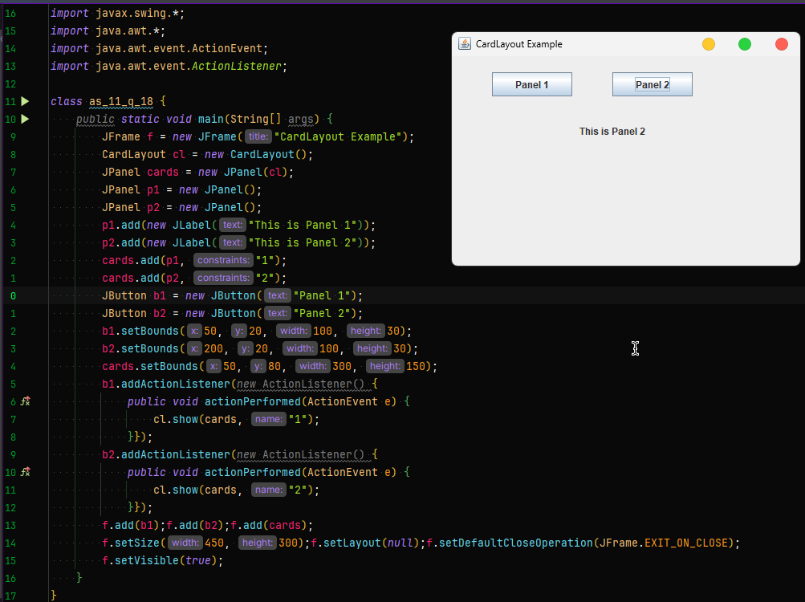
- Design a GUI that draws simple shapes (circle, rectangle, line)when selected from a menu.
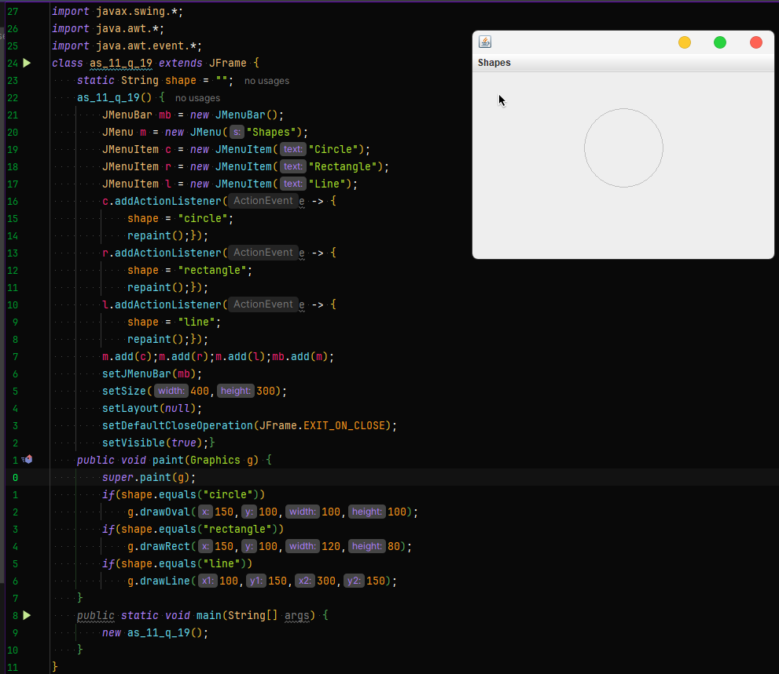
- Write a Swing application that simulates a traffic signal using colored circles.
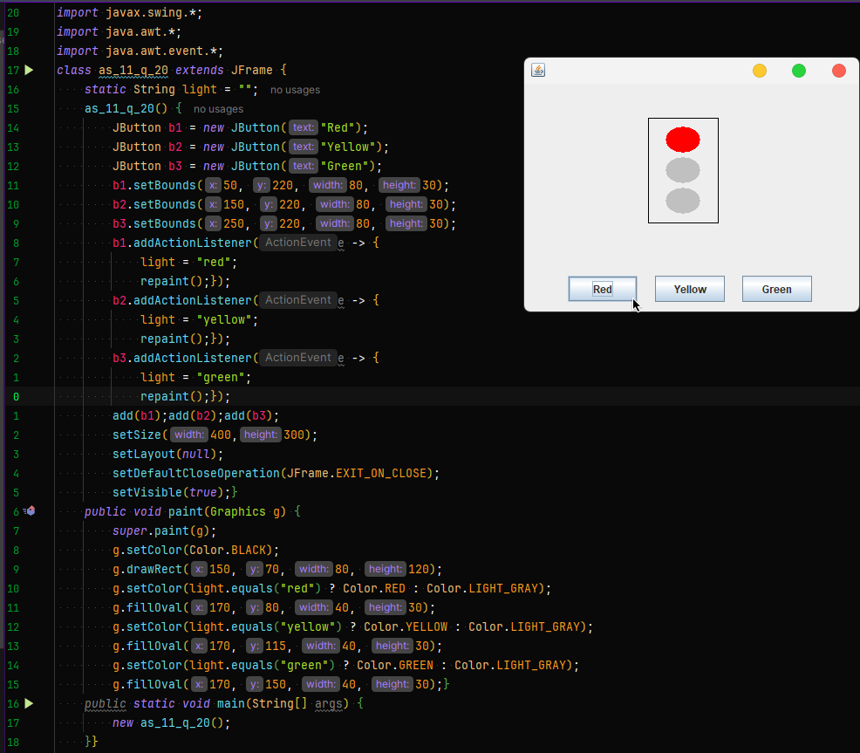
- Develop a multi-threaded Swing program where a progress bar updates while a background task runs.
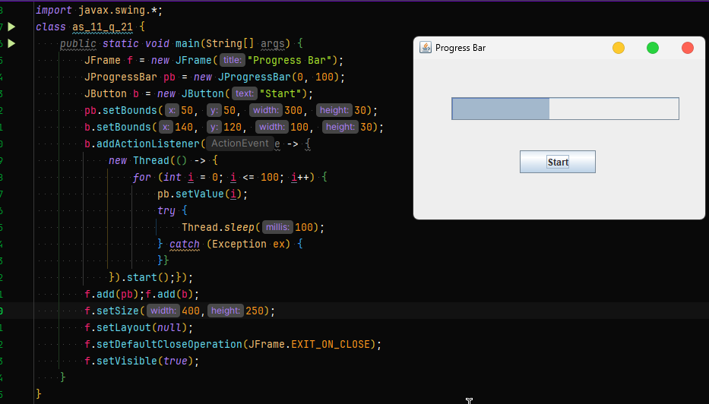
- Design a Swing application that creates a real-time chat interface between two windows.
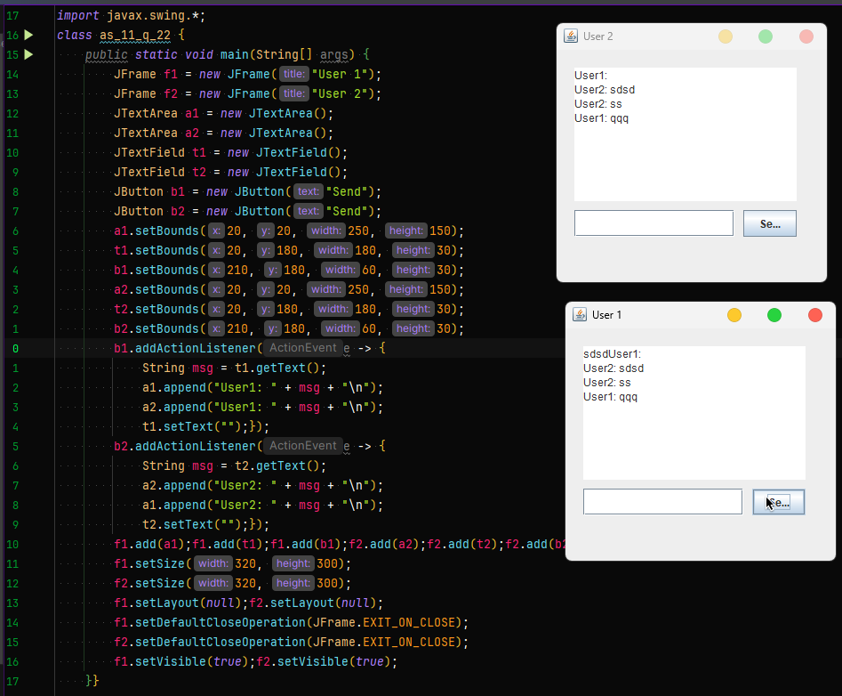
- Write a program that visualizes sorting algorithms using animated bars.
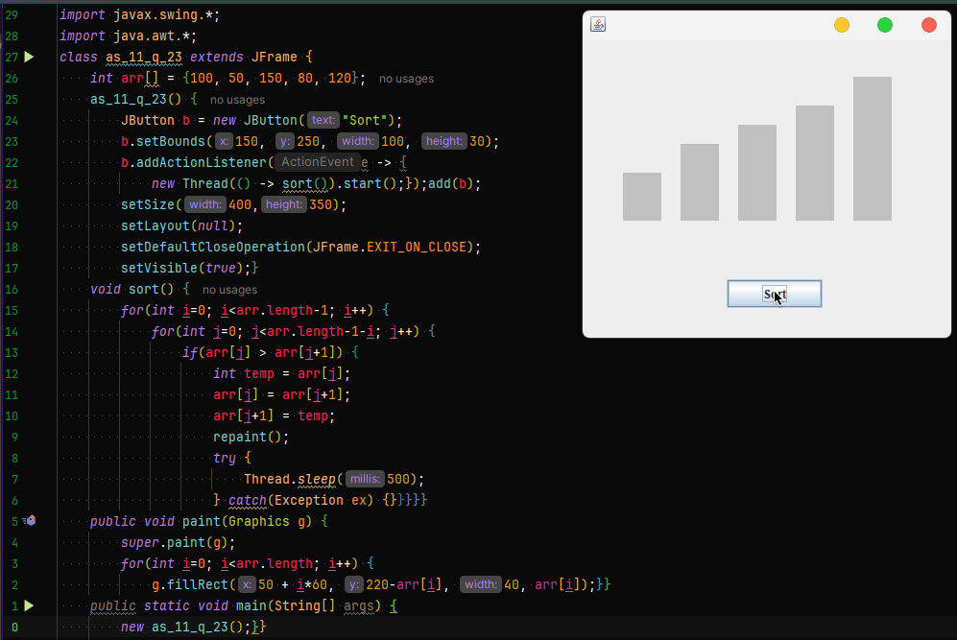
- Create a GUI that simulates a simple digital clock with alarm functionality.
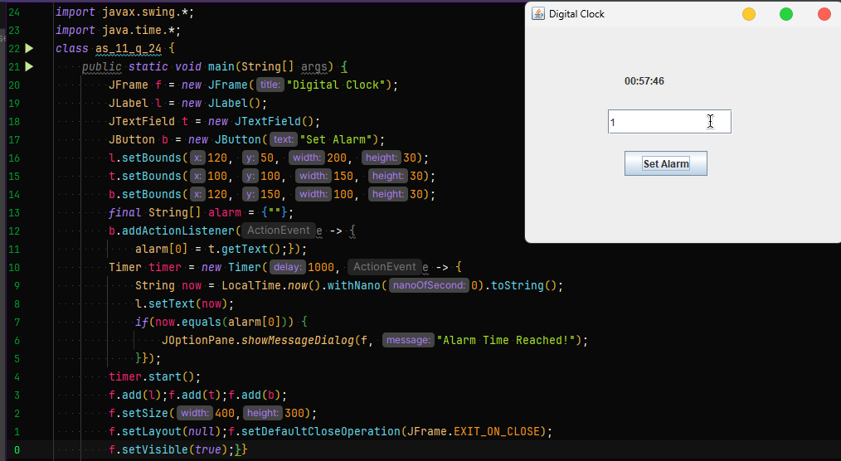

- Develop a Swing application that draws freehand sketches using mouse drag events.
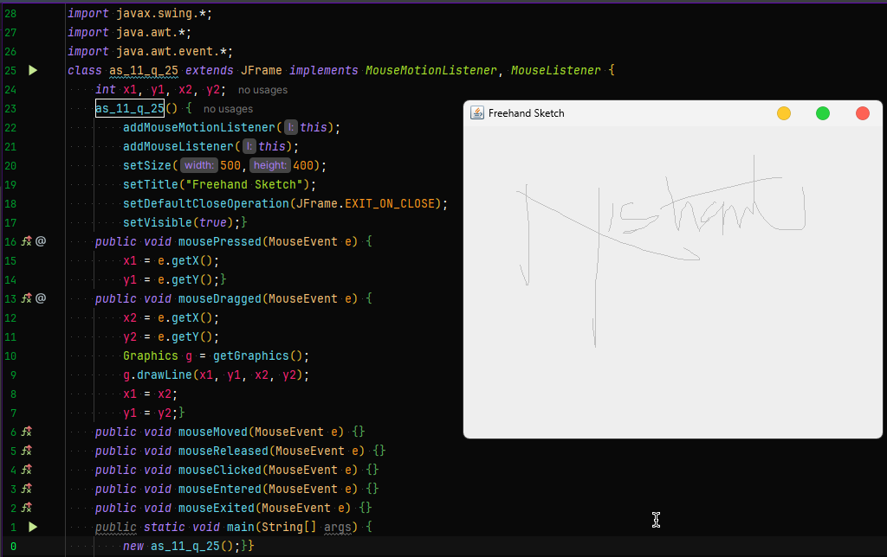
- Write a program that displays system resource information (CPU, memory) in graphical form.
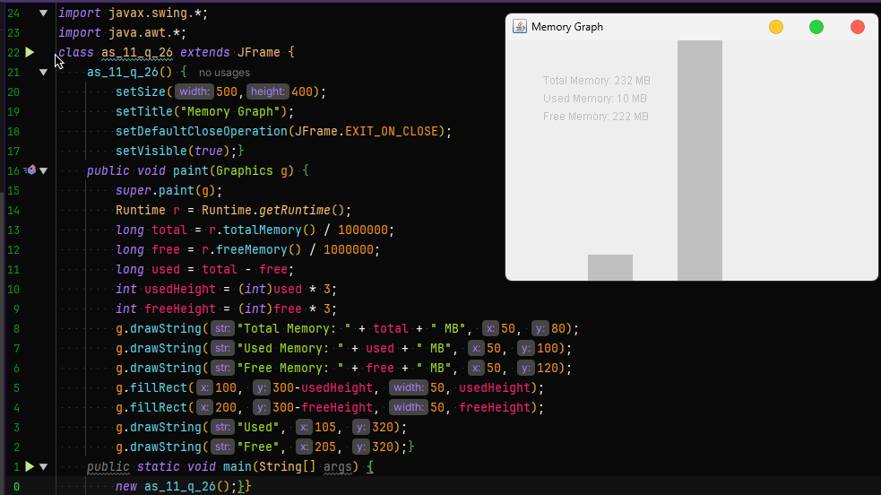

- Create a GUI-based file explorer that lists files and folders from a directory.
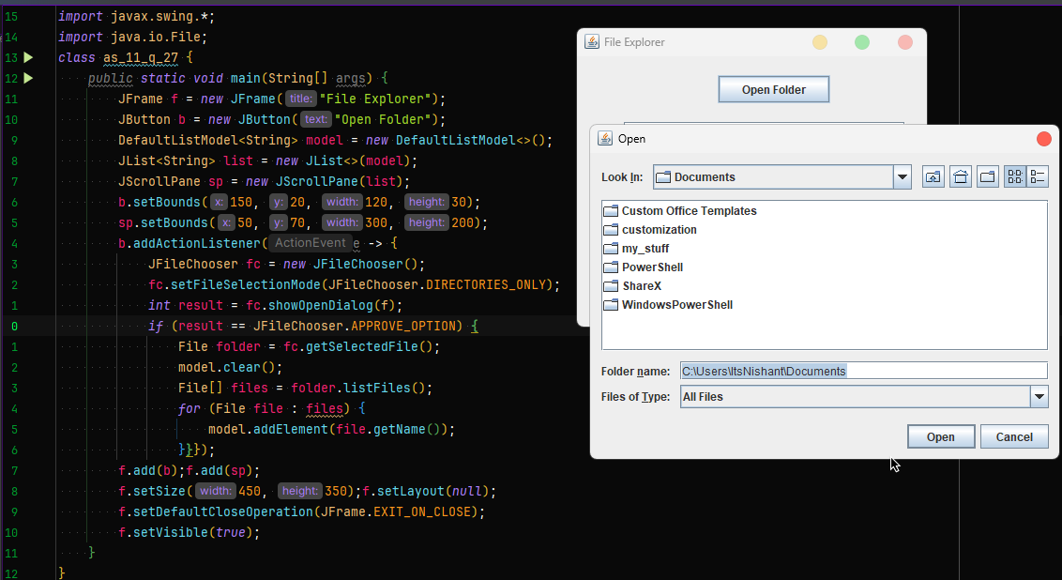
- Develop a Swing application that allows users to drag and drop components within the window.
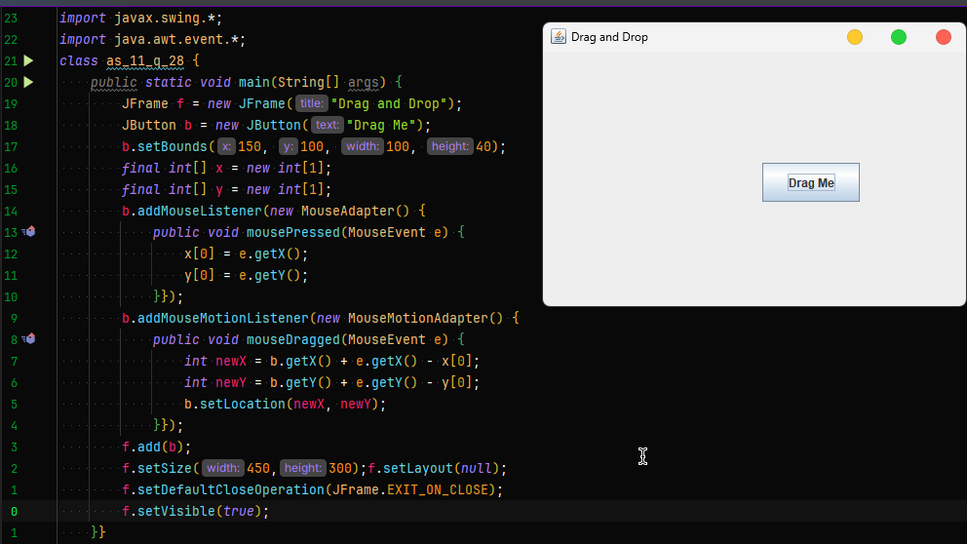

- Write a Swing program that creates a multi-tab text editor using JTabbedPane.
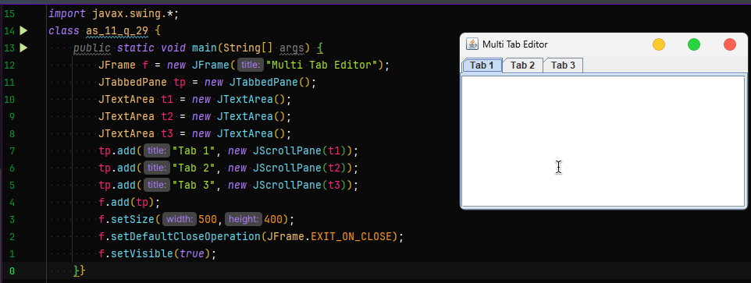
- Design a Swing application that generates a small dashboard displaying student statistics using charts and tables.
