OOPJ DAILY ASSIGNMENT 13 (15/03/26)
Nishant Nahar – 241551078
- Life Cycle of Thread
class Life extends Thread {
public void run() {
System.out.println("Thread is running"); // RUNNING state
}}
class ThreadLifeCycleSimple {
public static void main(String[] args) {
System.out.println("Nishant - 241551078");
Life t = new Life(); // NEW state
System.out.println("Thread state after creation: " + t.getState());
t.start(); // Thread starts -> RUNNABLE
System.out.println("Thread state after start(): " + t.getState());
try {
t.join(); // wait for thread to finish
} catch (InterruptedException e) {
e.printStackTrace();
}
System.out.println("Thread state after completion: " + t.getState()); // TERMINATED
}}
OUTPUT
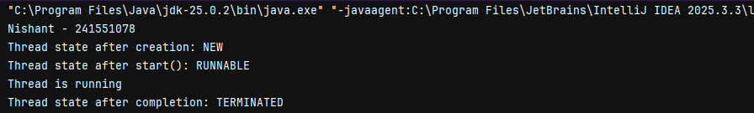
- Synchronized Method using Anonymous Class
class cc {
int count = 0;
synchronized void increment() {
count++;
System.out.println(count);}}
class SynchronizedDemo {
public static void main(String[] args) {
System.out.println("Nishant - 241551078");
cc ccc = new cc();
Thread t = new Thread() {
public void run() {
for (int i = 0; i < 5; i++) {
ccc.increment();
}}};
t.start();
}}
OUTPUT
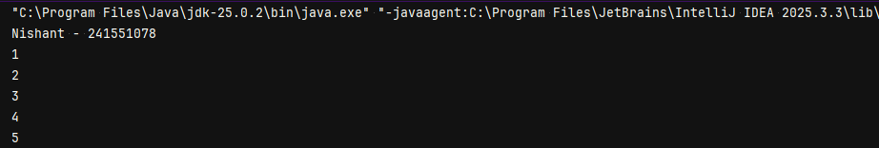
- Static Synchronization Using Anonymous Class
class counting {
static int count = 0;
static synchronized void increment() {
count++;
System.out.println(count);
}}
class StaticSyncAnonymousDemo {
System.out.println("Nishant - 241551078");
public static void main(String[] args) {
new Thread() {
public void run() {
for (int i = 0; i < 5; i++) {
counting.increment();
}}}.start();
}}
OUTPUT
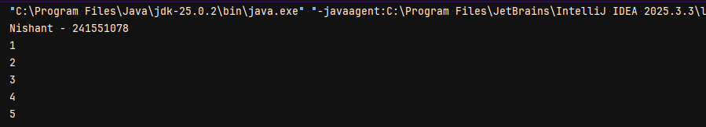
- Deadlock
class DeadlockShort {
public static void main(String[] args) {
System.out.println("Nishant - 241551078");
final Object lock1 = new Object();
final Object lock2 = new Object();
new Thread() {
public void run() {
synchronized(lock1) {
try { Thread.sleep(50); } catch (Exception e) {}
synchronized(lock2) {
System.out.println("Thread 1 done");
}}}}.start();
new Thread() {
public void run() {
synchronized(lock2) {
try { Thread.sleep(50); } catch (Exception e) {}
synchronized(lock1) {
System.out.println("Thread 2 done");
}}}}.start();
}}
OUTPUT
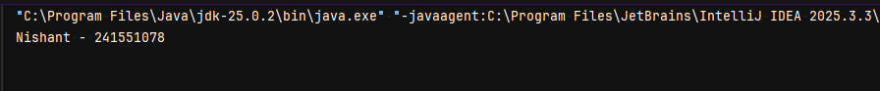
- Deadlock Avoiding
class NoDeadlock {
public static void main(String[] args) {
System.out.println("Nishant - 241551078");
final Object lock1 = new Object();
final Object lock2 = new Object();
new Thread() {
public void run() {
synchronized (lock1) { // acquire lock1 first
try {
Thread.sleep(50);
} catch (Exception e) {}
synchronized (lock2) {
System.out.println("Thread 1 done");
}}}}.start();
new Thread() {
public void run() {
synchronized (lock1) {
try {
Thread.sleep(50);
} catch (Exception e) {}
synchronized (lock2) { // then lock2
System.out.println("Thread 2 done");
}}}}.start();
}}
OUTPUT
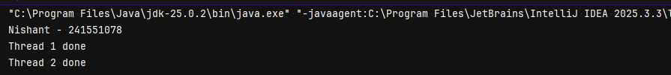
- Interrupting Thread
class inter extends Thread {
public void run() {
for (int i = 1; i <= 5; i++) {
System.out.println("Count: " + i);
try {
Thread.sleep(1000);
} catch (InterruptedException e) {
System.out.println("Thread was interrupted but continues...");
}}
System.out.println("Thread finished normally");
}}
class InterruptDemo {
public static void main(String[] args) {
System.out.println("Nishant - 241551078");
inter t = new inter();
t.start();
try {
Thread.sleep(2000);
} catch (InterruptedException e) {}
t.interrupt();
}}
OUTPUT
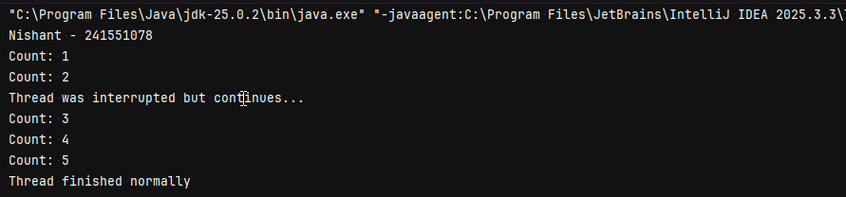
- Is interrupt Thread
class IsInter extends Thread {
public void run() {
for (int i = 1; i <= 5; i++) {
System.out.println("Count: " + i);
if (isInterrupted()) {
System.out.println("Thread detected interrupt using isInterrupted()");
}
try {
Thread.sleep(1000);
} catch (InterruptedException e) {
System.out.println("InterruptedException caught");
System.out.println("Thread interrupted status using interrupted(): " + Thread.interrupted());}}}}
class InterruptCheckDemo {
public static void main(String[] args) {
System.out.println("Nishant - 241551078");
IsInter t = new IsInter();
t.start();
try {
Thread.sleep(2500);
} catch (InterruptedException e) {}
t.interrupt();
}}
OUTPUT
