OOPJ DAILY ASSIGNMENT – 12 (18-02-2026)
Name – Nishant Nahar
Roll No – 241551078
- WAP to read 2 digit no and display it in the console
import java.io.*;
class AsciiDigit {
public static void main(String[] args) throws Exception {
System.out.println("Nishant Nahar - 241551078");
FileOutputStream fout = new FileOutputStream("digit.txt");
fout.write(50);
fout.write(53);
fout.close();
FileInputStream fin = new FileInputStream("digit.txt");
int d1 = fin.read() - 48;
int d2 = fin.read() - 48;
int number = d1 * 10 + d2;
System.out.println("Number = " + number);
fin.close();
}}
OUTPUT
- WAP to read 2 integer from the file and perform addition of it
import java.io.*;
class AAddition {
public static void main(String[] args) throws Exception {
System.out.println("Nishant Nahar - 241551078");
FileOutputStream fout = new FileOutputStream("num.txt");
fout.write(52);
fout.write(55);
fout.write(54);
fout.write(56);
fout.close();
FileInputStream fin = new FileInputStream("num.txt");
int a1 = fin.read() - 48;
int a2 = fin.read() - 48;
int num1 = a1 * 10 + a2;
int b1 = fin.read() - 48;
int b2 = fin.read() - 48;
int num2 = b1 * 10 + b2;
System.out.println("Number 1 = " + num1);
System.out.println("Number 2 = " + num2);
System.out.println("Sum = " + (num1 + num2));
fin.close();
}}
OUTPUT
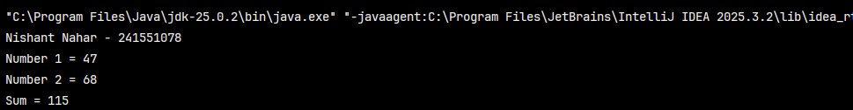
- WAP to read an array and sort it and then store in the file
import java.io.*;
public class AsciiArraySort {
public static void main(String[] args) throws Exception {
System.out.println("Nishant Nahar - 241551078");
FileOutputStream fout = new FileOutputStream(""arr.txt");
fout.write(55);
fout.write(51);
fout.write(57);
fout.write(49);
fout.write(53);
fout.close();
FileInputStream fin = new FileInputStream("arr.txt");
int arr[] = new int[5];
for (int i = 0; i < 5; i++) {
arr[i] = fin.read() - 48;}
fin.close();
for (int i = 0; i < arr.length; i++) {
System.out.print(arr[i] + " ");}
System.out.println();
for (int i = 0; i < arr.length - 1; i++) {
for (int j = 0; j < arr.length - 1 - i; j++) {
if (arr[j] > arr[j + 1]) {
int t = arr[j];
arr[j] = arr[j + 1];
arr[j + 1] = t;}}}
FileOutputStream fout2 = new FileOutputStream("sorted.txt");
for (int i = 0; i < arr.length; i++) {
fout2.write(arr[i] + 48);}
fout2.close();
System.out.println("Sorted Array:");
for (int i = 0; i < arr.length; i++) {
System.out.print(arr[i] + " ");
}}}
OUTPUT
