OOPJ DAILY ASSIGNMENT – 9 (12/01/26)
Name – Nishant Nahar
Roll No – 241551078
- Simple Java Package
package mypack;
public class Simple {
public static void main(String args[]) {
System.out.println("Welcome to package");
}}
OUTPUT
- Using packagename.*
- A Pack
package pack;
public class A {
public void msg() {
System.out.println("Hello");
}}
- B Pack
package mypack_1;
import pack.*;
class B {
public static void main(String args[]) {
A obj = new A();
obj.msg();
}
}
OUTPUT
- Using packagename.classname
  - A Pack
package pack_1;
public class A_1 {
public void msg() {
System.out.println("Hello");
}
}
b. B Pack
package mypack_2;
import pack_1.A_1;
class B_1 {
public static void main(String args[]) {
A_1 obj = new A_1();
obj.msg();
}
}
OUTPUT
- Using fully qualified name
  - A Pack
package pack_2;
public class A_2 {
public void msg() {
System.out.println("Hello");
}
}
  - B Pack
package mypack_3;
class B_2 {
public static void main(String args[]) {
pack_2.A_2 obj = new pack_2.A_2();// using fully qualified name
obj.msg();
}
}
OUTPUT
- Private Access Modifier
class pvt {
private int data = 40;
private void msg() {
System.out.println("Hello java");
}
}
public class pvt_1 {
public static void main(String args[]) {
pvt obj = new pvt();
System.out.println(obj.data);// Compile Time Error
obj.msg();// Compile Time Error
}
}
OUTPUT
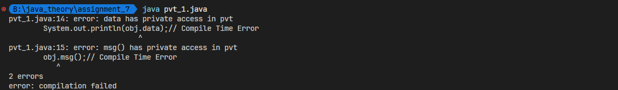
- Private Modifier Role
class A_4 {
private A_4() {
}// private constructor
void msg() {
System.out.println("Hello java");
}
}
public class pvt_role {
public static void main(String args[]) {
A_4 obj = new A_4();// Compile Time Error
}
}
OUTPUT
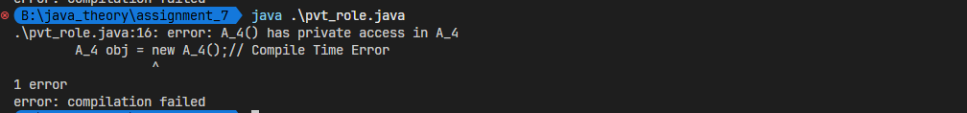
- Default Access Modifier
  - A Pack
package pack_3;
class def_A {
void msg() {
System.out.println("Hello");
}
}
  - B Pack
package mypack_4;
import pack_3.*;
class def_B {
public static void main(String args[]) {
def_A obj = new def_A();// Compile Time Error
obj.msg();// Compile Time Error
}
}
OUTPUT
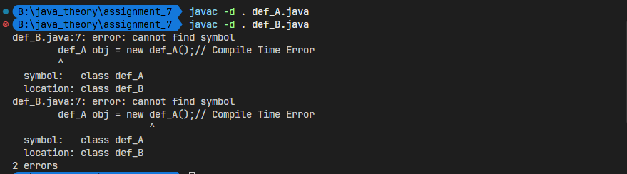
- Protected Access Monitor
  - A Pack
package pack_4;
public class pro_A {
protected void msg() {
System.out.println("Hello");
}}
  - B Pack (with extends)
package mypack_4;
import pack_4.*;
class pro_B extends pro_A {
public static void main(String args[]) {
pro_B obj = new pro_B();
obj.msg();
}}
OUTPUT
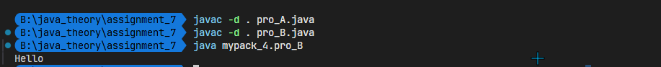
  - B Pack (Without Extends)
package mypack_4;
import pack_4.*;
class pro_B{
public static void main(String args[]) {
pro_B obj = new pro_B();
obj.msg();
}}
OUTPUT
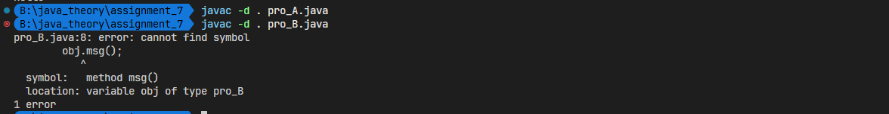
- Public Access Modifier
  - A Pack
package pack_5;
public class pub_A {
public void msg() {
System.out.println("Hello");
}}
  - B Pack
package mypack_5;
import pack_5.*;
class pub_B {
public static void main(String args[]) {
pub_A obj = new pub_A();
obj.msg();
}}
OUTPUT

- Method Overridding
class A_3 {
protected void msg() {
System.out.println("Hello java");
}}
public class meth_over extends A_3 {
void msg() {
System.out.println("Hello java");
} // C.T.Error
public static void main(String args[]) {
meth_over obj = new meth_over();
obj.msg();
}}
OUTPUT
