OOPJ DAILY ASSIGNMENT (25/02/2026)
Nishant Nahar – 241551078
- Priority Threading Code
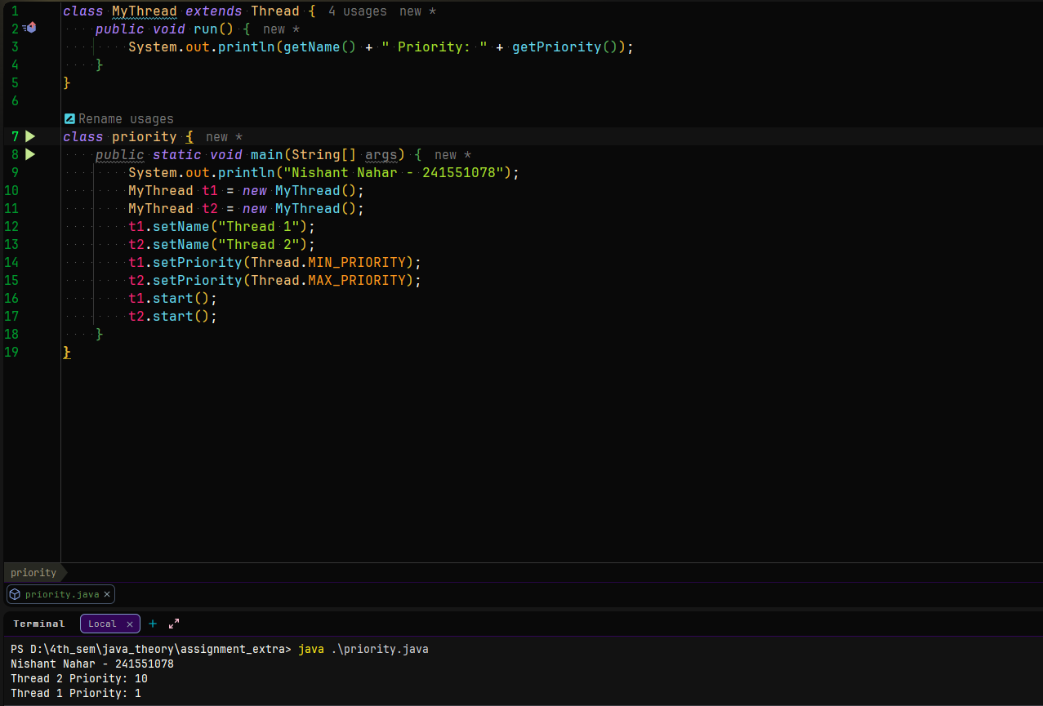
- Daemon Threading Code
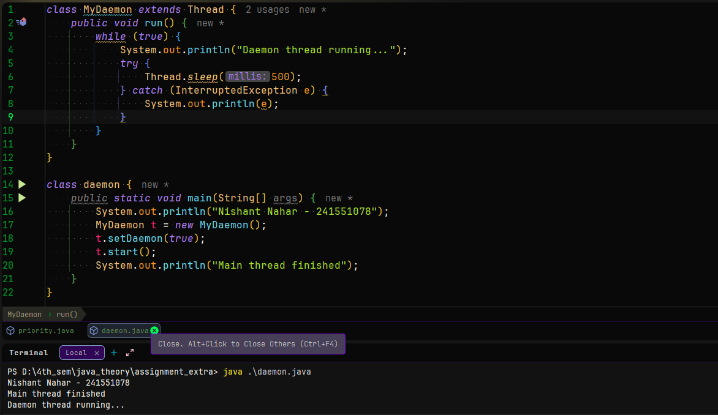
- Join() Threading Code
