OOPJ ASSIGNMENT (25-02-2026)
Name – Venya Kejriwal
Roll No – 24155517
- Join ()
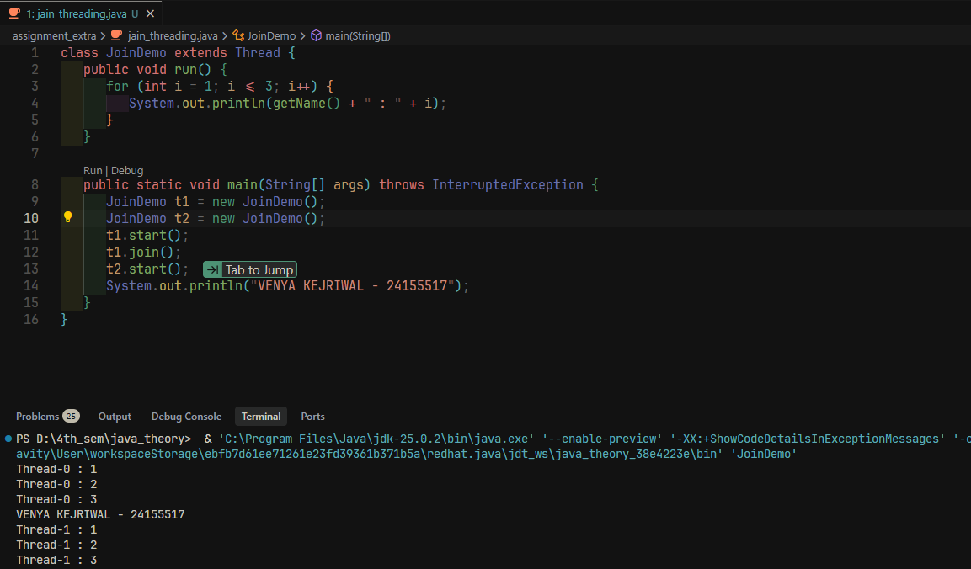
- Daemon Threading
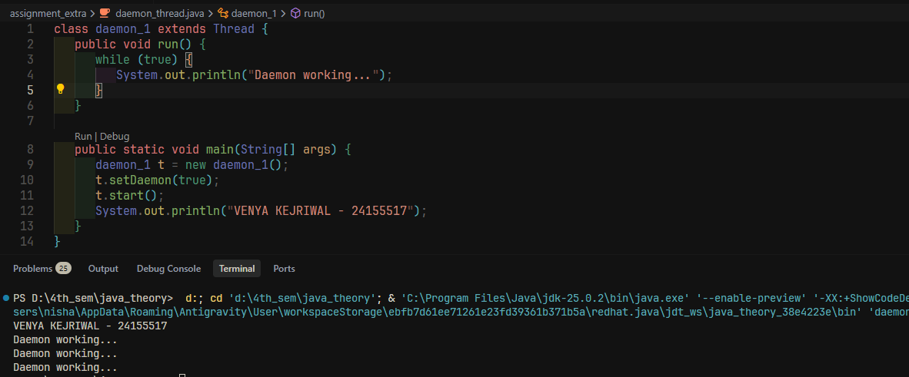

- Priority Threading
