OOPJ DAILY ASSIGNMENT – 11 (12/02/2026)
Name – Nishant Nahar
Roll No – 241551078
- Validate Rule 1 Exception While Overriding
import java.io.IOException;
class ppp {
void msg() {
System.out.println("parent");
}}
class TestExceptionChild extends ppp {
void msg() throws IOException {
System.out.println("TestExceptionChild");}
public static void main(String args[]) {
ppp p = new TestExceptionChild();
p.msg();
}}
OUTPUT
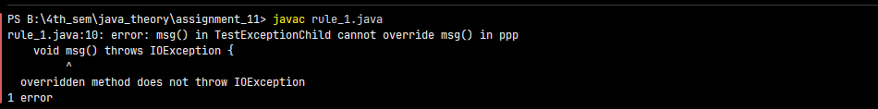
- Rule 2 Exception While Overriding
class ppp1 {
void msg(){System.out.println("parent");}}
class TestExceptionChild1 extends ppp1 {
void msg()throws ArithmeticException{
System.out.println("child");}
public static void main(String args[]){
ppp1 p=new TestExceptionChild1();
p.msg();
}}
OUTPUT
- Rule 3 Validation
class Parent {
void msg() throws Exception {
System.out.println("parent");
}}
class TestExceptionChild5 extends Parent {
void msg() {
System.out.println("child");
}
public static void main(String args[]) {
Parent p = new TestExceptionChild5();
try {p.msg();}
catch (Exception e) {
}}}
OUTPUT
- String is immutable
class Testimmutablestring {
public static void main(String args[]) {
String s = "Sachin";
s.concat(" Tendulkar”);
System.out.println(s);
}}
OUTPUT

