**Chapter-1 Introduction**

1. **Problems with Existing System**

The conventional and outdated navigation aids for persons with visual impairments, such as the walking cane (also called white cane or a stick) and guide dogs, exhibit numerous imperfections and limitations. These traditional methods often fail to provide sufficient information about obstacles or changes in terrain, leading to potential hazards and accidents. Moreover, reliance on guide dogs can be expensive and impractical for many individuals, while the white cane may lack accuracy in detecting low-hanging obstacles or drop-offs. Additionally, the training required for effectively using these aids can be time-consuming and inaccessible to certain individuals due to resource constraints. Furthermore, the social stigma associated with using traditional aids may deter some individuals from seeking assistance, exacerbating feelings of isolation and dependency.

1. Lack of Real-Time Feedback: Traditional aids such as white canes and guide dogs often lack the capability to provide real-time feedback to users about their immediate surroundings, making it challenging to navigate dynamically changing environments.
2. Limited Accessibility Features: Many existing navigation aids do not incorporate advanced accessibility features, such as voice guidance or tactile feedback, making them less effective for individuals with varying degrees of visual impairment.
3. Inadequate Training Resources: The training programs available for using traditional aids may not adequately prepare individuals for navigating complex environments or understanding the nuances of visual impairment, leading to suboptimal outcomes and safety concerns.
4. High Cost and Maintenance: Guide dogs, in particular, can be prohibitively expensive to acquire and maintain, posing a significant financial burden on individuals with visual impairments who may already face economic challenges.
5. Psychological Barriers: The reliance on traditional aids may contribute to feelings of dependency and inadequacy among individuals with visual impairments, leading to diminished self-confidence and reluctance to engage with the outside world.
6. **Proposed System**

One of the most significant problems for a completely or partially blind person is obstacle detection. So, a blind stick is a novel stick intended for visually impaired persons to aid in navigating. Using modern technology, our suggested smart blind stick enables visually impaired persons to travel with ease. The blind stick is made up of five major components: ultrasonic sensor, an Arduino UNO board, Jumper Wires, a buzzer, and a vibration Coin. This technique begins by employing ultrasonic sensors to identify impediments ahead through ultrasonic vibrations. When an obstruction is detected, the sensor reports that fact to the micro-controller. As a micro-controller, we utilized an Arduino UNO Mini. The micro-controller then estimates sensor-to-obstacle distance. If the obstacle is not within a certain distance, the circuit has no effect. If the barrier is nearby, the micro-controller transmits operational voltage to the buzzer and vibration motor. The buzzer is transmitted in the circuit as a warning signal. As a result, this system is beneficial for visually impaired persons.

1. Sensor Integration and Functionality: We will make Detailing on how the ultrasonic sensor works in conjunction with the Arduino UNO board to detect obstacles and provide feedback to the user.
2. Microcontroller Programming: We will use programming logic to implement in the Arduino UNO board to process sensor data, and activate the warning signals (buzzer and vibration motor) accordingly.
3. User Interface and Feedback Mechanism: Describing how visually impaired individuals interact with the smart blind stick, including any auditory or tactile feedback mechanisms to convey obstacle proximity.
4. Portability and Ergonomics: Discussing the design considerations for making the blind stick lightweight, portable, and easy to handle for users with visual impairments.
5. Cost-effectiveness and Accessibility: Analysing the affordability and accessibility of the proposed system compared to existing navigation aids for visually impaired individuals, considering factors such as manufacturing costs and ease of procurement.
6. **Aim of the system**

The primary aim of this project is to engineer an advanced assistive device, leveraging Arduino technology. The overarching goal is to enhance the mobility, safety, and independence of visually impaired individuals through innovative means.

1. Enhanced Mobility:

The project seeks to address the challenges faced by visually impaired individuals in navigating their surroundings by developing a smart blind stick capable of providing real-time obstacle detection and navigation assistance. By leveraging Arduino technology and ultrasonic sensors, the device aims to offer users greater mobility and freedom of movement.

1. Safety Enhancement:

Central to the project's aim is the improvement of safety for visually impaired users. By accurately detecting obstacles and providing timely warnings through auditory and tactile feedback mechanisms, the smart blind stick aims to reduce the risk of accidents and collisions, thereby enhancing the safety of individuals with visual impairments during their daily activities.

1. Independence Promotion:

An essential aspect of the project is the promotion of independence among visually impaired individuals. By equipping users with a reliable and intuitive navigation aid, the smart blind stick empowers them to navigate their surroundings with confidence and autonomy, reducing dependence on external assistance.

1. Technological Innovation:

The project represents a significant technological innovation in the field of assistive devices for individuals with visual impairments. the smart blind stick offers a cost-effective and efficient solution tailored to the specific needs of visually impaired users.

1. Accessibility and Inclusivity:

Accessibility and inclusivity are key considerations in the development of the smart blind stick. By designing a device that is user-friendly, affordable, and accessible to individuals with socioeconomic backgrounds.

1. **Objective of the System**

The aim of the Blind Stick Using Arduino system is to enhance independent travel for visually impaired individuals. It incorporates sound-based cues and haptic vibration feedback to assist navigation, prioritizing comfort and accessibility. By leveraging multi-sensory feedback, it addresses unique challenges and promotes confidence and safety, empowering users to travel autonomously with ease.

1. Enhanced Navigation Assistance

Utilizing ultrasonic sensors and intelligent algorithms to detect obstacles and provide timely feedback to the user.

Implementing directional cues and proximity alerts to guide users along safe paths and avoid collisions.

1. Comfort and Accessibility

Designing ergonomic and user-friendly interfaces for easy handling and interaction.

Customizing feedback options to accommodate individual preferences and sensory needs.

1. Safety and Risk Mitigation

Incorporating real-time obstacle detection and response mechanisms to reduce accidents and improve situational awareness.

Implementing emergency override features for immediate cessation of feedback in critical situations.

1. Empowerment and Independence

> Fostering self-confidence and independence by enabling users to navigate diverse environments confidently.

Promoting inclusivity and equal access to public spaces by reducing barriers to mobility for visually impaired individuals.

1. Continuous Improvement and Innovation

Engaging with user feedback and iterative testing to refine system functionalities and address evolving user needs.

Exploring advancements such as GPS integration, machine learning algorithms, and wearable technology to enhance navigation precision and versatility.

1. **Scope of the System**

The development of the Blind Stick Using Arduino involves hardware and software development, user interface design, testing, accessibility considerations, documentation, and scalability planning. Hardware development includes designing the physical components and integrating sensors and vibration motors. Software development entails programming the microcontroller and developing algorithms for obstacle detection and feedback. User interface design focuses on creating an intuitive interface for configuring settings. Testing ensures effectiveness and reliability under various conditions. Accessibility features are incorporated to cater to different levels of visual impairment. Comprehensive documentation and ongoing support are provided. The system is designed with scalability in mind for future enhancements and integration with other technologies, aiming to maximize impact and accessibility.

1. Hardware Development

Physical Component Design: Designing the stick's form factor for comfort, durability, and ease of use.

Sensor Integration: Incorporating ultrasonic sensors for distance measurement and obstacle detection.

Vibration Motor Integration: Integrating haptic feedback mechanisms for conveying information to the user.

1. Software Development

Microcontroller Programming: Writing code for the Arduino microcontroller to process sensor data and control feedback mechanisms.

Algorithm Development: Creating algorithms for obstacle detection, distance estimation, and feedback generation.

User Interface Programming: Developing an interface for users to customize settings and interact with the system.

1. Testing and Validation

Functional Testing: Ensuring all hardware components and software functionalities work together seamlessly.

Usability Testing: Gathering feedback from visually impaired users to assess ease of use and effectiveness.

Performance Testing: Evaluating the system's accuracy in obstacle detection and feedback delivery under various environmental conditions.

1. Accessibility Considerations

Adaptive Feedback: Implementing customizable settings for sound volume, vibration intensity, and sensitivity.

Voice Prompts: Incorporating spoken instructions or alerts for users with varying levels of visual impairment.

1. **Methodology**
2. **Sensor Calibration:**

Before data collection, the Obstacle sensor module was calibrated to ensure accurate distance measurements. This involved adjusting parameters such as sensitivity and threshold levels to optimize sensor performance.

1. **Test Scenarios Definition:**

Various test scenarios were defined to simulate different environmental conditions and object configurations. These scenarios included stationary objects, moving objects, varying distances, and cluttered environments.

1. **Data Acquisition Setup:**

The Blind Stick using Arduino was deployed in each test scenario, with the Obstacle sensor module positioned at a fixed location or mounted on a Stick for scanning. The system was powered and connected to a computer for data logging.

1. **Data Logging and Analysis:**

Data was collected in real-time as the Blind Stick scanned the environment and detected objects. Distance measurements, object presence, and other relevant parameters were logged at regular intervals using Arduino's serial communication capabilities into the computer for only Development period.

1. **Methodology of System Design**

Defined the overall architecture of the Blind Stick using Arduino, including hardware components, sensor integration, and software modules. Designed the interface between the Object Detection sensor module and the Arduino microcontroller, considering communication protocols and data processing requirements. Explored options for feedback mechanisms and user interface elements to provide meaningful feedback to the user.

1. **System Requirement Tools**

For IoT projects, system requirement tools play a pivotal role in shaping the development process and ensuring the success of the final product. These tools enable IoT teams to articulate the specific functionalities, performance criteria, security measures, and interoperability requirements that the system must meet. Given the complexity and interconnected nature of IoT ecosystems, requirement tools help in defining clear communication protocols, data formats, device compatibility, and scalability parameters. Additionally, they aid in identifying and addressing potential vulnerabilities, ensuring robust cybersecurity measures are integrated into the design. Moreover, these tools facilitate the mapping of user requirements to technical specifications, guiding the development of IoT solutions that align closely with user needs and expectations.

1. **Hardware Component Used**

|  |  |  |
| --- | --- | --- |
| **Component Picture** | **Component Name** | **Quantity** |
|  | Arduino UNO Mini | **1** |
| Robocraze Banggood HC-SR04 DC 5V Ultrasonic Module Distance Measuring Transducer Sensor | HC-SR04 Ultrasonic Sensor | **1** |
|  | Coin Vibration Motor | **1** |
|  | Wooden Stick | **1** |
|  | Jumper Wires | **3** |
|  | Piezo Buzzer | **1** |
|  | Battery Connector | **1** |
| Eveready 9 Volt Battery | 9V Battery | **1** |
|  | Cable Tie Clips | **3** |

1. **Software Components Used:**

|  |  |
| --- | --- |
| **Software Names** | **Picture** |
| 1. Arduino IDE (integrated development environment). |  |
| 1. Tinker cad | Autodesk Tinkercad - YouTube |
| 1. GitHub |  |

1. **Languages Used:**

* **C++**

1. **Important Components**

* Ultrasonic Sensor: HC –SR04:

An Ultrasonic sensor is a device that can measure distance or detect obstacles ahead of it by using sound waves. It measures distance by sending out an ultrasonic sound wave at a selected frequency and listening for that sound to revert back. The module consists of a transmitter, a receiver and a control circuit including a crystal oscillator. The four pins of the ultrasonic sensors are: Supply Pin Vcc (5V) Trigger Pin (Input) Echo Pin (Output) Ground Pin (0V).

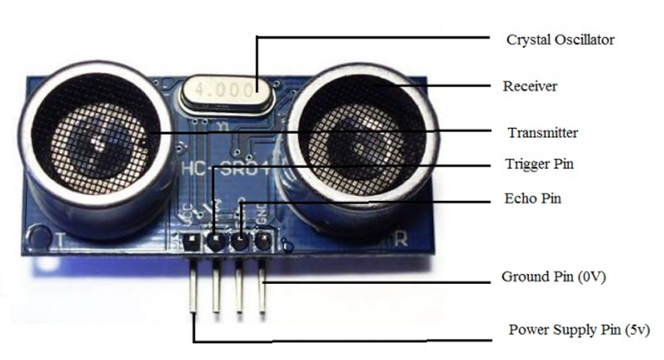

* Buzzer:

A buzzer is a sound generating device. 5v continuous tone buzzer used in this project. It is a magnetic type transducer. Sound pressure level is 82dB and frequency is 203KHz. It can generate continuous beep tones. Operating voltage of this is 5VDC and rated voltage is 3VDC. Current rating is 30mA.

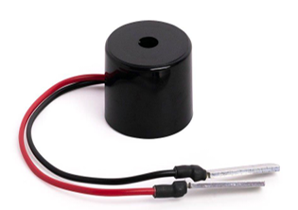

* Vibration Coin:

Coin type vibration motor is used in this project. Figure 3.11(a) shows the physical shape of the Coin type vibration motor. This small device consists of rotor, stator, armature, windings, brushes etc. The need for smaller, thinner designs led to the adaptation of brush motor technology into the coin-type vibration motor.

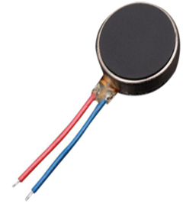

* Arduino

Arduino is actually a microcontroller which can be either used directly by purchasing from the vendor or can be made at home using the components, owing to its open-source hardware feature. It is basically used in communications and in controlling or operating many devices. Arduino is an open-source electronics platform based on easy-to-use hardware and software. Arduino boards are able to read inputs activate a motor, turning on an LED, publishing something online. You can tell your board what to do by sending a set of instructions to the microcontroller on the board. To do so you use the Arduino programming language (based on Wiring), and the Arduino Software (IDE), based on Processing.

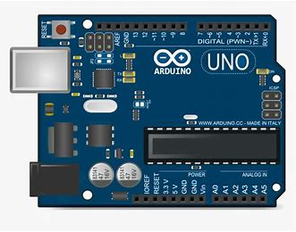

1. **Project Planning Gantt Chart**

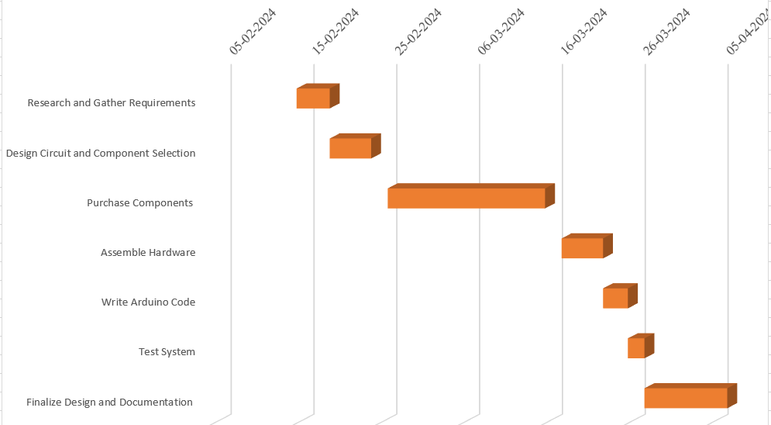

Fig 1 Gantt Chart

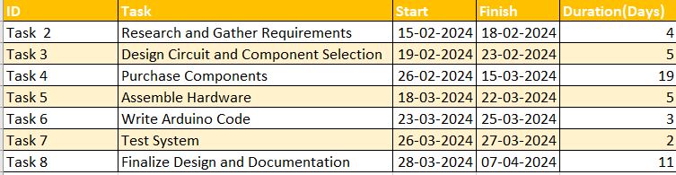

Fig 2 Image Showing Data Used for Making Gantt Chart

**Chapter-2**

**System Requirements Analysis**

1. **Project Overview**

The aim of this project is to assist blind people to navigate without needing help from others. Ultrasonic Sensors are employed to detect front obstacles. In order to keep the stick along a definitive path, the project testing was carried out as designed, the stick will trigger an alarm notification via buzzer and vibration to its user on encountering any obstacle. Arduino IDE (V1.6.3) has been used as the programming software in this project.

1. **Identification of Actors and their roles in the Project**

* Visually Impaired User: The primary user of the blind stick system. Their role is to use the blind stick to navigate their surroundings safely. They interact with the system by holding the stick and receiving feedback from it.

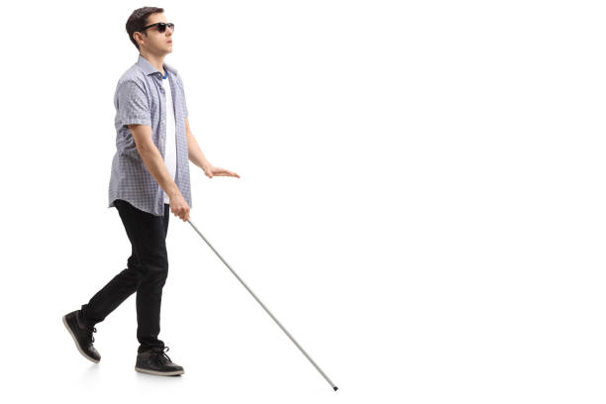

Fig 3 Example of Visually Impaired User

* Arduino Microcontroller: The brain of the system. It processes data from sensors, triggers feedback mechanisms (such as vibrations or sounds), and controls the overall functionality of the blind stick.

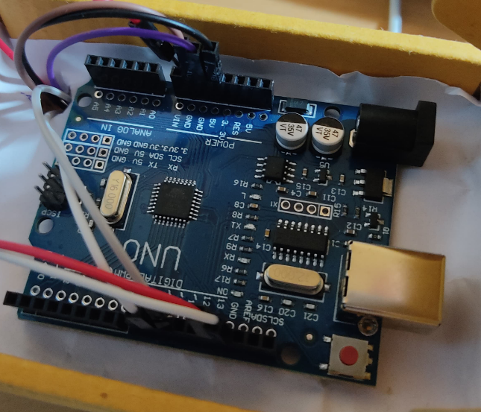

Fig 4 Arduino Microcontroller

* Sensors (Ultrasonic): These sensors detect obstacles in the user's path. They send data to the Arduino microcontroller, which then processes this information to provide appropriate feedback to the user.

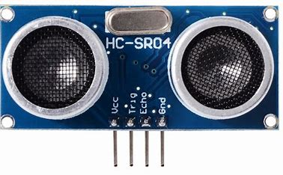

Fig 5 Ultrasonic Distance Sensor (HC-SR04)

* 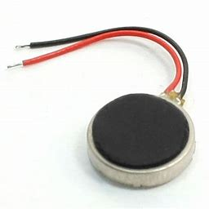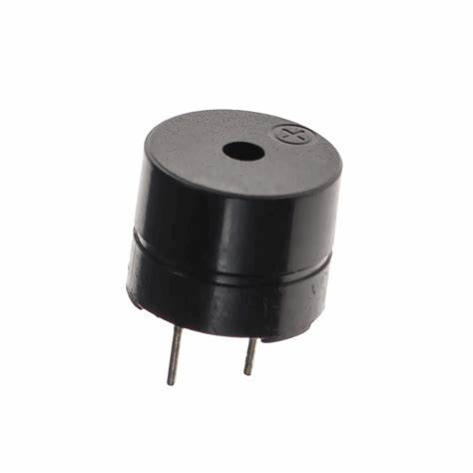Feedback Mechanisms (Vibrations, Sounds): These mechanisms provide feedback to the user based on the sensor data.

Fig 7 Vibration Coin

Fig 6 Buzzer

* Battery or Power Source: Provides power to the Arduino microcontroller and other electronic components of the blind stick system.

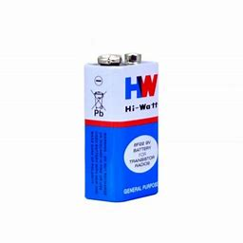

Fig 8: 9V Battery

* Maintenance Personnel: Individuals responsible for maintaining and troubleshooting the blind stick system. Their role is to address any technical issues that may arise during the operation of the system also Change the Battery time to time.

1. **Product Functions**

1. Obstacle Detection: The primary function of the Blind Stick is to detect obstacles in the user's path using ultrasonic sensors. It continuously scans the surroundings and provides feedback to the user when obstacles are detected.

2. Distance Measurement: The device measures the distance between the user and detected obstacles, providing crucial information about their proximity. This helps users make informed decisions about navigation and obstacle avoidance.

3. Feedback Mechanisms: The Blind Stick provides feedback to the user through vibration motors and a buzzer. Vibrations alert the user to the presence and proximity of obstacles, while the buzzer emits auditory signals for additional awareness.

4. Standalone Operation: The Blind Stick operates independently of external devices or systems, ensuring reliability and accessibility in various environments. It does not require connectivity to smartphones or navigation apps for its core functionalities.

5. Customization: The device offers customization options such as adjustable sensitivity settings and feedback intensity levels, allowing users to tailor the device to their specific needs and preferences.

6. Portability: The Blind Stick is designed to be lightweight and portable, allowing users to carry it with ease during daily activities.

7. Compatibility: While primarily standalone, the Blind Stick may feature interfaces for potential future integration with external systems or devices. This ensures compatibility with evolving technologies and user needs.

8. Accessibility: Accessibility features are incorporated to ensure the device is user-friendly for individuals with visual impairments.

* 1. **Constraints**

Developing the Blind Stick Using Arduino involves navigating various constraints to ensure the device's functionality, reliability, and usability. Here are some key constraints that we encounter:

1. Hardware Limitations: The device operates within the constraints of the Arduino microcontroller's processing power, memory, and input/output capabilities. Designing efficient algorithms and interfaces to maximize hardware resources while meeting user requirements is essential.
2. Power Constraints: The Blind Stick relies on battery power for operation, necessitating considerations for power consumption, battery life, and charging requirements. Optimizing power management strategies and selecting energy-efficient components help extend operating time and enhance user experience.
3. Cost Constraints: Cost-effective design choices are necessary to make the Blind Stick accessible to users with varying financial resources. Balancing performance, features, and affordability ensures the device remains within budget constraints without compromising quality or functionality.
4. Size and Weight Constraints: The device's form factor must be compact and lightweight to facilitate portability and ease of use for visually impaired individuals. Designing a device that is both ergonomic and durable while minimizing size and weight constraints is essential for user comfort and mobility.
5. Regulatory Compliance: Compliance with regulatory standards and guidelines, including accessibility requirements for assistive devices, ensures the Blind Stick meets legal and safety obligations. Adhering to relevant regulations mitigates legal risks and enhances user trust and confidence in the product.
6. Environmental Constraints: The Blind Stick must perform reliably in diverse environmental conditions, including indoor and outdoor settings, varying lighting conditions, and different terrain types. Testing and validation in real-world environments help identify and address environmental constraints to ensure device effectiveness and user satisfaction.
7. User Experience Constraints: Designing intuitive interfaces, clear feedback mechanisms, and accessible controls is crucial for ensuring a positive user experience. Understanding user preferences, cognitive abilities, and mobility challenges helps overcome usability constraints and enhances device usability and effectiveness.
8. Technological Constraints: The Blind Stick's functionality may be limited by the availability and compatibility of sensors, communication interfaces, and other technology components. Keeping abreast of advancements in sensor technology and software development tools helps mitigate technological constraints and leverage emerging opportunities for innovation.

**Chapter-3**

**System Design**

1. **Block Diagram**

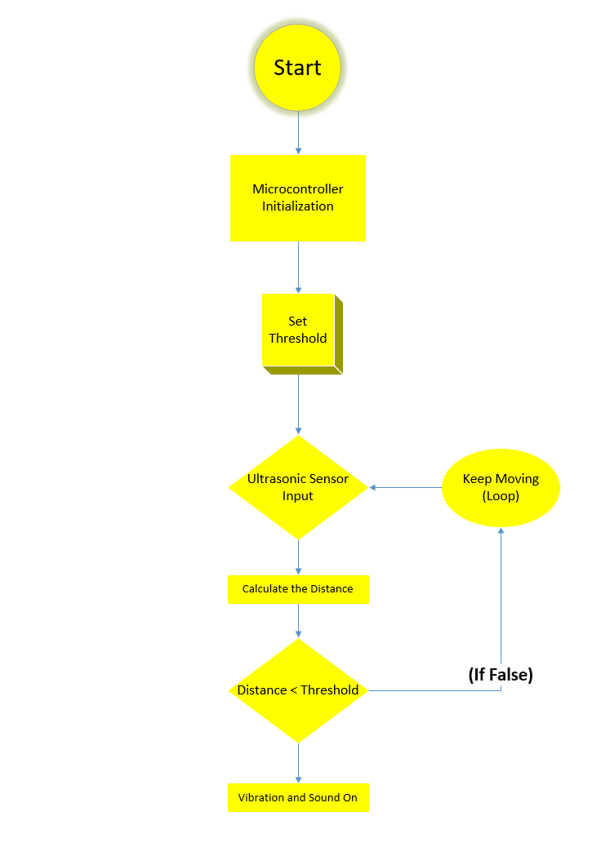

Fig 9 Block Diagram of Our Blind Stick

**Block Diagram Explanation**

* Start: In this our Project Block started.
* Microcontroller initialization: In this Stage our Arduino Board gets initialized using 9V battery pack.
* Set Threshold: In this Stage we will set a threshold value inside our Arduino Uno mini Board using Arduino IDE.
* Ultrasonic Sensor Input: In this Stage the ultrasonic sensor(HC-SR04) will send values to our microcontroller.
* Calculate the Distance: In this Stage our microcontroller processes the values received from ultrasonic sensor.
* Distance < Threshold: In this Stage threshold value is checked by microcontroller, and if its TRUE then next Stage starts until its FALSE.
* Vibration and Sound On: In this Stage Vibration and sound is used as a feedback.

1. **Data Flow Diagram (0 Level-DFD)**

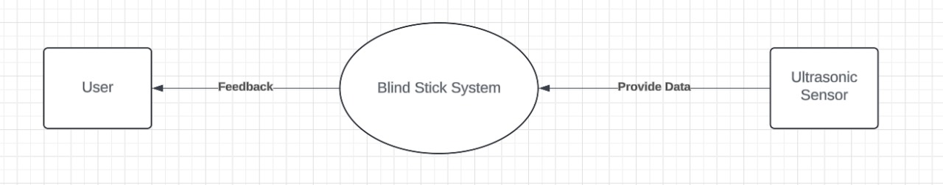A Data Flow Diagram (DFD) is a graphical representation of the flow of data through a system. It's a tool used in software engineering to illustrate how data moves between processes, data stores, and external entities in a system.

Fig 10: Level 0 DFD

1. **Entity Relationship Diagram**

An Entity Relationship Diagram (ERD) is a visual representation used to model the relationships between entities within a database system. Entities represent real-world objects or concepts, while relationships describe how these entities interact with each other. ERDs typically consist of entities (represented as rectangles), attributes (depicted within the entities), and relationships (shown as lines connecting entities). Entities can have various types of relationships, such as one-to-one, one-to-many, or many-to-many, which are crucial for understanding the data structure and constraints of a database. ERDs are fundamental tools in database design, enabling designers and stakeholders to visualize and communicate the structure of a database system, identify dependencies, and ensure data integrity and efficiency. They serve as a blueprint for database implementation, aiding in the development process and providing a clear framework for system maintenance and optimization.

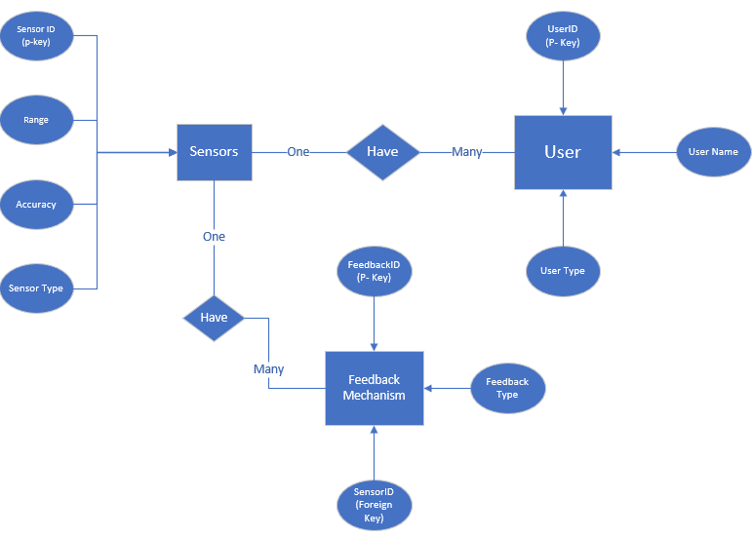

Fig 11: ER Diagram

1. **Use Case Diagram**

A Use Case Diagram is a visual representation that depicts the interactions between users (actors) and a system to achieve specific goals or tasks. Actors are individuals, organizations, or external systems that interact with the system, while use cases represent the functionality or services provided by the system. Use Case Diagrams illustrate how users interact with the system by showing the relationships between actors and use cases through lines known as associations. These diagrams help stakeholders understand the system's behaviour and requirements by providing a high-level overview of its functionality. Use Case Diagrams are valuable tools in software development, aiding in requirements gathering, communication between stakeholders, and the validation of system functionality. They serve as a foundation for system design and development, guiding the development team in implementing features that align with user needs and business objectives.

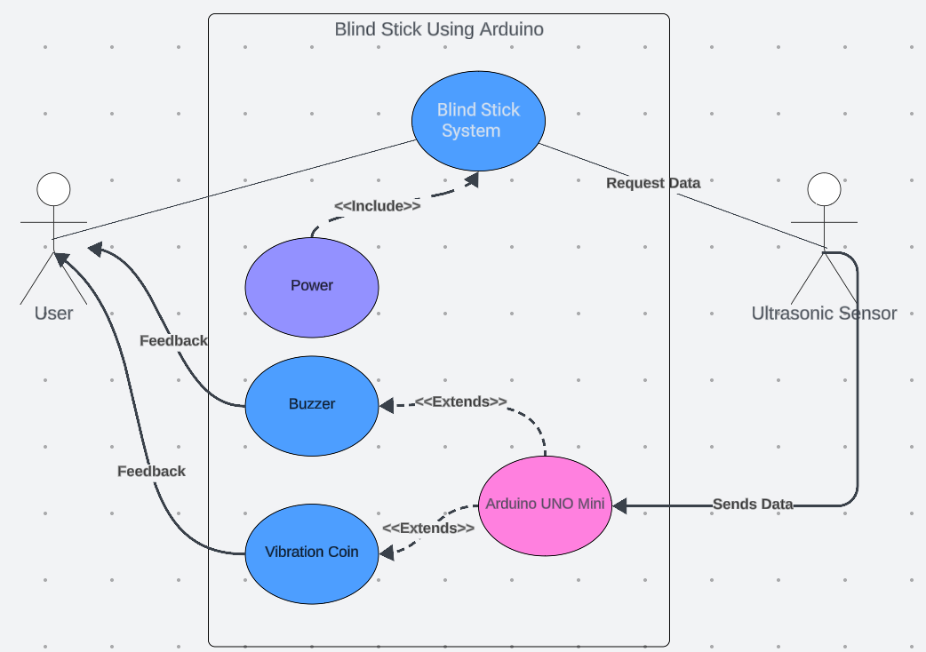

Fig 12: Use Case Diagram

1. **Sequence Diagram**

A Sequence Diagram is a visual representation that illustrates the interactions between objects or components within a system over time. It shows the sequence of messages exchanged between these objects to accomplish a specific task or scenario. In a Sequence Diagram, objects are represented as lifelines, and the messages exchanged between them are depicted as arrows. These diagrams help developers and stakeholders understand the flow of control and communication in a system, highlighting the order of execution and the interactions between different components. Sequence Diagrams are invaluable in software development for designing and understanding the behavior of complex systems, facilitating communication between team members, identifying potential bottlenecks or errors, and ensuring that system requirements are met. They provide a detailed view of system dynamics, aiding in the analysis, design, and implementation phases of the development process.

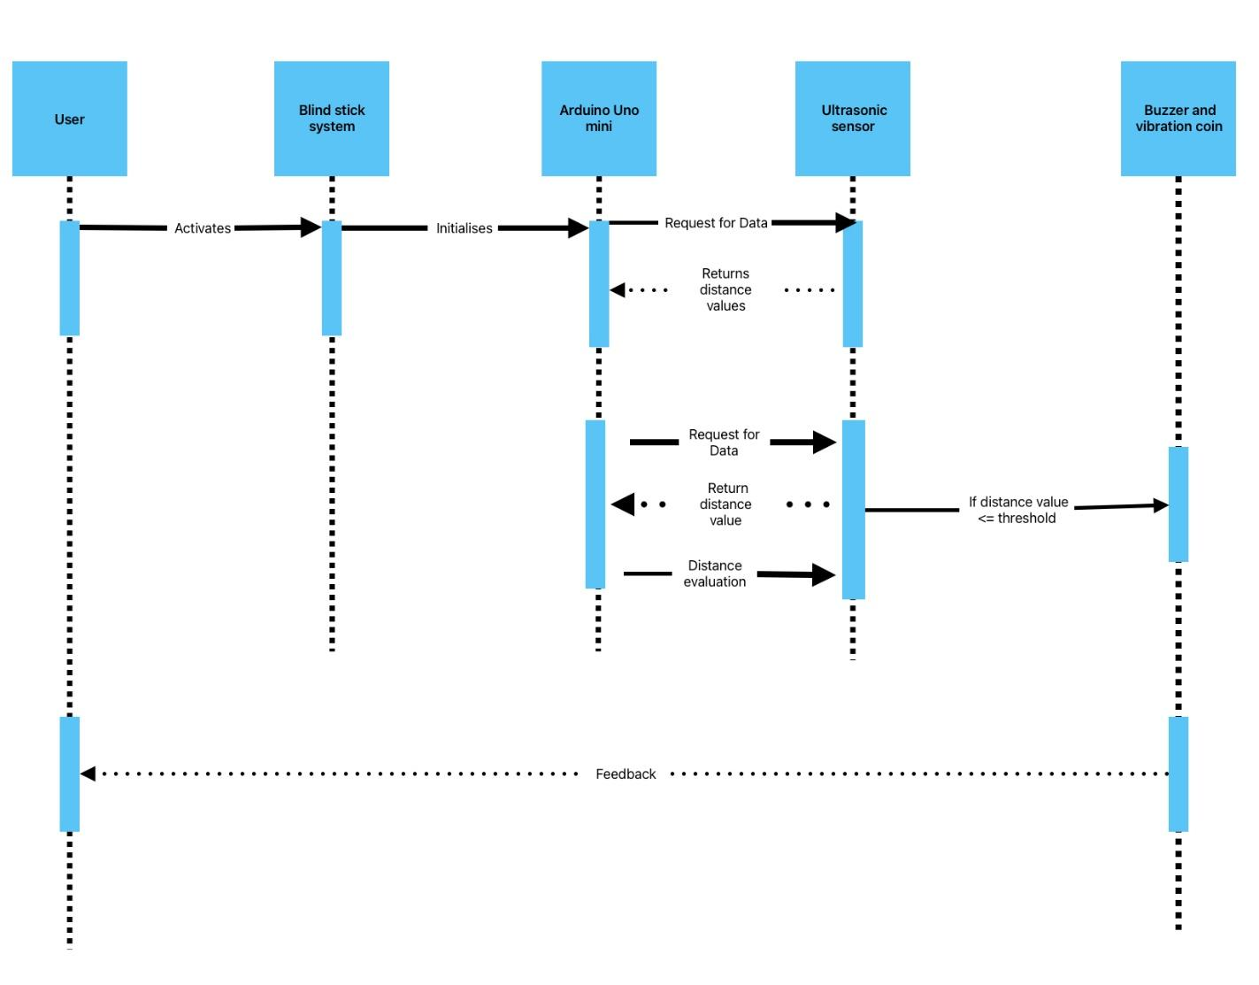

Fig13: Sequence Diagram

**Chapter-4**

**System Development & Implementation**

1. **Coding Samples**

const int trigPin = 9;

const int echoPin = 10;

const int buzzer = 12;

const int vib = 13;

long duration;

int distance;

int safetyDistance;

void setup() {

pinMode(trigPin, OUTPUT);

pinMode(echoPin, INPUT);

pinMode(buzzer, OUTPUT);

pinMode(vib,OUTPUT);

Serial.begin(9600);

}

void loop() {

delay(500);

digitalWrite(trigPin, LOW);

delayMicroseconds(2);

digitalWrite(trigPin, HIGH);

delayMicroseconds(10);

digitalWrite(trigPin, LOW);

duration = pulseIn(echoPin, HIGH);

distance= duration*0.034/2;

safetyDistance = distance;

if (safetyDistance <= 75){

digitalWrite(buzzer, HIGH);

digitalWrite(vib, HIGH);

}

else{

digitalWrite(buzzer, LOW);

digitalWrite(vib, LOW);

}

Serial.print("distance: ");

Serial.print(distance);

Serial.print("cm");

Serial.println("");

}

1. **Prerequisites**
2. **Arduino IDE Installation:** Ensure that you have the Arduino IDE installed on your computer. You can download it from the official Arduino website and install it according to the instructions provided.
3. **Board Selection:** Before writing code, you need to select the appropriate Arduino board you are using. This can be done through the "Tools" menu in the Arduino IDE. Select the correct board model to match the one you have.
4. **Driver Installation:** If you're using a board that requires a driver to communicate with your computer (such as the Arduino Uno or Nano), make sure you have installed the necessary drivers. Usually, the Arduino IDE provides guidance on how to install drivers for different boards.
5. **Port Connection:** Ensure that your Arduino board is properly connected to your computer via USB or another communication interface. This is necessary for uploading code to the board and for serial communication between the board and the computer.

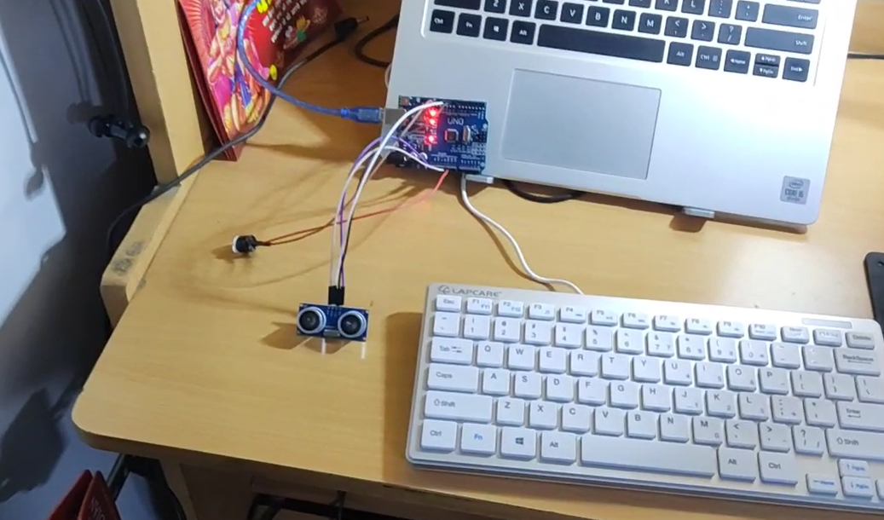

Fig 14: Arduino Board Connected to a Laptop via USB

**Chapter-5**

**System Testing**

1. **Functional Testing**

Functional testing of our project involves verifying that the device operates correctly according to its intended functions and requirements.

1. Define Functional Requirements: We started by clearly defining the functional requirements of the blind stick. These includes detecting obstacles, providing feedback to the user, and ensuring portability and ease of use.

* We achieved obstacle detection by using distance sensor.
* We provided haptic feedback to user by using Buzzer and Vibration coin similar to which we use in our smart phones.
* We ensured portability and easy of use by making our stick with no dependence on external device like smart phones for voice detection.

1. Develop Test Cases: Based on the functional requirements, we created a set of test cases that cover different scenarios and interactions with the blind stick. Test cases included inputs, expected outputs, and specific constraints.

Test Case 1: Obstacle Detection - The Blind Stick encounters an obstacle within its detection range.

Test Case 2: User Input Validation - The Blind Stick receives user input through buttons or switches.

Test Case 3: Feedback Mechanism - The Blind Stick provides feedback to the user through vibrations or sound

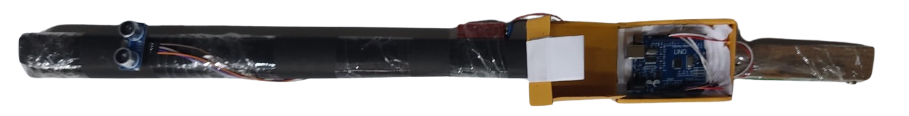

Fig14.1 Blind Stick at the time of Testing

1. Implement the Blind Stick Software: We Wrote the software code for the blind stick using the Arduino IDE. This involves programming sensors (ultrasonic sensor) to detect obstacles, controlling actuators (vibration motors or buzzer) to provide feedback.

* We wrote the code in C++ only for.
* Writing a C++ code is not enough, we had converted that stick into a sketch and upload it into microcontroller.

1. Test Individual Components: Tested each component of the blind stick separately to ensure they function correctly. For example, we have tested the sensor readings, verifying that feedback mechanisms work as intended or not.

* First and foremost, we tested our microcontroller the Arduino UNO mini working.
* We first tested each component without mounting it to a stick to check the sensors accuracy.
* Then we Tested our whole System with mounted on a stick.

1. User Testing: This Involves user with visual impairments in the testing process to gather feedback on the effectiveness and usability of the interface.

* For user testing I walked around with half closed eyes to test the blind stick.

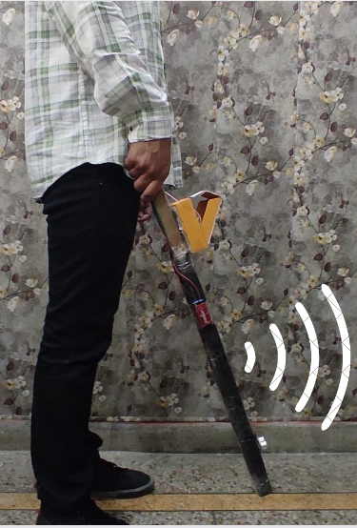

Fig 14.2: Testing the Blind Stick

**Chapter-6**

**Scope of Improvement, Summary and Conclusion**

1. **System Summary**
2. Obstacle Detection:

* The system effectively detects obstacles in the user's path using ultrasonic sensor (HC-SR04).
* Our sensor is mounted on a stick which makes it more accurate and effective.

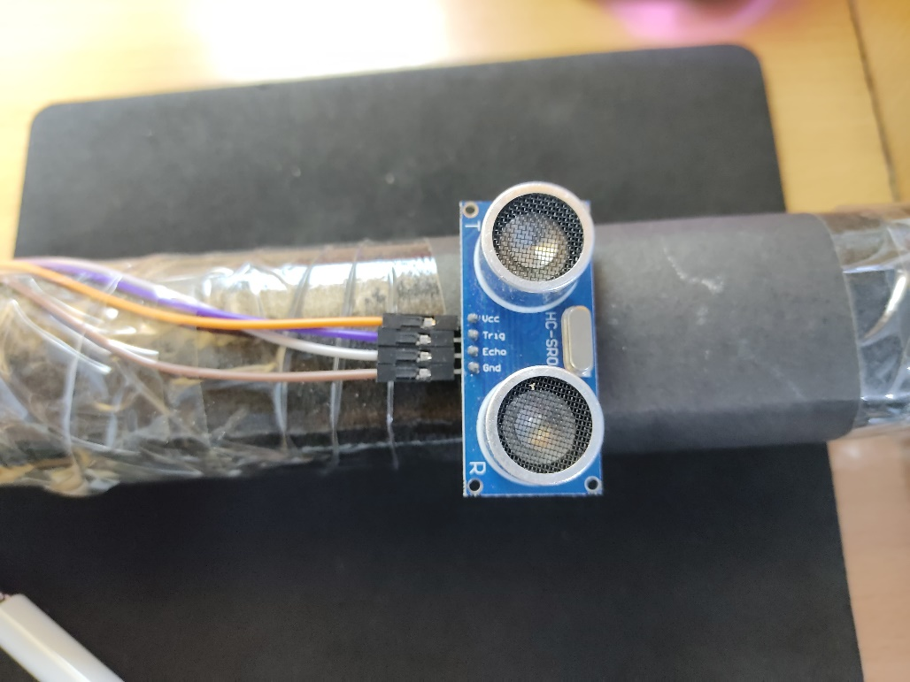

Fig 15 HC-SR04 Mounted on a Wooden Stick

1. Feedback Mechanisms:

* It provides feedback to the user through both auditory (buzzer) and tactile (vibrator) cues, alerting them to obstacles in their surroundings.
* Both vibration coin and buzzer is connected so both can provide synchronized feedback.
* Vibration coin is placed near the handle so it will provide best vibrations alert to the blind person.

1. Integration Possibilities:

* There is potential for integration with additional features, such as wireless connectivity for data logging, remote monitoring, or integration with navigation systems.
* There are Endless Possibilities of Integration of multiple technology in our Blind Stick. For example connecting it with Android/IOS application with a GPS intact or integration with a camera intact for object detection.

1. Synchronized Feedback: The vibration coin and buzzer are interconnected to provide synchronized feedback, enhancing the user's ability to perceive and react to obstacles effectively.
2. **Future Scope and Improvisation**
3. Sensitivity and Accuracy: Enhance the sensors' sensitivity to detect obstacles more accurately, especially small or low-lying obstacles. This could involve using more advanced sensors or refining the calibration and signal processing algorithms.
4. Customizable Feedback: Allow users to customize the feedback provided by the buzzer and vibrator based on their preferences and needs. Provide options for adjusting the intensity, frequency, and patterns of vibrations and sounds to better suit individual preferences.
5. Multimodal Feedback: Implement additional feedback mechanisms, such as speech output or tactile feedback, in addition to the buzzer and vibrator. This can provide users with multiple modes of feedback to better convey information about their surroundings.
6. Obstacle Differentiation: Develop algorithms to differentiate between different types of obstacles based on their size, shape, and distance. This could enable the blind stick to provide more informative feedback, such as indicating the presence of a person, a wall, or a low-hanging object.
7. Integration with Navigation Systems: Integrate the blind stick with navigation systems or smartphone apps to provide users with additional contextual information about their surroundings, such as nearby landmarks, points of interest, or navigation directions.
8. Wireless Connectivity: Add wireless connectivity, such as Bluetooth or Wi-Fi, to enable communication with other devices or sensors. This could facilitate remote monitoring, data logging, or connectivity with smart home systems for enhanced functionality.
9. Battery Life Optimization: Improve the efficiency of power management and optimize the device's power consumption to extend battery life. This could involve implementing low-power modes, optimizing algorithms, or using energy-efficient components.
10. Durability and Portability: Enhance the durability and portability of the blind stick by using lightweight and rugged materials, waterproofing components, and designing for ease of carrying and storage.
11. Multipurpose: The device can be attached to a wheelchair with autonomous navigation for crippled blind person.
12. **Conclusion**

This walking assistive stick represents a significant breakthrough in enhancing the mobility and independence of visually impaired individuals, offering a reliable and cost-effective solution that doesn't require constant assistance from others. The project's core mission was to alleviate the challenges faced by blind individuals during navigation and travel, and the developed device has shown promising results in providing smoother and safer navigation experiences both indoors and outdoors. By incorporating advanced sensor technologies and multi-sensory feedback mechanisms, the device addresses critical aspects of blind assistive technology, contributing to a more inclusive and accessible environment for the visually impaired.

Future Scopes and Enhancements

* Voice Notification and Navigation Features: Integrating voice-based notifications and navigation guidance will significantly enhance user experience and confidence, especially in complex or unfamiliar environments.
* Autonomous Navigation for Wheelchair Integration: Extending the device's capabilities to seamlessly integrate with wheelchairs and offer autonomous navigation features will greatly benefit individuals with both visual impairment and mobility challenges.
* Solar Panels with Rechargeable Batteries: Implementing renewable energy solutions such as solar panels combined with rechargeable batteries will ensure sustained operation and reduce dependency on external power sources, enhancing the device's reliability and accessibility.
* Enhanced Sensor Capabilities: Upgrading sensors for improved accuracy, range detection, and adaptability to diverse environmental conditions will further enhance user safety and navigation efficiency.
* Integration with Smart Assistive Technologies: Collaborating with smart home systems, wearable devices, and IoT platforms will enable seamless connectivity and personalized assistive experiences tailored to individual user needs.

1. **References**
2. Arduino: http://www.arduino.cc/
3. SparkFun Tutorials: https://learn.sparkfun.com/tutorials/tags/arduino
4. Arduino Project Hub: https://create.arduino.cc/projecthub
5. All About Circuits - Arduino Projects: https://www.allaboutcircuits.com/arduino/projects/
6. DIY Hacking - Arduino Projects: https://diyhacking.com/category/projects/arduino-projects/
7. Arduino Forum: https://forum.arduino.cc/
8. CircuitDigest - Arduino Projects: https://circuitdigest.com/projects/tag/arduino
9. Electronics-Lab - Arduino Projects: https://www.electronics-lab.com/projects/tag/arduino/
10. Random Nerd Tutorials - Arduino Projects: https://randomnerdtutorials.com/projects/
11. Electronics For You - Arduino Projects: https://electronicsforu.com/tag/arduino-projects
12. Arduino Stack Exchange: https://arduino.stackexchange.com/
13. Element14- Arduino Projects:https://www.element14.com/community/community/project14/arduino
14. Circuit Basics - Arduino Tutorials: https://www.circuitbasics.com/arduino-tutorials/
15. Open Electronics - Arduino Projects: https://www.open-electronics.org/category/arduino/
16. Arduino Project Hub: https://create.arduino.cc/projecthub
17. Instructables Arduino Projects: https://www.instructables.com/howto/arduino+projects/
18. Hackster.io Arduino Projects: https://www.hackster.io/arduino/projects
19. GitHub: https://github.com/
20. Reddit r/arduino: <https://www.reddit.com/r/arduino/>
21. Stack-overflow: https://stackoverflow.com/