A Major Project Report on

**BLIND STICK USING ARDUINO**

Submitted in partial fulfilment of the requirements for the award of the degree of

Bachelor of Computer Applications (BCA)

To

Guru Gobind Singh Indraprastha University, Delhi

**Guide: Submitted by:**

**Ms. Sushma Malik 1. ADITYA RAWAT (01290302021)**

**Associate Professor (IT) 2. VANSHIKA (03590302021)**



**Batch (2021-2024)**

**CERTIFICATE**

This is to certify that this Major Project Report entitled **Blind Stick Using Arduino** submitted in partial fulfilment of the degree of Bachelor of Computer Applications to the **Ms. Sushma Malik** done by **Mr. Aditya Rawat (Roll No. 01290302021**) and **Ms. Vanshika (Roll No. 03590302021)** is an is an authentic work carried out by them at Institute of Innovation in Technology and Management under my guidance. The matter embodied in this project work has not been submitted earlier for award of any degree to the best of my knowledge and belief.

**__________________**   **____________________**

Signature of the Guide

**__________________**

Signature of the student

**ACKNOWLEDGEMENT**

We are thankful to all the faculty members, for providing their valuable time and guidance in elaborating views of studying the project details and getting the right vision for its implementation. We are highly thankful to our Project guide **Ms. Sushma Malik**, who not only supervised us during our project but also gave us valuable suggestions which will be very beneficial for us in the future. We would also like to thank our colleagues, who assisted us and helped throughout.

With gratitude,

1. **ADITYA RAWAT**

2. **VANSHIKA**

**ABSTRACT**

Blindness or visual impairment refers to the inability to see, presenting challenges in performing daily tasks such as walking down the street or visiting friends. To address this issue, we developed a Smart Blind Stick, designed to provide users with a sense of safety during their walks. This innovative device utilizes an ultrasonic sensor, controlled by an Arduino UNO Mini, for artificial vision and object detection. The stick offers feedback through a buzzer and vibrator motor, ensuring a cost-effective obstacle detection solution. Our aim is to empower visually impaired individuals to navigate their surroundings with confidence and independence, mirroring the manoeuvres of sighted individuals.

**BLIND STICK USING ARDUINO**

**SYNOPSIS**

1. **Objective And Scope**

Objective:

Our Objective was to develop an embedded system on a blind man walking stick that would detect obstacles and. The stick we made detects obstacles in the forward direction and instructs the user to turn left or right, wherever there is more free space.

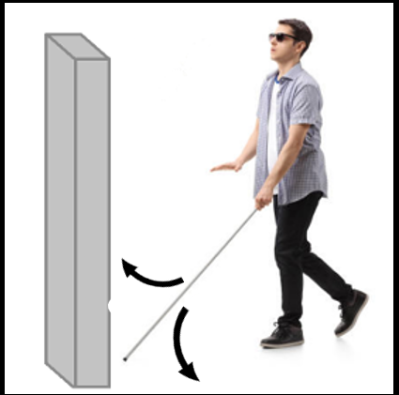

Scope:

The Scope of this project is to develop a cost-effective Smart Stick using Arduino for visually impaired individuals. Integrating object detection sensors, it provides real-time feedback on obstacles, prioritizing simplicity and portability. Exclusions include advanced features to focus on essential functionalities. The project aims to deliver a user-friendly prototype, contributing to improved mobility and accessibility.

1. **Core Functionalities**

The core functionalities of a Smart Stick for a blind person using Arduino involve leveraging technology to enhance mobility and safety.

Object Detection:

* Utilize sensors (e.g., ultrasonic or infrared) to detect obstacles and provide real-time feedback on the user’s surroundings.

Feedback Mechanism:

* Implement audio and/or haptic feedback to convey information about the distance and direction of detected obstacles.

User-Friendly Interface:

* Design a straightforward and intuitive interface, ensuring ease of use for individuals with visual impairments.

Portability:

* Ensure the stick is lightweight, portable, and easy to carry, facilitating convenient use in various environments.

Affordability:

* Prioritize cost-effective components to make the Smart Stick accessible to a broader user base.

1. **Methodology**

The working method behind this visually impaired stick is based on a simple concept. We are using five key components to build this project - an Ultrasonic Sensor HC SR 04, an Arduino UNO Mini board, a Buzzer, a Vibration Coin and a 9V Battery. Using the ultrasonic sensor, the device detects any obstacle that come in the path of the use and send warnings to the user. The proposed method is shown in the diagrams below.

1. 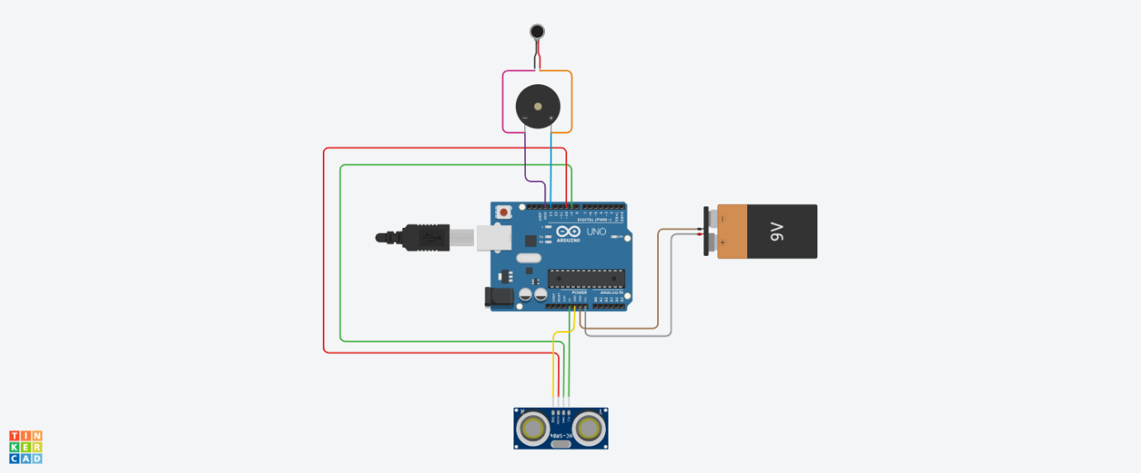**Circuit Diagram**

Fig ‘A’: Circuit Diagram of Blind Stick

From the ultrasonic sensor- Power, Trigger, Echo and Ground Pins are connected respectively to VIN, 9, 10 and GND pin of the Arduino Board. The positive pin of Buzzer is connected to 13 pin of the Arduino and negative side goes to GND. There is also a connection between GND of Arduino and the negative pins of Vibrating Motor and Battery. The other wire of vibrating motor is connected with 13.

1. **Description**

In this system, as shown in Fig. ‘A’. The Ultrasonic sensor transmits ultrasonic sound waves from the transmitter portions as soon as the circuit power supply is turned on. When an item passes in front of the sensor, its surface reflects ultrasonic sound waves back to the sensor's receiver portion, which subsequently picks up the wave and produces an output.

The Arduino UNO Mini receives this output data. The device's primary controller is an Arduino board. Using this data, micro-controller calculates the distance between the obstacle and the device. If the distance is within the threshold limit (which is 30cm in our project) then the micro-controller sends signal to Buzzer and Vibrator. The buzzer and vibrating motor are then both given operational voltage by the Arduino. The buzzer now starts to make noise, and the motor begins to vibrate. If not, then device will not give any warning. when an item is not detected by the sensors. Both the buzzer and the motor are disabled in this situation.

1. **CONCLUSION**

We come to the conclusion that the visually impaired persons can benefit from our project, "Blind Stick Using Arduino" Visual impairment is now present even in young children. They are aware of the risks involved; therefore, they cannot take this thing easily. The child or individual will lose the will to walk independently if the risk of injury is rising quickly. The Modern Blind Stick serves as a fundamental foundation to aid those who are blind in securely navigating both indoor and outdoor spaces. Both cost-effective and efficient. People who are blind or visually handicapped now have a much simpler time because of this stick. They become more independent and are better able to safely and easily navigate crowded sidewalks. It tries to overcome the problem of blind people on a day-to-day basis. The smart stick alerts users when there are objects or obstacles in their path. The system's superiority shows that it offers millions of blind people all over the world a low-cost solution.