Computer Networks Lab Assessment 5

Suryakumar P 21MIS1146

(a) Design a Client-Server LAN with Mesh Topology using Cisco Packet Tracer and check the PDU transmission between the nodes.

**Aim:**

To design a Client-Server LAN with Mesh Topology using Cisco Packet Tracer and check the PDU transmission between the nodes.

**Method:**

1. First, open the Cisco packet tracer desktop
2. Then, create a network topology
3. Use an Automatic connecting cable to connect the devices with others.
4. Configure the PCs (hosts) with IPv4 address.
5. Assigning IP address using the ipconfig command.
6. Also, we can also assign an IP address with the help of a command.
7. Go to the command terminal of the PC.
8. Then, type ipconfig <IPv4 address><subnet mask><default gateway>i) Verify the connection by pinging the IP address of any host in PC0.
9. Use the ping command to verify the connection.
10. We will check if we are getting any replies or not.
11. Here we get replies from a targeted node on both PCs.
12. Hence the connection is verified.

**CPT:**

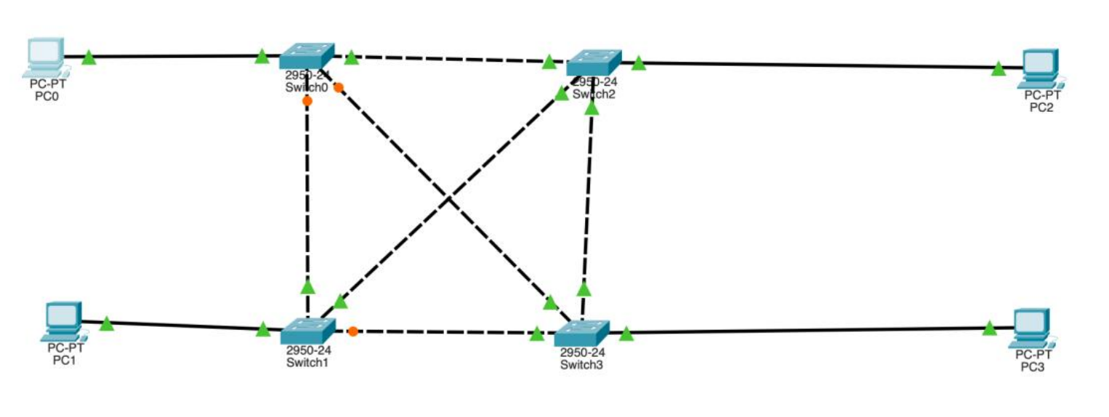

**Configure IP Address of each PC.**

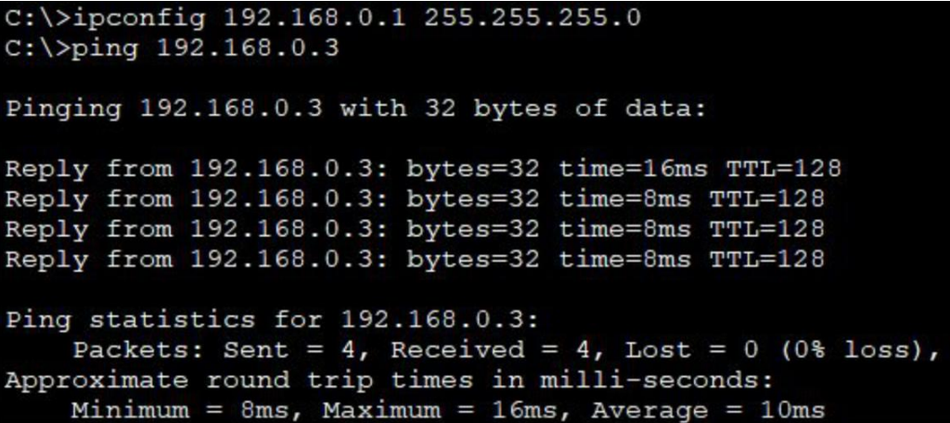

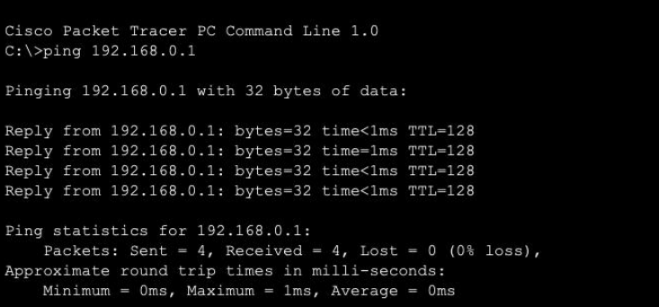

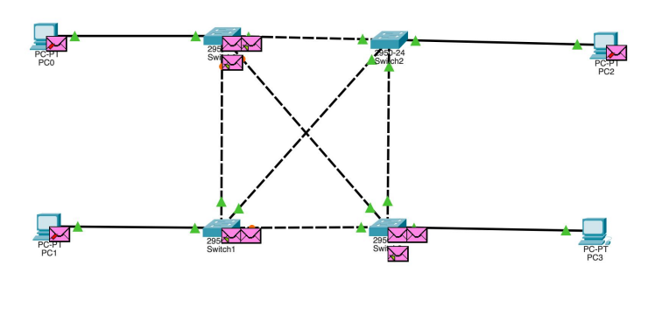

**(b) Configure ARP using CPT:**

**Aim:**

To configure ARP (Address Resolution Protocol) using Cisco packet tracer

**Method:**

a) Open Cisco Packet Tracer and create a new project.

b) Add the necessary devices to your network topology. At a minimum, you will need two devices: a switch and a router. You can add more devices as needed.

c) Connect the devices using appropriate cables. For example, connect a Fast Ethernet port on the switch to a Fast Ethernet port on the router.

d) Configure the IP addresses on the devices.

e) Configure ARP on the devices. By default, Cisco devices have ARP enabled. You don't need to explicitly enable it.

f) Verify the ARP table on the devices

g) Test ARP functionality. Ping from one device to another device using their IP addresses. PC> ping <IP_ADDRESS>.

h) Verify connectivity. Ensure that the ping is successful and that the devices can communicate with each other.

**CPT:**

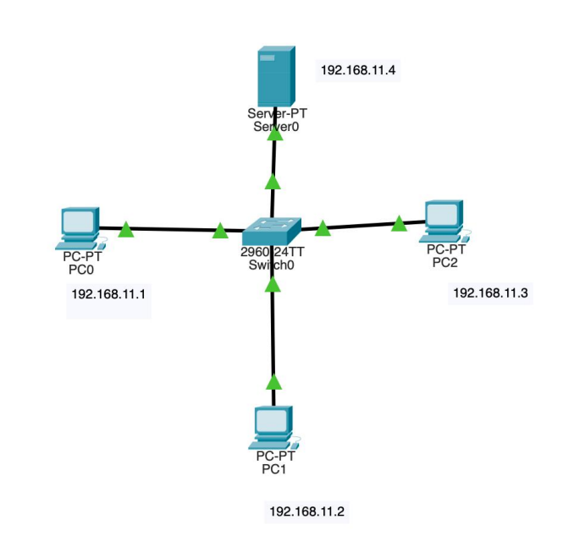

**Configure IP Address for each PC.**

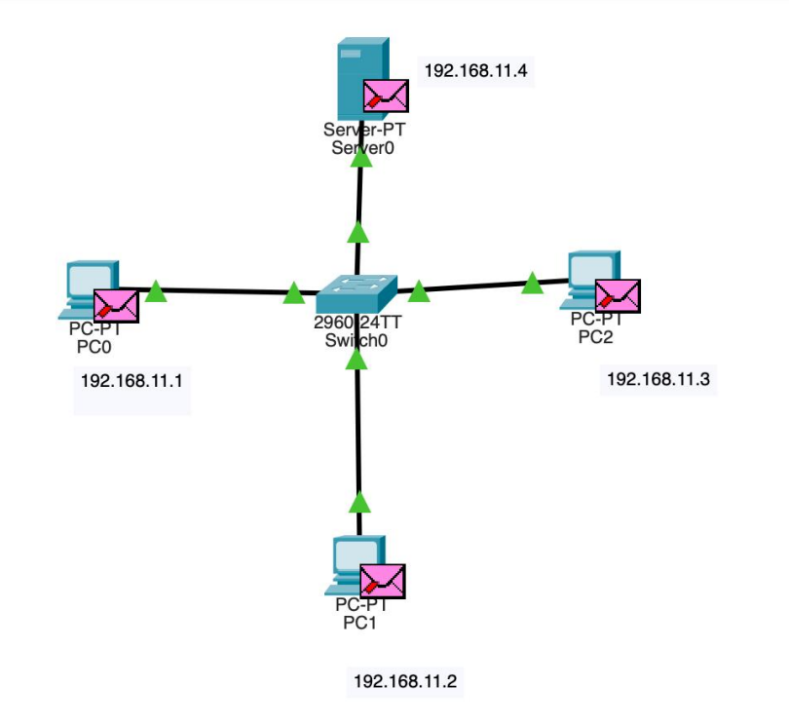

**ARP for PC0:**

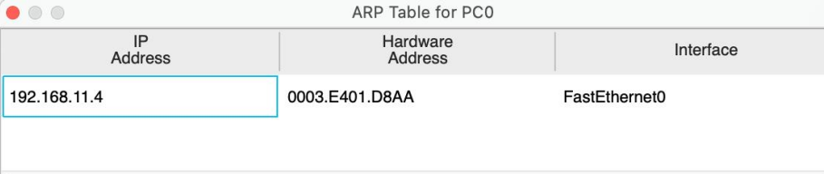

**ARP for Server:**

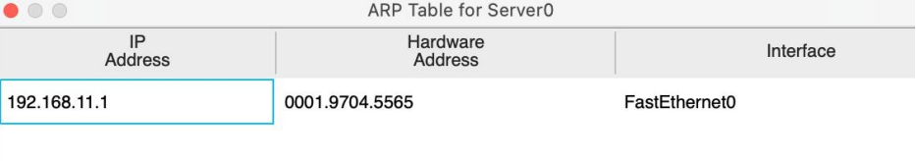

**CMD:**

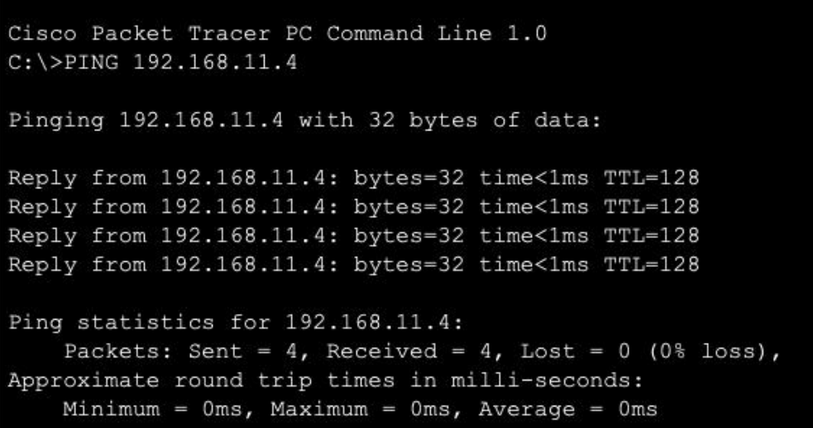

**(c) Design a network with OSPF using CPT:**

**Aim:**

To design a network with OSPF using CPT

**Method:**

A. Open Cisco Packet Tracer and create a new project.

B. Add the necessary devices to your network topology. At a minimum, you will need routers that will participate in the OSPF routing process. You can add additional devices such as switches and PCs as needed.

C. Connect the devices using appropriate cables. Connect the router interfaces to form the desired network topology.

D. Configure IP addresses on the router interfaces. Assign IP addresses to the router interfaces connected to the OSPF network Router(config-if) # ip address. E. Enable OSPF on the routers Router(config)# router OSPF Router(config-router) # network area.

F. Test OSPF routing. Configure a PC or another device connected to the network to use an IP address within the OSPF network. Use the ping command to test connectivity between devices.

G. Monitor OSPF routing updates.

H. Verify connectivity and routing. Ensure that devices can communicate with each other using OSPF for routing and that the OSPF routing table is correctly populated.

**CPT:**

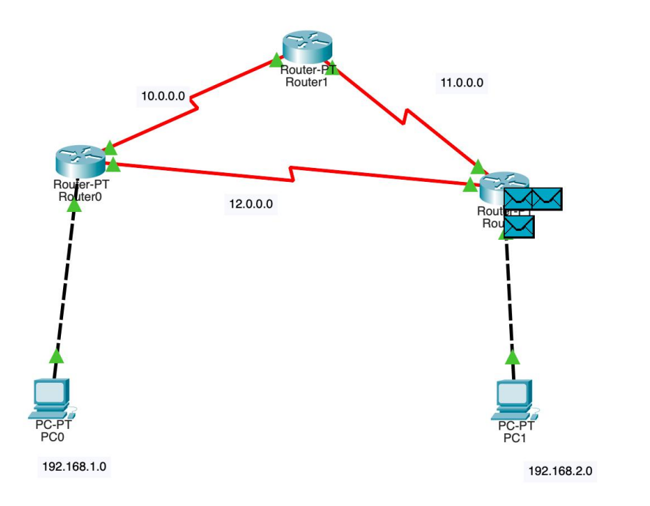

Configure IP address and Default Gateway.

Router 0:

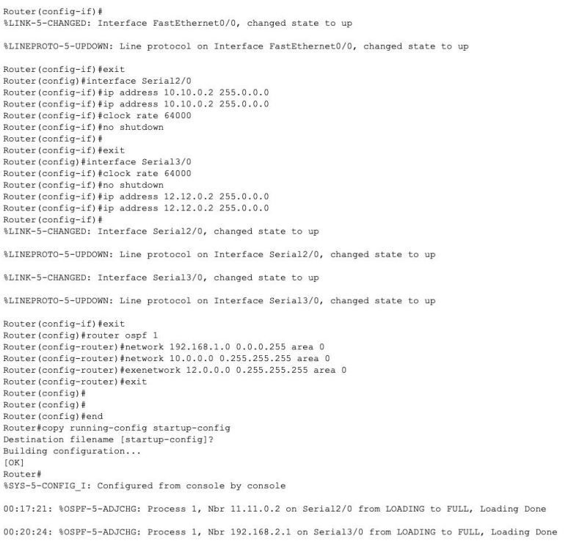

Router 1:

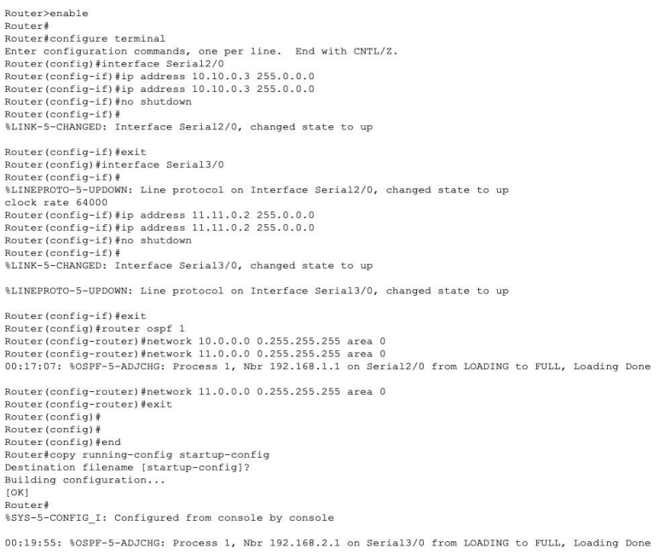

Router 2:

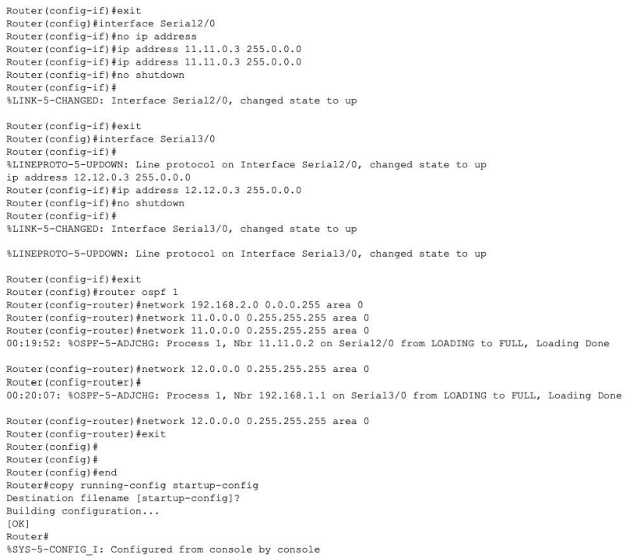

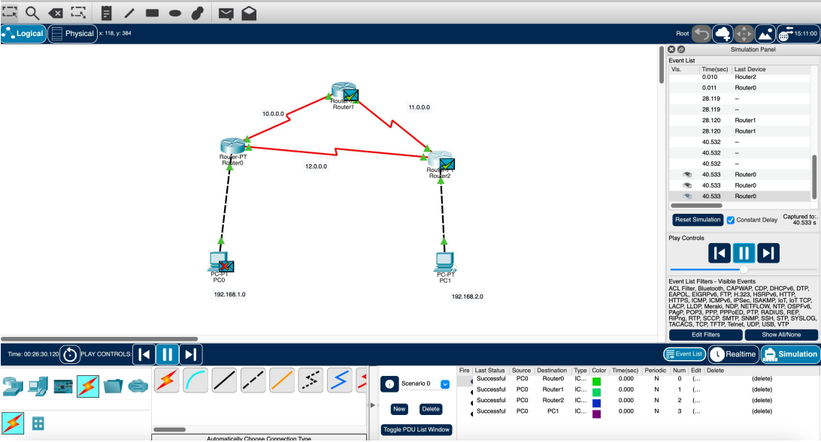

**(d) Configure DHCP using CPT**

Aim:

To Implement a Packet Tracer script that configures a DHCP server and multiple DHCP clients and the DHCP server should provide IP addresses, subnet masks, and default gateways to the clients dynamically.

Method:

● Open Cisco Packet Tracer and create a new network topology.

● Add a server and a switch to the topology.

● Connect the server and switch using a straight-through cable.

● Connect a PC to the switch using a straight-through cable.

● Configure the IP address of the server interface connected to the switch.

● Configure the default gateway on the PC to be the IP address of the server interface connected to the switch.

● Click on "Services" in the bottom left corner of the Packet Tracer window.

● Click on "DHCP" in the list of available services.

● Drag and drop the DHCP service onto the router.

● Double-click on the DHCP service to open the configuration window.

● Configure the DHCP pool by entering the following information:

○ Pool Name

○ Network

○ Subnet Mask

○ Default Router: Enter the IP address of the server interface connected to the switch.

○ DNS Server: Enter the IP address of DNS server. ○ Click on "Save" to save the DHCP configuration.

● Right-click on the router and select "Start" to start the DHCP service.

**CPT:**

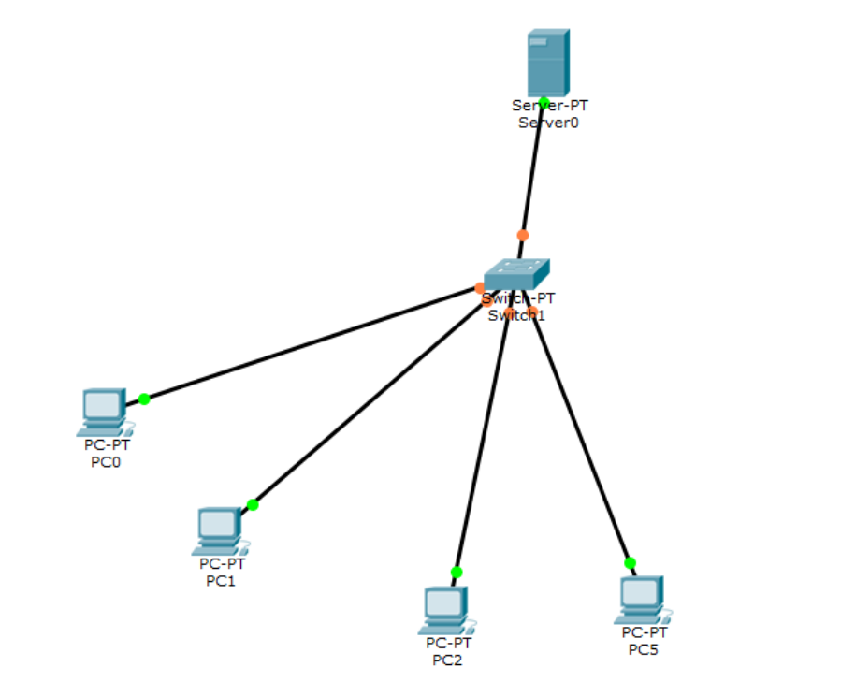

**Server – DHCP Configuration:**

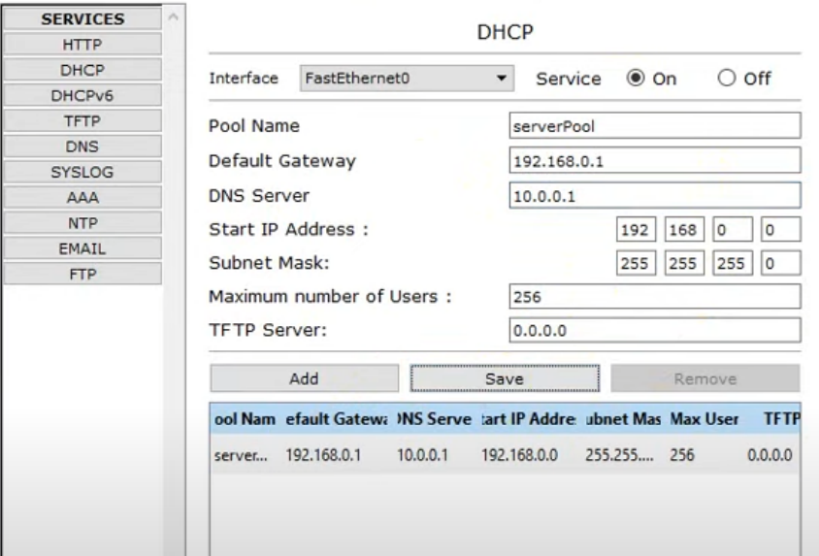

* Configure each PC with Server’s DHCP

After Configuration:

