IoT Domain Analyst CH - 1

Suryakumar P 21MIS1146

__________________________________________________________________

Question 2:

An IR (Infrared) sensor is integrated into a smart home system to detect motion (e.g., for security or energy efficiency). The system uses Node-RED on a Raspberry Pi to monitor motion, trigger events, and generate a log file with timestamps for each detection on every 2 seconds of interval. The log file can be used for auditing or behavior analysis.

Procedure:

1. **Connect the IR Sensor:** Attach the IR sensor to the Raspberry Pi by connecting its VCC, GND, and OUT pins to the appropriate GPIO pins.
2. **Install Node-RED:** Ensure Node-RED is installed and running on the Raspberry Pi.
3. **Create a Node-RED Flow:** Set up a flow using input (GPIO), trigger (2-second interval), function (generate log entry), and output (log file) nodes.
4. **Deploy and Test:** Deploy the flow and test by moving in front of the sensor to ensure motion detection logs are recorded.
5. **Review Logs:** Check the log file (/home/pi/21MIS1146/log_ir.txt) for timestamped motion detection entries.

Components:

Raspberry Pi 4, IR sensor, Jumper Wires.

Flow:

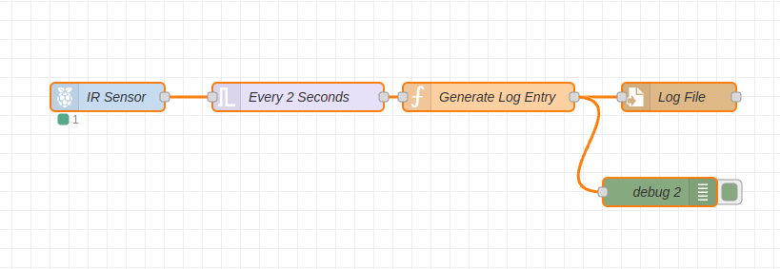

Screenshot:

Debug:

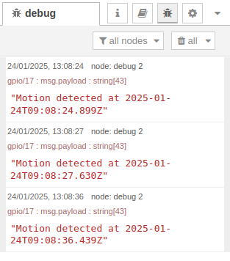

Log File:

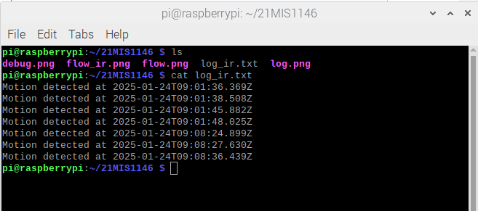

JSON:

[

{

"id": "3ae6781fe2172304",

"type": "tab",

"label": "Flow 1",

"disabled": false,

"info": "",

"env": []

},

{

"id": "f1b1c1a0.1b1c1",

"type": "rpi-gpio in",

"z": "3ae6781fe2172304",

"name": "IR Sensor",

"pin": "17",

"intype": "up",

"debounce": "25",

"read": true,

"bcm": true,

"x": 400,

"y": 420,

"wires": [

[

"f2b1c1a0.1b1c1"

]

]

},

{

"id": "f2b1c1a0.1b1c1",

"type": "trigger",

"z": "3ae6781fe2172304",

"name": "Every 2 Seconds",

"op1": "",

"op2": "0",

"op1type": "pay",

"op2type": "str",

"duration": "2",

"extend": false,

"overrideDelay": false,

"units": "s",

"reset": "",

"bytopic": "all",

"topic": "topic",

"outputs": 1,

"x": 600,

"y": 420,

"wires": [

[

"f3b1c1a0.1b1c1"

]

]

},

{

"id": "f3b1c1a0.1b1c1",

"type": "function",

"z": "3ae6781fe2172304",

"name": "Generate Log Entry",

"func": "if (msg.payload === 0) {\n msg.payload = 'Motion detected at ' + new Date().toISOString();\n return msg;\n} else {\n return null;\n}",

"outputs": 1,

"timeout": "",

"noerr": 0,

"initialize": "",

"finalize": "",

"libs": [],

"x": 800,

"y": 420,

"wires": [

[

"f4b1c1a0.1b1c1",

"64e7d2681e6118aa"

]

]

},

{

"id": "f4b1c1a0.1b1c1",

"type": "file",

"z": "3ae6781fe2172304",

"name": "Log File",

"filename": "/home/pi/21MIS1146/log_ir.txt",

"filenameType": "str",

"appendNewline": true,

"createDir": true,

"overwriteFile": "false",

"x": 1000,

"y": 420,

"wires": [

[]

]

},

{

"id": "64e7d2681e6118aa",

"type": "debug",

"z": "3ae6781fe2172304",

"name": "debug 2",

"active": true,

"tosidebar": true,

"console": false,

"tostatus": false,

"complete": "payload",

"targetType": "msg",

"statusVal": "",

"statusType": "auto",

"x": 980,

"y": 520,

"wires": []

}

]