IoT Challenging Task 3

Suryakumar P 21MIS1146

____________________________________________________________________________

### **Aim:**

To use an ultrasonic sensor with polynomial regression (order 2) to predict human presence based on distance. The system predicts and classifies motion detection using data collected from the sensor.

### **Procedure:**

1. Connect the ultrasonic sensor to the Raspberry Pi GPIO pins.
2. Set up Node-RED to read data from the ultrasonic sensor at regular intervals.
3. Process the sensor data and store distance readings and motion status (1 or 0).
4. Apply polynomial regression (order 2) on the collected data to predict motion detection.
5. Display the prediction result (human detected or not) on the Node-RED debug panel.

**Flow:**  
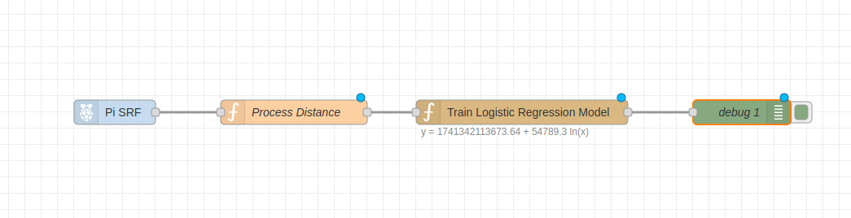

**RaspPi:**

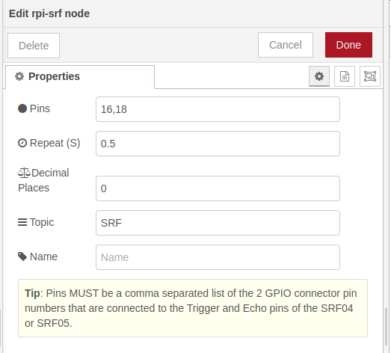

**Function:**

let echo_time = msg.payload;

let distance = (echo_time * 34300) / 20000;

msg.payload = {

"distance": distance,

"motion_detected": (distance < 200) ? 1 : 0,

"time": new Date().getTime()

};

return msg;

**Entire Flow JSON:**

[

{

"id": "27c22d84fab3e330",

"type": "tab",

"label": "Flow 5",

"disabled": false,

"info": "",

"env": []

},

{

"id": "6c447e17c26dcaa1",

"type": "mqtt-broker",

"name": "",

"broker": "localhost",

"port": "1883",

"clientid": "",

"autoConnect": true,

"usetls": false,

"protocolVersion": "4",

"keepalive": "60",

"cleansession": true,

"autoUnsubscribe": true,

"birthTopic": "",

"birthQos": "0",

"birthRetain": "false",

"birthPayload": "",

"birthMsg": {},

"closeTopic": "",

"closeQos": "0",

"closeRetain": "false",

"closePayload": "",

"closeMsg": {},

"willTopic": "",

"willQos": "0",

"willRetain": "false",

"willPayload": "",

"willMsg": {},

"userProps": "",

"sessionExpiry": ""

},

{

"id": "fa17c850baa268a7",

"type": "ui_tab",

"name": "Home",

"icon": "dashboard",

"order": "1"

},

{

"id": "eeb70c14a1c5d7c3",

"type": "ui_tab",

"name": "Home",

"icon": "dashboard",

"order": "1"

},

{

"id": "3bb4c2ef0e9061e5",

"type": "ui-base",

"name": "My Dashboard",

"path": "/dashboard",

"appIcon": "",

"includeClientData": true,

"acceptsClientConfig": [

"ui-control",

"ui-gauge",

"ui-chart"

],

"showPathInSidebar": false,

"headerContent": "page",

"navigationStyle": "default",

"titleBarStyle": "default",

"showReconnectNotification": true,

"notificationDisplayTime": 1,

"showDisconnectNotification": true

},

{

"id": "0c8ab04fb82f578e",

"type": "ui-theme",

"name": "Default Theme",

"colors": {

"surface": "#ffffff",

"primary": "#0094CE",

"bgPage": "#eeeeee",

"groupBg": "#ffffff",

"groupOutline": "#cccccc"

},

"sizes": {

"density": "default",

"pagePadding": "12px",

"groupGap": "12px",

"groupBorderRadius": "4px",

"widgetGap": "12px"

}

},

{

"id": "04971a423a1fbe59",

"type": "ui-page",

"name": "Page 1",

"ui": "3bb4c2ef0e9061e5",

"path": "/page1",

"icon": "home",

"layout": "grid",

"theme": "0c8ab04fb82f578e",

"breakpoints": [

{

"name": "Default",

"px": "0",

"cols": "3"

},

{

"name": "Tablet",

"px": "576",

"cols": "6"

},

{

"name": "Small Desktop",

"px": "768",

"cols": "9"

},

{

"name": "Desktop",

"px": "1024",

"cols": "12"

}

],

"order": 1,

"className": "",

"visible": "true",

"disabled": "false"

},

{

"id": "2a4891668bd1b21a",

"type": "ui-group",

"name": "Group 1",

"page": "04971a423a1fbe59",

"width": 6,

"height": 1,

"order": 1,

"showTitle": true,

"className": "",

"visible": true,

"disabled": false,

"groupType": "default"

},

{

"id": "0a13d40c111c68f6",

"type": "ui-spacer",

"group": "2a4891668bd1b21a",

"name": "spacer",

"tooltip": "",

"order": 2,

"width": "1",

"height": "1",

"className": ""

},

{

"id": "a556fd8707695b02",

"type": "ui-page",

"name": "Page 2",

"ui": "3bb4c2ef0e9061e5",

"path": "/page2",

"icon": "home",

"layout": "grid",

"theme": "0c8ab04fb82f578e",

"breakpoints": [

{

"name": "Default",

"px": "0",

"cols": "3"

},

{

"name": "Tablet",

"px": "576",

"cols": "6"

},

{

"name": "Small Desktop",

"px": "768",

"cols": "9"

},

{

"name": "Desktop",

"px": "1024",

"cols": "12"

}

],

"order": 2,

"className": "",

"visible": "true",

"disabled": "false"

},

{

"id": "f7d231bb.c5b38",

"type": "ui_tab",

"name": "Dashboard",

"icon": "dashboard",

"order": 1

},

{

"id": "a28af727e468f2cb",

"type": "function",

"z": "27c22d84fab3e330",

"name": "Process Distance",

"func": "let echo_time = msg.payload; \nlet distance = (echo_time * 34300) / 20000; \nmsg.payload = {\n \"distance\": distance,\n \"motion_detected\": (distance < 200) ? 1 : 0,\n \"time\": new Date().getTime()\n};\n\nreturn msg;",

"outputs": 1,

"timeout": 0,

"noerr": 0,

"initialize": "",

"finalize": "",

"libs": [],

"x": 550,

"y": 340,

"wires": [

[

"6a5dc23ff830ddc8"

]

]

},

{

"id": "6a5dc23ff830ddc8",

"type": "regression",

"z": "27c22d84fab3e330",

"name": "Train Logistic Regression Model",

"dataSetSize": "0",

"regressionType": "logarithmic",

"polynomialOrder": "1",

"precision": 2,

"xInputField": "payload.distance",

"xInputFieldType": "msg",

"yInputField": "payload.time",

"yInputFieldType": "msg",

"yOutputField": "topic",

"yOutputFieldType": "msg",

"functionOutputField": "string",

"functionOutputFieldType": "msg",

"resultOnly": true,

"x": 830,

"y": 340,

"wires": [

[

"83c2ac7d5ab8e517"

]

]

},

{

"id": "83c2ac7d5ab8e517",

"type": "debug",

"z": "27c22d84fab3e330",

"name": "debug 1",

"active": true,

"tosidebar": true,

"console": false,

"tostatus": false,

"complete": "payload.y",

"targetType": "msg",

"statusVal": "",

"statusType": "auto",

"x": 1100,

"y": 340,

"wires": []

},

{

"id": "9125be36f1da1399",

"type": "rpi-srf",

"z": "27c22d84fab3e330",

"name": "",

"topic": "SRF",

"pulse": "0.5",

"pins": "16,18",

"precision": "0",

"x": 330,

"y": 340,

"wires": [

[

"a28af727e468f2cb"

]

]

}

]