Big Data Technologies DA 2

Suryakumar P 21MIS1146

**Dataset – Sensor Readings (1.4 Million + Rows), Algorithm: Linear Regression – Finding MSE**

1. Python – joblib algorithm for Parallel Processing:

import pandas as pd

from sklearn.model_selection import train_test_split

from sklearn.linear_model import LinearRegression

from sklearn.metrics import mean_squared_error

from joblib import Parallel, delayed

import numpy as np

*# Load the CSV file into a pandas DataFrame*

df = pd.read_csv("sensor_data.csv", header=None, names=["SensorReading"])

*# Extract the input feature (X) and create the target variable (y) from row indices*

X = df[["SensorReading"]]

y = np.arange(len(df))

*# Split the data into training and testing sets*

X_train, X_test, y_train, y_test = train_test_split(X, y, test_size=0.2, random_state=42)

*# Initialize the linear regression model*

model = LinearRegression()

*# Function to fit the model and make predictions*

def fit_model(X_train, y_train, X_test):

*# Train the model*

    model.fit(X_train, y_train)

*# Make predictions*

    return model.predict(X_test)

*# Perform parallel processing using joblib*

predictions = Parallel(n_jobs=-1)(delayed(fit_model)(X_train, y_train, X_test) for _ in range(10))

*# Calculate mean squared error for each set of predictions*

mse_values = [mean_squared_error(y_test, pred) for pred in predictions]

*# Print mean squared error for each set of predictions*

for i, mse in enumerate(mse_values):

    print(f"Mean Squared Error for set {i+1}: {mse}")

*# Average mean squared error across all sets*

average_mse = sum(mse_values) / len(mse_values)

print("Average Mean Squared Error:", average_mse)

**Output:**

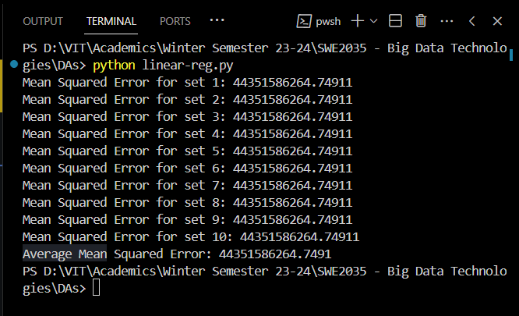

**Hadoop:**