21ECC203T – DIGITAL LOGIC DESIGN
Project Report on Smart Traffic Light Controller Using ESP8266
Submitted by
NARESH V – RA2511004040003
VARUN S GUHAN – RA2511004040016
JANAPAREDDI ROHITH – RA2511004040059
SYED MUBASHIR AHAMED – RA2511004040061
in partial fulfillment for the award of the degree
of
BACHELOR OF TECHNOLOGY
in
ELECTRONICS AND COMMUNICATION ENGINEERING

DEPARTMENT OF ELECTRONICS AND COMMUNICATION ENGINEERING
FACULTY OF ENGINEERING AND TECHNOLOGY
SRM INSTITUTE OF SCIENCE AND TECHNOLOGY
Vadapalani Campus, Chennai – 26
OCTOBER 2026
BONAFIDE CERTIFICATE
Certified that this report is the bonafide work of NARESH V, VARUN S GUHAN, JANAPAREDDI ROHITH, and SYED MUBASHIR AHAMED, submitted in partial fulfillment of the requirements for the course 21ECC203T – Digital Logic Design, for the project titled “Smart Traffic Light Controller Using ESP8266” during the academic year 2026–2027.
Signature of Faculty-In-Charge Signature of HOD
Dr. A. Vasuki Dr. S. Karthik
Assistant Professor Head of the Department
Dept. of Electronics and Communication Dept. of Electronics and Communication
Engineering Engineering
Date: ____________________

1. Abstract
This project demonstrates a basic traffic-light controller using an ESP8266 development board. Three LEDs represent the red, yellow, and green signals. The ESP8266 controls the LEDs through digital output pins according to a programmed timing sequence. The intended sequence is red for 5 seconds, green for 5 seconds, and yellow for 5 seconds, repeating continuously. The prototype is a low-cost educational model for understanding microcontrollers, digital outputs, and simple automation. The current build has shown an issue in which the red and yellow LEDs sometimes light together; the wiring and pin assignments should be checked before presenting it as fully working.

2. Introduction
Traffic lights help organize vehicles and pedestrians at road intersections. A conventional traffic signal follows a timed sequence to indicate when traffic should stop, prepare to move, or proceed. This mini project models that behavior using an ESP8266 board and LEDs. Instead of using separate timer and logic integrated circuits, the controller uses a small program to switch each output on and off.

3. Aim
To design and demonstrate a simple traffic-light sequence using an ESP8266, three LEDs, and current-limiting resistors.

4. Objectives
- Understand how a microcontroller controls external components.
- Use digital GPIO pins to switch LEDs on and off.
- Implement a timed red–green–yellow sequence.
- Build and test a low-cost traffic-light model on a breadboard.

5. Components Required
S. No. | Component | Quantity
1 | ESP8266 NodeMCU development board | 1
2 | Red LED | 1
3 | Yellow LED | 1
4 | Green LED | 1
5 | 220 Ω resistor (one per LED) | 3
6 | Breadboard | 1
7 | Male-to-male jumper wires | As required
8 | USB cable and computer with Arduino IDE | 1 each

Circuit Diagram
Intended connections: D7 controls red, D6 controls yellow, and D5 controls green. Each LED has its own 220 Ω series resistor, and all LED cathodes connect to GND.
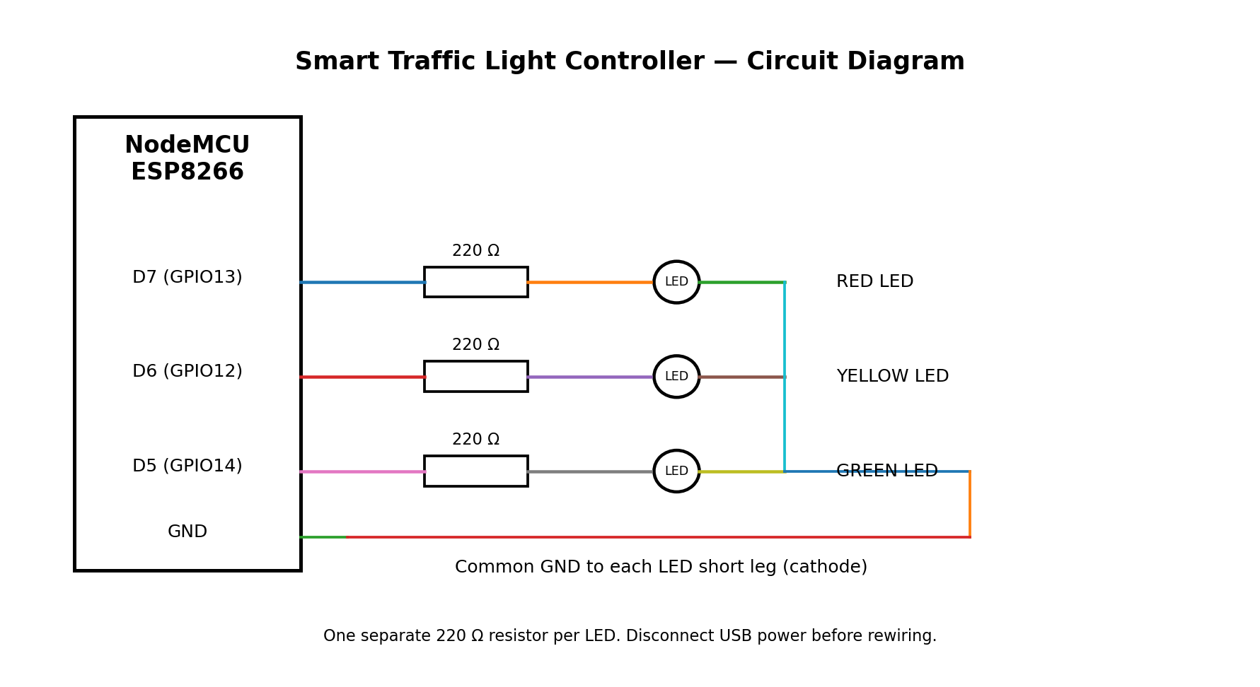

ESP8266 Pin Diagram
NodeMCU labels D5, D6, and D7 correspond to GPIO14, GPIO12, and GPIO13 respectively. The G pin is ground. Follow the labels printed on your board.
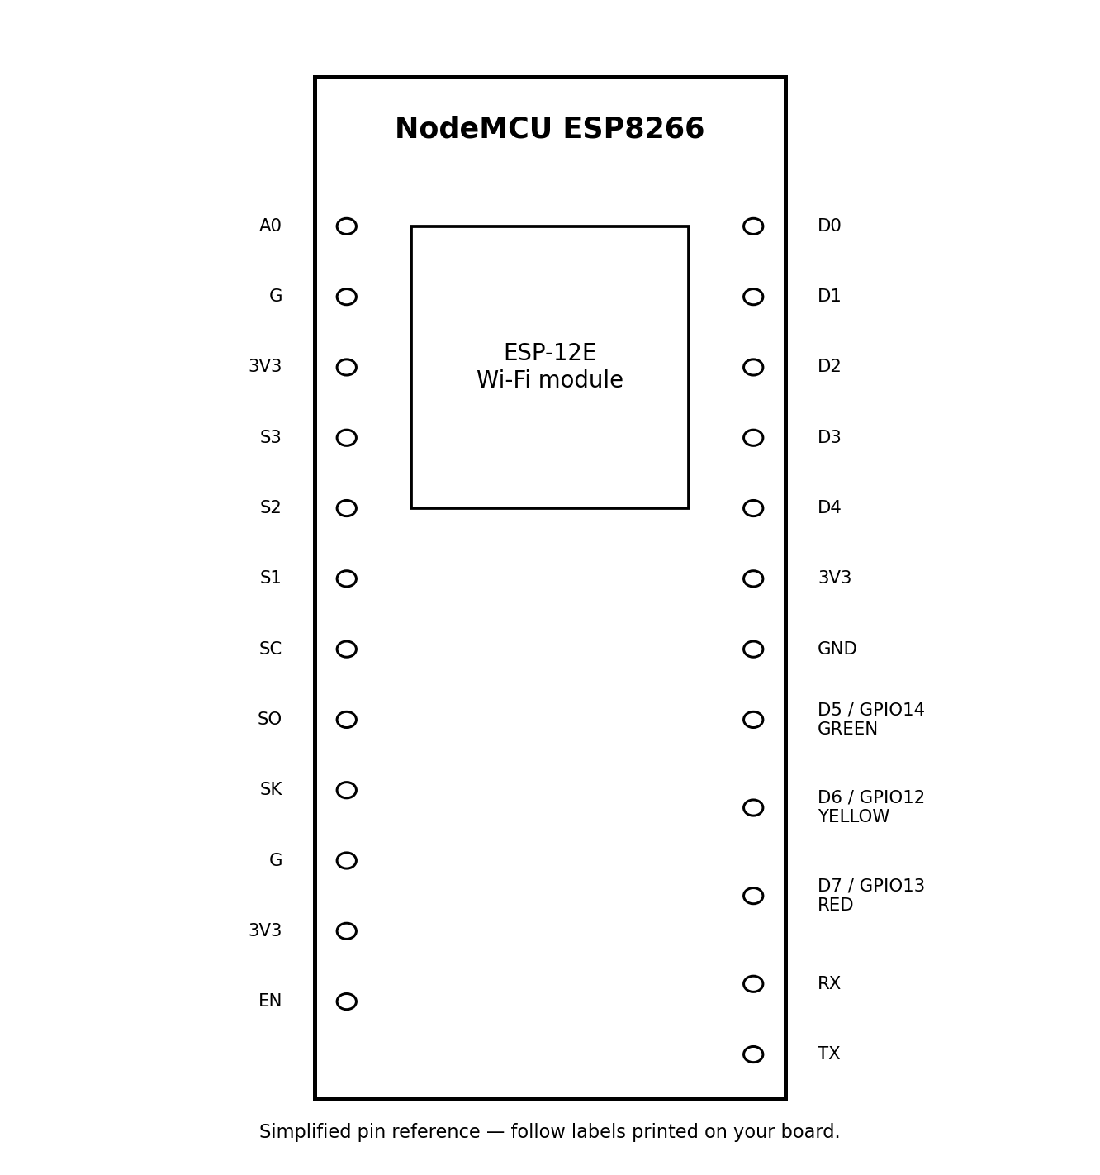

6. Hardware Connections
Use the pin labels printed on the ESP8266 board. The following is the intended connection plan; the exact GPIO mapping must match the program uploaded to the board.
- Red LED anode (long leg) → 220 Ω resistor → D5 (GPIO14).
- Yellow LED anode (long leg) → 220 Ω resistor → D6 (GPIO12).
- Green LED anode (long leg) → 220 Ω resistor → D7 (GPIO13).
- Connect each LED cathode (short leg) to a GND pin on the ESP8266.
- Each LED must have its own resistor. Do not connect an LED directly to a GPIO pin without a resistor.
- Disconnect USB power before changing the wiring. Ensure the LEDs and jumpers are not shorting adjacent breadboard rows.
Important: ESP8266 board labels such as D5, D6, and D7 are not the same as GPIO numbers. If the sketch uses different pins, either change the wiring or update the sketch so both agree.

7. Working Principle
The program configures three GPIO pins as outputs. It turns on one LED for a specified time while turning the other two off. The controller then moves to the next signal and repeats the sequence.
Signal | LED state | Duration
Red | Red ON; yellow and green OFF | 5 seconds
Green | Green ON; red and yellow OFF | 5 seconds
Yellow | Yellow ON; red and green OFF | 5 seconds
The timing can be changed in the program. For a real road system, signal timing and safety interlocks must be designed and validated professionally; this breadboard model is for demonstration only.

8. Program
The following example is for the Arduino IDE with an ESP8266 board package installed. It uses D5 for red, D6 for yellow, and D7 for green, matching the connection plan above.
const int RED = D5;
const int YELLOW = D6;
const int GREEN = D7;
void setup() {
pinMode(RED, OUTPUT);
pinMode(YELLOW, OUTPUT);
pinMode(GREEN, OUTPUT);
}
void loop() {
// Red signal
digitalWrite(RED, HIGH);
digitalWrite(YELLOW, LOW);
digitalWrite(GREEN, LOW);
delay(5000);
// Green signal
digitalWrite(RED, LOW);
digitalWrite(YELLOW, LOW);
digitalWrite(GREEN, HIGH);
delay(5000);
// Yellow signal
digitalWrite(RED, LOW);
digitalWrite(YELLOW, HIGH);
digitalWrite(GREEN, LOW);
delay(5000);
}

9. Testing and Observations
The program was uploaded successfully to the ESP8266, as indicated by the upload log reaching 100% and reporting that the data hash was verified. During hardware testing, the red LED illuminated. The user also observed that the red and yellow LEDs sometimes illuminated together and that LED brightness differed. These observations indicate that the physical wiring, breadboard row placement, resistor placement, or correspondence between code pin names and actual board pins still needs to be verified. The prototype should be described as under testing until each signal operates independently.

10. Advantages
- Low cost and simple components.
- Timing can be changed by editing software.
- Helps demonstrate embedded programming and digital logic.
- Can be expanded with pedestrian buttons, sensors, or status monitoring.

11. Limitations
- The current model represents only one traffic signal and does not sense actual traffic.
- It depends on a stable power supply and correct wiring.
- The current prototype has a simultaneous red/yellow LED issue that must be corrected.
- It is an educational model and must not be used to control real road traffic.

12. Applications and Future Scope
This model can be used for classroom demonstrations and introductory embedded-systems projects. Future improvements could include a pedestrian crossing button, vehicle detection using suitable sensors, a countdown display, multiple-road junction sequencing, and Wi-Fi-based monitoring. Any expanded design should include careful testing so conflicting signals cannot be activated together.

13. Conclusion
The Smart Traffic Light Controller demonstrates how an ESP8266 can control LEDs in a timed sequence. The software upload completed successfully, and the red LED was observed to light. However, the red/yellow overlap reported during testing shows that the hardware connections or pin mapping require further checking. After correcting and verifying the connections, the project can serve as a useful demonstration of microcontroller-based automation.

14. References
- ESP8266 Arduino Core documentation: https://arduino-esp8266.readthedocs.io/
- Arduino IDE software: https://www.arduino.cc/en/software
- ESP8266 NodeMCU board pin labels and board documentation supplied by the manufacturer.

Working Model
The following photographs show the assembled ESP8266-based traffic light controller on a breadboard during testing. The red, yellow, and green LEDs are demonstrated in different states.
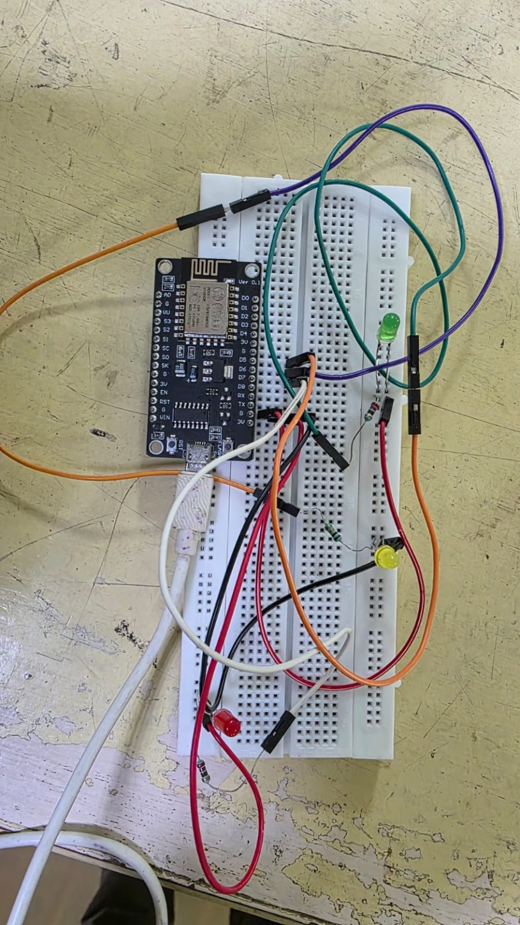
Figure 1: Complete breadboard setup of the traffic light controller.

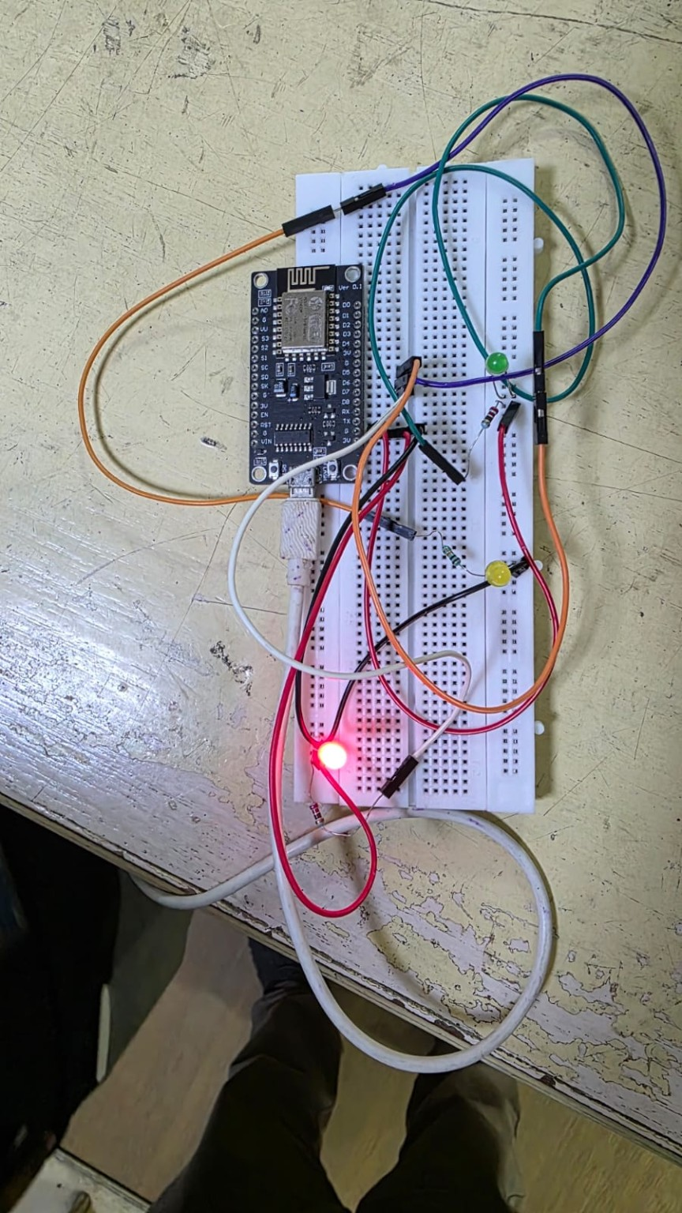
Figure 2: Working model with the red LED illuminated.
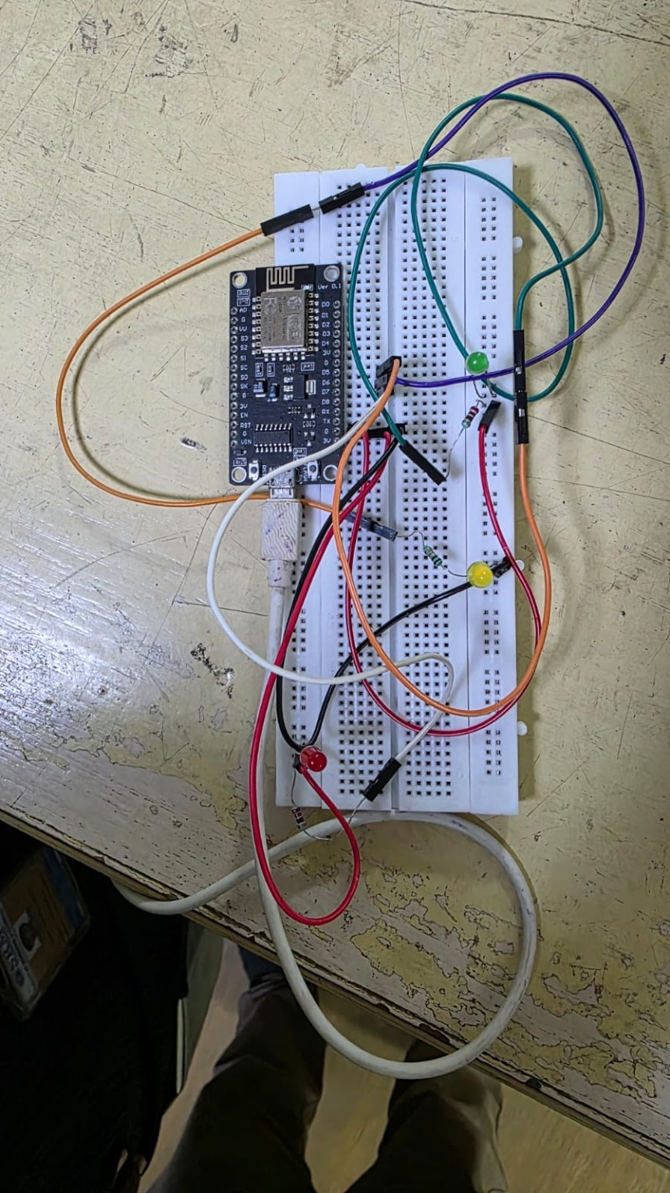
Figure 3: Working model during the traffic-light sequence.
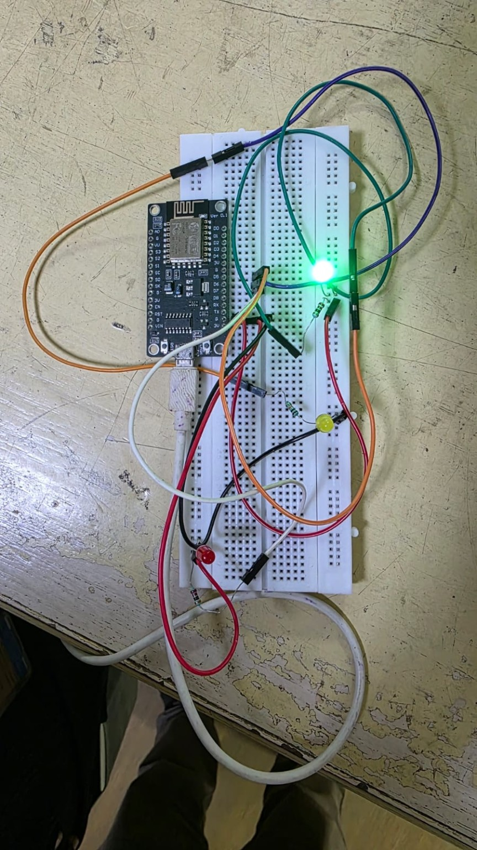
Figure 2: Working model with the green LED illuminated.

