**Pure Health Natural Products**

**A Minor Project Report**

Submitted in Partial Fulfillment of the Requirements for the

Award of the Degree of

**MASTER OF COMPUTER APPLICATIONS**



**Session: 2022 – 2023**

**SUPERVISED BY**

**Prof. Nidhi <>**

**SUBMITTED BY**

**Anand Choudhary (0827CA19DD06)**

**<> <>**

**Faculty of Computer Applications**

**Acropolis Institute of Technology & Research, Indore DECEMBER - 2022**

**CERTIFICATE**

This is to certify that this project report entitled “**Bulk SMS Email and WhatsApp Service”** **By Anand Choudhary (0827CA19DD06) &**

**<>** submitted to Faculty of Computer Applications, Acropolis Institute of Technology & Research, Indore in DDMCA VII semester in the partial fulfillment of the requirements for the degree of Master of Computer Applications during the academic year 2022-2023, his/her work is satisfactory.

Signature of HOD Signature of Supervisor

Prof. Geeta Santhosh Prof.

Signature of External Examiner Signature of Internal Examiner

Date:

Place: Indore

**ACKNOWLEDGMENT**

* My heart full thanks to Prof. Nidhi <>, faculty of F.C.A Department, Acropolis Institute of Technology and Research, for giving me the accessory environment to acquire knowledge and skill.
* My sincere and warmest thanks to Mrs. Geeta Santosh, Head of the Department of Computer Application, Acropolis Institute of Technology and Research, for her valuable and inspiring guidance and encouragement given throughout the period of this project.
* My thanks and appreciations also go to my college classmates in developing the project and people who have willingly helped me out with their abilities

**ABSTRACT**

Information sharing is a major factor for development in the country. It is a time taking process to share information to all the citizens of the country through media and newspaper. In this modern generation almost, everyone has a mobile phone in their hand. We can use this opportunity to share information directly to them through SMS or EMAIL. This will save time and money and information can be shared with a larger community within short time duration. Also, such service can be used to repeatedly send SMS in case of emergency situations.

**CONTENTS**

**Chapters**

1. **Introduction**

1.1. General Description of Project

1.2. Objective

1.3. Goals

1. **Study of Existing System and System Requirements**

2.1. Identification of Need

2.1.1. Existing System & its limitations

2.2. Preliminary Investigation

2.2.1. Proposed System

2.3. Feasibility Study

2.3.1. Technical Feasibility

2.3.2. Operational Feasibility

2.3.3. Economical Feasibility

1. **Project Planning**

3.1 Gantt Chart

1. **System Analysis**

4.1 Software Requirement Specification

4.1.1 External Interface Requirement

4.1.1.1 User Interface

4.1.1.2 Hardware Interface

4.1.1.3 Software Interface

4.1.1.4 Communication Interface

4.1.2 Functional Requirement of the System

4.1.3 Non-functional Requirement

4.1.3.1 Performance

4.1.3.2 Reliability

4.1.3.3 Availability

4.1.3.4 Security

4.1.3.6 Portability

4.1.4 Proposed System Architecture

4.2 System Analysis Tools

4.2.1 E-R Diagram

4.2.2 Data Flow Diagram

4.2.3 Software & Hardware Requirements

4.2.4 Overview of Technologies Used

1. **System Design**

5.1 UML Diagram

5.1.1. Use-Case Diagram

5.1.2 Sequence Diagram

5.2 User Interface Design

1. **Testing**

6.1. Testing techniques and testing strategies used

6.1.1 Testing Technique

6.2. Test reports

6.2.1. Test Report Using Various Testing Techniques

1. **Conclusion**
2. **Future Enhancements**
3. **References**
4. **Bibliography**

**List of Tables:**

|  |  |  |
| --- | --- | --- |
| **Sr no.** | **Name of Table** | **Page Number** |
| 3.1 | Gantt Chart | 14 |

**List of figures:**

| **Sr no.** | **Name of Figures** | **Page no.** |
| --- | --- | --- |
| 4.1.4 | Proposed system architecture | 18 |
| 4.2.1 | E-R Diagram | 19 |
| 4.2.2 | Data Flow Diagram | 20 |
| 5.1.1 | Use-case Diagram | 24 |
| Fig 1: | Homepage | 28 |
| Fig 2: | Message service | 28 |
| Fig 3: | WhatsApp service | 29 |
| Fig 4: | Email service | 30 |

**1. Introduction of Project**

**1.1 General description of project**

The title of project is **“**Bulk SMS Email and WhatsApp Service**”** It will be a website with A bulk SMS, email and WhatsApp service which can convey information to larger audience in short interval of time is a requirement. It can include alerts, warnings and news that are of high importance can needs to be delivered to all the citizens of the country in a single go.

**1.2 Objective**

To create a website that is easy to use and can send huge amount of message or mail to the users by extracting their details from an excel file.

**1.3 Goals**

To create an bulk sms email and whatsapp service website that can perform following task:

**Admin**

* Admin can extract data from a excel.
* Admin can write a message or mail.
* Admin can send a message or mail to all contacts extracted form excel.

**2. Study of Existing System and System Requirements**

**2.1 Identification of need**

There are so many services which send information to through either mail, SMS or WhatsApp.

**2.1.1. Existing System & its limitations**

i. Existing systems can send information by one medium only but in our project is designed to send messages and mail, WhatsApp all on the same website.

**2.2. Preliminary Investigation**

**2.2.1 Proposed System**

In this project we proposed that our project should be capable of sending information through all medium by a single excel file and it should be easy to use.

**2.2 Feasibility Study-**

**2.2.1 Technical Feasibility**

It is technically feasible and will working perfectly fine in minimum of 1Ghz Processor, 1GB RAM, 30GB HDD, a working internet connection and a browser is needed to run and debug the website, programming environments like VS code, sublime code and XAMPP are required for coding and testing

**2.2.2 Operational Feasibility**

This website performs all the task which are require to send an information in the form of message and can be used as the alternative of the exiting models.

**2.2.3 Economical Feasibility**

There will be few things that will require to keep this project working they are as follow.

1. Domain cost
2. Cloud hosting
3. API Cost
4. Developmental Energy Consumption (Electricity Bill and Manpower)

**3 Project Planning**

**3.1 Gantt Chart**

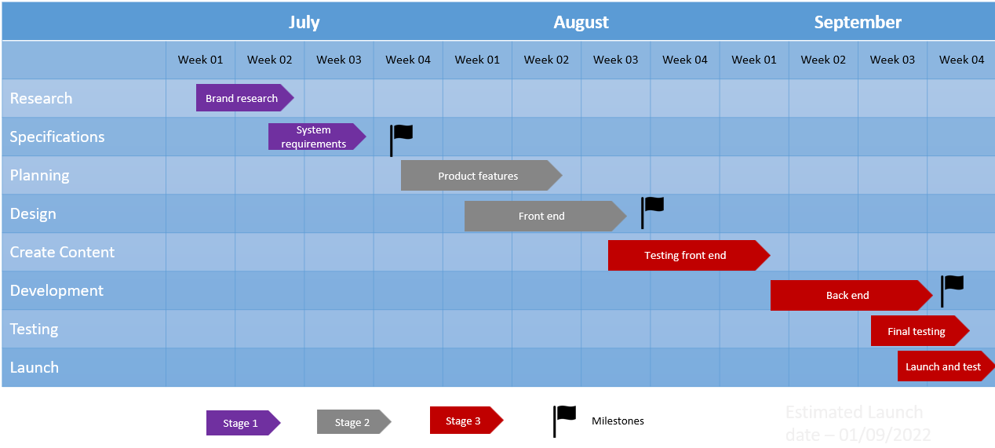

**4. System Analysis**

**4.1 Software Requirements**

**4.1.1 External Interface Requirements**

**4.1.1.1 User Interface**

**Browser:** A web browser is application software for accessing the World Wide Web. Since our website is hosted over the internet it will require to interact with our website.

**4.1.1.2 Hardware** **Interface**

* **Processor:** Intel i3 10th gen 2.4 GHz clock speed
* **RAM:** 4 GB DDR4 RAM
* **Storage:** 256 GB SSD
* **Monitor:** 60 Hz panel FHD display

**4.1.1.3 Software Interface**

**VS CODE /Sublime:** This are the code editor made for Windows, Linux and macOS Features include support for debugging, syntax highlighting, intelligent code completion, snippets, code refactoring, and embedded Git. Users can change the theme, keyboard shortcuts, preferences, and install extensions that add additional functionality.

**4.1.1.4 Communication Interface**

Google Meet: Real-time meetings by Google. Using your browser, share your video, desktop, and presentations with teammates and customers.

**4.1.2 Functional Requirement of the System**

**Minimum Hardware Requirements for our Program:**

* + PROCESSOR: Above 1GHz
  + RAM: 1 Gigabyte (GB) or Greater
  + HARDDISK: 1 gigabyte (GB) of free space or Greater
  + Keyboard & Mouse
  + MONITOR: 50Hz

**Minimum Software Requirements:**

We wanted to make this project independent from operating system so we create it in the form of website so that anyone with any device can access it.

* Operating System: Any operating system that support browser
* Download speed of 1 Mbps or greater for better performance.
* At least 2 GB of RAM, with 500 MB available for smooth browsing.

**4.1.3 Non-functional Requirement**

**4.1.3.1 Performance**

Our software is fully optimized to work on most of the computer. Works well on a pc with minimum 1 GB RAM and it does not need that much processing. It will need the Internet to work along with a Browser that supports JavaScript, HTML, CSS.

**4.1.3.2 Reliability**

The website does not require that much maintenance because it has a failsafe mechanism that has to be managed in Database and the server will be live all the time so if any server shutdown hits the data will be not deleted.

**4.1.3.3 Availability**

The website will be live 24/7 hours. Occasionally there will be server outbreak or shut down for maintenance and time will be notified for the users and the server uptime will be notified.

**4.1.3.4 Security**

As long as excel file is safe there is nothing to be worried about since website do not save any type of data there is nothing to steal.

**4.1.3.6 Portability**

The website is compatible with computer that have browsers regardless of what Operating system is.

**4.1.4 Proposed system architecture**

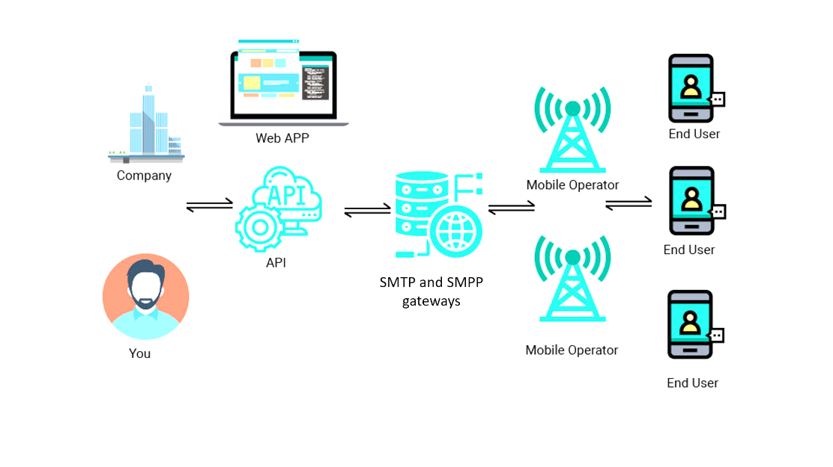

**4.2 System Analysis Tools**

**4.2.1 E-R Diagram**

**4.2.2 DFD Diagram:**

Level 0: Context level of DFD

Level 1: Register/Login

Level 2: Order, refund, and delivery

**4.2.3 Software & Hardware Requirements**

**4.2.3.1 Hardware requirement**

* + PROCESSOR: Above 1GHz
  + RAM: 1 Gigabyte (GB) or Greater
  + HARDDISK: 1 gigabyte (GB) of free space or Greater
  + Keyboard & Mouse
  + MONITOR: 50Hz

**4.2.3.2 Software requirement**

operating system with has a latest version of google chrome and Microsoft edge not mobile only computer.

**4.2.4 Overview of Technologies Used**

We have used html 5, css 3, JavaScript, Django and hosting and domain.

**5. SYSTEM DESIGN**

**5.1. UML Diagram**

**Use Case**

**Use Case Diagram for Administration activities.**

**Admin**

**Use Case Diagram for User activities**

**User**

**5.3. User Interface Design**

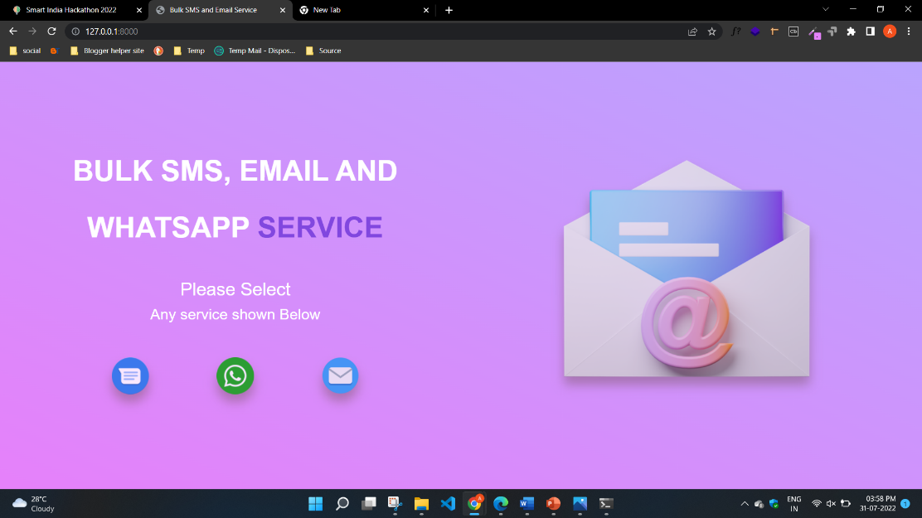

Fig1: HOMEPAGE

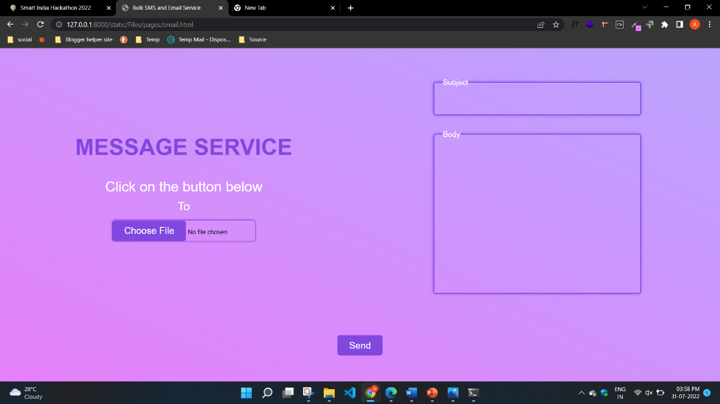

Fig 2: Message service

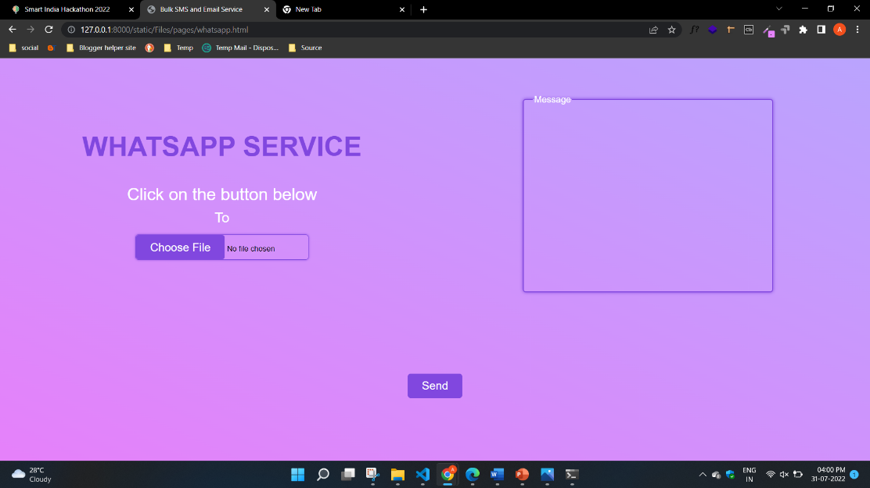

Fig 3: WhatsApp service

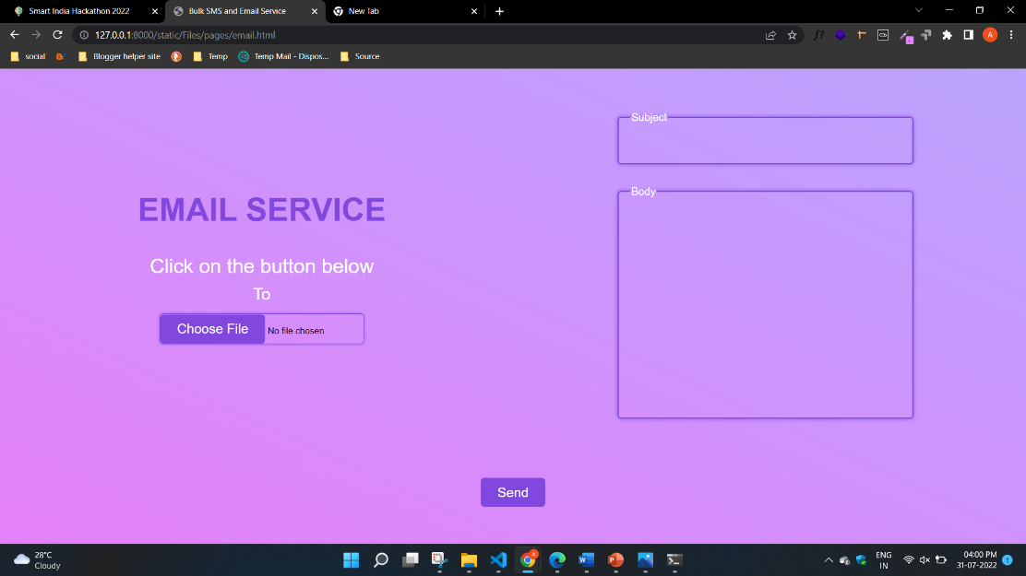

Fig 4: Email service

**6. Testing**

Testing is the process of exercising software with the intent of finding errors and ultimately correcting them. The following testing techniques have been used to make this project free of errors.

**6.1 Testing techniques**

**6.1.1Compatibility With Different Browsers**  
This form of testing is conducted to ensure that the product being developed offers provide proper support for early browsers and has browser specific extensions. While conducting this testing, it is also important to verify that it can cover main platforms like Linux, Windows, Mac etc.

**6.1.2 Page Display**  
Testing the product for this feature helps in verifying any incorrect display of pages, runtime error messages, poor download time of a page, dead hyperlink, or font sizing error. Identifying this form of error helps in ensuring that all such errors are rectified on time.

**6.1.3 Session Expiry**  
This includes testing the website on parameters like the duration for which a session lasts, its storage, etc. Testing this feature is important to ensure the maximum safety and security of the user’s confidential data like bank account details, passwords, etc.

**6.1.4 Usability**  
When you own a website, it is important to ensure that it proves useful to its users. Test to ensure that it does not have poor site navigation, performs when someone navigates through the catalogue and is also available with complete support in case the need arises.

**6.1.5 Analysis of Content**  
One must ensure that the content available/visible to the end user is authentic and not at all misleading. This implies that the website should be thoroughly checked for the presence of any offensive or deceptive content, copyright of the images present on the website, possibility of personalizing the content, etc.

**6.1.6 Data Backup and Recovery**  
Our website do not store any data so there is no risk of data loss. Unless and until excel data is leaked from a high official which is not a normal scenario.

**6.1.7 System Integration**  
The extent to which a website integrates with the system is an important factor to consider when developing a website. To verify this, the testing team needs to check and confirm the data interface format, interface frequency and volume capacity, updates, and performance.

**6.2 Test Reports**

**6.2.1 Test reports using various techniques**

* using different browsers, we ensure that the product being developed offers provide proper support and has browser specific extension and able to cover main platform like Linux, Mac, windows.
* Using page Display feature helps a lot in finding errors and any kind of incorrect display of pages poor downloading time of a page’s font sizing error.
* **Conclusion**

In summary of this minor Project, we created an website with all functions that can be used to send information to huge amount of population in short period of time.

* **FUTURE ENHANCEMENTS**
* Better UI
* More functionalities will be added with time

**REFRENCES and BIBLIOGRAPHY**

* **HTML : https://html.com/**
* **DJANGO :** **https://docs.djangoproject.com/en/4.0/**
* **GITHUB :** **https://github.com/**
* **W3SCHOOLS : https://www.w3schools.com**
* **JAVASCRIPT : https://www.javascript.com/**
* **CSS: https://www.w3.org/style/css/overview.en.html**