Jeff Shapiro

jeff@shapirohousehold.com

Supernotepad

Documentation

Contents

Description 2

User interface requirements 2

Features 3

Concept Design 4

Original Design 4

Screenshot 5

Main Window Screenshot. 5

Font Selector screenshot. 5

Open/Save Dialog box 6

Description

SuperNotepad is a simple and basic to operate light text editing program. All the features you need to be able to do some quick editing. Designed for beginners and also for the times when you need a quick and simple program to edit/update a text file.

# User interface requirements

The application can run on any hardware which supports windows 7 or later. The system must have at least 100MB of free disk space to install the program and recommended minimum of 1GB of memory to load the application.

# Features

New

Clear all existing text and return to default format.

Open

Open a pre-existing text file.

Close

Close the program

Save

Save the text file. If a pre-existing file was opened this will save over the top. Otherwise it will give you the option of choosing a name and location to save.

Save As

Will give you the option of choosing a name and location to save. May be used to save over the top of a pre-existing file.

Clear

Remove all text from the writing area but will keep the current format.

Select All

Highlight all the text in the writing space.

Font

Change the font style and colours.

Time Display

Displays the current time in the status bar on the bottom right hand side.

Concept Design

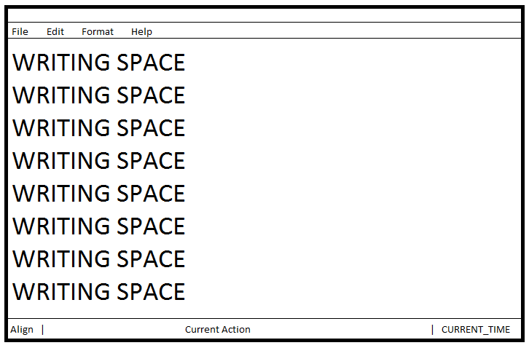

## Original Design

# Screenshot

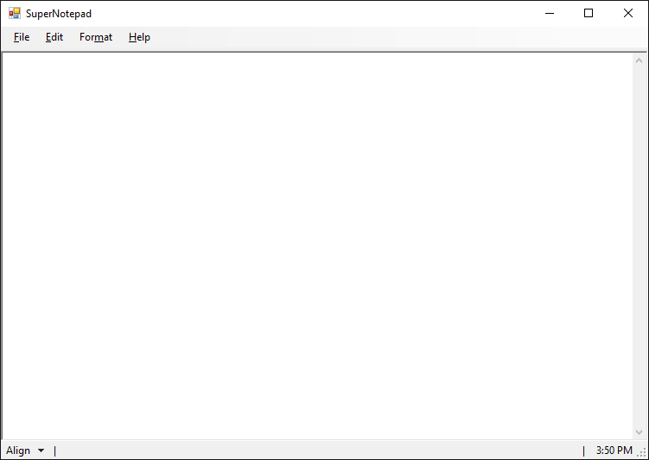

## Main Window Screenshot.

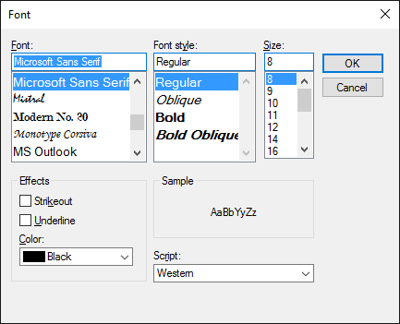

## Font Selector screenshot.

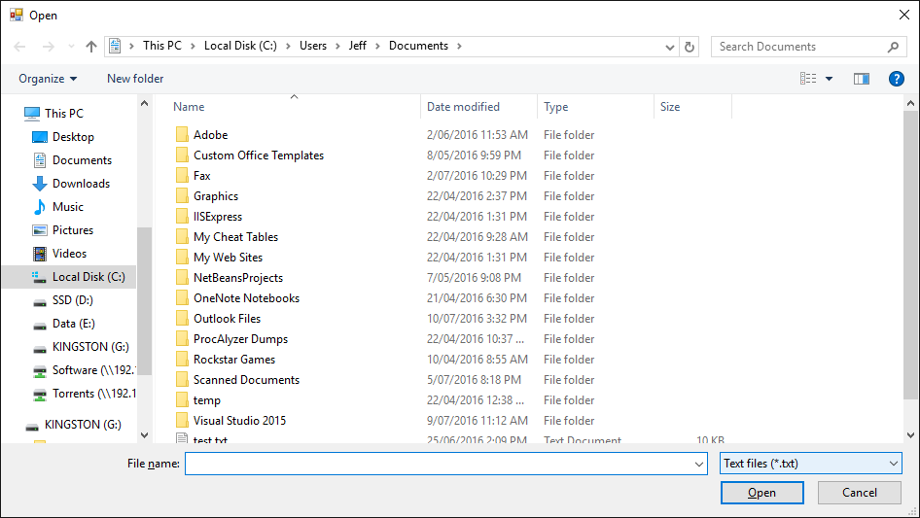

## Open/Save Dialog box