Jeff Shapiro

jeff@shapirohousehold.com

SuperPaint

Documentation

Contents

Description 2

User interface requirements 2

Features 2

Concept Design 3

Screenshot 4

Main Window Screenshot. 4

Basic Colour Selector screenshot. 4

Description

SuperPaint is a very simple and very basic to operate light paint program. All the features you need to be able to do some quick and easy touch ups on existing images. Designed for beginners and also for the times when you need a quick and simple program to draw a simple image.

# User interface requirements

The application can run on any hardware which supports windows 7 or later. The system must have at least 100MB of free disk space to install the program and recommended minimum of 1GB of memory to load the application.

# Features

Draw a Filled

* Square
* Rectangle
* Circle
* Ellipse

Draw Outline

* Square
* Rectangle
* Circle
* Ellipse

Draw Straight Line

Pencil drawing mode

Eraser

Basic Colour selector

* 21 Pre-set Colours
* Customisable Red Green Blue colour Selection

Full Colour Dialog

Changeable Background Colour

Adjustable

* Line thickness
* Eraser Thickness
* Line style
  + Solid
  + Dash
  + Dash Dot
  + Dash Dot Dot
  + Dot

Open existing images

Concept Design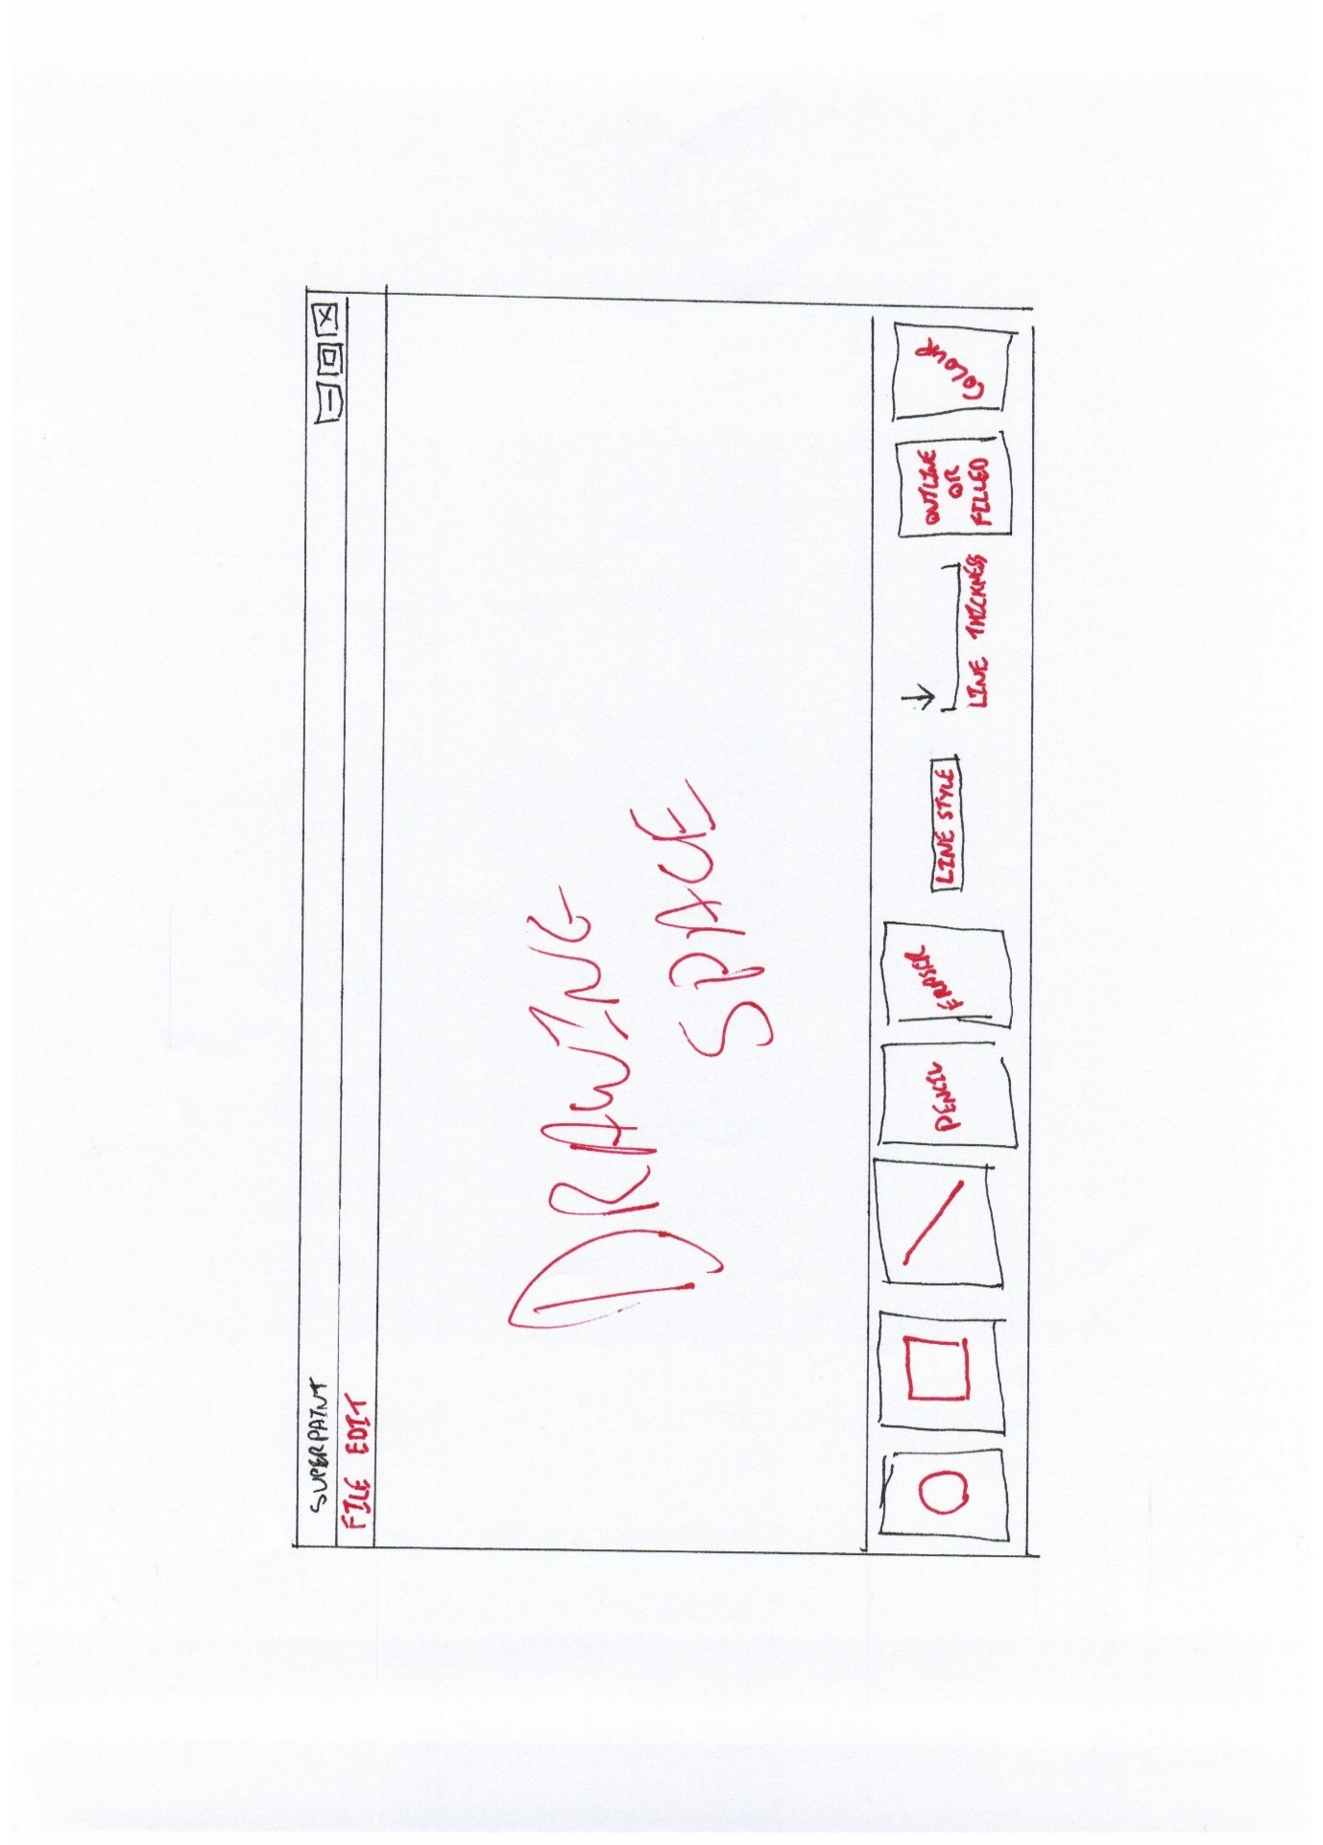

Original Design

# Screenshot

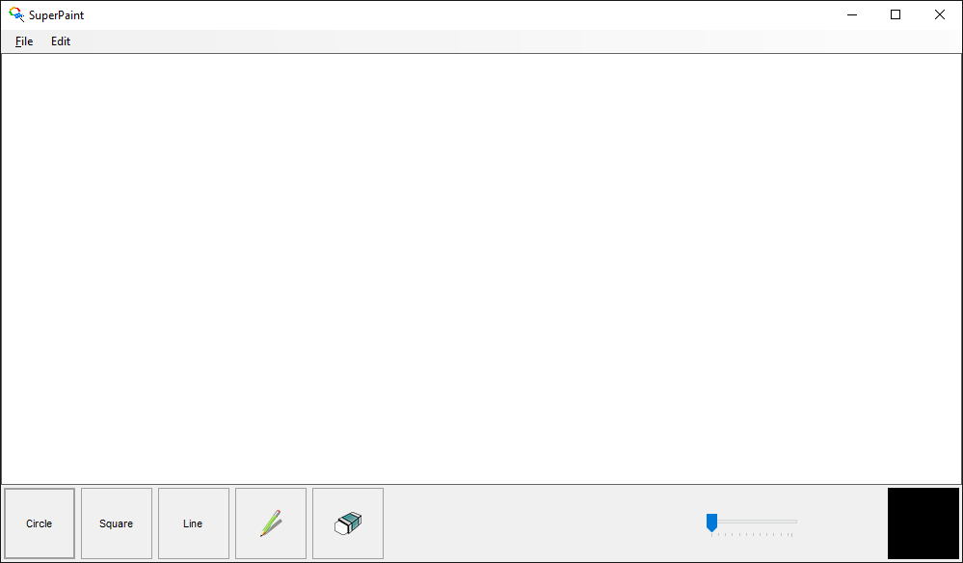

## Main Window Screenshot.

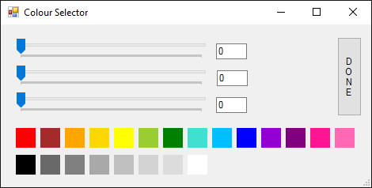

## Basic Colour Selector screenshot.