Jeff Shapiro

jeff@shapirohousehold.com

Yahtzee

Documentation

Contents

Description 2

User interface requirements 2

Features 3

Concept Design 4

Original Design 4

Screenshot 5

Main Window Screenshot. 5

Font Selector screenshot. 5

Open/Save Dialog box 6

Description

Yahtzee is a [dice game](https://en.wikipedia.org/wiki/Dice_game) made by [Milton Bradley](https://en.wikipedia.org/wiki/Milton_Bradley_Company) (now owned by [Hasbro](https://en.wikipedia.org/wiki/Hasbro)), which was first marketed as "Yatzie" by National Association Service of Toledo, Ohio, in the early 1940s. Yatzie was included in a game set called "LUCK - 15 Grand Dice Games". It was marketed under the name of Yahtzee by game entrepreneur [Edwin S. Lowe](https://en.wikipedia.org/wiki/Edwin_S._Lowe) in 1956. Lowe is also responsible for introducing Bingo to the U.S. market.[[1]](https://en.wikipedia.org/wiki/Yahtzee#cite_note-1) The game is a development of earlier dice games such as [Poker Dice](https://en.wikipedia.org/wiki/Poker_Dice), [Yacht](https://en.wikipedia.org/wiki/Yacht_(dice_game)) and [Generala](https://en.wikipedia.org/wiki/Generala). It is also similar to [Yatzy](https://en.wikipedia.org/wiki/Yatzy), which is popular in Scandinavia.

The object of the game is to score points by rolling five [dice](https://en.wikipedia.org/wiki/Dice) to make certain combinations. The dice can be rolled up to three times in a turn to try to make various scoring combinations. A game consists of thirteen rounds. After each round the player chooses which scoring category is to be used for that round. Once a category has been used in the game, it cannot be used again. The scoring categories have varying point values, some of which are fixed values and others where the score depends on the value of the dice. A Yahtzee is five-of-a-kind and scores 50 points; the highest of any category. The winner is the player who scores the most points.

# User interface requirements

The application can run on any hardware which supports windows 7 or later. The system must have at least 100MB of free disk space to install the program and recommended minimum of 1GB of memory to load the application.

# Features

New

Clear all existing text and return to default format.

Open

Open a pre-existing text file.

Close

Close the program

Save

Save the text file. If a pre-existing file was opened this will save over the top. Otherwise it will give you the option of choosing a name and location to save.

Save As

Will give you the option of choosing a name and location to save. May be used to save over the top of a pre-existing file.

Clear

Remove all text from the writing area but will keep the current format.

Select All

Highlight all the text in the writing space.

Font

Change the font style and colours.

Time Display

Displays the current time in the status bar on the bottom right hand side.

Concept Design

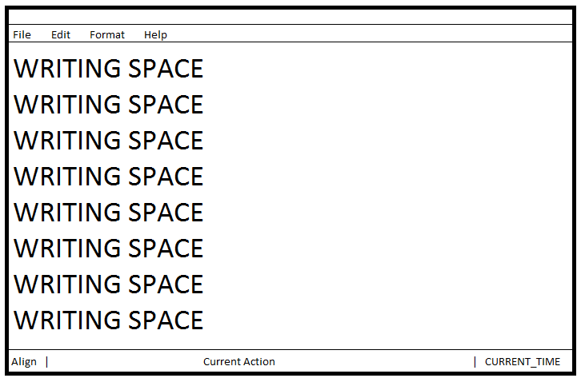

## Original Design

# Screenshot

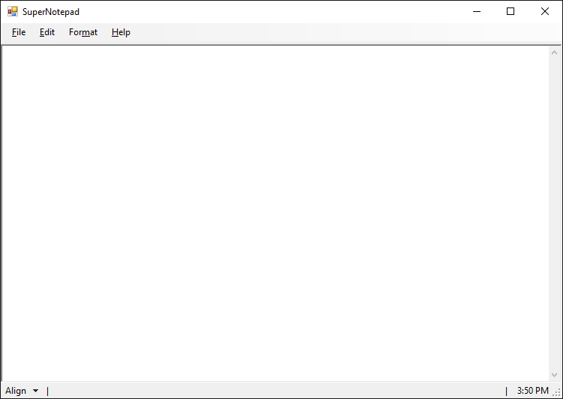

## Main Window Screenshot.

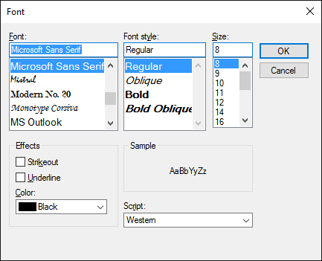

## Font Selector screenshot.

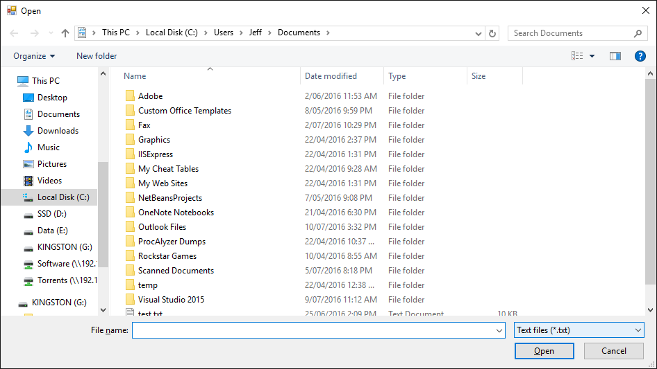

## Open/Save Dialog box