System Design Document
ShopEase — Secure Retail Web Application
ICT203 Web Application Development | Assessment 3

1. Overview
ShopEase follows a classic three-tier web architecture: a browser-based client tier, an application/server tier running PHP on Apache, and a relational database tier on MySQL. The PHP layer is organised in a lightweight MVC pattern — a single front controller (index.php) routes incoming requests to controllers, which interact with the database via PDO and render views built on the Bootstrap 5 framework.

2. Architecture Diagram
The diagram below shows the request flow from the client browser, through the Apache + PHP application layer, into the MySQL database. The AI Help Assistant operates entirely within the application tier — it does not call any external AI service — keeping all data inside the local stack.
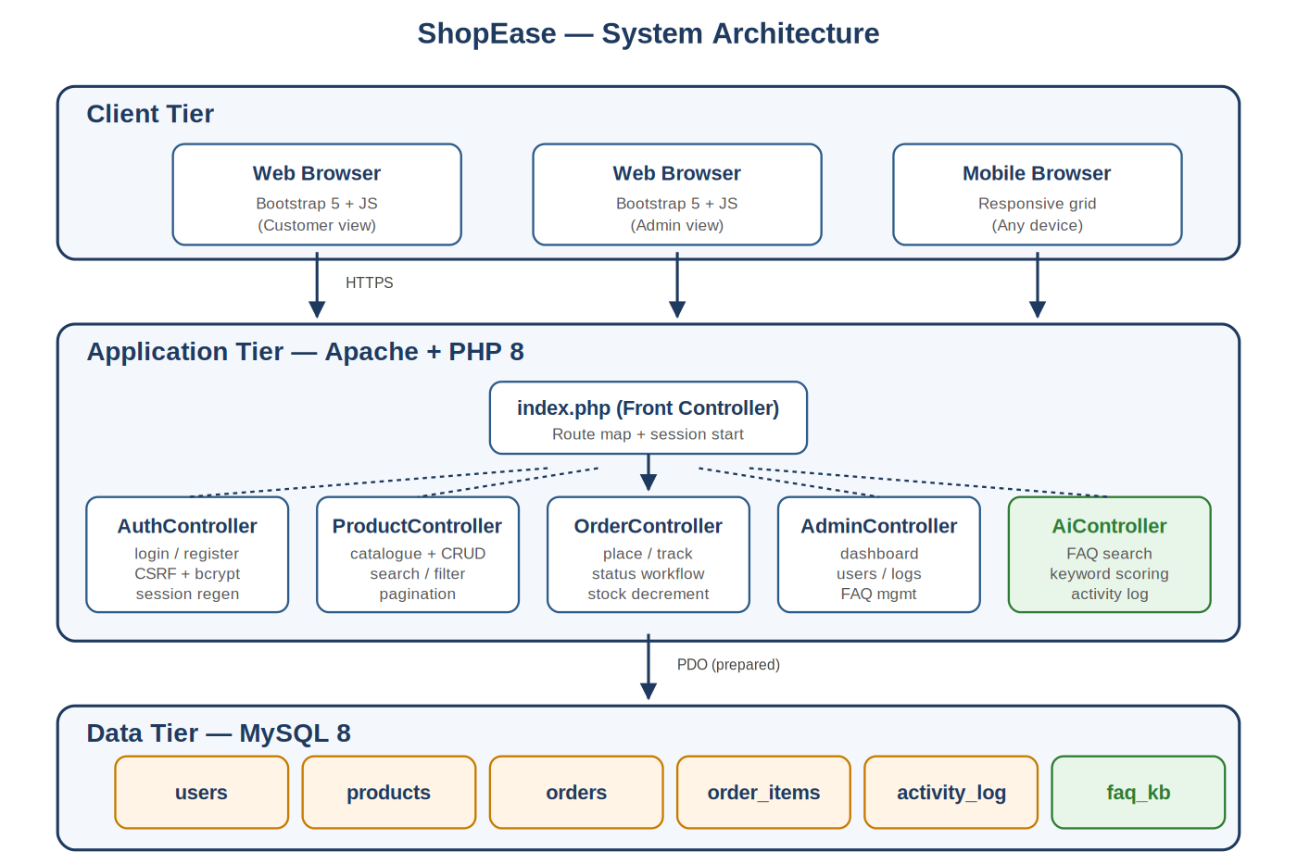

2.1 Components
Client tier — Any modern browser rendering Bootstrap 5 views with vanilla JavaScript for client-side validation. No SPA framework; the server renders HTML.
Application tier — Apache + PHP 8 running a front-controller router (index.php) that dispatches to one of five controllers: Auth, Product, Order, Admin, and Ai. Controllers enforce CSRF protection, role-based access, and prepared-statement queries.
Data tier — MySQL 8 with six tables (users, products, orders, order_items, activity_log, faq_kb). Accessed exclusively through PDO; no raw mysqli queries.

3. Entity Relationship Diagram
The ERD below shows the six tables in the ShopEase database and the foreign-key relationships between them. Primary keys are underlined in the schema; foreign keys link orders to users, order_items to both orders and products, and activity_log back to users for full auditing.
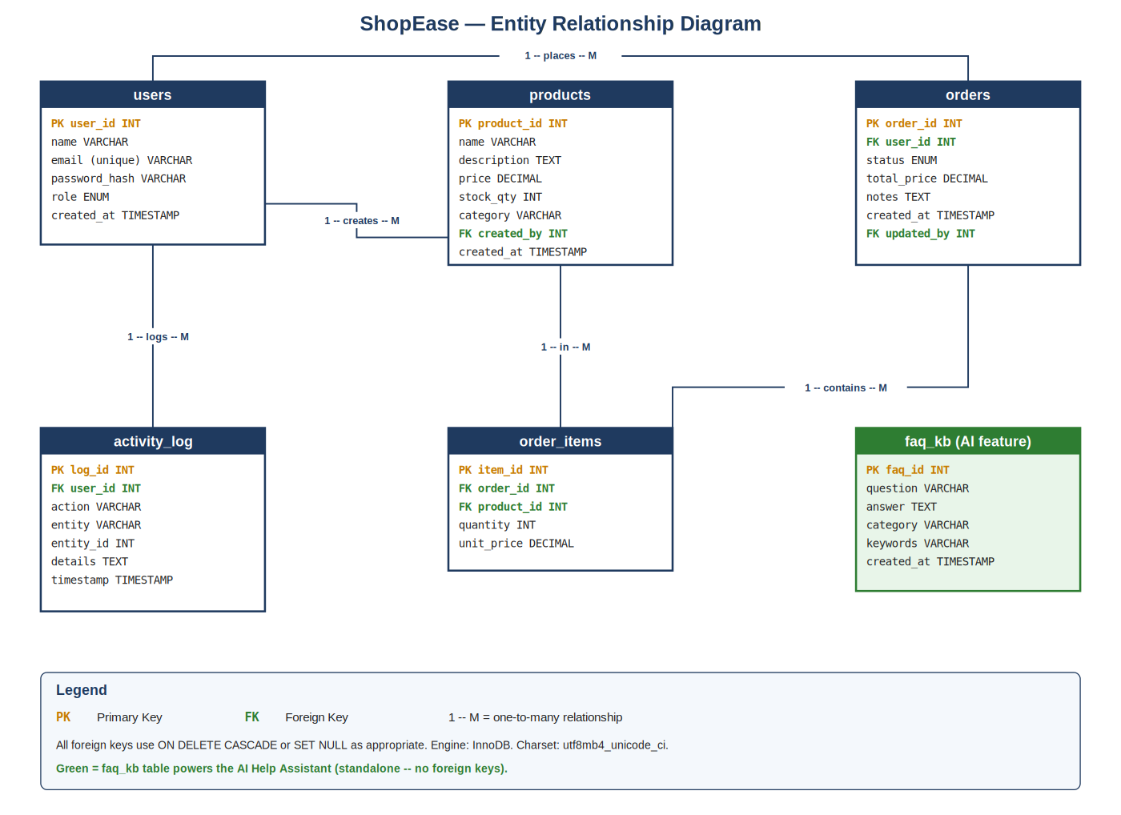

3.1 Key Relationships
- users (1) → (M) orders — each customer can have many orders.
- orders (1) → (M) order_items — each order contains one or more line items.
- products (1) → (M) order_items — each product can appear in many orders.
- users (1) → (M) products — the admin who created a product is recorded via created_by.
- users (1) → (M) activity_log — every action is attributable to a user (nullable on delete).
- faq_kb is a standalone table powering the AI Help Assistant; no foreign keys.

4. Application Routes / Endpoints
ShopEase uses a single front-controller (index.php) that dispatches clean URL routes. The table below lists all routes exposed by the application, grouped by area. POST routes are protected by a CSRF token validated server-side.

4.1 Authentication
Method | Path | Purpose
GET | /login | Show login form
POST | /login | Authenticate user, regenerate session
GET | /register | Show registration form
POST | /register | Create new customer account
GET | /logout | Destroy session, redirect to login

4.2 Products
Method | Path | Purpose
GET | /products | Catalogue with search, filter, pagination
GET | /products/{id} | View single product detail
GET | /products/create | Show create-product form (admin)
POST | /products/create | Insert new product (admin)
GET | /products/{id}/edit | Show edit form (admin)
POST | /products/{id}/edit | Update product (admin)
POST | /products/{id}/delete | Delete product (admin)

4.3 Orders
Method | Path | Purpose
GET | /orders | List orders (own for customer, all for admin)
GET | /orders/{id} | View order detail with line items
GET | /orders/create | Show order placement form
POST | /orders/create | Place order, decrement stock
POST | /orders/{id}/status | Update order status (admin only)
POST | /orders/{id}/cancel | Cancel pending order (customer)

4.4 Admin
Method | Path | Purpose
GET | /admin | Admin dashboard with summary metrics
GET | /admin/users | Manage user accounts
GET | /admin/logs | View activity audit log
GET | /admin/faq | List and manage FAQ entries
POST | /admin/faq | Create new FAQ entry
POST | /admin/faq/{id}/delete | Remove FAQ entry

4.5 AI Help Assistant
Method | Path | Purpose
GET | /help | Render Help Assistant interface
POST | /api/help | JSON endpoint: accepts { query }, returns scored FAQ matches + disclaimer

5. Request → Response Flow
A typical request flow proceeds as follows:
- Browser sends an HTTP request to Apache (e.g. POST /shopease/orders/create).
- Apache hands the request to index.php via .htaccess URL rewriting.
- index.php parses the path, matches it against the route map, and instantiates the corresponding controller.
- The controller validates CSRF, enforces login/role checks, then runs PDO prepared statements.
- Results are passed into the view template (in /app/views), which is rendered as HTML.
- Response is returned to the browser; any sensitive action is also written to the activity_log table.
Prepared by the ShopEase team for ICT203 Assessment 3.

