Grazioso Salvare Rescue Animal Dashboard
About the Project
This project is a web dashboard created for Grazioso Salvare. The purpose of the dashboard is to help the client review animal shelter outcome data from the Austin Animal Center and identify dogs that may be good candidates for rescue training.
The dashboard connects to a MongoDB database using a Python CRUD module. It displays the shelter data in an interactive table and allows the user to filter the data by rescue type. The dashboard also includes a map that shows the selected animal’s location and a chart that summarizes the visible animal breeds.
Dashboard Functionality
The dashboard includes the following features:
- A Grazioso Salvare logo
- A unique identifier with my name
- An interactive data table populated from MongoDB
- Rescue type filters:
  - Reset
  - Water Rescue
  - Mountain or Wilderness Rescue
  - Disaster or Individual Tracking
- A geolocation map that updates based on the selected table row
- A breed chart that updates based on the filtered data
Screenshots
Reset / Starting View
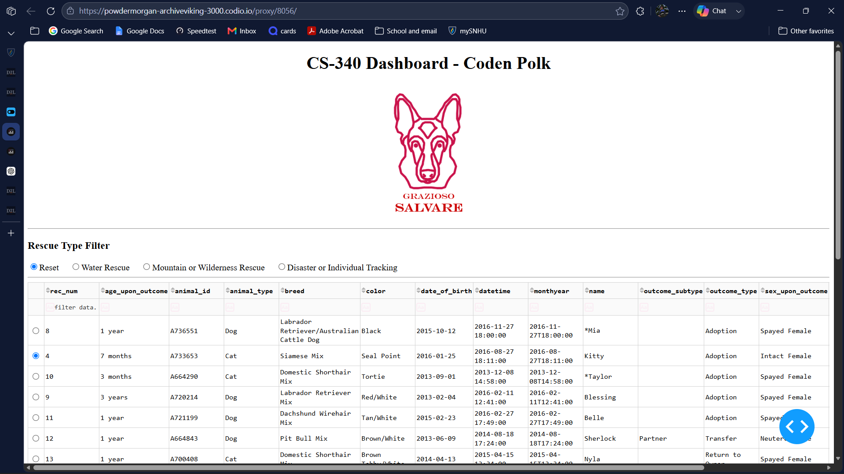
Water Rescue Filter
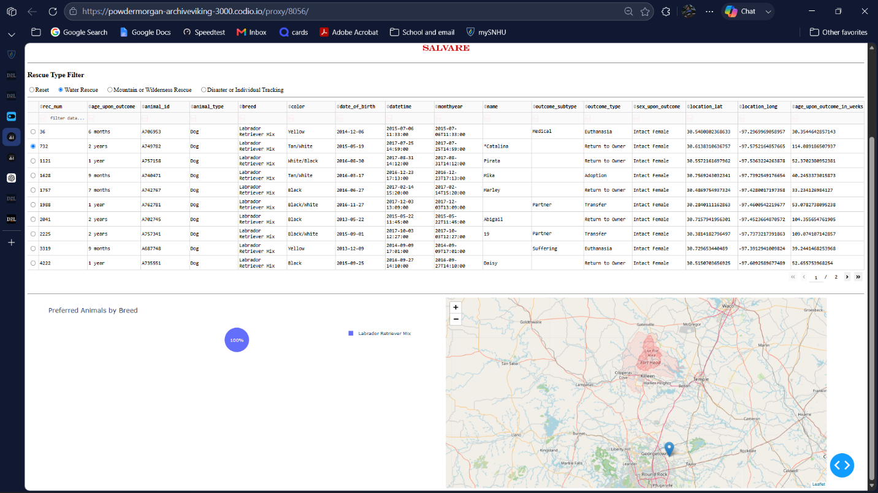
Mountain or Wilderness Rescue Filter
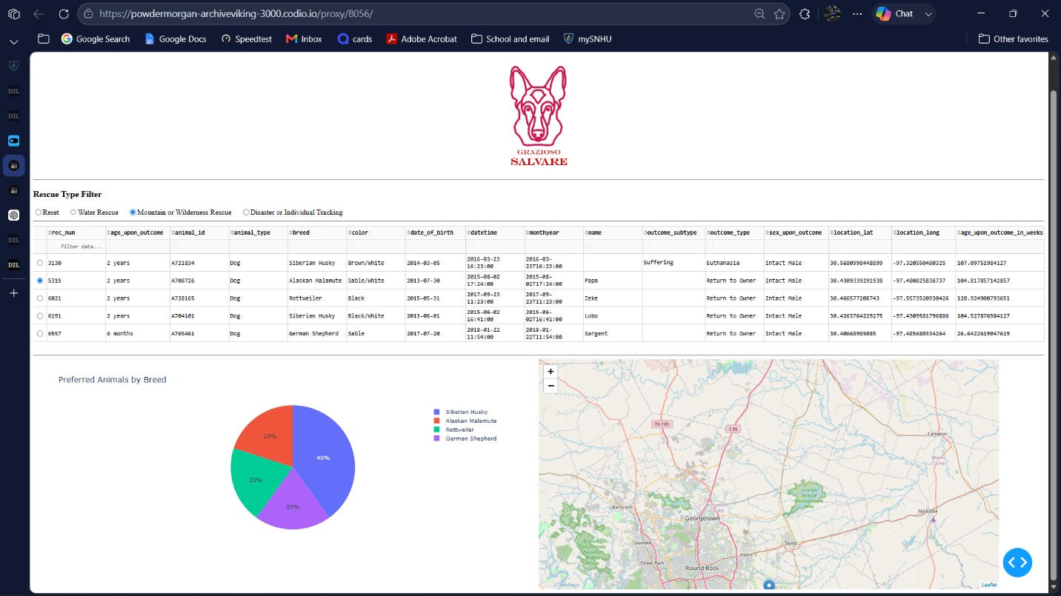
Disaster or Individual Tracking Filter
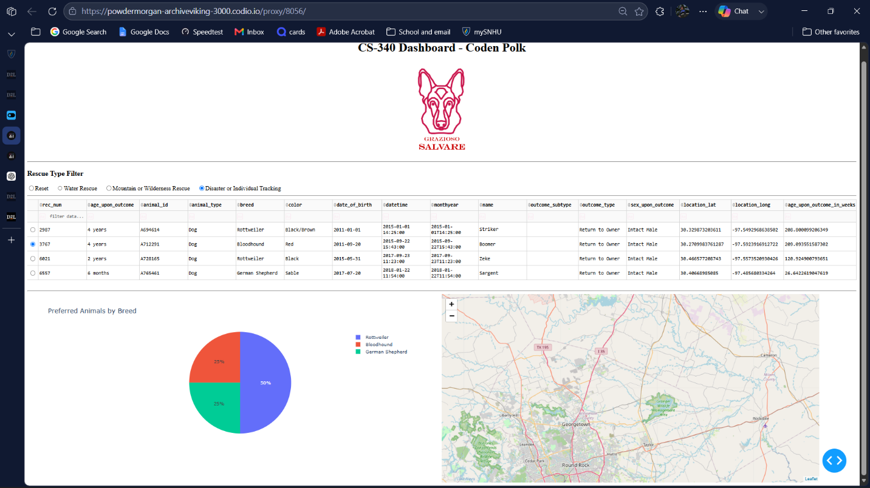
Tools Used
MongoDB
MongoDB was used as the database for this project. It works well for this type of application because the Austin Animal Center data is stored as documents. MongoDB makes it easy to query records using fields such as animal type, breed, sex, and age.
MongoDB also works well with Python through the PyMongo library. PyMongo allows the dashboard to send queries to the database and return the matching records as Python data structures.
Python
Python was used as the main programming language for the project. It was used to build the CRUD module, connect to MongoDB, process the data with Pandas, and create the dashboard.
PyMongo
PyMongo was used to connect the Python code to the MongoDB database. The CRUD module uses PyMongo to perform database operations, especially read queries for retrieving animal records.
Dash
Dash was used to build the web dashboard. It provides the visual components of the application, such as radio buttons, data tables, charts, and layout elements. Dash callbacks were used as the controller logic to update the dashboard when a user selects a filter or chooses a row in the data table.
Pandas
Pandas was used to convert MongoDB query results into a DataFrame. This made it easier to display the data in the Dash data table and use the data for charts and map updates.
Dash Leaflet
Dash Leaflet was used to create the geolocation map. The map uses the latitude and longitude fields from the selected animal record to show where the animal is located.
Plotly Express
Plotly Express was used to create the breed chart. The chart updates based on the records currently shown in the data table.
Steps Taken to Complete the Project
- Imported the Austin Animal Center Outcomes data set into MongoDB.
- Created a MongoDB user named aacuser with access to the aac database.
- Built a Python CRUD module named animal_shelter.py.
- Connected the dashboard to the CRUD module using the AnimalShelter class.
- Retrieved all records from the animals collection and loaded them into a Pandas DataFrame.
- Created an interactive Dash data table to display the shelter records.
- Added radio button filters for the rescue categories.
- Created MongoDB queries for each rescue type.
- Added a Dash callback to update the table based on the selected rescue filter.
- Added a geolocation map that updates based on the selected row in the table.
- Added a breed chart that updates based on the filtered data.
- Added the Grazioso Salvare logo and my unique identifier to the dashboard.
- Tested the dashboard using the Reset, Water Rescue, Mountain or Wilderness Rescue, and Disaster or Individual Tracking filters.
- Captured screenshots showing the dashboard working correctly.
Challenges and Solutions
One challenge was making sure the MongoDB authentication worked correctly. I solved this by verifying the username and password in the Mongo shell and then using the same credentials in the Python CRUD module.
Another challenge was displaying MongoDB records in the Dash data table. MongoDB returns an _id field as an ObjectId, which can cause display issues in Dash. I solved this by removing the _id column from the DataFrame before loading the data into the table.
A third challenge was getting the map to update correctly when a row was selected. I solved this by enabling single-row selection in the data table and using the selected row index to retrieve the latitude and longitude values for the map marker.
Another issue was handling cases where no row or column was selected yet. I solved this by adding checks for None values in the callback functions so the dashboard would not crash when it first loaded.

