DriverPass System Design Diagrams

Use Case Diagram
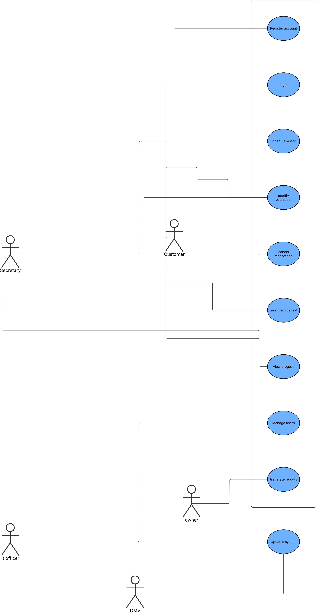
Explanation:
The use case diagram illustrates the interactions between the different users of the DriverPass system. There are five main types of user accounts: a customer, a secretary, an owner, an IT officer and a DMV. Customers have the ability to register for an account, log into their accounts, schedule lessons, manage their reservations and take practice tests. Secretaries can assist customers with scheduling their lessons and modifying existing reservations. Owners can generate reports pertaining to the DriverPass system and manage training packages for customers. IT Officers manage all user accounts and manage access into the DriverPass system. The DMV is responsible for updating rules and procedures. The use case diagram provides an overview of all of the major functions of the DriverPass system as well as the primary roles that users play within the system.

Activity Diagram – Schedule Lesson
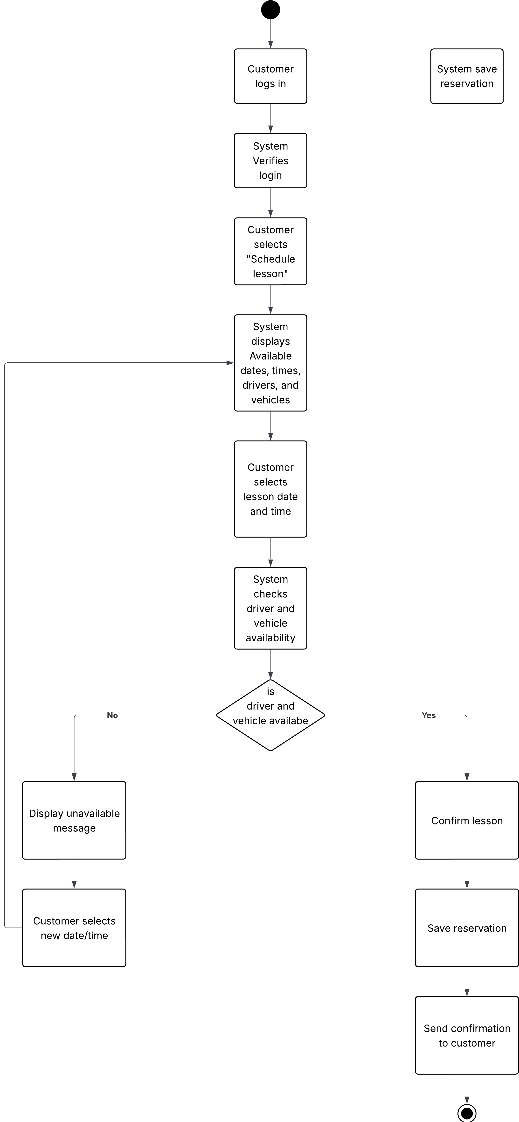
Explanation:
The DriverPass scheduling process for booking a lesson with your instructor is depicted in this activity diagram. The customer logs on to their account and chooses to schedule a lesson. The customer then views a list of instructors, times, and vehicles. After the customer chooses an instructor's available lesson time, DriverPass checks to see if those instructors are available. If not, the schedule will not allow for the booking. If the instructor and vehicle are available for the requested lesson time, then the system will confirm, create and notify the customer that they have a scheduled lesson. Therefore, the system maintains a proper plan/schedule for managing lesson booking.

Activity Diagram – Customer Registration
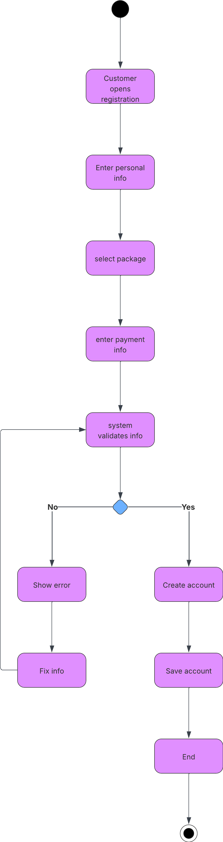
Explanation:
The first step of the registration process is to go to the DriverPass Registration Page. The new user will fill out their basic account information and select a training package. After that, they will submit their payment information very much the same way they submitted their account information. After the DriverPass system has validated all of the above-mentioned information, if any errors were found, the customer will be required to fix those errors before a new DriverPass Account will be created for them. This diagram shows how the DriverPass System ensures that the customer's data is accurate before creating their Account.

Sequence Diagram
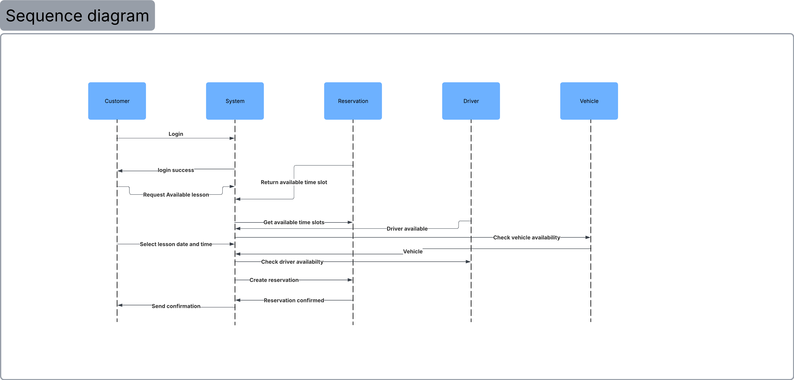Explanation:
This sequence diagram illustrates how different components within the DriverPass system will interact when a customer schedules a lesson. The customer first logs into the system and requests available lesson times from the system. The system will communicate with the reservation system to get available time slots and will also check driver and vehicle availability before creating the reservation and confirming it. Once confirmed, the system will send a confirmation back to the customer. The diagram illustrates the sequence of communication between system components.

Class Diagram
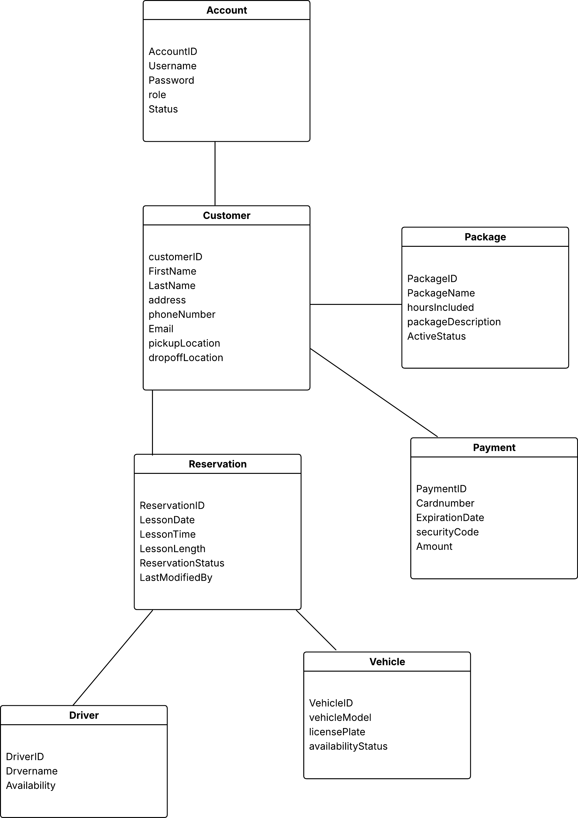Explanation:
The class diagram shows the main components of the DriverPass system and how they are connected. The Customer class stores user information, while the Account class manages login credentials and roles. Customers can select a Package, make a Payment, and schedule a Reservation. Each reservation is linked to a Driver and a Vehicle to ensure proper scheduling. This diagram represents the structure of the system and how data is organized and related across different parts of the application.

