Automated CI/CD Pipeline for a Vehicle Service Booking Portal: Jenkins, Docker and Ansible with Automated Quality Gates
Student: Aditya Sinha | Roll No.: 23102C0037 | Topic: DevOps - CI/CD and Configuration Management
1. Abstract
Small web applications are often released by hand: a developer builds on a laptop, copies an archive to a server and hopes the environment matches. This paper describes a fully scripted delivery workflow for the Vehicle Service Booking Portal (VSBP), a Java 17 / Spring Boot 3.3 application in which customers book and track service appointments and an admin confirms them. A Jenkins declarative pipeline compiles the code, runs the JUnit/Mockito test suite and a Selenium UI gate, packages one WAR and then deploys it three ways: to Tomcat per environment, as a versioned Docker image, and to an Ubuntu node configured by an idempotent Ansible role with one-command rollback. We compare this stack with GitHub Actions, GitLab CI and GitOps/Kubernetes, and propose three low-cost extensions: security scanning, webhook triggers and monitoring with DORA metrics.
2. Introduction
DevOps joins development and operations through automation, fast feedback and shared ownership [1][2]. Research on software-delivery performance links four measures (deployment frequency, lead time, change-failure rate and time to restore) to organisational outcomes [3][13]. Continuous Integration (CI) merges and verifies every change automatically [4]; Continuous Delivery (CD) keeps the verified artefact always deployable [1]. The VSBP repository follows a Git-flow variant (main, develop, feature/*, bugfix/*, ci/*, ops/*) with pull requests, so each merge into develop is a candidate release.
3. Problem Statement
Without automation the VSBP team faces: (a) "works on my machine" drift between dev, staging and production; (b) regressions reaching users because UI journeys such as book, cancel and confirm are checked manually; (c) slow, error-prone deployments with no audit trail of which commit runs where; (d) servers built by hand that cannot be recreated; and (e) no fast way back when a release fails. The goal is a pipeline that turns every commit into a tested, versioned, deployable artefact and a verified running service, and that stops automatically when any check fails.
4. Existing Approaches, Tools and Limitations
Table 1 compares the mainstream options for the CI/CD, packaging and configuration layers.
Approach / tool | Strengths | Limitations for this project
Manual build and copy | No tooling; instant for one developer | Not repeatable, no audit trail, no test gate, human error
Jenkins (pipeline as code) [5] | Free, self-hosted, huge plugin set, Jenkinsfile versioned with code, runs on Windows and Linux agents | Server to maintain; plugins and tool names need care; polling adds latency without a webhook
GitHub Actions [9] / GitLab CI [10] | Hosted runners, YAML next to code, marketplace actions | Minutes quota on private repos; less control of local Tomcat/Docker hosts; lock-in to one platform
Docker [6] vs. VM images | Same image in every environment, layered cache, small JRE runtime | Needs registry and host; persistence needs volumes
Ansible [7] vs. Chef/Puppet | Agentless (SSH), readable YAML, idempotent modules | Slower on very large fleets; push model only
Kubernetes + Argo CD (GitOps) [11][12] | Self-healing, rolling updates, declarative state in Git | Heavy operational cost for a single-service portal
Selenium WebDriver [8] | Real-browser end-to-end checks in CI | Slower and more brittle than unit tests; needs headless Chrome

Key gap: single tools solve one stage each. The project needs one pipeline that couples tests, packaging, containers and server provisioning with fail-fast gating, at a cost a student team can run on one machine.
5. Proposed Technical Solution and Architecture
The solution is a pipeline-as-code design (Figure 1). Git is the single source of truth; Jenkins orchestrates; Maven produces one immutable WAR; Docker and Ansible are two interchangeable delivery targets; Spring Boot Actuator provides the health signal that decides whether a deployment succeeded. Items marked "new" are the proposed extensions beyond the current baseline.
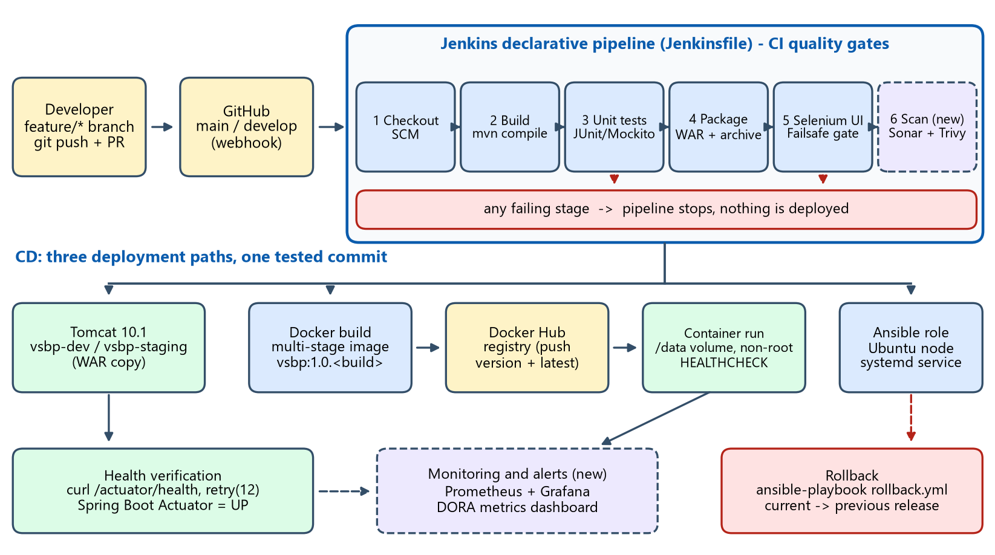
Figure 1. Architecture of the proposed CI/CD workflow (dashed boxes = proposed additions).
Design principles. (1) Build once, deploy many: the tested WAR is the artefact, environment name is a pipeline parameter (DEPLOY_ENV = dev | staging | prod). (2) Fail fast: a failing unit or Selenium stage aborts the build before any deploy stage. (3) Everything is code: Jenkinsfile, Dockerfile and Ansible role live in the repository. (4) Verify, do not assume: each deployment polls /actuator/health. (5) Reversible releases: Ansible keeps releases side by side with a current symlink.
6. Implementation Steps
1. Version control. Protect main and develop; work on feature/* branches merged by pull request using the repository's issue and PR templates; tag releases.
2. Jenkins setup. Install Jenkins LTS on JDK 17, add the Git, Pipeline, JUnit and Docker Pipeline plugins, register tools Maven-3.9 and JDK-17, create a "Pipeline script from SCM" job with an SCM poll (H/2 * * * *) that a GitHub webhook replaces.
3. CI stages. Checkout, mvn compile, mvn test (JUnit 5 + Mockito, report published), mvn package -Dapp.environment=<env> with the WAR archived and fingerprinted.
4. UI quality gate. Run Selenium WebDriver journeys headless through the Maven Failsafe plugin [8][14]; the goals are bound explicitly so the gate runs on every verify; screenshots are archived on failure.
5. Deploy to Tomcat. Copy the WAR to webapps/vsbp-<env>.war and retry curl --fail on /actuator/health up to 12 times [15].
6. Containerise. Multi-stage Dockerfile [6]: Maven build stage with a cached dependency layer, then a small JRE-alpine runtime running as a non-root user with a HEALTHCHECK; tag 1.0.<build>, push to Docker Hub, replace the running container with a /data volume.
7. Provision with Ansible. Role vsbp installs Java 17, creates the service user and folders, copies the release, templates the environment file and systemd unit, then waits for health. A second run reports no changes (idempotency); rollback.yml re-points current to the previous release [7].
8. Proposed extensions. Add SonarQube static analysis and Trivy image scanning as stage 6, switch polling to a webhook, and export Actuator metrics to Prometheus/Grafana with alerts.
7. Output and Results
Running the pipeline on the repository produces: a green stage view per commit; JUnit and Failsafe reports and archived screenshots; a fingerprinted WAR; two parallel Tomcat deployments (/vsbp-dev and /vsbp-staging) each showing its own environment name; a versioned image on Docker Hub; and an Ansible-built node that answers {"status":"UP"} on /actuator/health. A deliberately injected defect (docs/defect-demo) turns the build red at the test stage and nothing is deployed, which demonstrates the gate.
Aspect | Before (manual) | After (pipeline)
Release steps run by a human | Build, copy, restart, check (4+) | 1 click or 0 (SCM trigger)
Test gate before deploy | Optional, by memory | Mandatory: unit + Selenium
Rebuild a server | Hours, undocumented | One ansible-playbook run, idempotent
Rollback | Manual re-copy | One playbook: symlink switch + health check

8. Benefits
Shorter lead time and fewer failed releases through early, automatic feedback [3]; identical artefacts across environments, removing configuration drift; a complete audit trail from commit to running container; reproducible infrastructure; and a safe, rehearsed recovery path. The stack is open-source and runs on a single workstation, so cost stays near zero. Limitations: Jenkins needs upkeep, H2 suits demos rather than production, and Selenium suites must be kept small to stay fast.
9. Conclusion
A Jenkins pipeline that combines unit tests, a Selenium gate, a Docker image and an Ansible role gives the VSBP project a repeatable, auditable and reversible delivery process without the overhead of Kubernetes. The proposed security scanning, webhooks and monitoring close the main remaining gaps, and the same Jenkinsfile can later feed a GitOps cluster if the portal grows.
References
[1] J. Humble and D. Farley, Continuous Delivery. Addison-Wesley, 2010.
[2] G. Kim, J. Humble, P. Debois and J. Willis, The DevOps Handbook. IT Revolution Press, 2016.
[3] N. Forsgren, J. Humble and G. Kim, Accelerate: The Science of Lean Software and DevOps. IT Revolution Press, 2018.
[4] M. Fowler, "Continuous Integration," 2006. https://martinfowler.com/articles/continuousIntegration.html
[5] Jenkins Project, "Pipeline" user documentation. https://www.jenkins.io/doc/book/pipeline/
[6] Docker Inc., "Multi-stage builds" and Dockerfile reference. https://docs.docker.com/build/building/multi-stage/
[7] Red Hat, Ansible Documentation: roles, idempotency and playbooks. https://docs.ansible.com/ansible/latest/
[8] SeleniumHQ, Selenium WebDriver Documentation. https://www.selenium.dev/documentation/
[9] GitHub, GitHub Actions Documentation. https://docs.github.com/en/actions
[10] GitLab, GitLab CI/CD Documentation. https://docs.gitlab.com/ee/ci/
[11] Argo Project, Argo CD Documentation (GitOps). https://argo-cd.readthedocs.io/
[12] The Kubernetes Authors, Kubernetes Documentation. https://kubernetes.io/docs/
[13] DORA (Google Cloud), DevOps Capabilities and Four Key Metrics. https://dora.dev/
[14] Apache Maven, Maven Failsafe Plugin. https://maven.apache.org/surefire/maven-failsafe-plugin/
[15] VMware/Broadcom, Spring Boot Reference: Actuator health endpoints. https://docs.spring.io/spring-boot/reference/actuator/

